Repository <https://github.com/natarazworld/NTSPBMS615Repo.git>

<https://github.com/natarazworld/NTSPBMS615Repo.git>

Git Hub : <https://www.youtube.com/watch?v=_frCuw5JWdQ&list=PLVlQHNRLflP-C43xWt10PB3gKC8DDPB12>

Gradle : <https://www.youtube.com/watch?v=5JkqrUu4kGM>

<https://www.youtube.com/watch?v=CfATtI9_nMA>

<https://www.youtube.com/watch?v=A12Z8LjJEMo>

<https://www.youtube.com/watch?v=jTJwieViWQQ&t=7074s>

**Microservices Introduction Videos: Spring Rest & Microservices**

Day-1 [https://youtu.be/Tlp45YhOE-8](https://l.facebook.com/l.php?u=https%3A%2F%2Fyoutu.be%2FTlp45YhOE-8%3Ffbclid%3DIwAR1htMB_oTj9-4MWbzB9rk9E_FaKO94pEkkqBT6LUstz91O7nFwsBBksEuo&h=AT2piIgHExr9vRcYVFfU70dBE82o35lURkeztvYaxScN6DQlX_nDzdrpEbIfmeZoGTojlnuq71dYmVoN80gbNoiv8-k3GLZNLtimSqOydBpLFgNGLpbeaKbiz2EP5RfQl9R8&__tn__=-UK-R&c%5b0%5d=AT05PAF6wtEL5U5msvUwOZS2cTEpcdD9SUzX9wqAilFYdLtkVpJiE_gwQynSemoPTGQ4OOv8dngPplm303F4h0ZXeRKLEm2L8BarnfdophVtU2QpdsBRchmEv_cZLa2Jd7TflMqHHZApaGy5axQxoe8lwVNGzk3kcRh8eIxjsuCOF-GfEa-zG_JX2NNcqLZ99tmT84Z-6f-H)

Day-2 [https://youtu.be/EpaNqWAVadI](https://l.facebook.com/l.php?u=https%3A%2F%2Fyoutu.be%2FEpaNqWAVadI%3Ffbclid%3DIwAR26XRHmswsytH72hYCctZrjPDAfrIe9eWgkmMxfUPlt0sATh-Ug7Px5CGQ&h=AT1qOwXCErOme3DJZRFZ4CUMqv-vuYSq5aWMKnehBhsl9MZWbo14wLsusMWhDhiToXPA9NlvyLeeZD1fJRJmZX0TJcoZxFznOr25cCx2ULbw4SuSpdRa4OUrXJW-xT6JO1kx&__tn__=-UK-R&c%5b0%5d=AT05PAF6wtEL5U5msvUwOZS2cTEpcdD9SUzX9wqAilFYdLtkVpJiE_gwQynSemoPTGQ4OOv8dngPplm303F4h0ZXeRKLEm2L8BarnfdophVtU2QpdsBRchmEv_cZLa2Jd7TflMqHHZApaGy5axQxoe8lwVNGzk3kcRh8eIxjsuCOF-GfEa-zG_JX2NNcqLZ99tmT84Z-6f-H)

Day-3 [https://youtu.be/BWfLY15xj_w](https://l.facebook.com/l.php?u=https%3A%2F%2Fyoutu.be%2FBWfLY15xj_w%3Ffbclid%3DIwAR34j_y7dHTjyFmhTkho012TB38YkrG2EI5JUpSqII5Ju7NdoEyihcHeWbo&h=AT2rPLLDC6FYkG1VEVrmINRk4bCI_UTGUhQNPBG0buQW3uXE_Q9qndy8aT_rPma85XidHKwflRY084zUGkEtFx8DQy7ZjguG28p29Hk6hUUDuJG-TvNJa0jc_sFnkQ6xC5pk&__tn__=-UK-R&c%5b0%5d=AT05PAF6wtEL5U5msvUwOZS2cTEpcdD9SUzX9wqAilFYdLtkVpJiE_gwQynSemoPTGQ4OOv8dngPplm303F4h0ZXeRKLEm2L8BarnfdophVtU2QpdsBRchmEv_cZLa2Jd7TflMqHHZApaGy5axQxoe8lwVNGzk3kcRh8eIxjsuCOF-GfEa-zG_JX2NNcqLZ99tmT84Z-6f-H)

Day-4 [https://youtu.be/UQJ8ToGWN4Y](https://youtu.be/UQJ8ToGWN4Y?fbclid=IwAR0Fw0cHlZ4wF5I9apviLZcvMd5rIR_RUwsXR1QkMl6bVUSV2vTYE27dCAs)

Day-5 [https://youtu.be/05Kg91stFtU](https://youtu.be/05Kg91stFtU?fbclid=IwAR3fsWOKI3ZpbsXZ0wN73dowj9H9C7t0F7qtky46JzDS_2spELgq07SWdN0)

Day-6 [https://youtu.be/p9MJ-aSNlM0](https://youtu.be/p9MJ-aSNlM0?fbclid=IwAR3fsWOKI3ZpbsXZ0wN73dowj9H9C7t0F7qtky46JzDS_2spELgq07SWdN0)

**Junit5, HttpUnit & Mockito Workshop Session-1 | by Mr. Nataraj**

https://www.youtube.com/watch?v=6VVplfYp40M

https://www.youtube.com/watch?v=AI3b3FY2iD0

https://www.youtube.com/watch?v=7Xq4j0Q7aPE

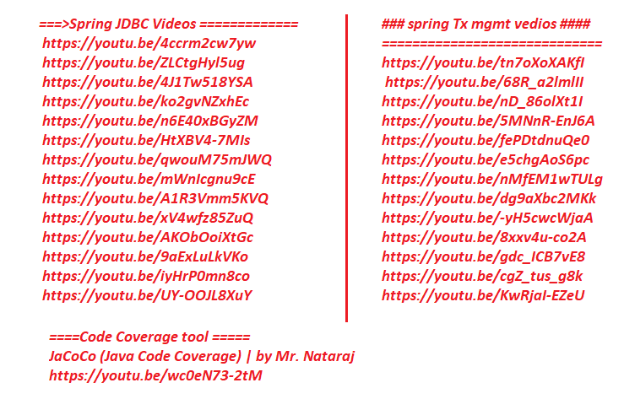

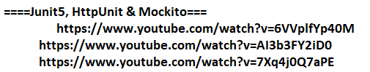

**Table of Contents**

**Microservices Introduction Videos: Spring Rest & Microservices** 1

**Junit5, HttpUnit & Mockito Workshop Session-1 | by Mr. Nataraj** 1

**Table of Contents** 2

1. NTSPBMS615- spring Boot MVC Intro -- May 23rd- 2022 4

2. NTSPBMS615-More on Distributed Apps- May 24th 2022 7

3. NTSPBMS615-May28th-2022 -SOAP WebServices and RestFullWebServices 14

4. NTSPBMS615-June2nd-2022 -Frist Spring RestApp Development 22

5. Spring Rest & MicroServices 23

6. NTSPBMS615-June 3rd-2022 -Frist Spring RestApp Testing Using POSTMAN Tool 27

7. NTSPBMS615-June6th-2022-Working with JSON from @RestController 32

8. NTSPBMS615-June 7th-2022-Working with JSON format data in @RestController 35

9. NTSPBMS615-June 10th-2022-Working @RequestBody-@ResponseBodyAnnotations 43

10. NTSPBMS615-June 14th-2022- Sending Complex Json Data and converting to objs using @ReponseBody 47

11. NTSPBMS615-June 15th-2022- Passing input values to RestAPI comp as request params 51

12. NTSPBMS615-June 16th-2022- Passing input values to RestAPI comp as Path variables 54

13. NTSPBMS615-June 17th-2022- More on Path Variables 57

14. NTSPBMS615-June 18th-2022- MiniProject on SpringRest 60

15. NTSPBMS615-June 24th-2022- MiniProject on SpringRest-CURD Operations 66

16. NTSPBMS615-June 25th-2022- @ControlAdvice- ExceptionHandling 71

17. NTSPBMS615- Swagger -Api documentation-june28th-2022 75

18. NTSPBMS615- Rest Consumer using RestTemplate-June 30th-2022 79

19. NTSPBMS615- Rest Consumer using RestTemplate-July 1st-2022 83

20. NTSPBMS615- Rest Consumer using RestTemplate-July 2nd-2022-exchange(-) method 86

21. NTSPBMS615- july 4th-Spring MVC and spring Rest Comminication 94

22. NTSPBMS615- july 9th-Spring MVC and spring Rest Comminication 97

23. NTSPBMS615- July 16th-2022- Spring Cloud-MicroServiceARchitecture 111

24. NTSPBMS615- July 18th-2022- Spring Cloud-Eureka server 113

25. NTSPBMS615- July 19th-2022- publishing MSProject to EurekaServer 116

26. NTSPBMS615- July 20th-2022- Inter Communication of MS 118

27. NTSPBMS615- July 23rd-2022- Intra MS communication using LBC 123

28. NTSPBMS615- July 24th-2022- Intra MS communication using Feign Client 127

29. NTSPBMS615- July25th- 27th-2022- Config Server 131

30. NTSPBMS615- July 28th-2022- Config Server 137

31. NTSPBMS615- July 29th-2022- @RefreshScope-Spring Boot actuators 139

32. NTSPBMS615- July 31st july - spring boot actuators 141

33. NTSPBMS615- aug 2nd 2022 - Circuit breker 144

34. NTSPBMS615- aug 3rd 2022 - Circuit breaker 147

35. NTSPBMS615- Hystrix DashBoard -aug 4th-2022 151

36. NTSPBMS615- aug 5th 2022 Distributed Tracking&Logging Using slueth -zipkin 154

37. NTSPBMS615 - API Gateway -zuul -Aug 8-2022 161

38. NTSPBMS615- API Gateway -zuul Filters -Aug 10th-13th2022 164

39. NTSPBMS615-Intro to spring security -aug14th 168

40. NTSPBMS615-Example App on Spring Boot Security -Aug 16th 172

41. NTSPBMS615-Spring Boot Security with Spring data JPA -aug21st NTSPBMS615-Spring Boot Security with Spring data JPA -aug22nd 180

42. NTSPBMS615- Aug 23rd -2022-Spring Boot Security with Spring data JPA 187

43. NTSPBMS615- Aug 24th -2022-Spring Boot Security -CSRF Problem and Solution 191

44. NTSPBMS615- Aug 25th -26th-2022-Spring Boot Security - Working with LDAP Server 194

45. NTSPBMS615- OAuth2.x Intro -- Aug 27th-2022 198

46. NTSPBMS615- OAuth2.x Implementation -- Aug 30th-2022 201

47. NTSPBMS615- Messaging Intro - sept2nd-2022 207

48. NTSPBMS615- Messaging using JMS - sept 3rd 2022 210

49. NTSPBMS615- Messaging using JMS for sendign Object as Message - sept6th 2022 220

50. NTSPBMS615- kafka Intro - sept 7th 224

51. NTSPBMS615- Developing Kafka Clients using Java APIs - sep9th-2022 230

52. NTSPBMS615- MiniProject using MicroServices -sept13th-2022 239

# NTSPBMS615- spring Boot MVC Intro -- May 23rd- 2022

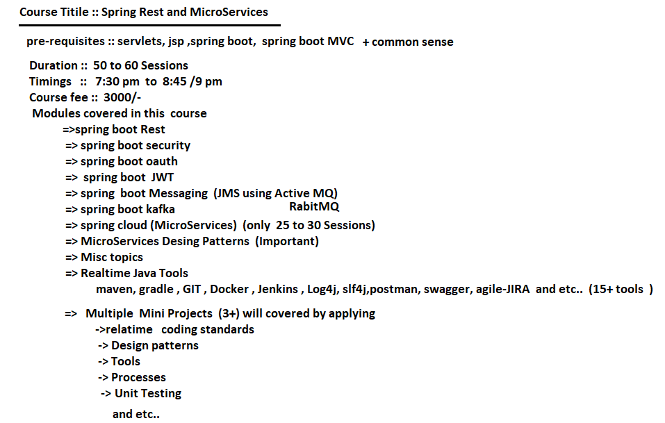

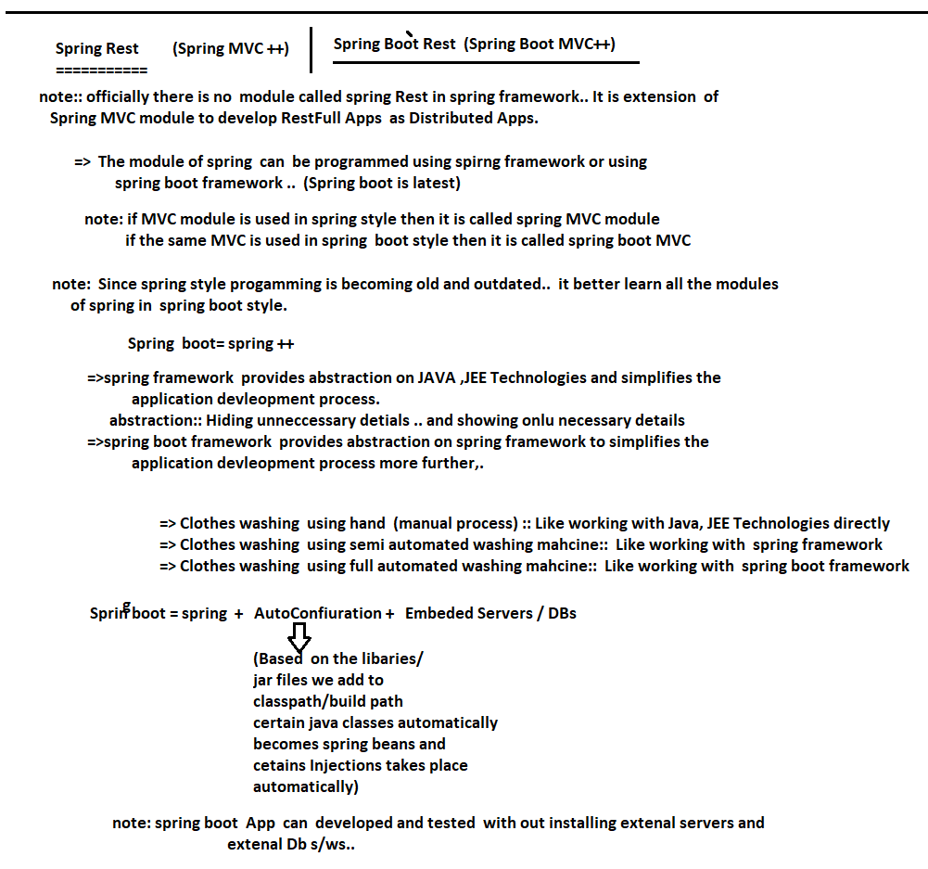

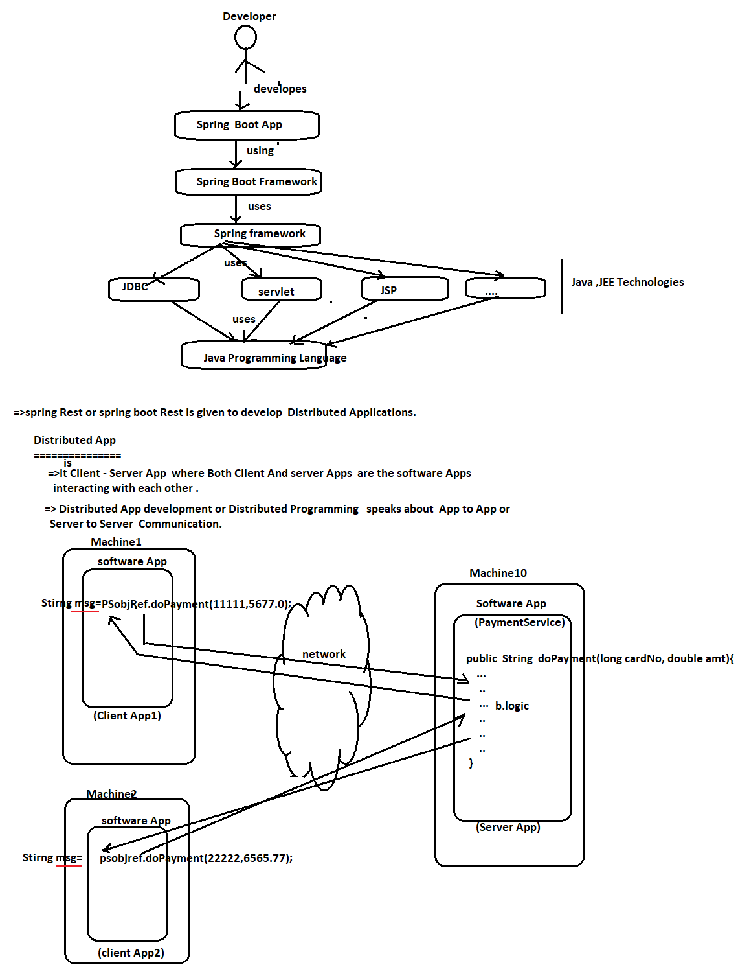

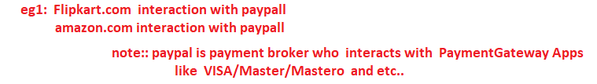

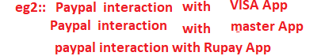

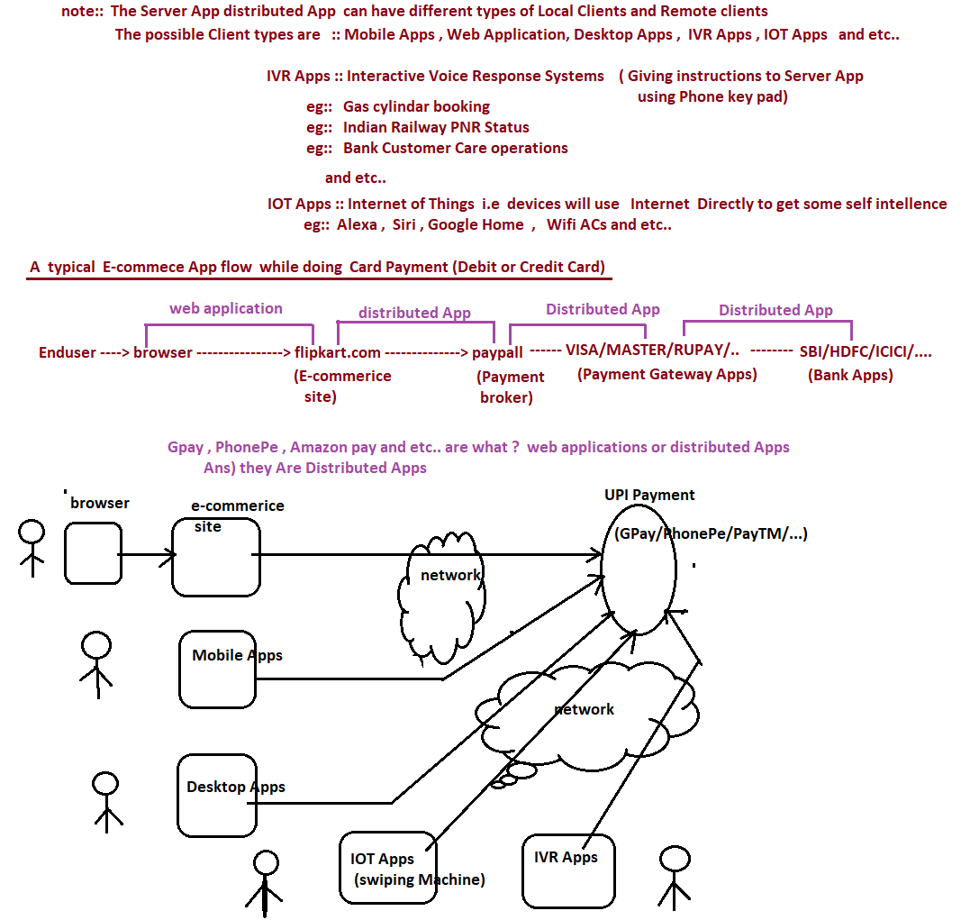

# NTSPBMS615-More on Distributed Apps- May 24th 2022

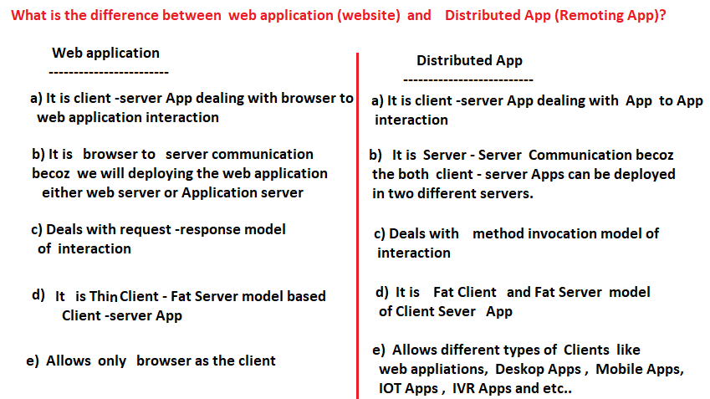



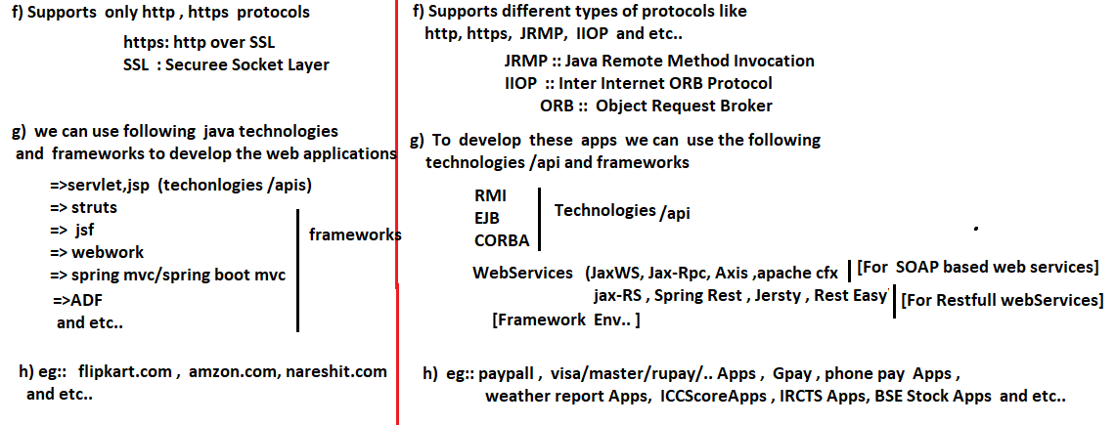

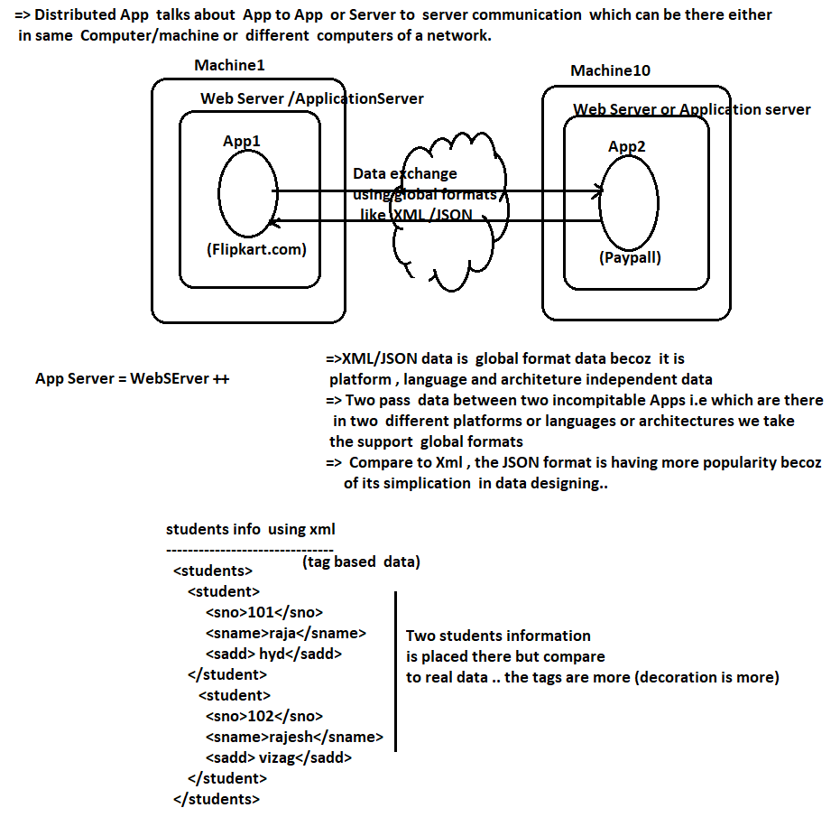

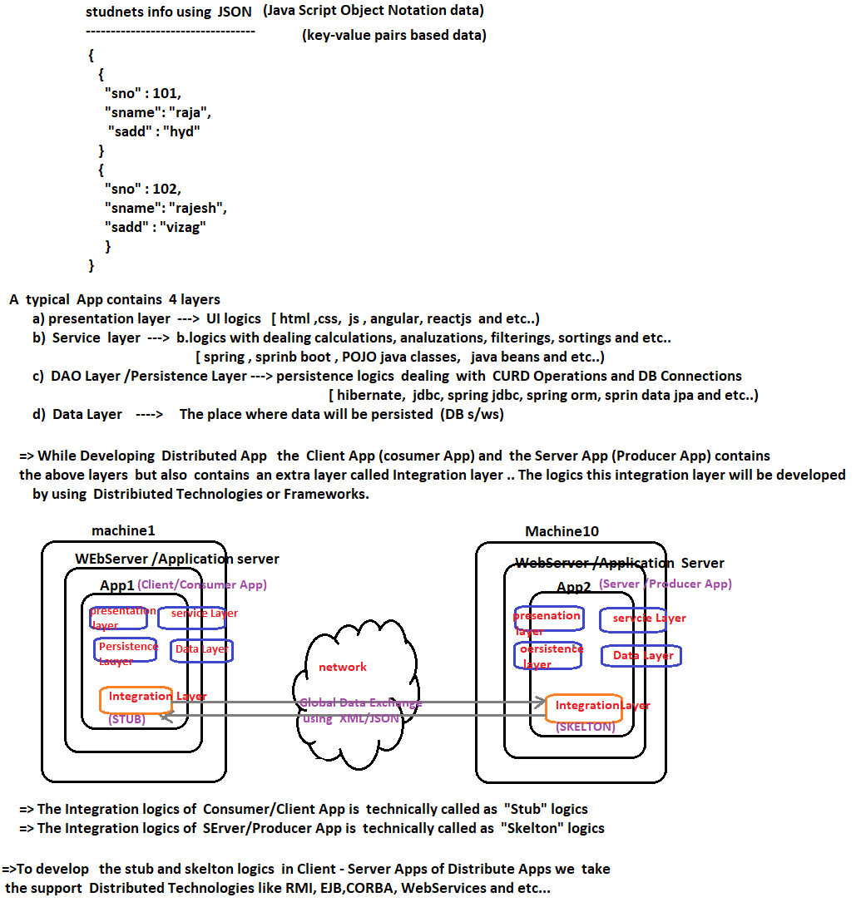

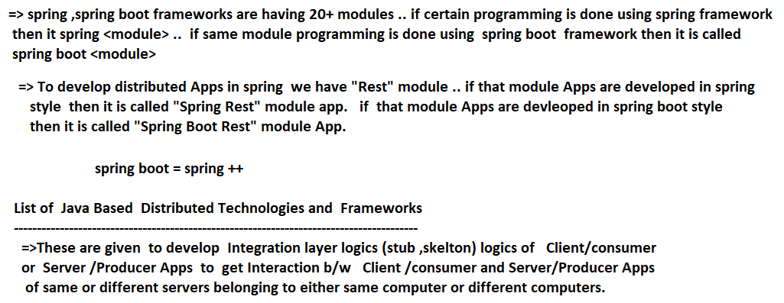

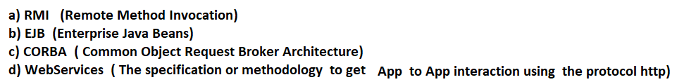

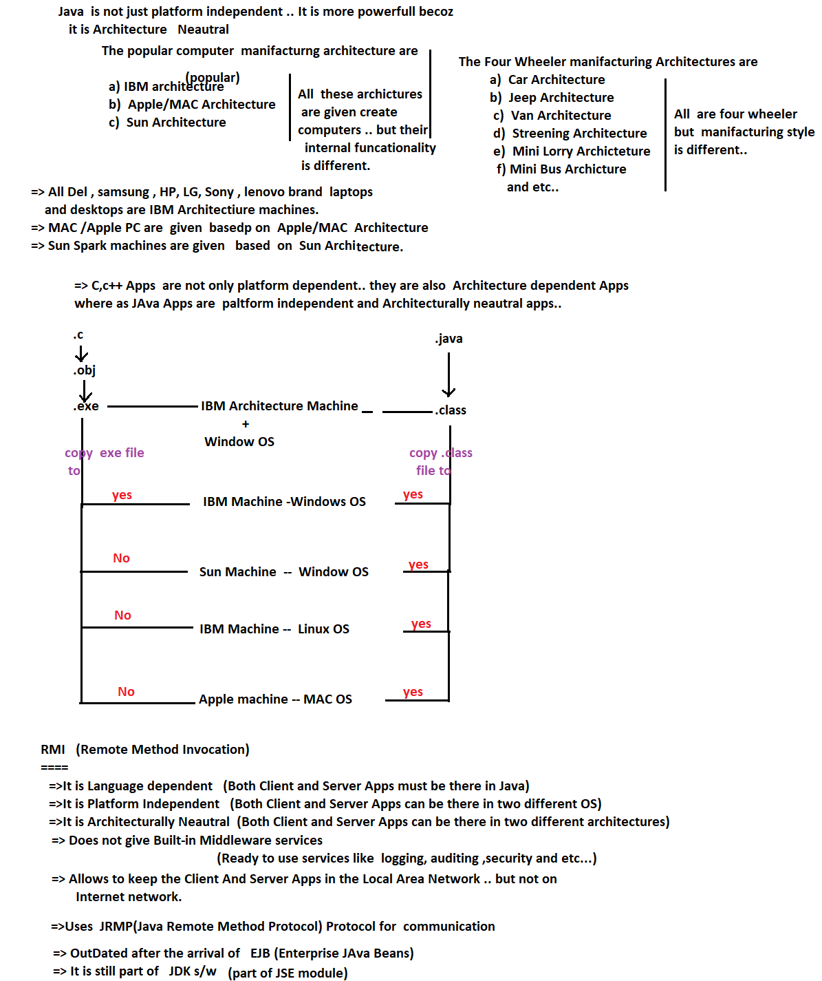

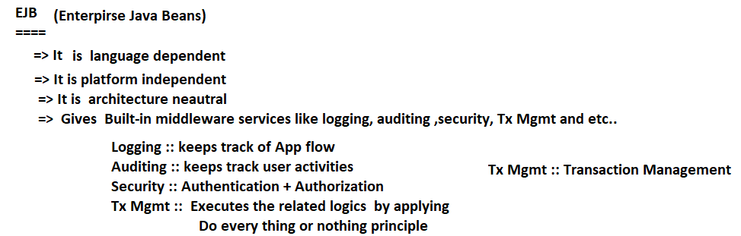

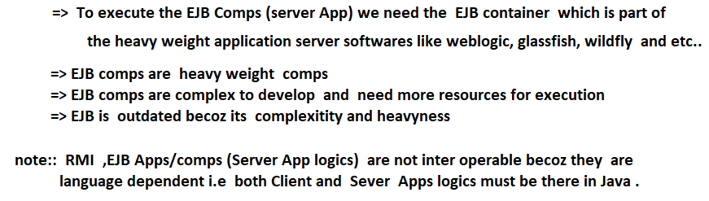

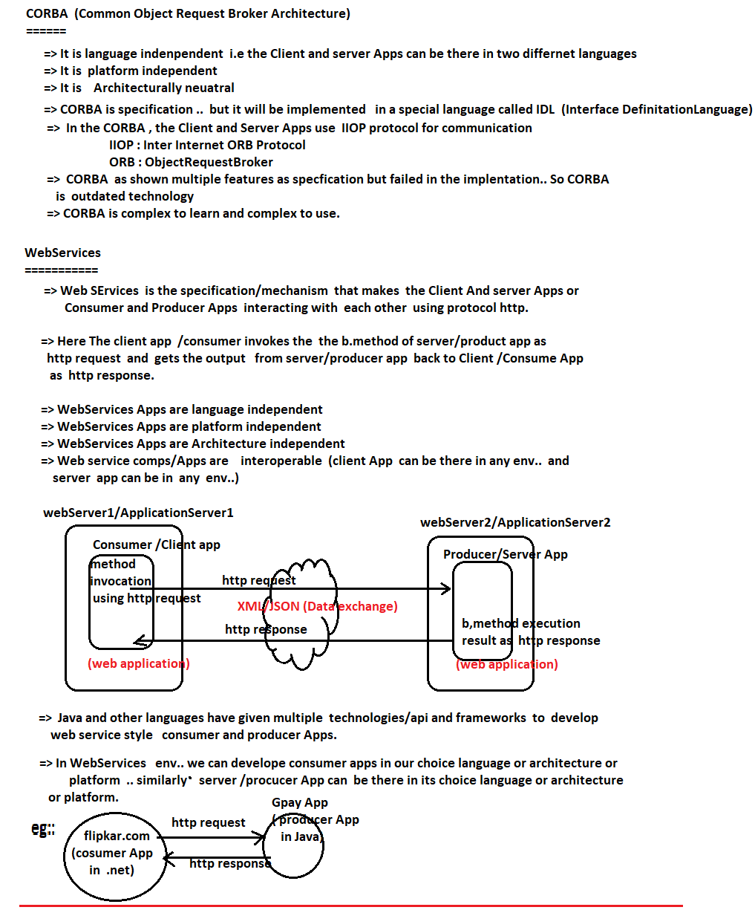

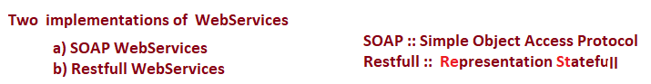

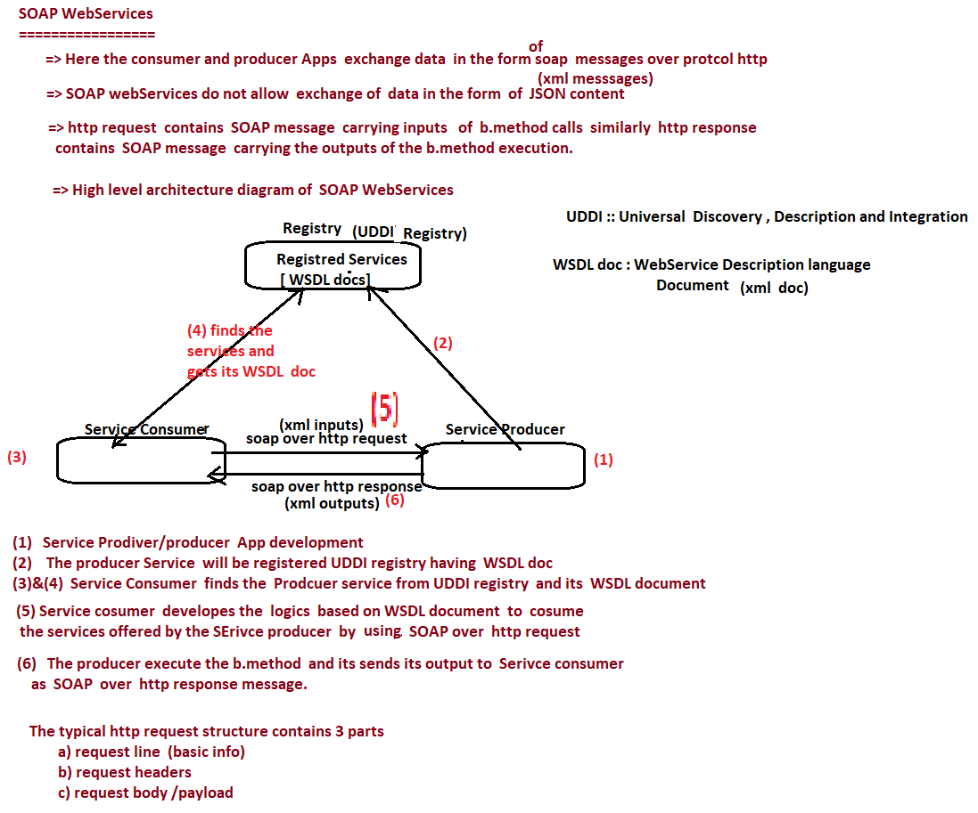

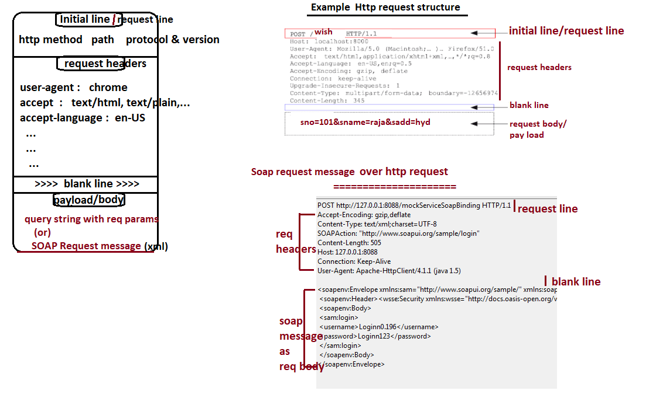

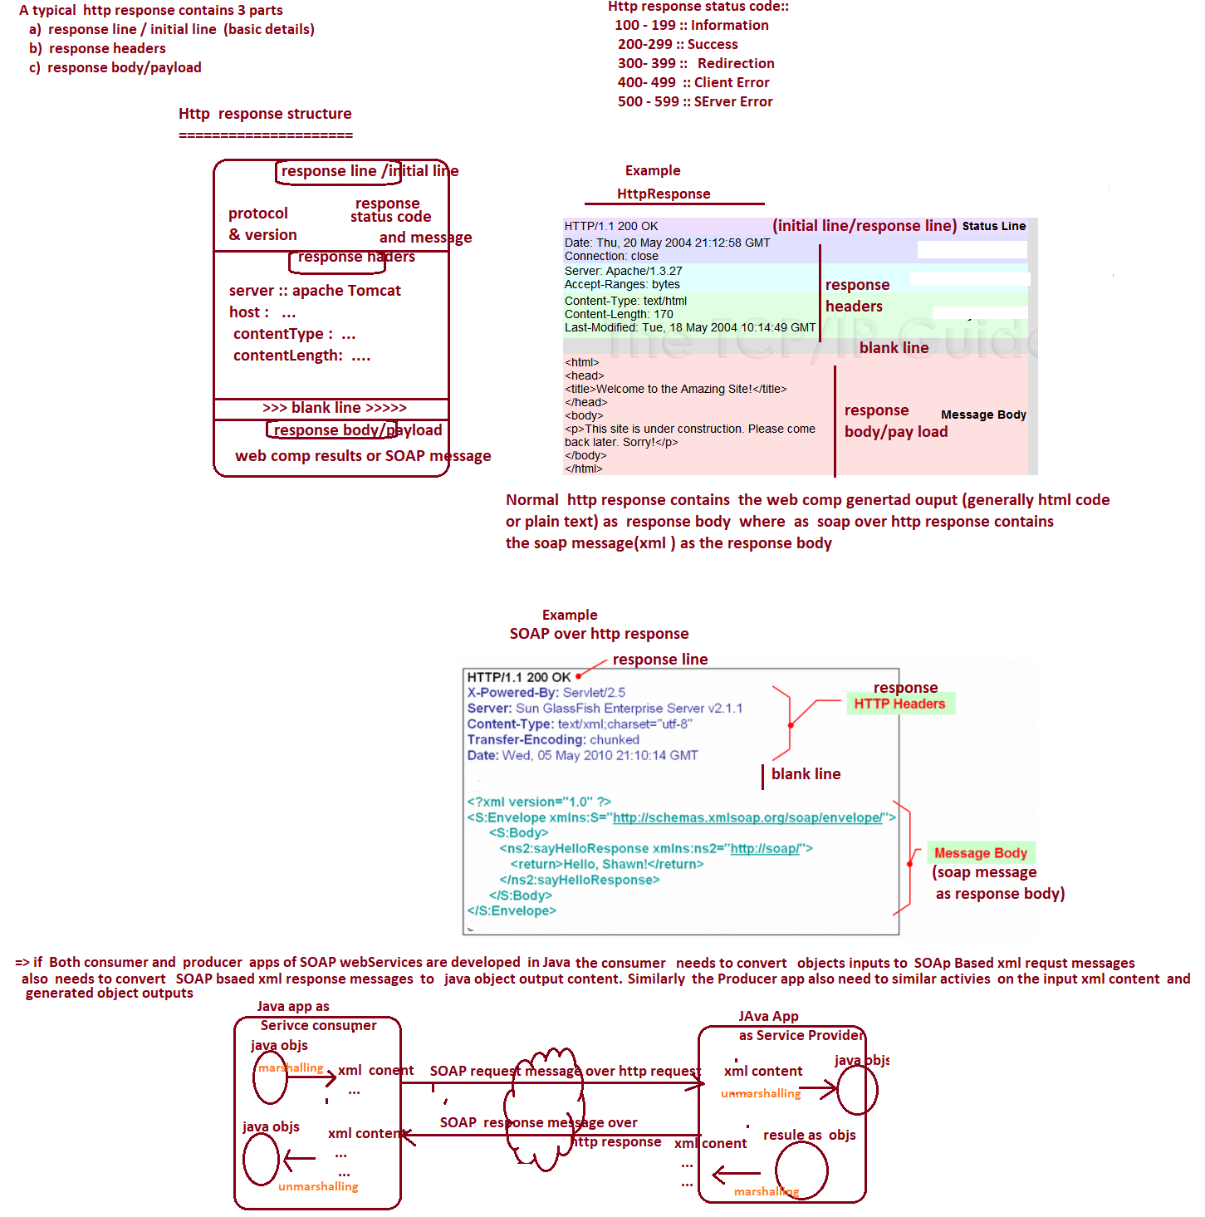

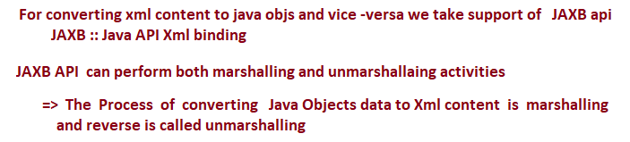

# NTSPBMS615-May28th-2022 -SOAP WebServices and RestFullWebServices

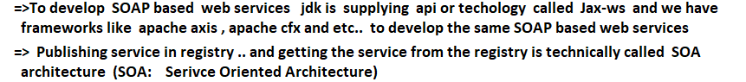

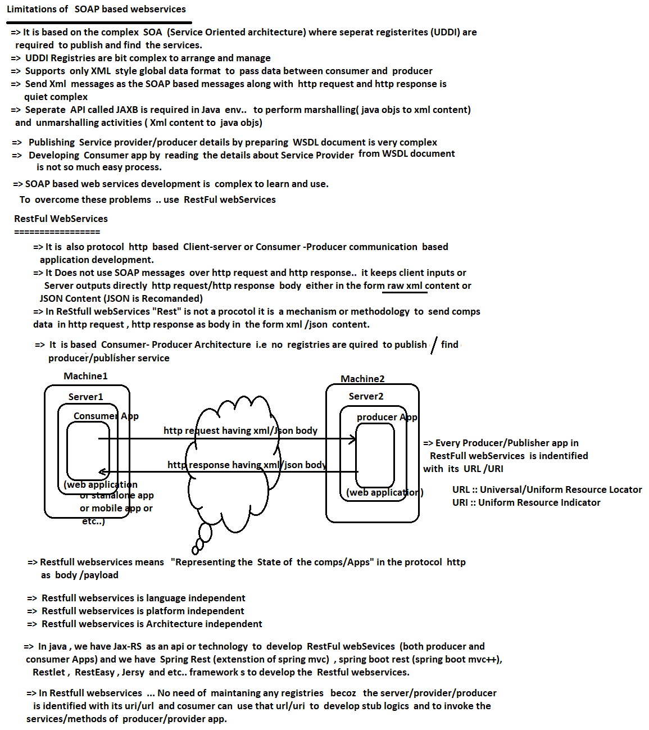

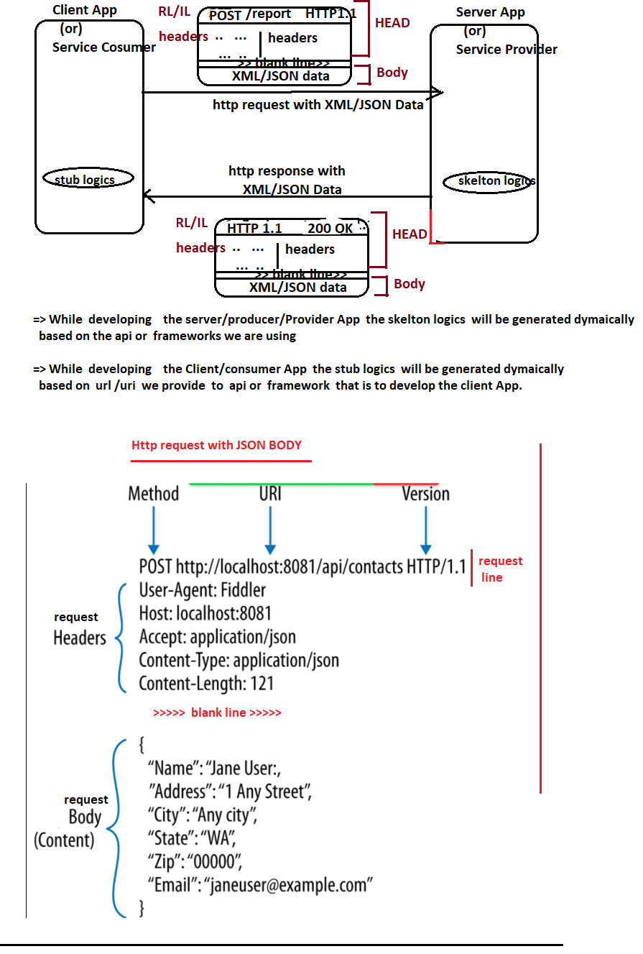

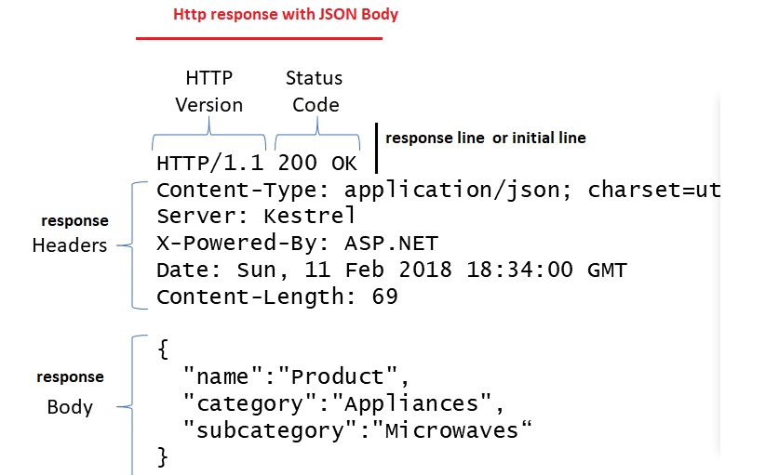

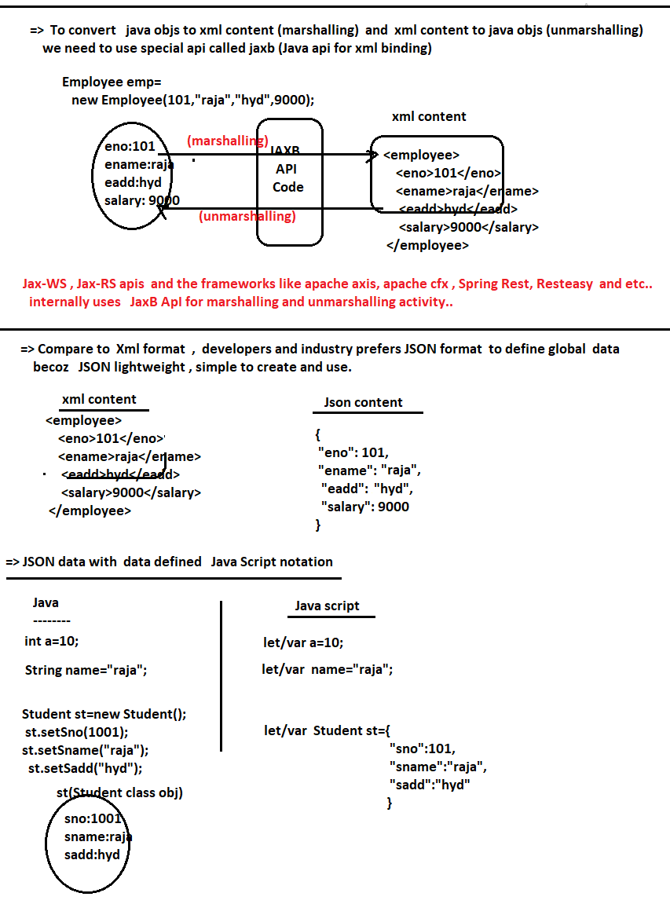

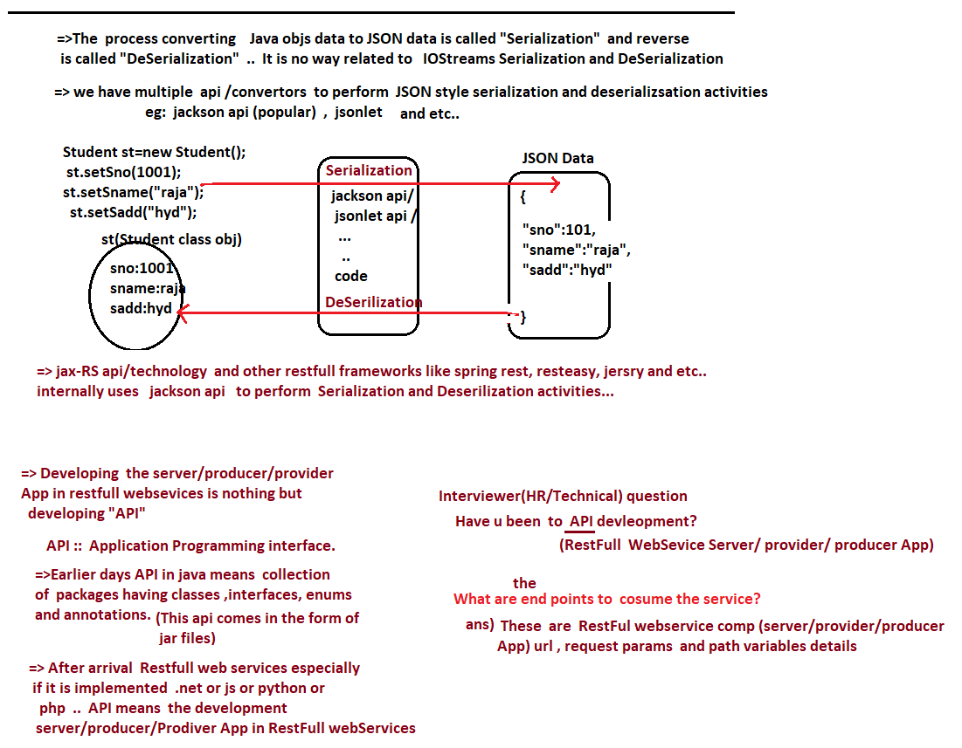

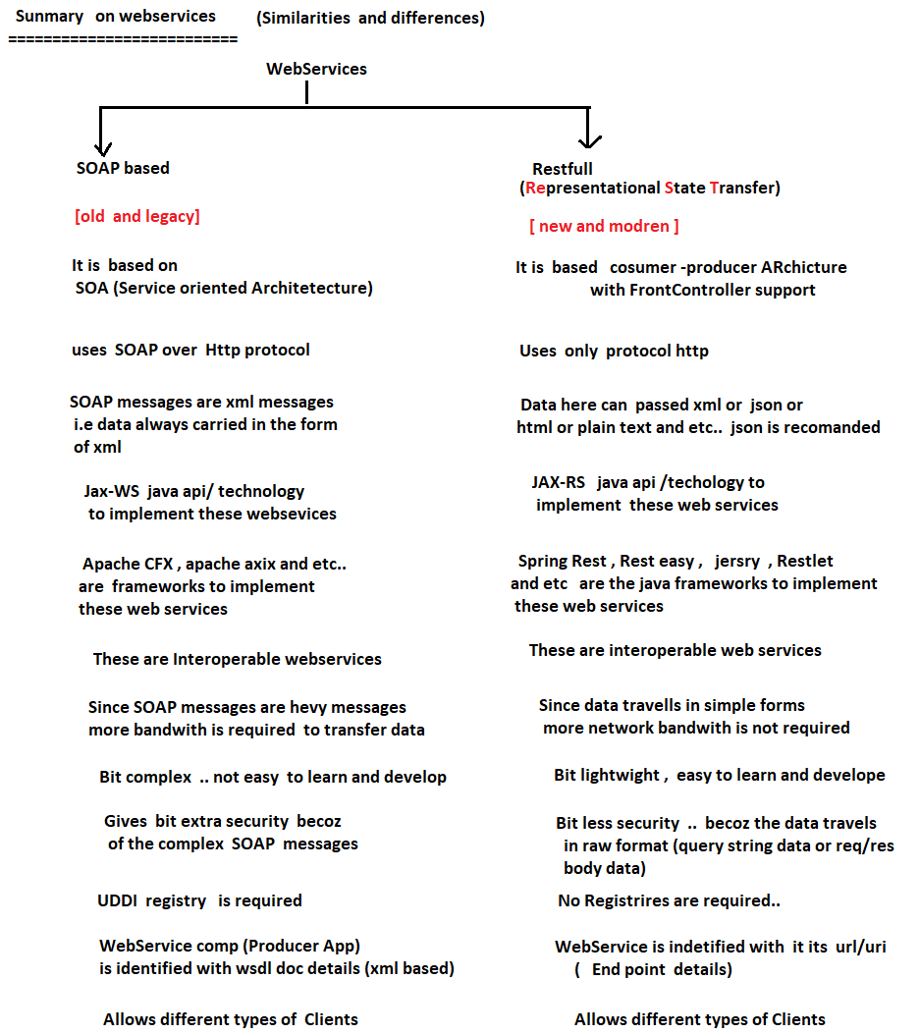

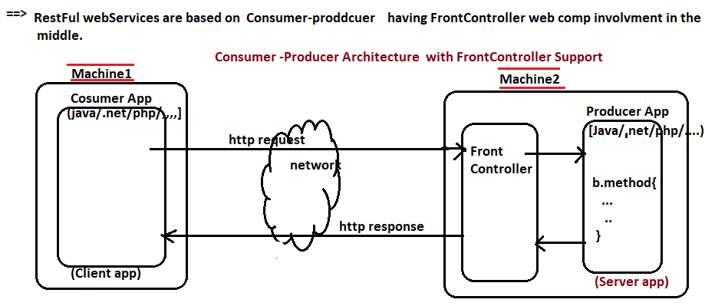

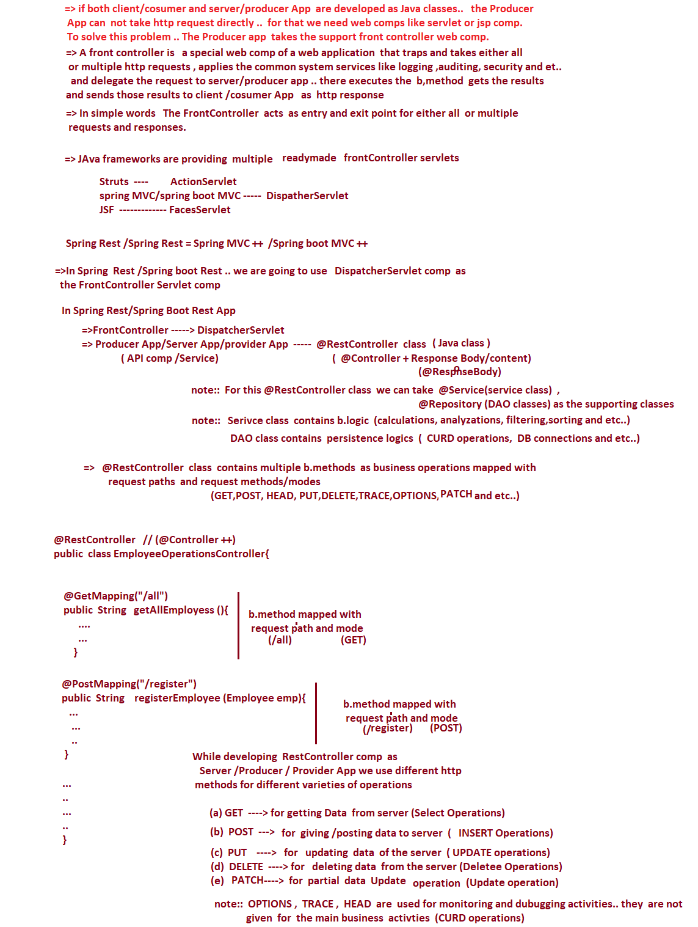





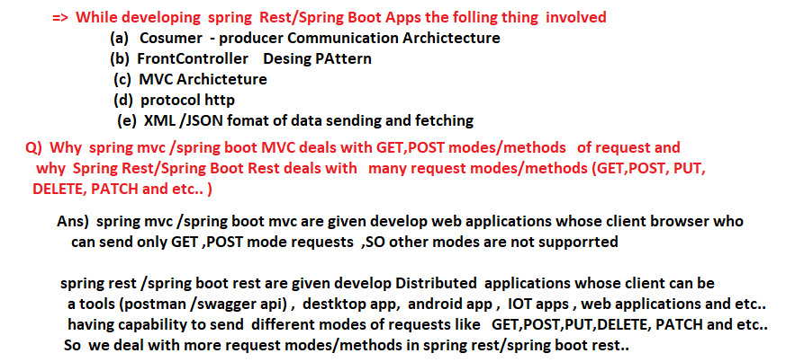

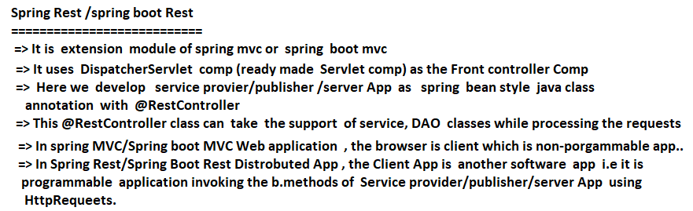

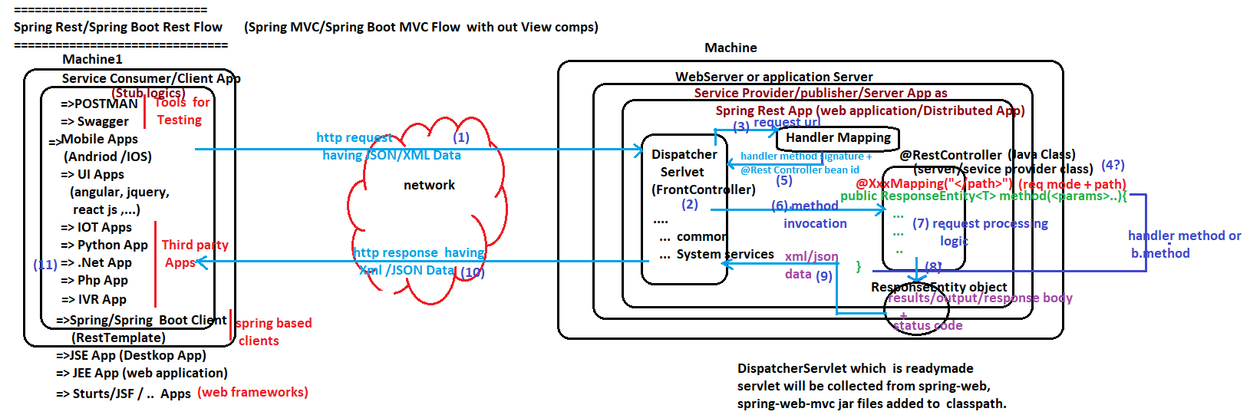

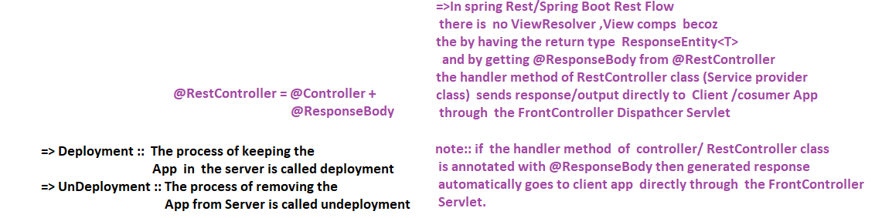

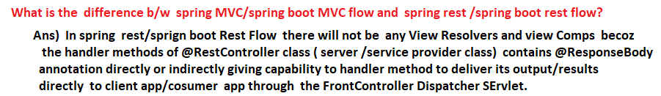

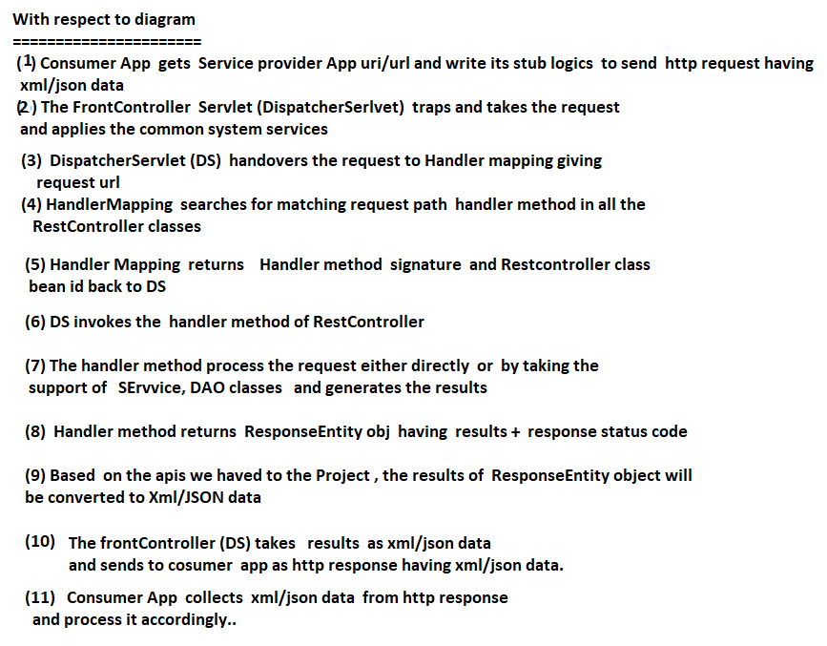

# NTSPBMS615-June2nd-2022 -Frist Spring RestApp Development

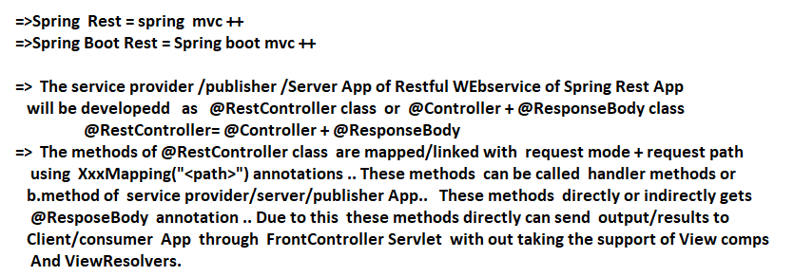

# Spring Rest & MicroServices

Day-1- <https://www.youtube.com/watch?v=Tlp45YhOE-8>

Day-2- <https://www.youtube.com/watch?v=EpaNqWAVadI>

Day-3- <https://www.youtube.com/watch?v=BWfLY15xj_w>

Day-4- <https://www.youtube.com/watch?v=UQJ8ToGWN4Y>

Day-5- <https://www.youtube.com/watch?v=05Kg91stFtU>

Day-6- <https://www.youtube.com/watch?v=p9MJ-aSNlM0>

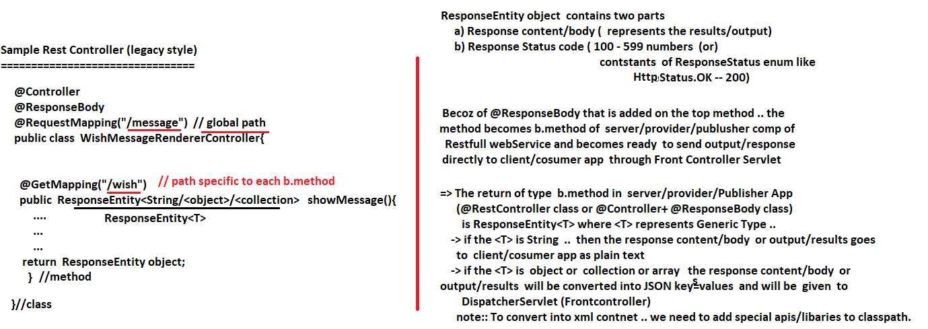

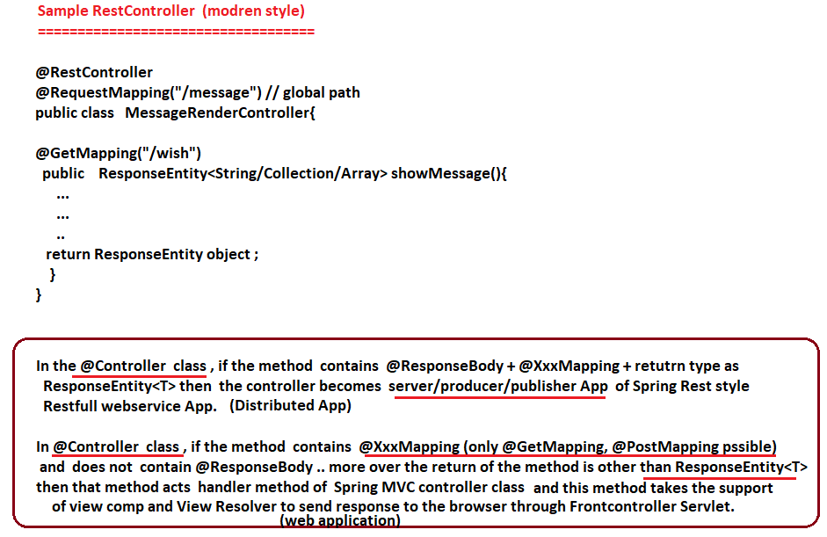

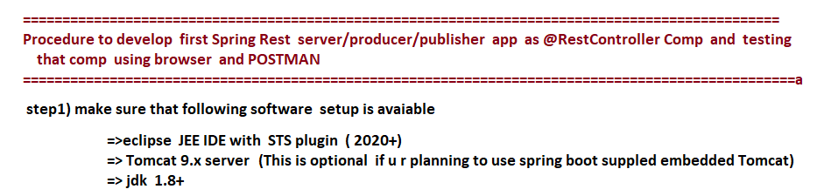

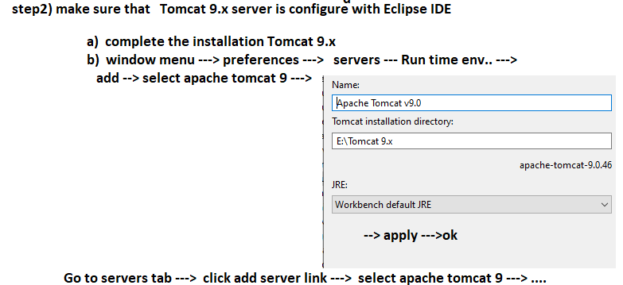

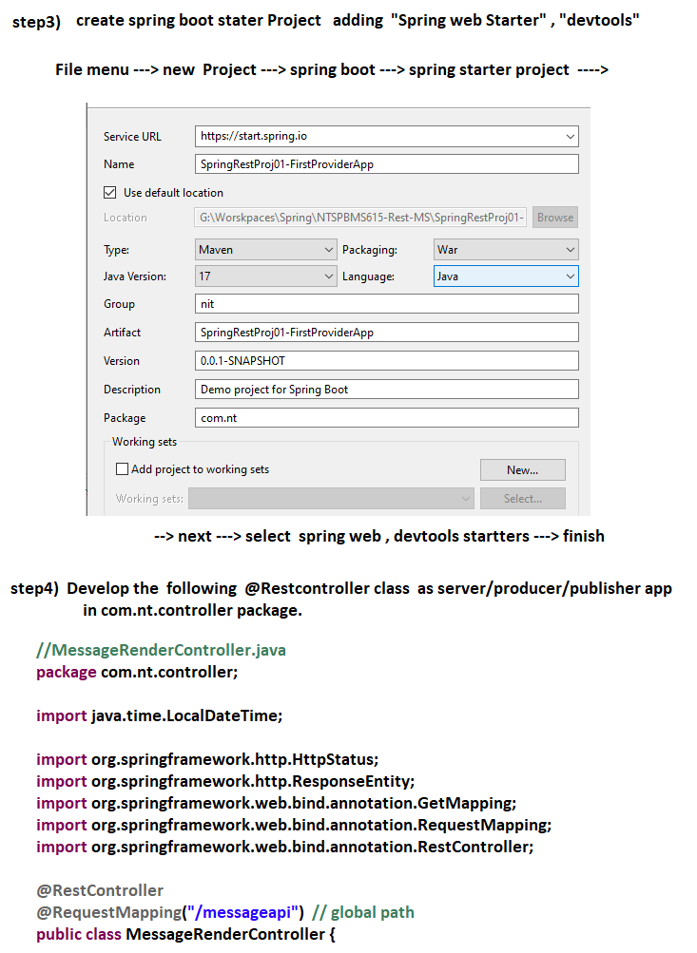

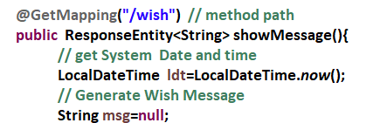

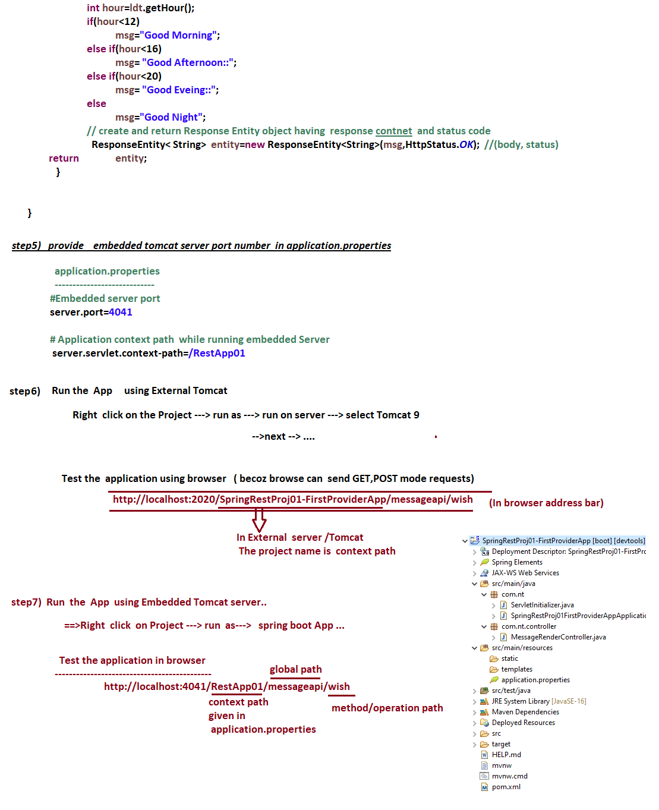

# NTSPBMS615-June 3rd-2022 -Frist Spring RestApp Testing Using POSTMAN Tool



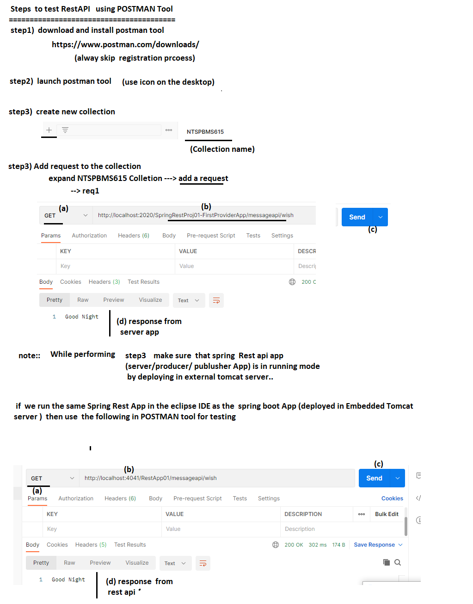

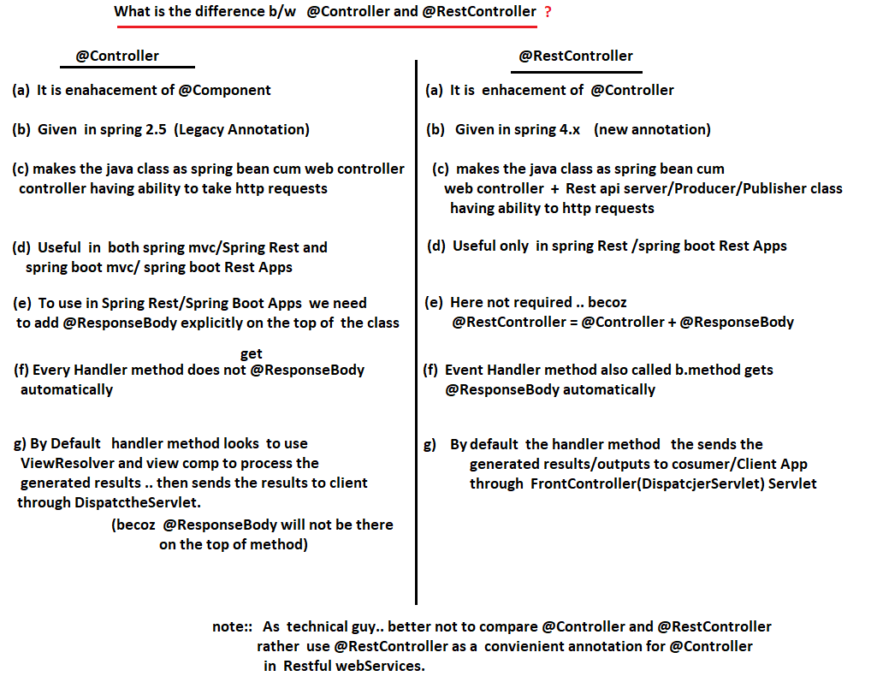

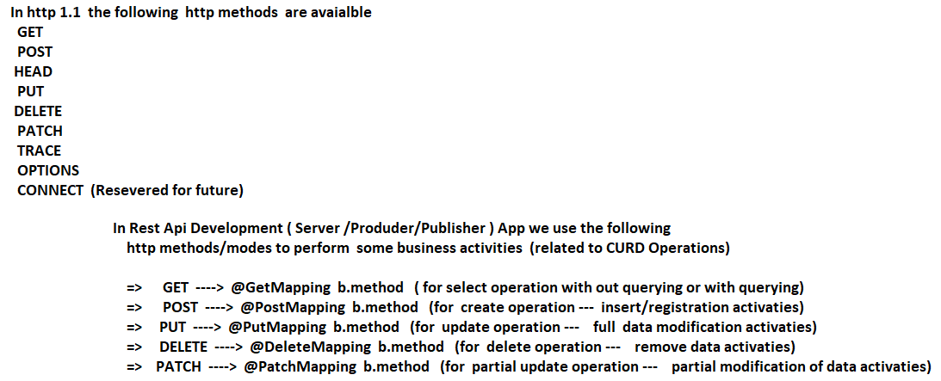

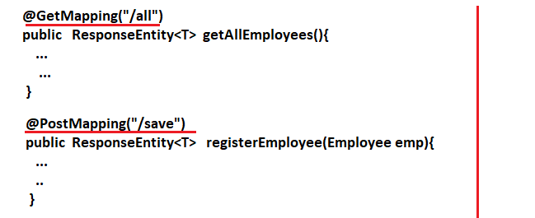

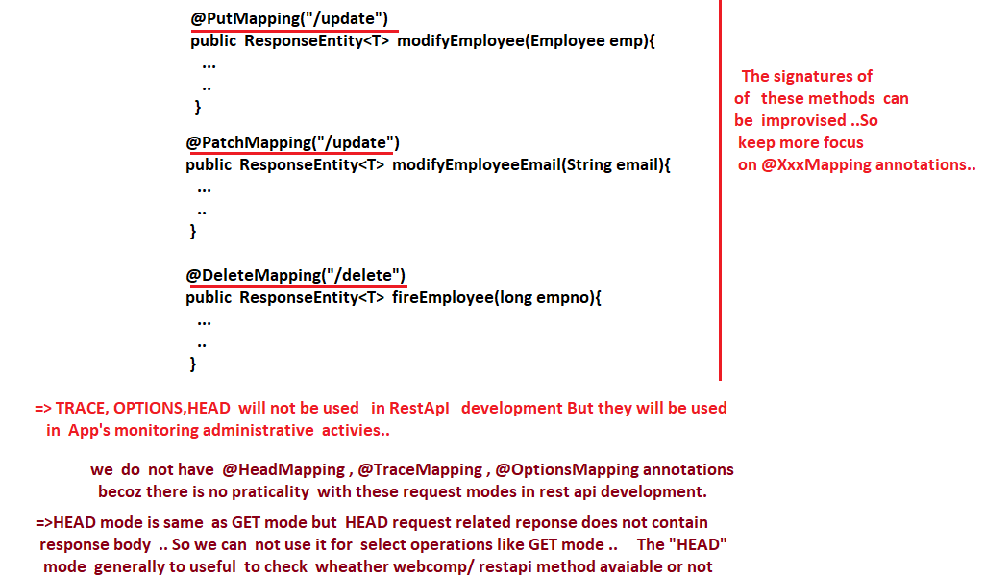

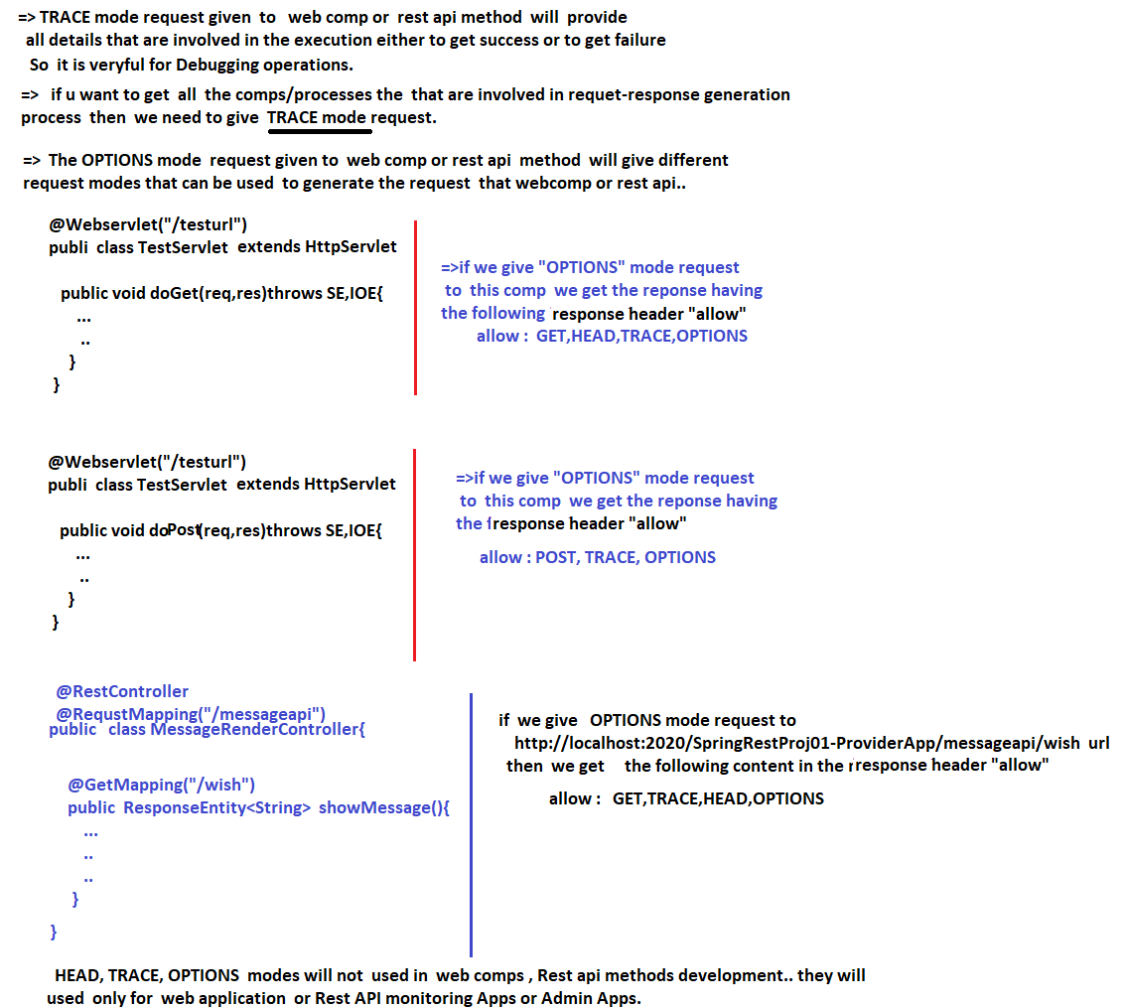

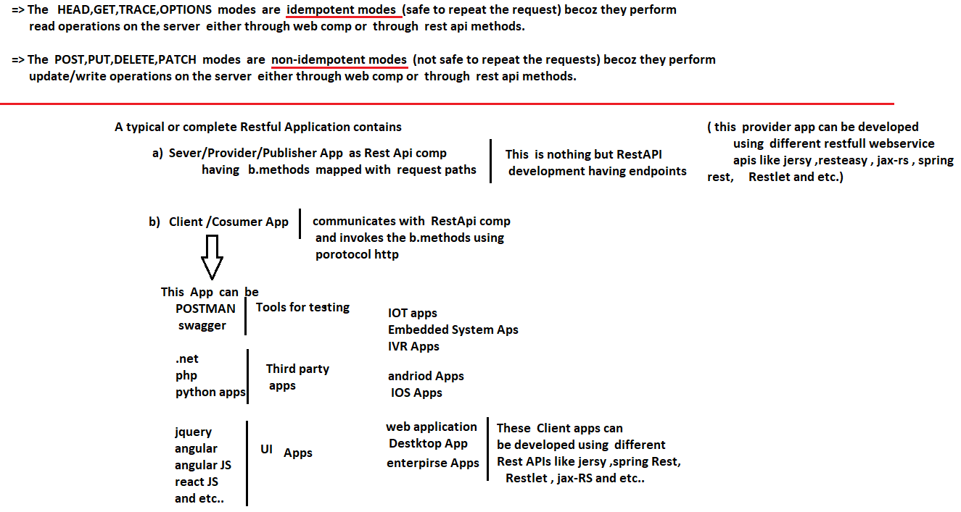

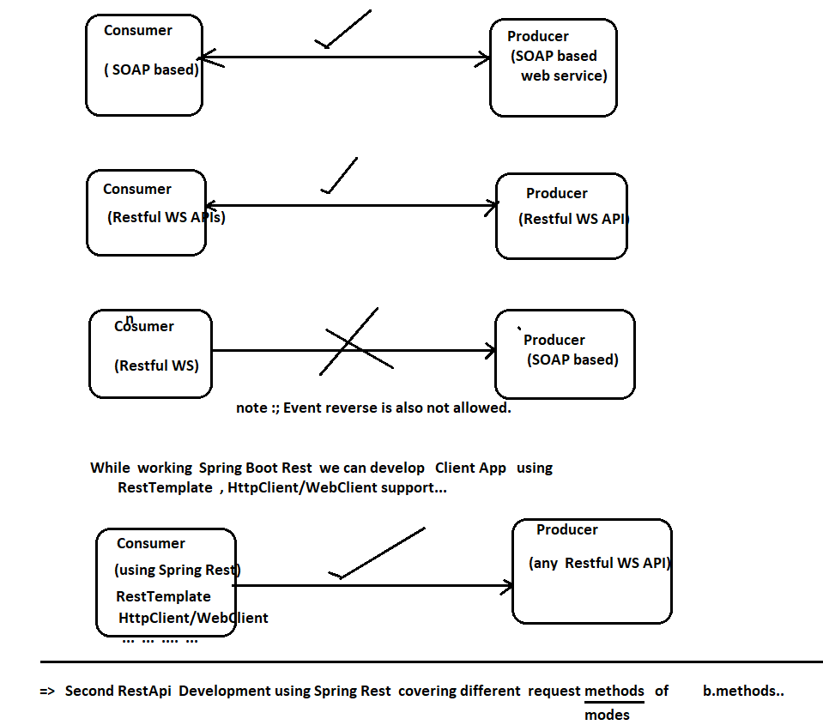

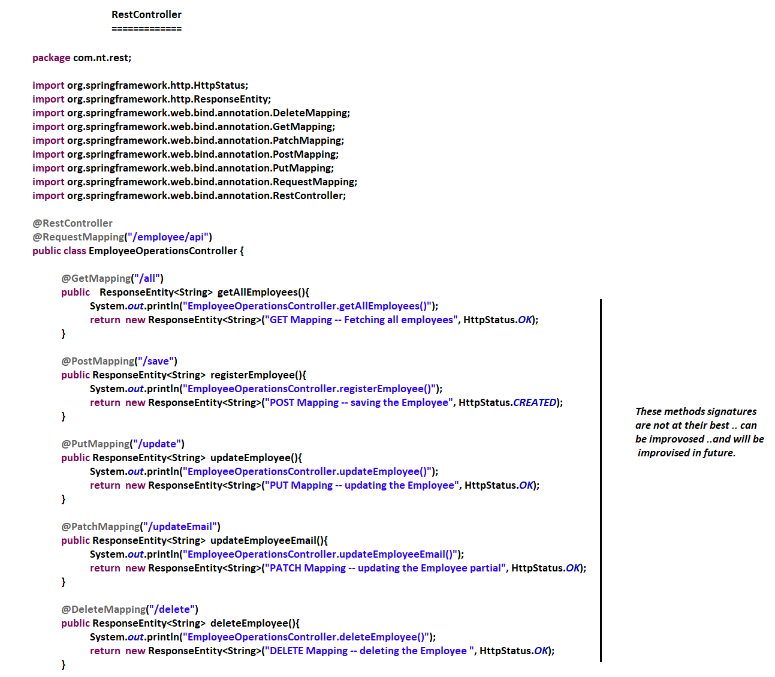

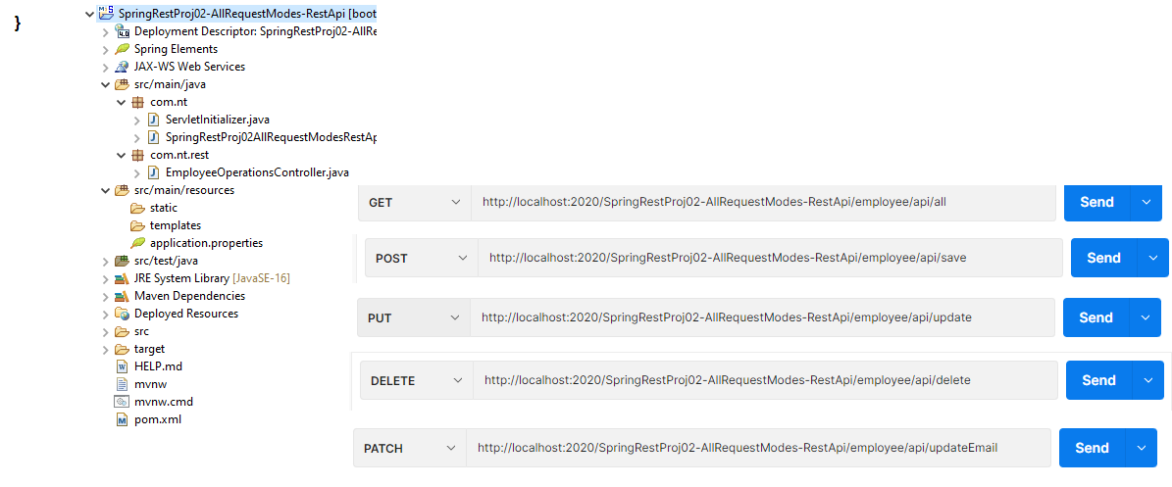

# NTSPBMS615-June6th-2022-Working with JSON from @RestController

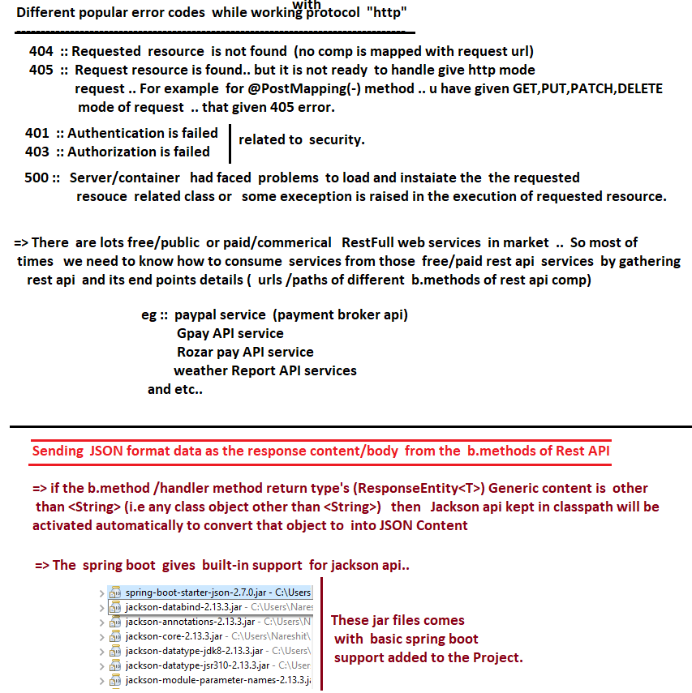

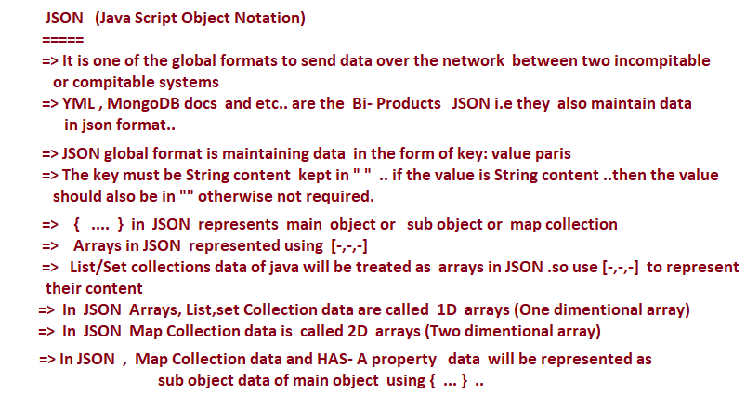



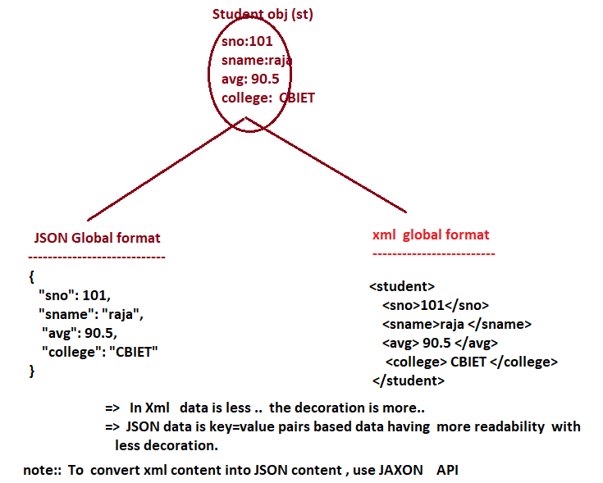

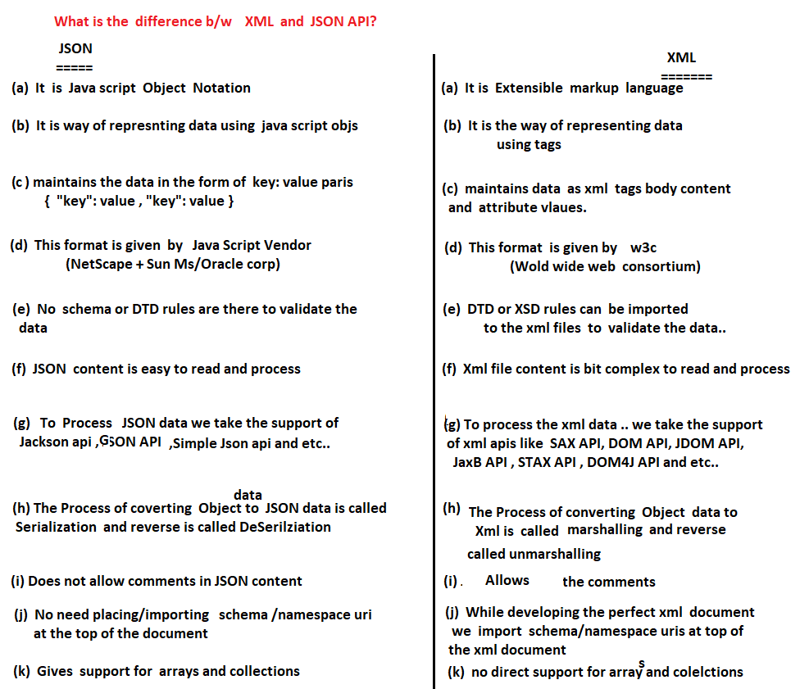

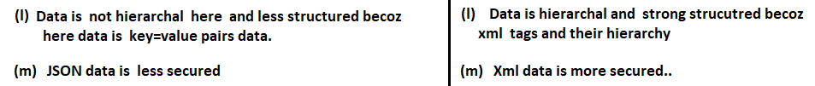

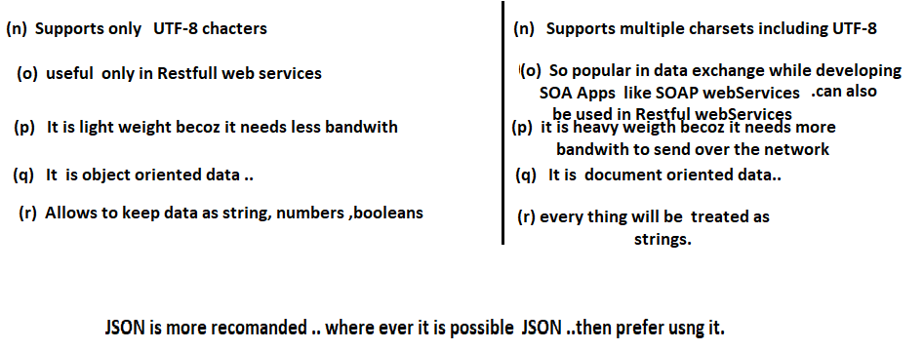

# NTSPBMS615-June 7th-2022-Working with JSON format data in @RestController

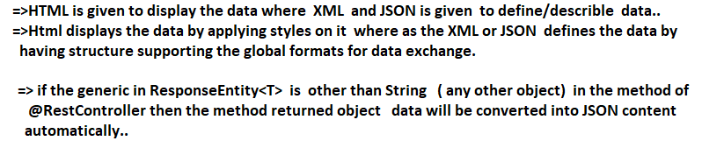

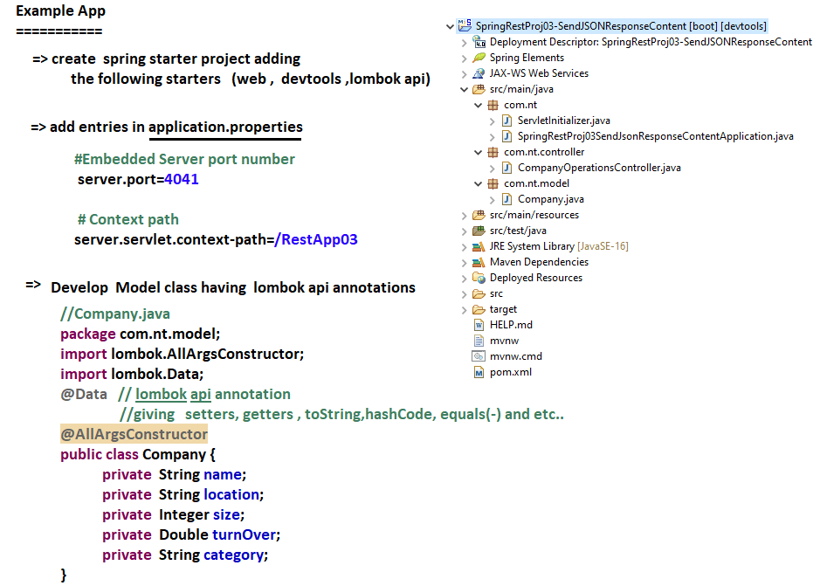

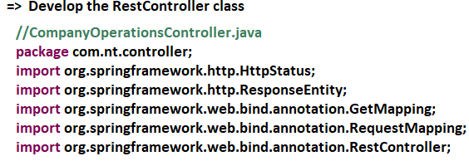

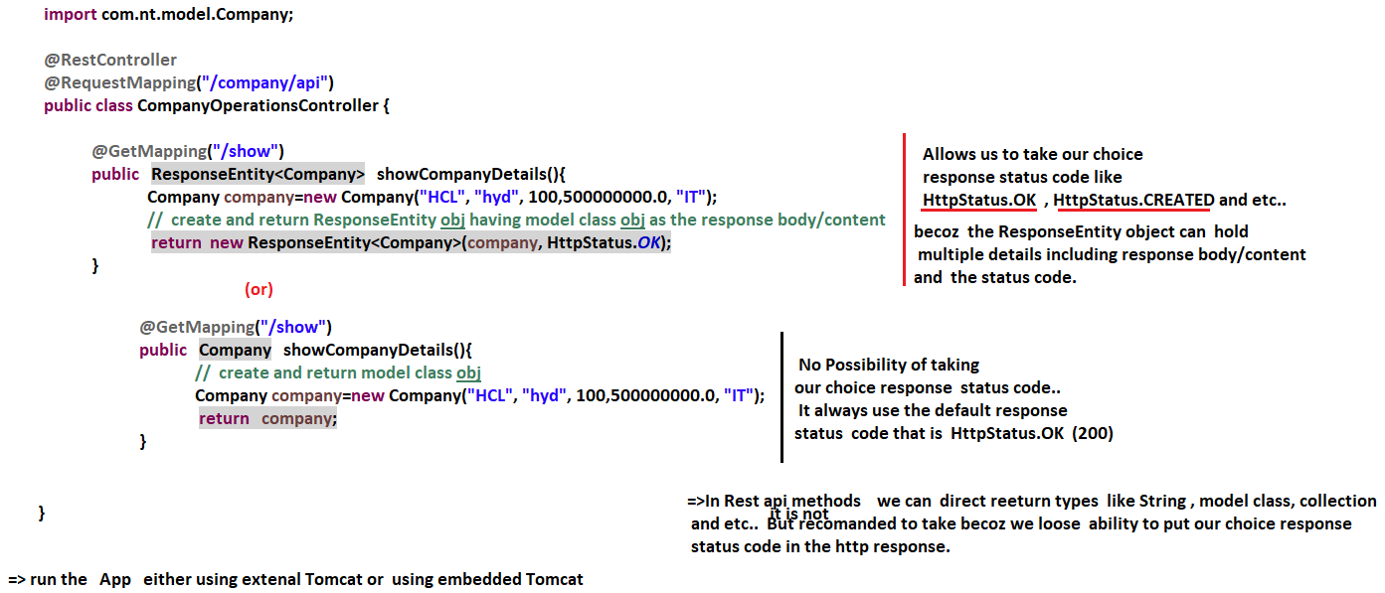

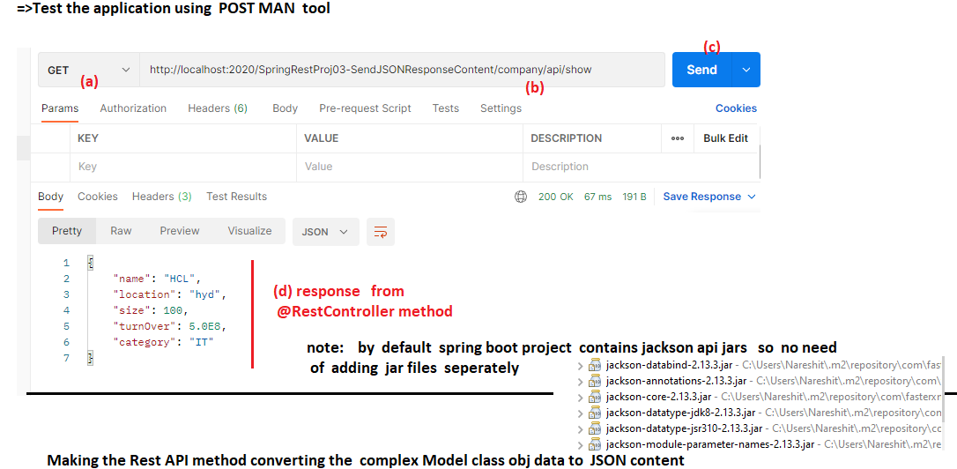

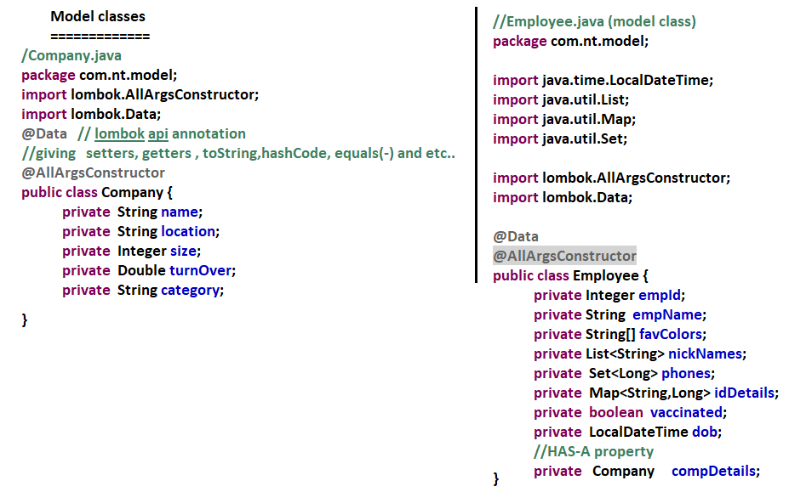

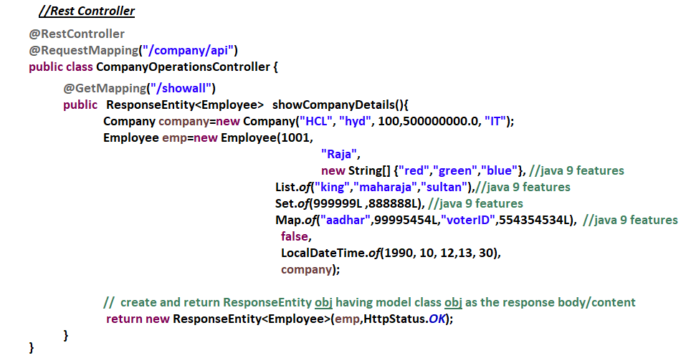



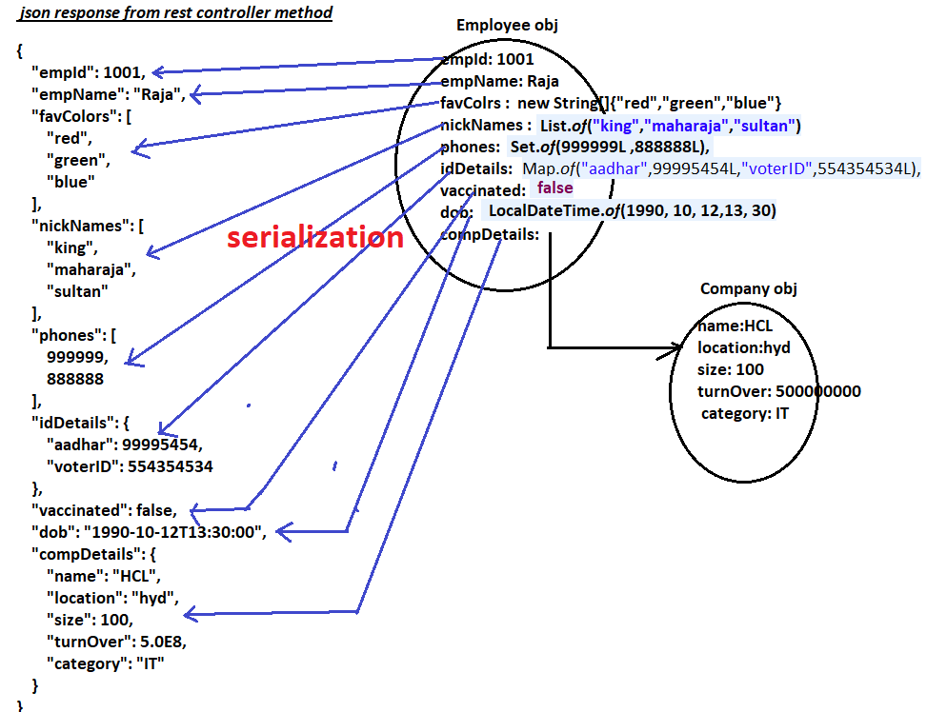

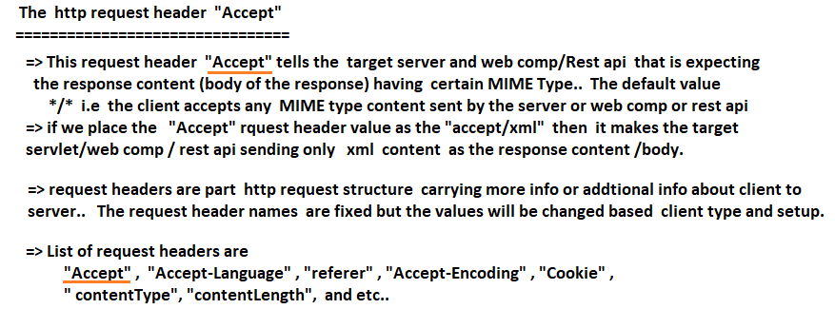

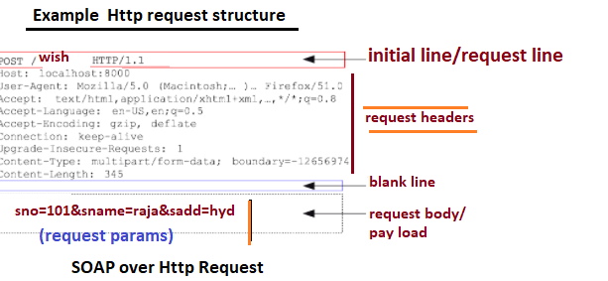

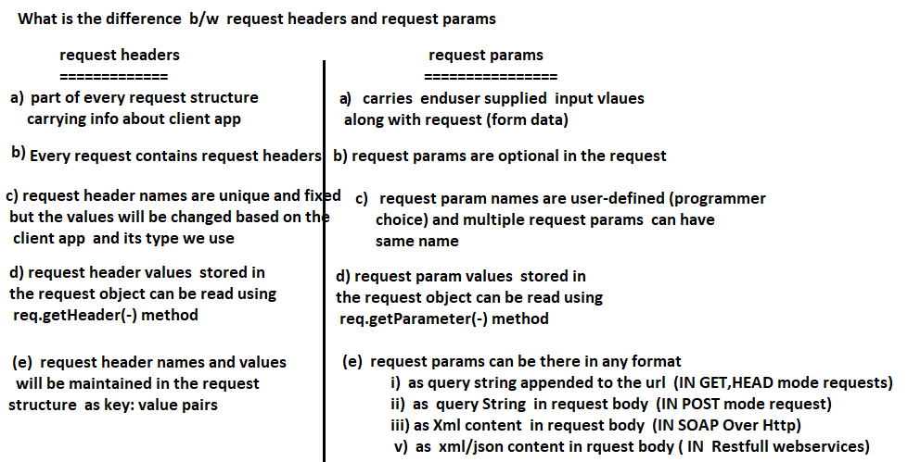

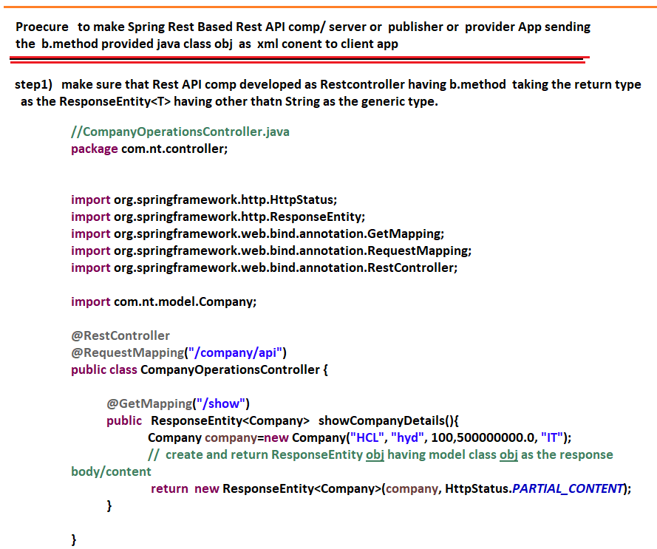

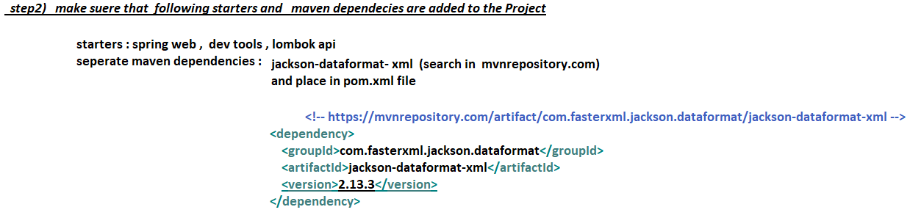

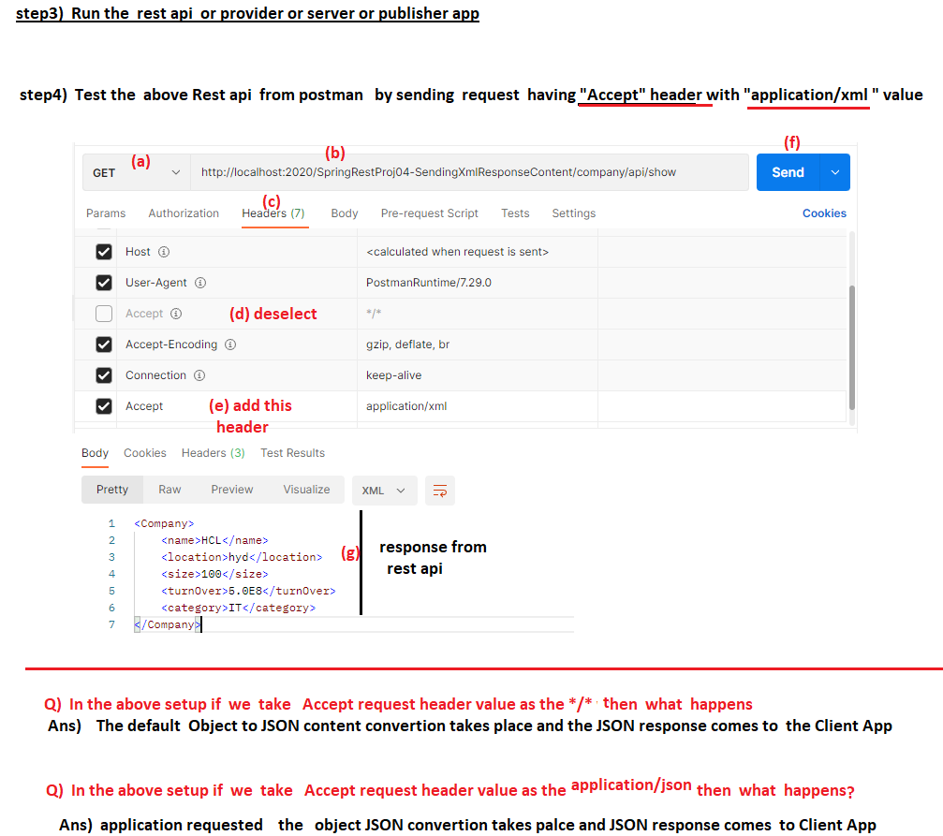

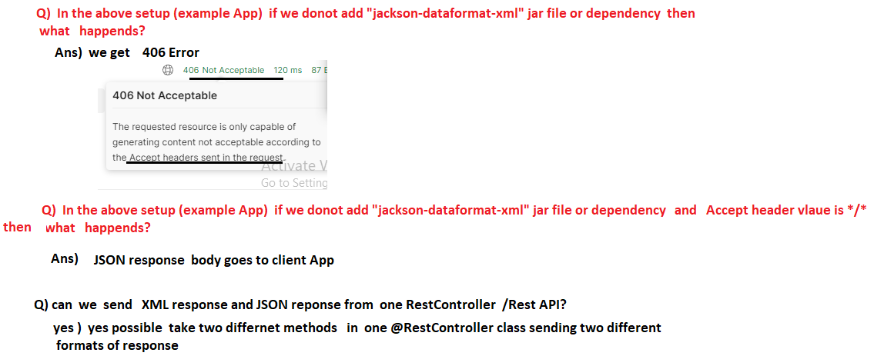

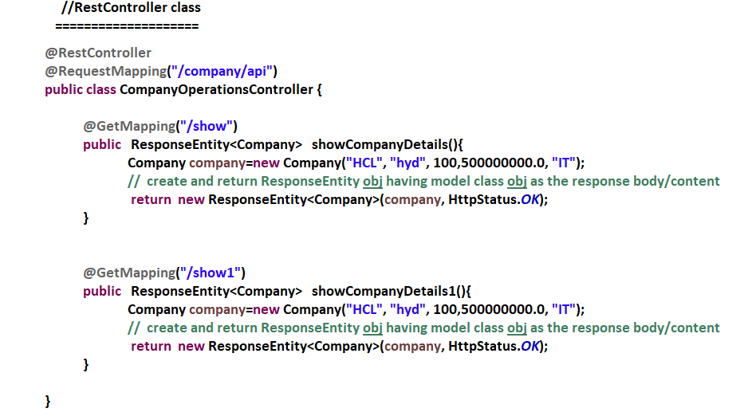

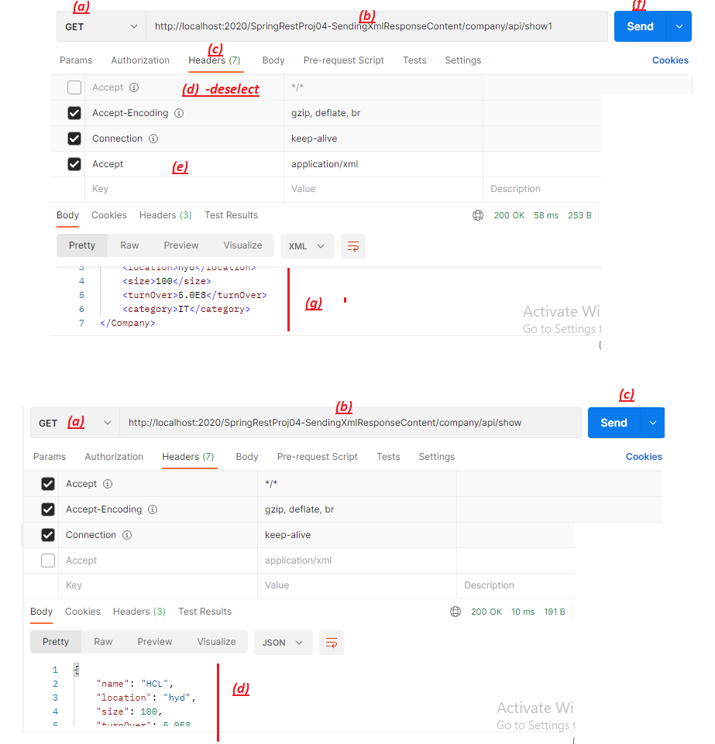

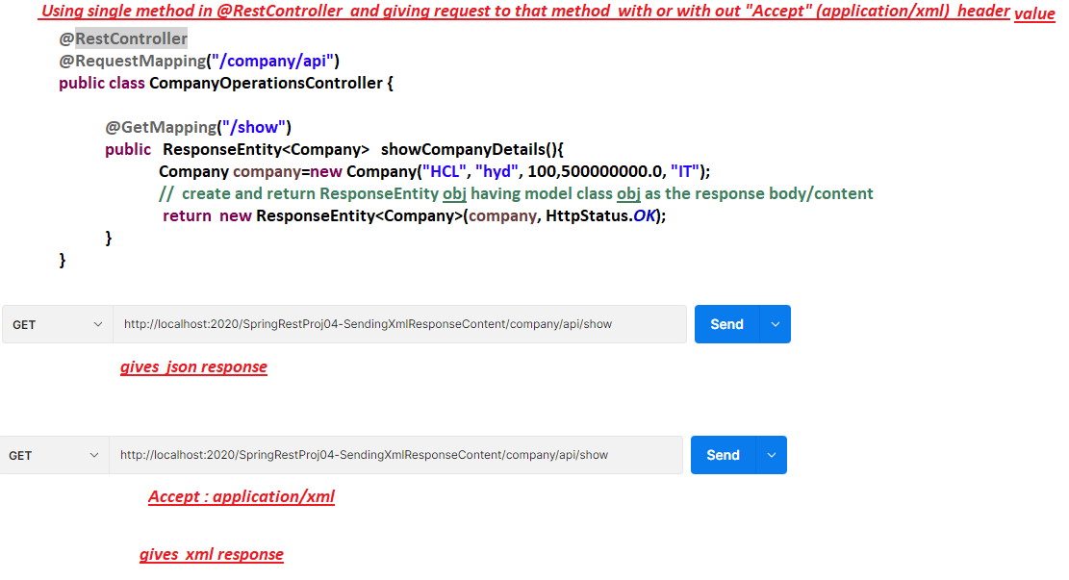

# NTSPBMS615-June 10th-2022-Working @RequestBody-@ResponseBodyAnnotations

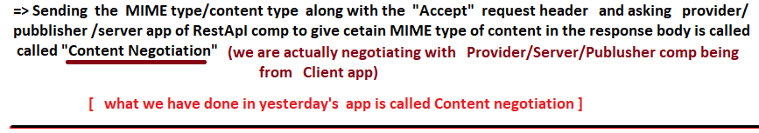

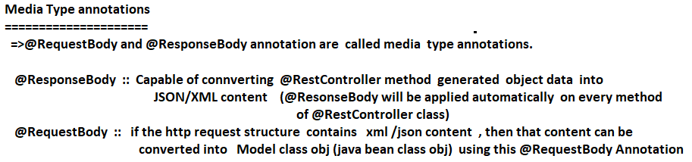

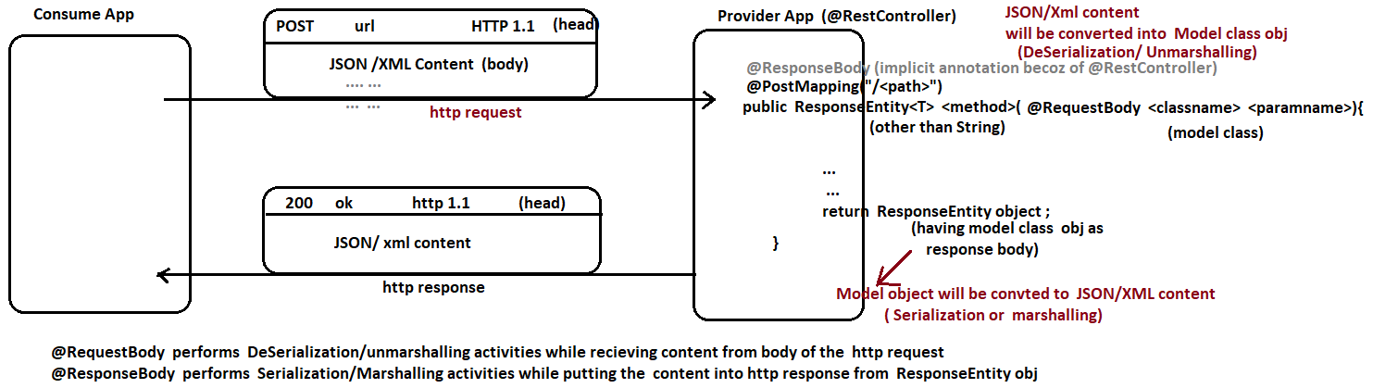

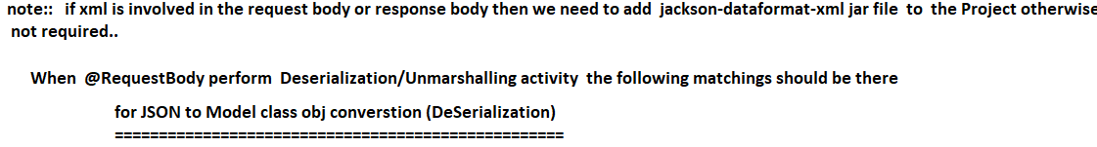

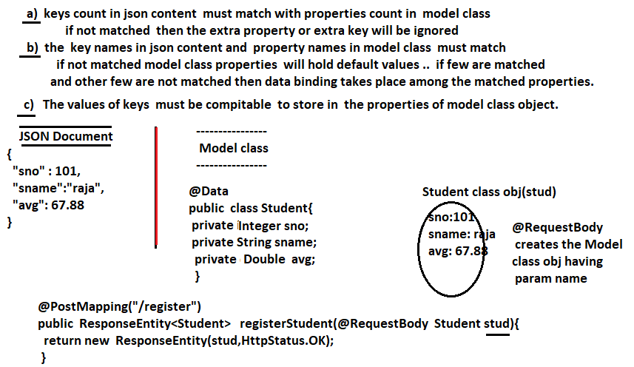

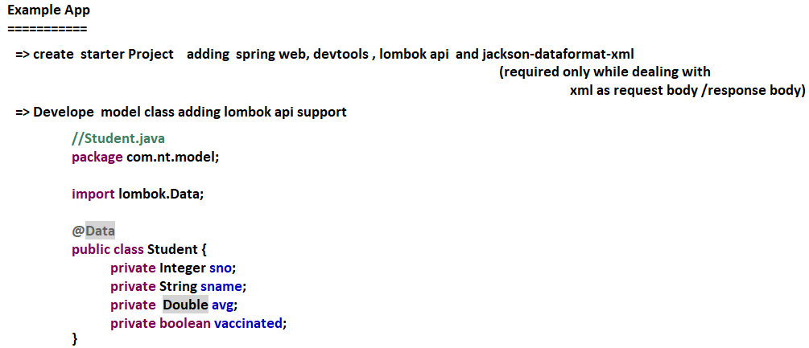

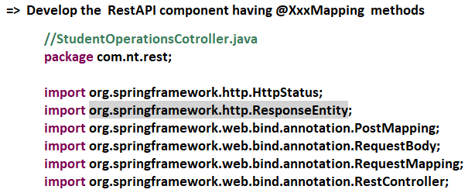

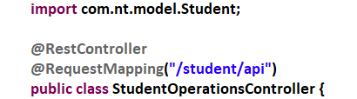

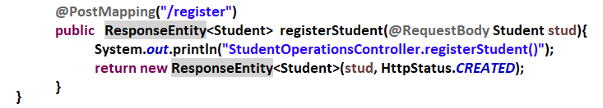

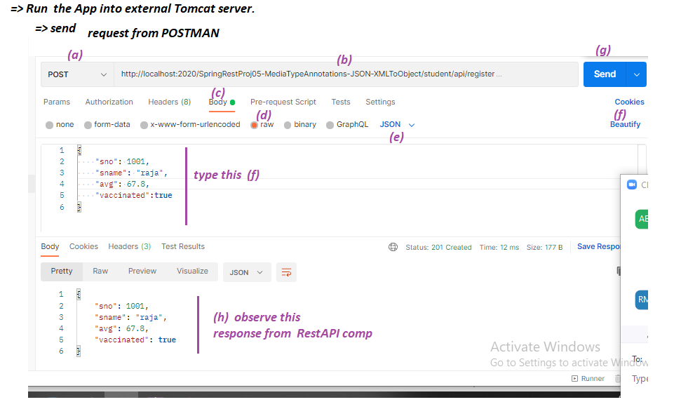

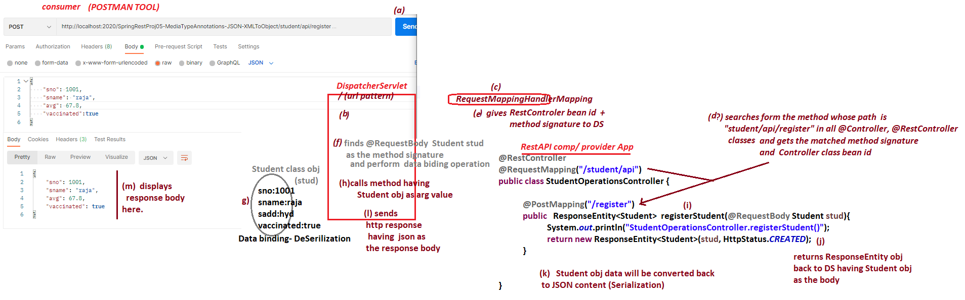

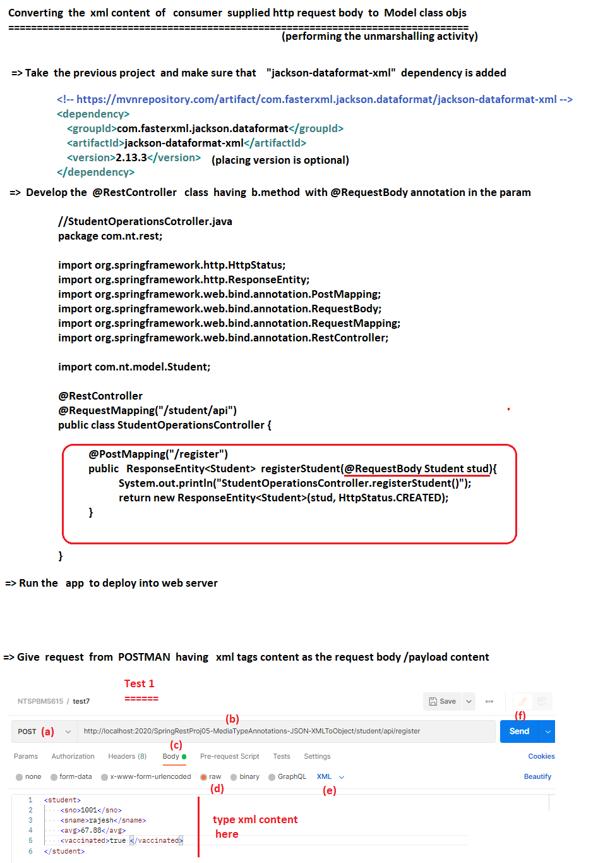

# NTSPBMS615-June 14th-2022- Sending Complex Json Data and converting to objs using @ReponseBody

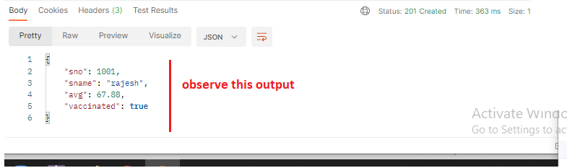

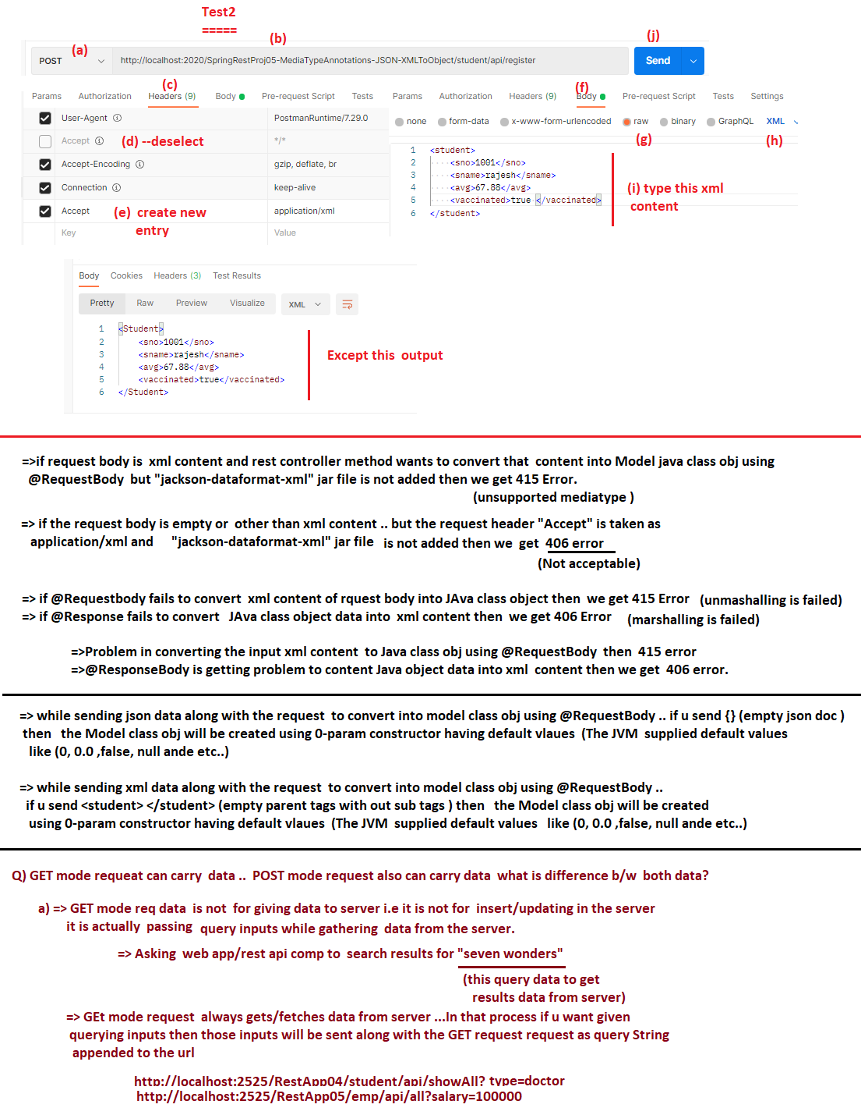

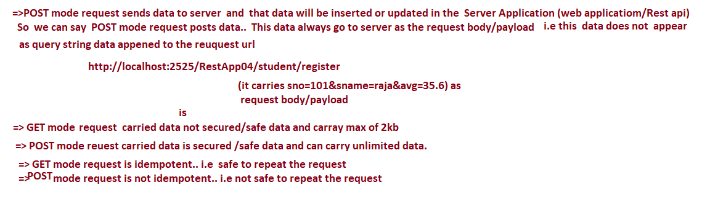

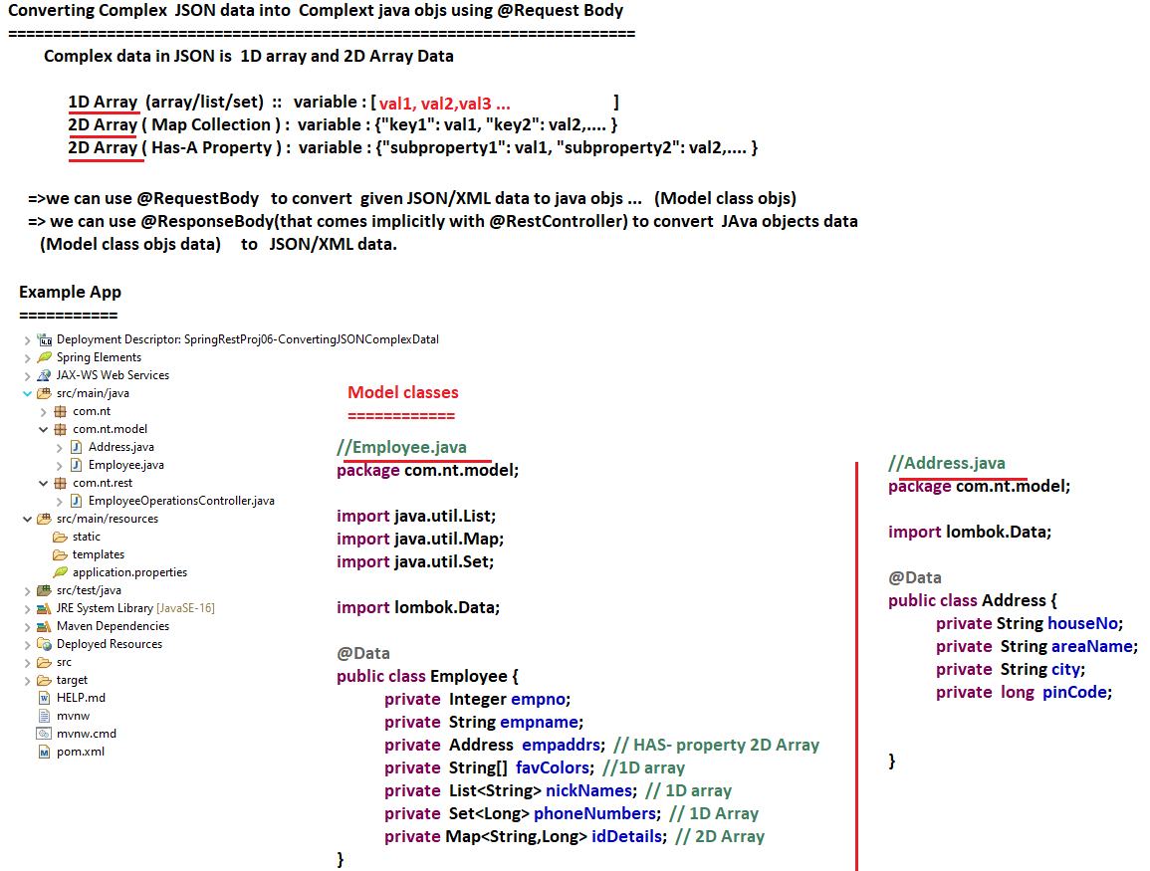

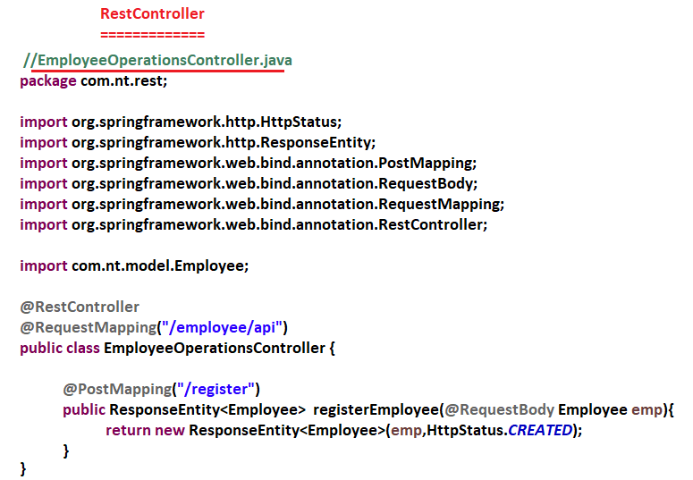

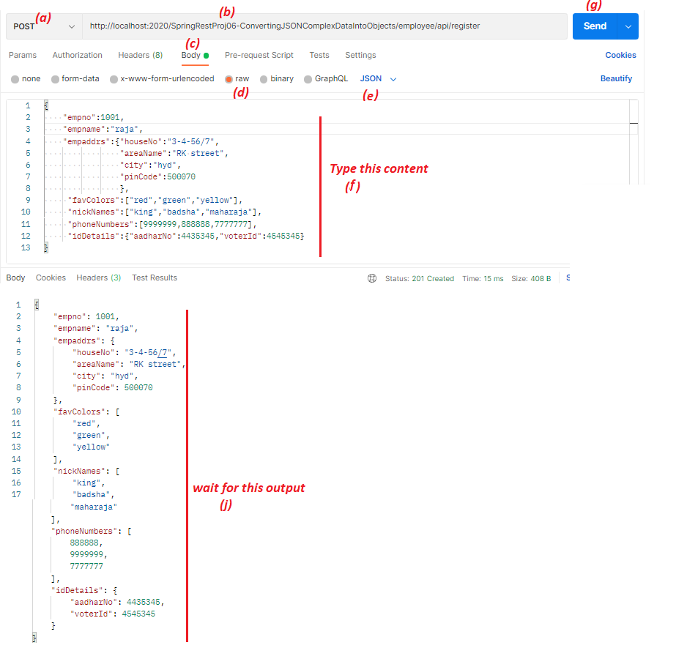

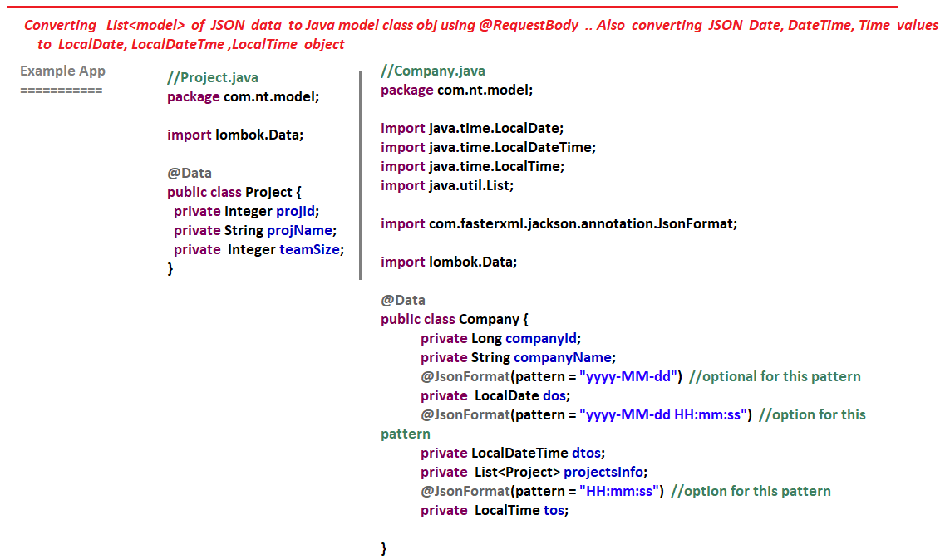

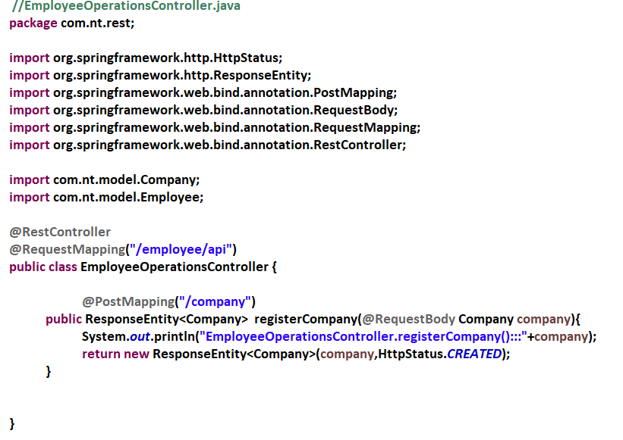

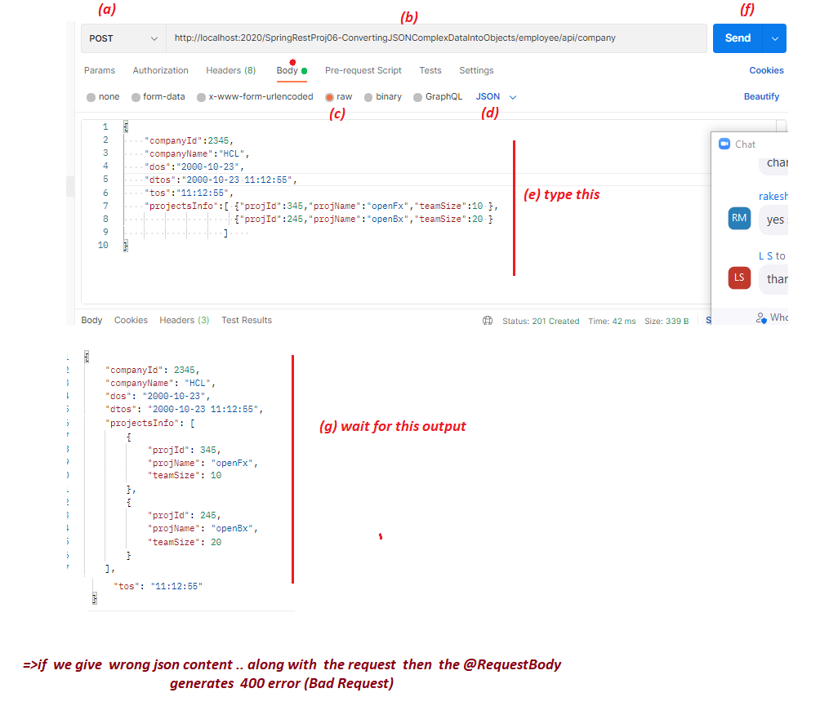

# NTSPBMS615-June 15th-2022- Passing input values to RestAPI comp as request params

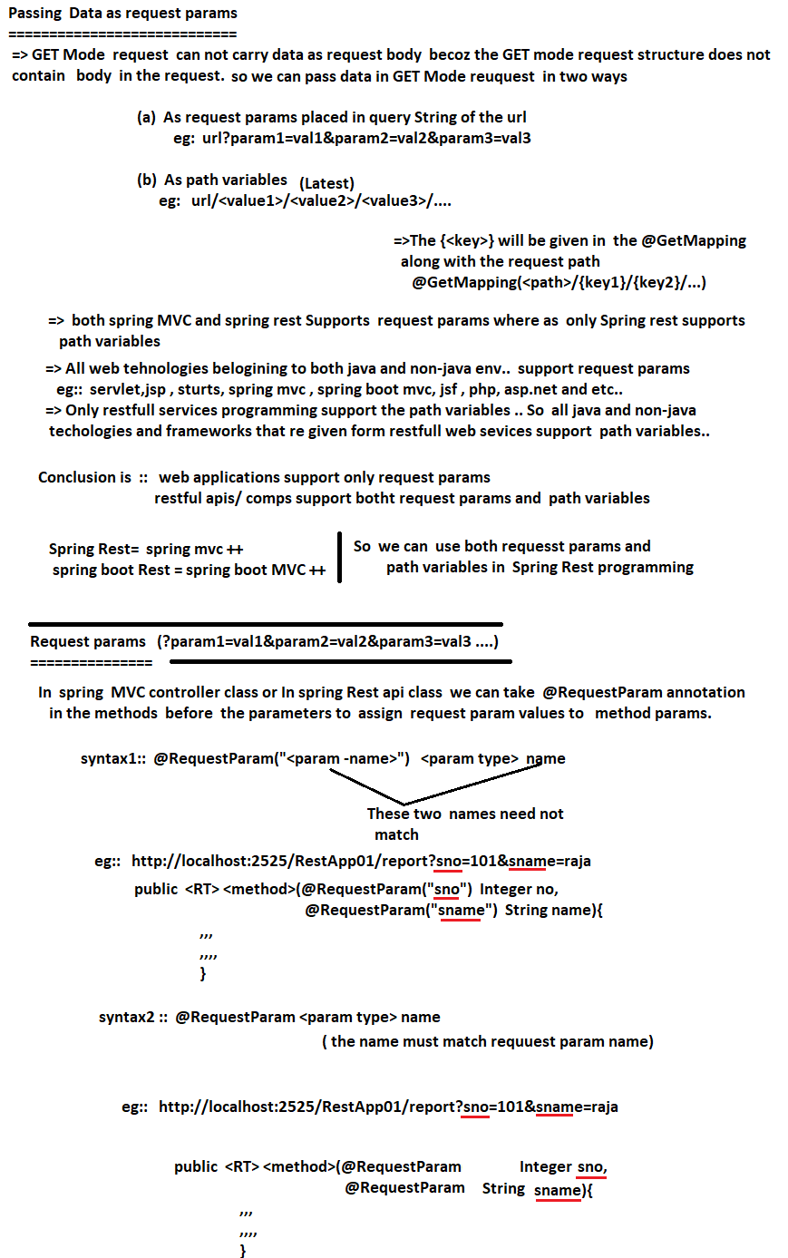

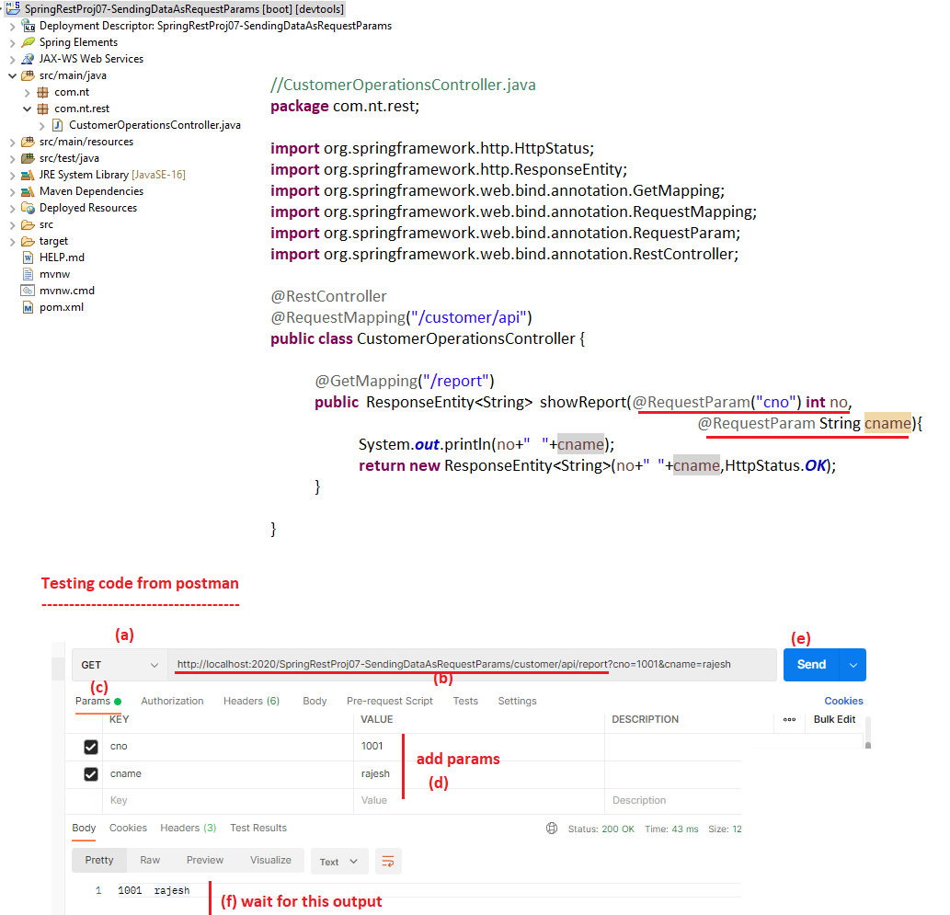

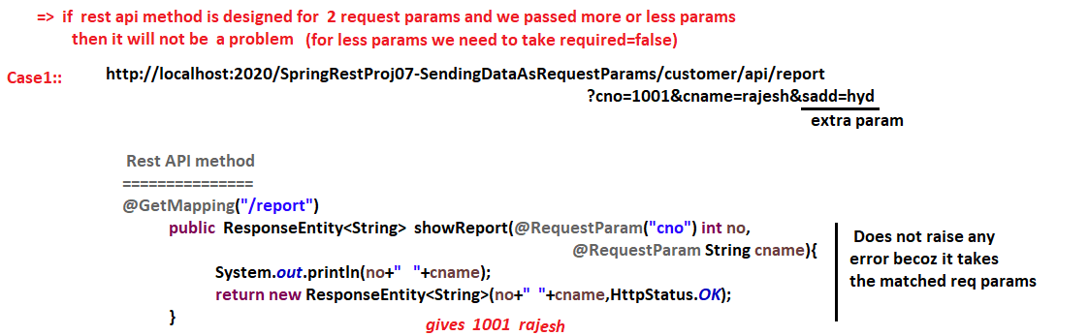

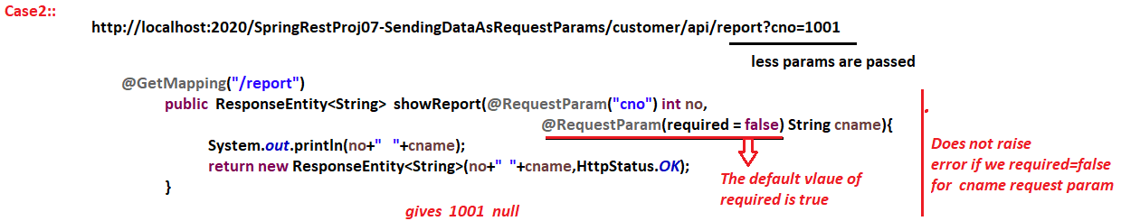

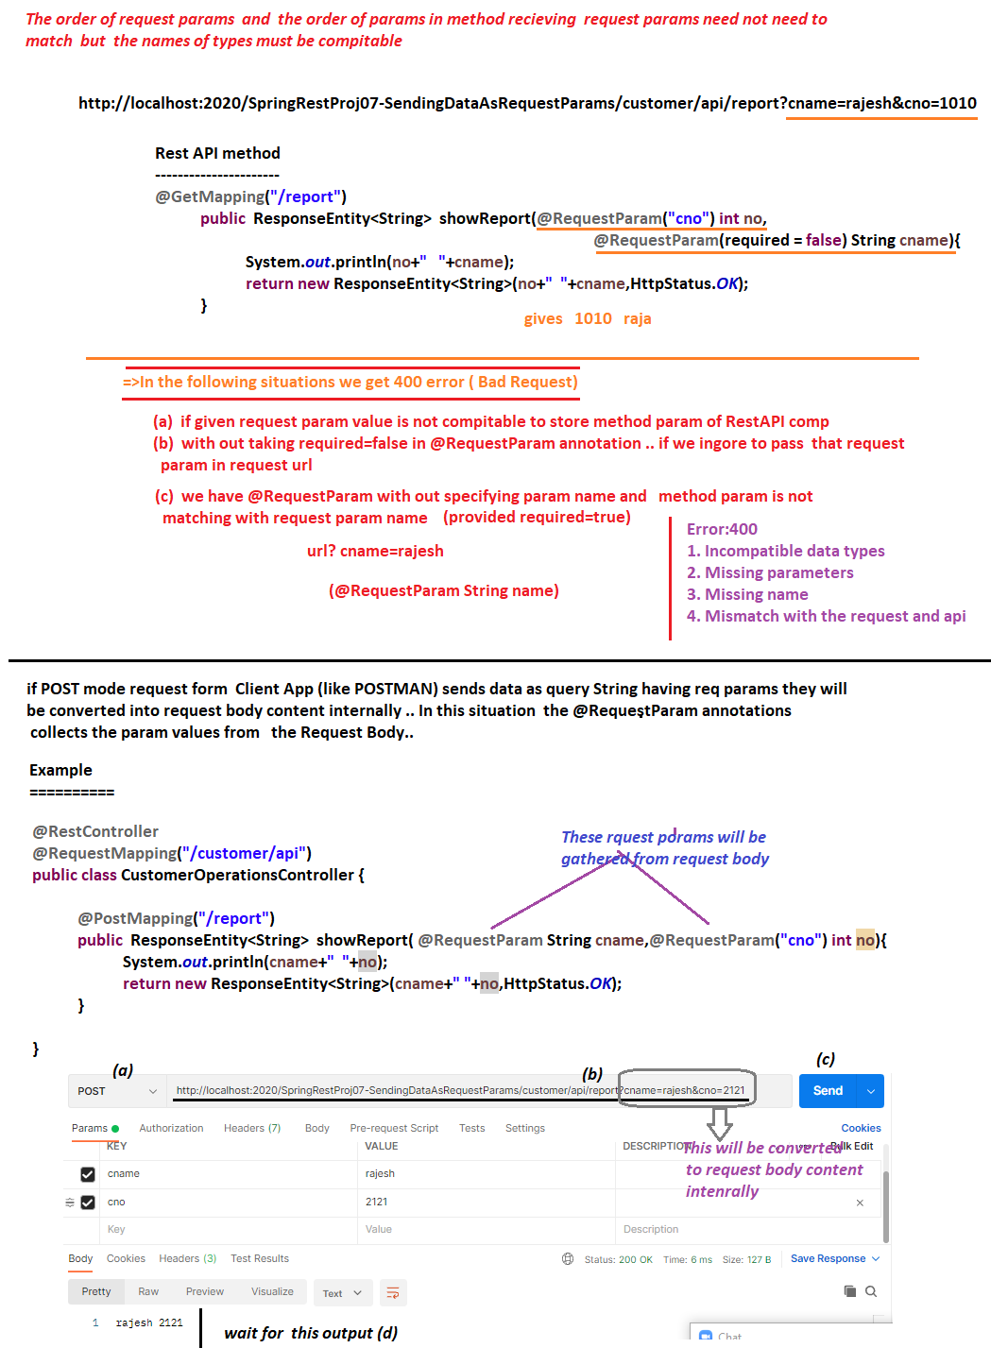



# NTSPBMS615-June 16th-2022- Passing input values to RestAPI comp as Path variables

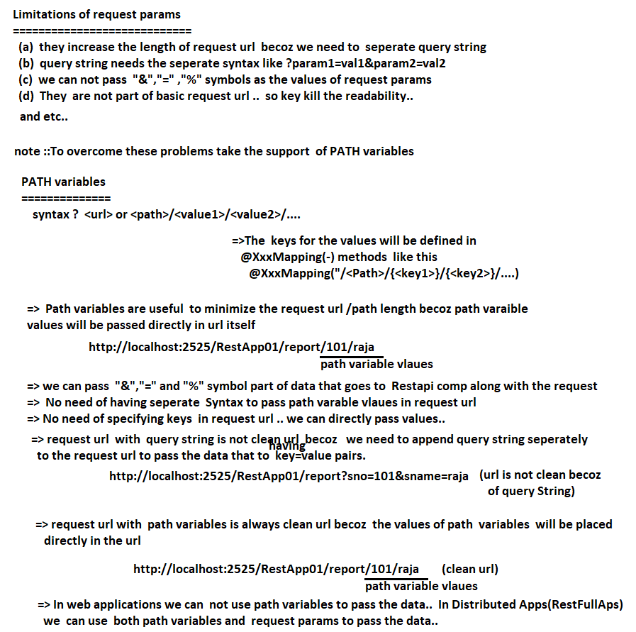

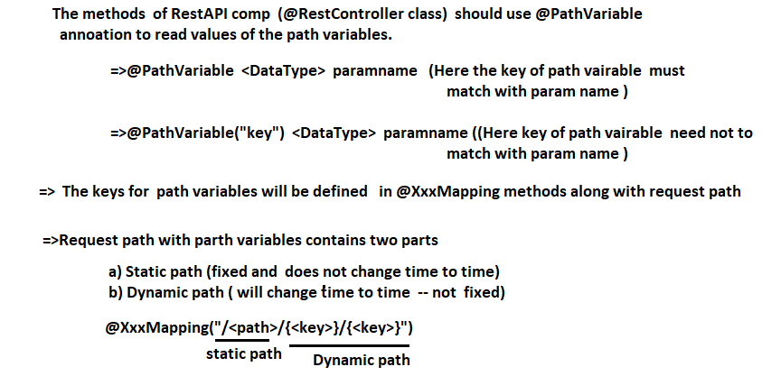

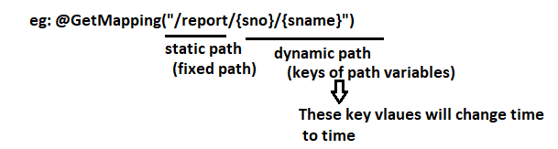

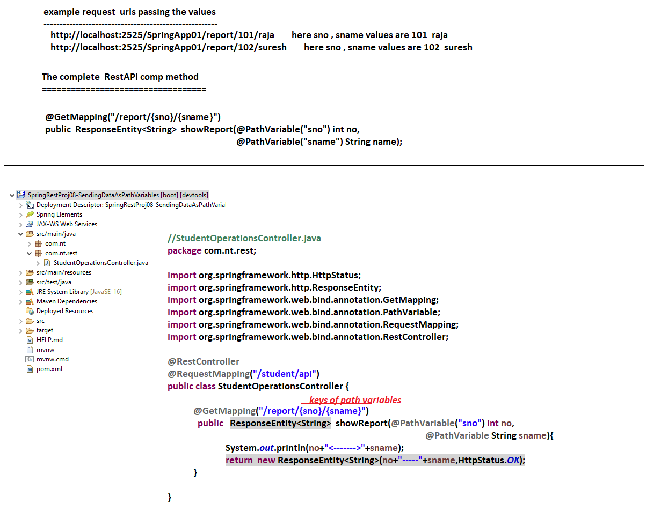

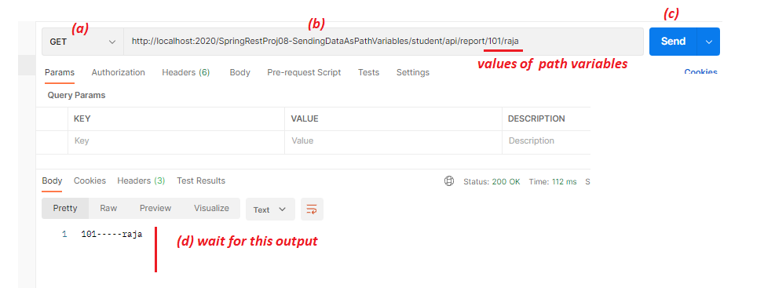

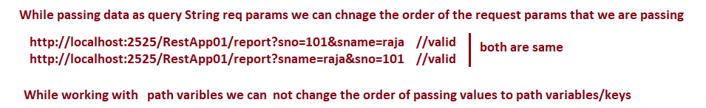

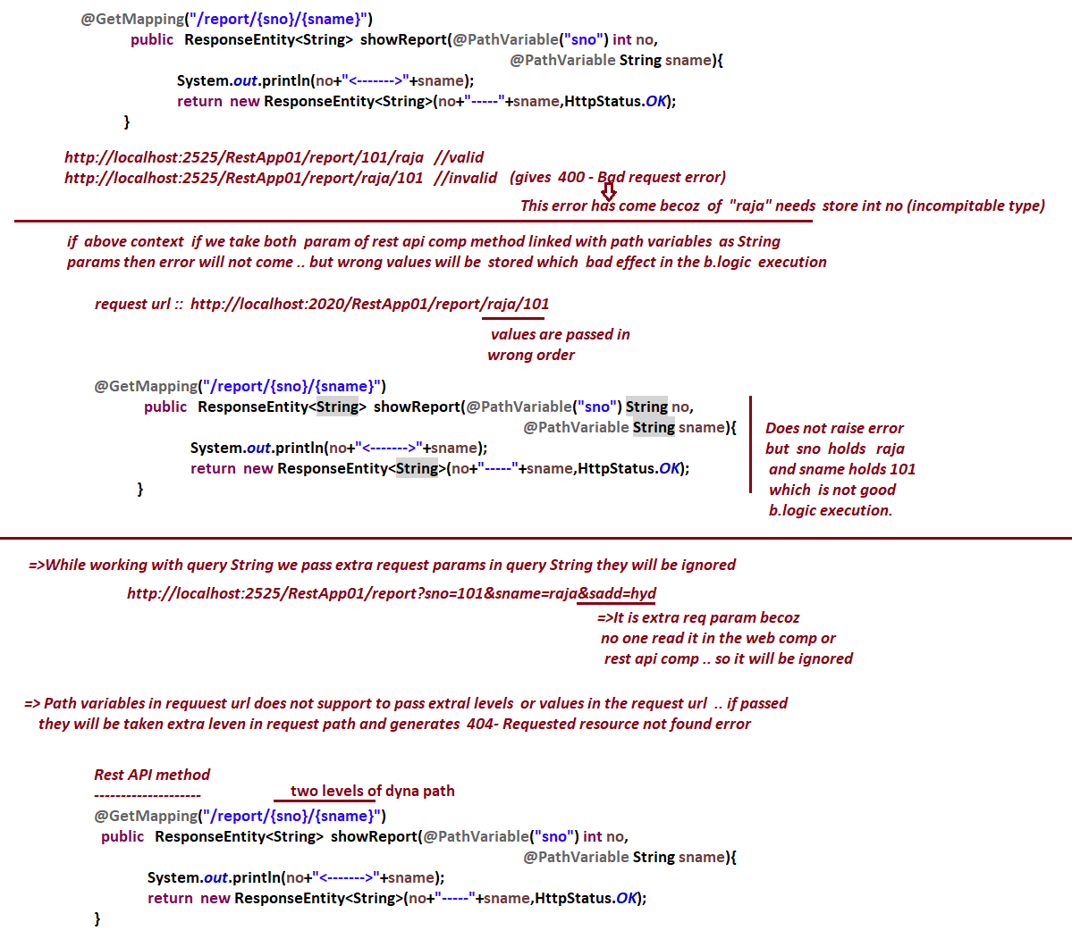

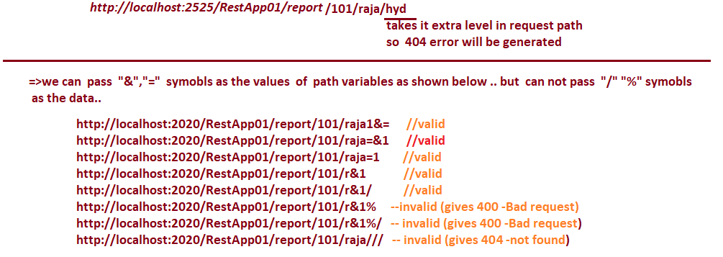

# NTSPBMS615-June 17th-2022- More on Path Variables

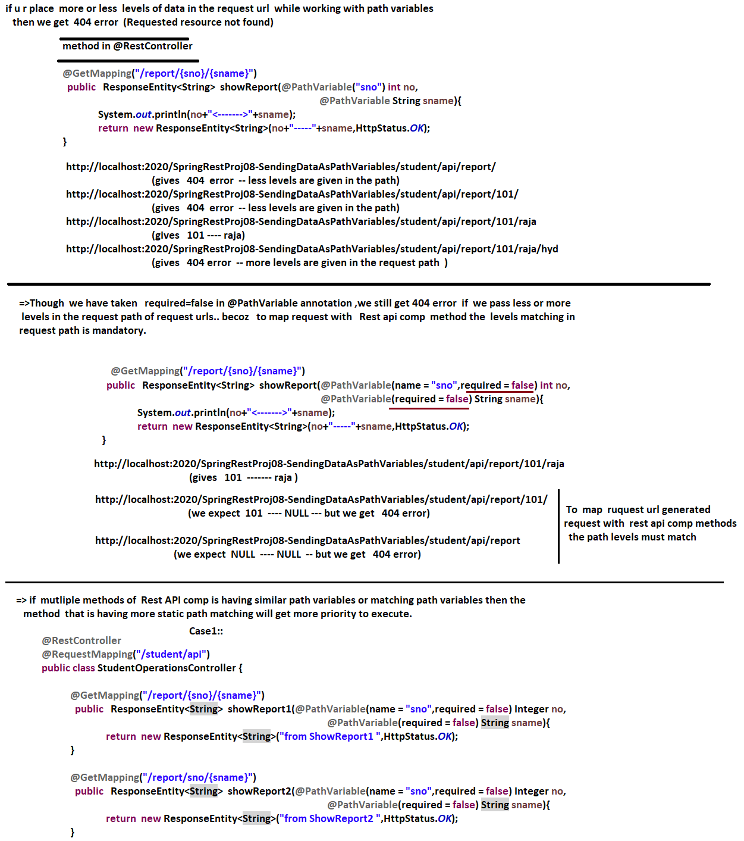

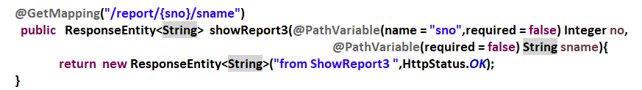

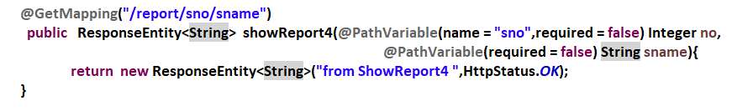

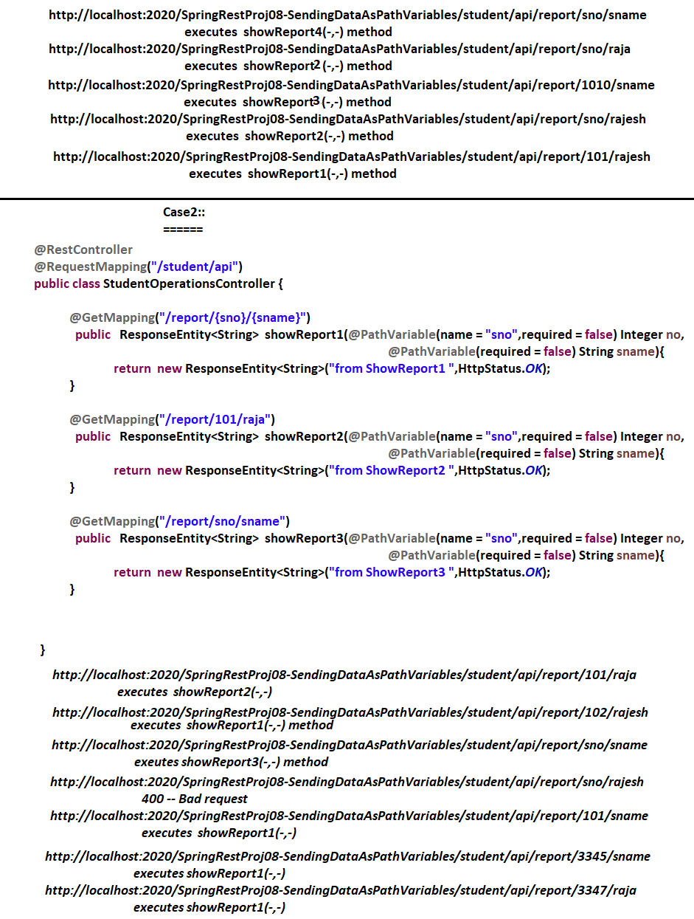



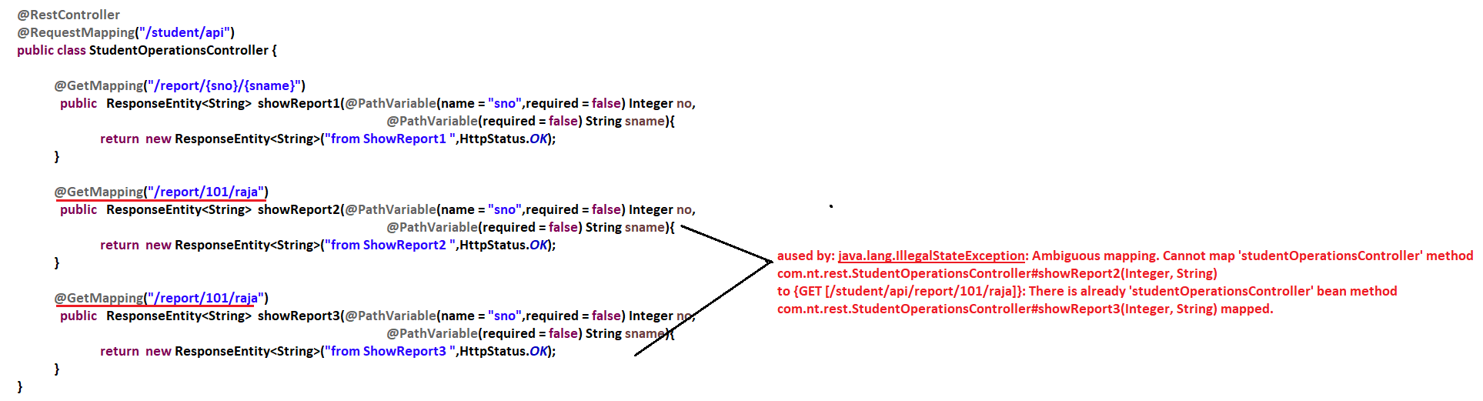

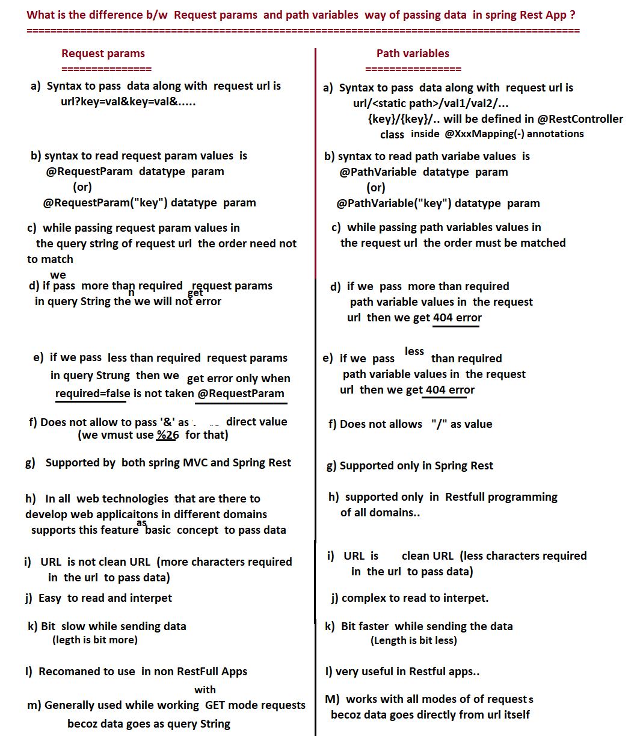

# NTSPBMS615-June 18th-2022- MiniProject on SpringRest

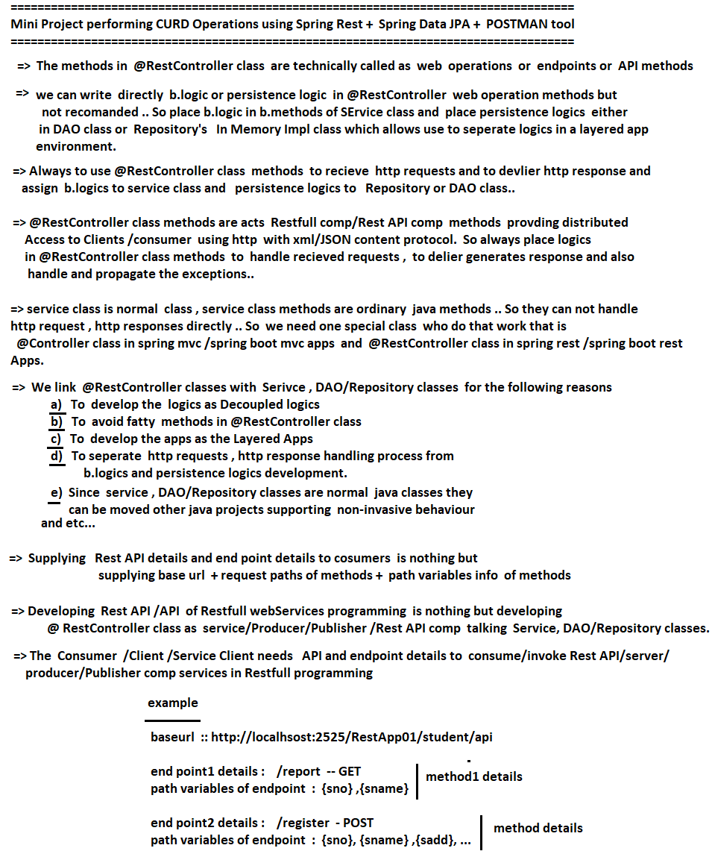

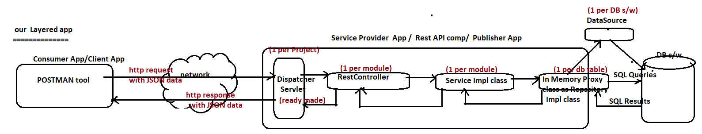

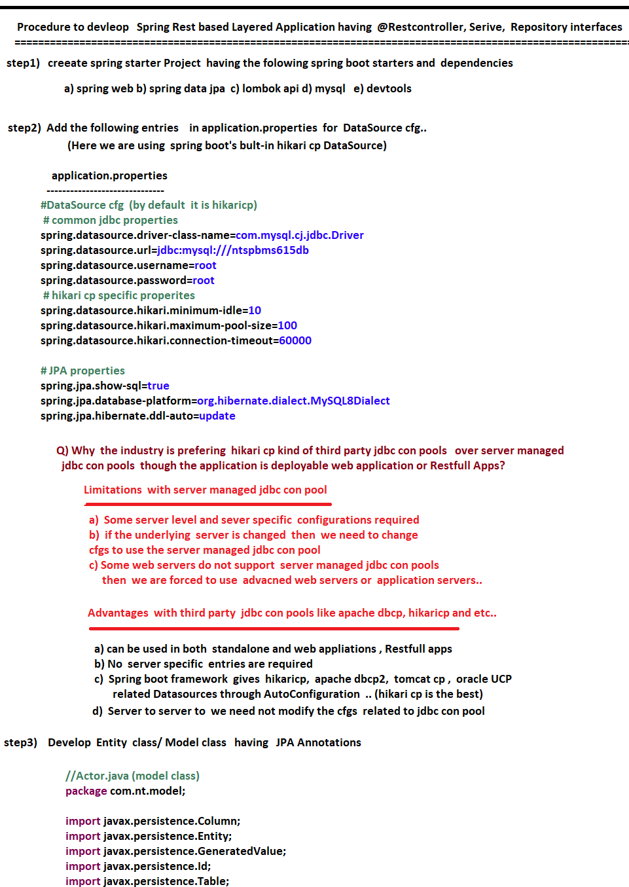

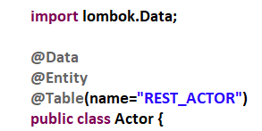

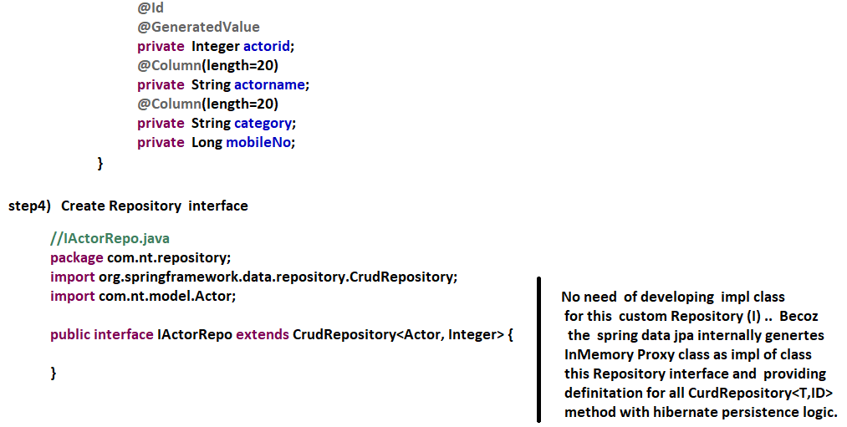

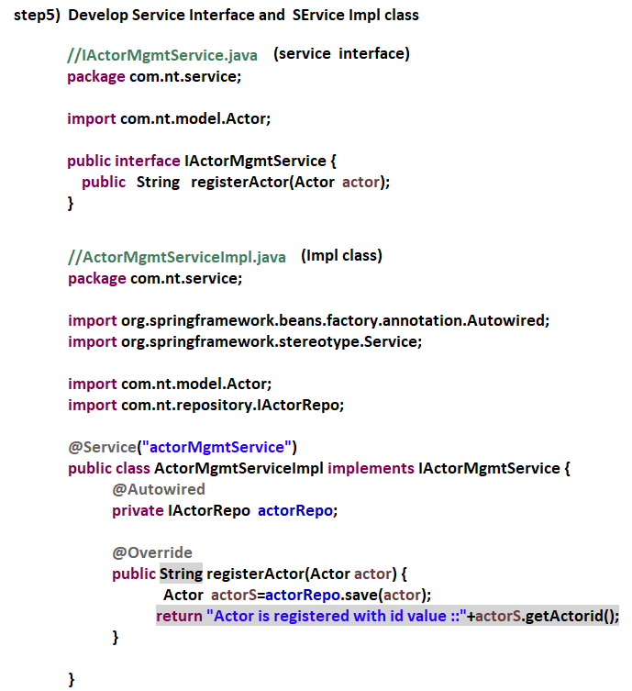

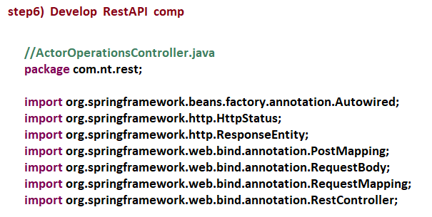

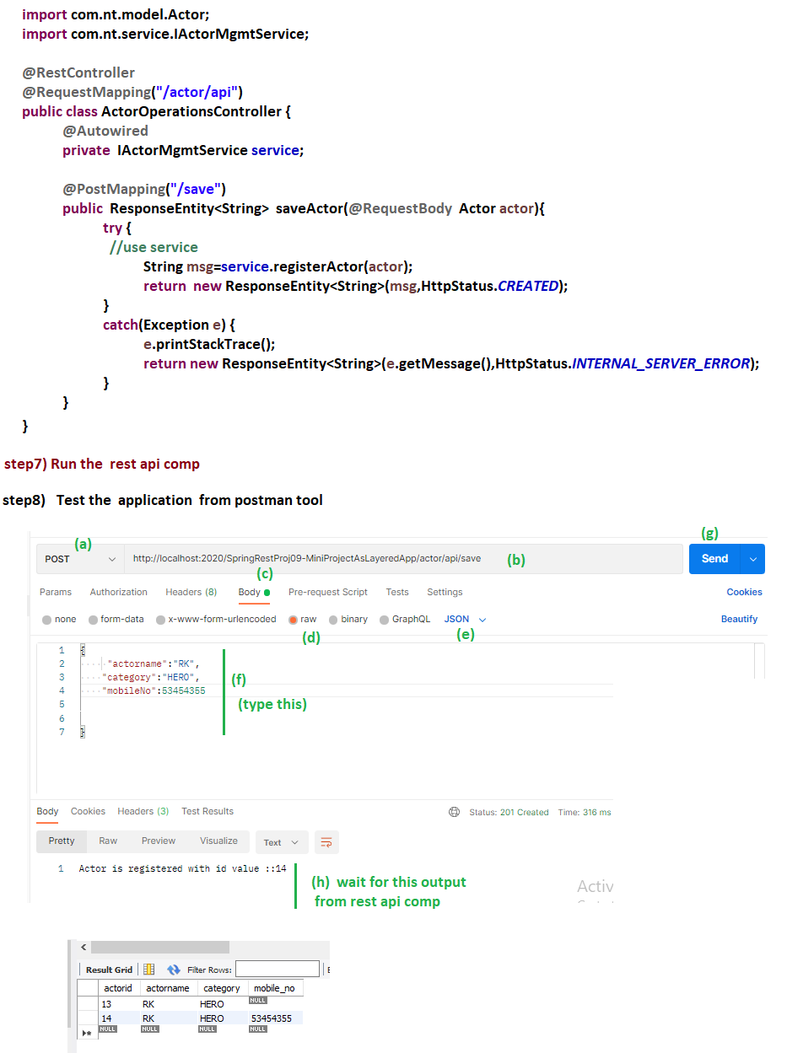

NTSPBMS615-June 22nd-2022- MiniProject on SpringRest-CURD Operations

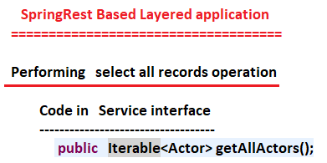

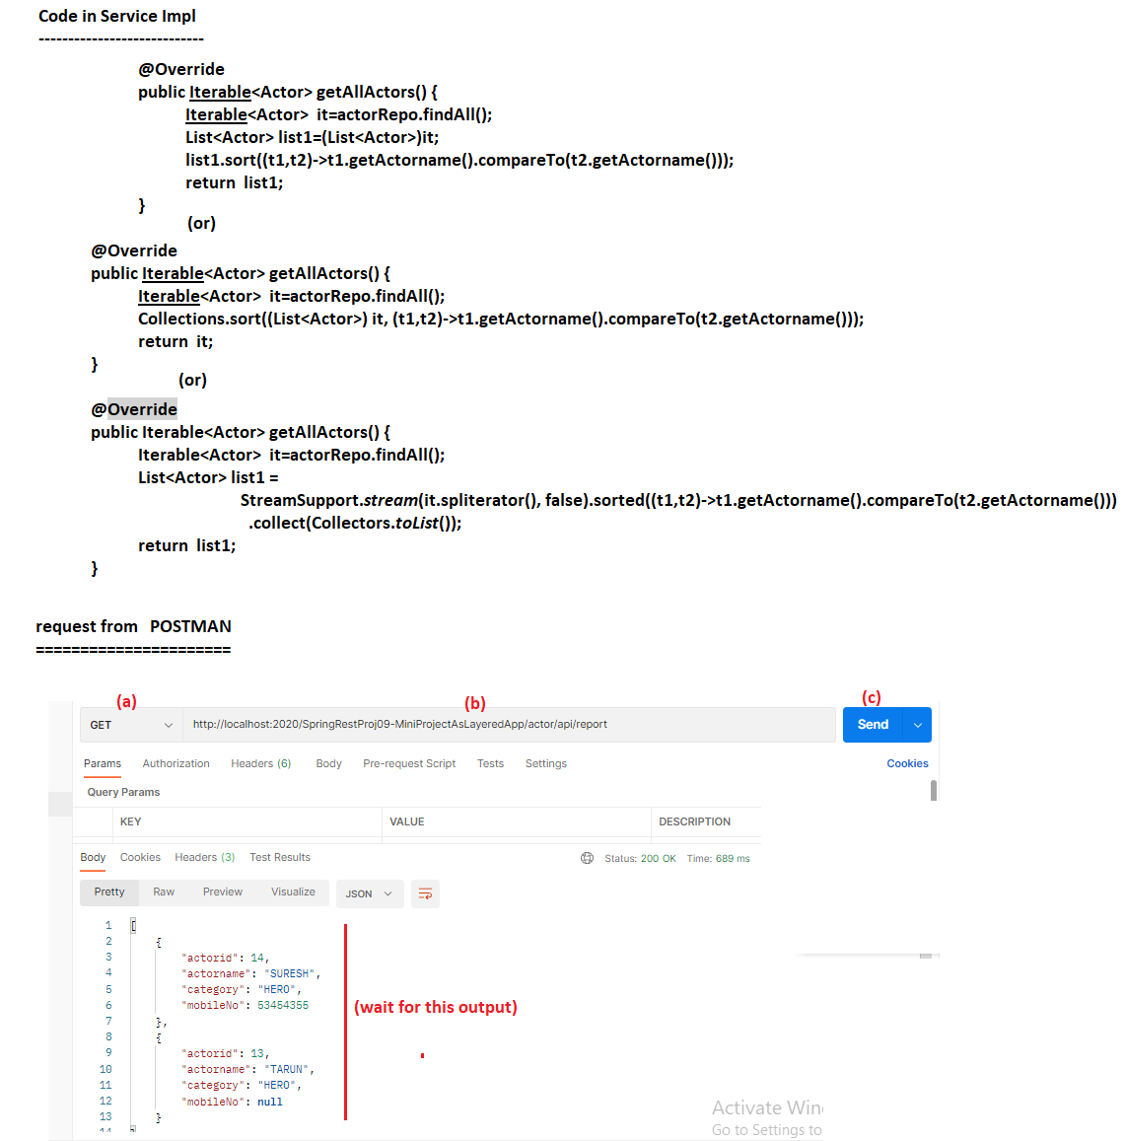

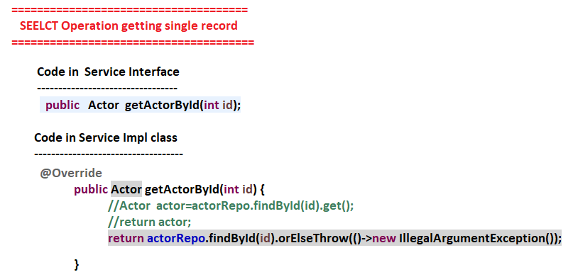

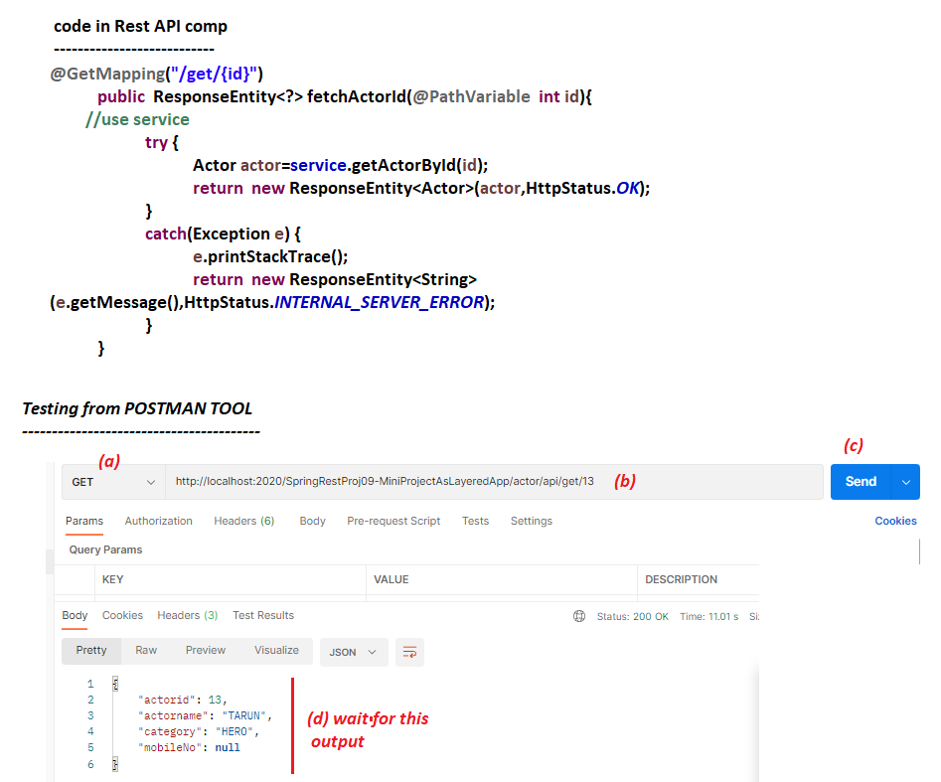

# NTSPBMS615-June 24th-2022- MiniProject on SpringRest-CURD Operations

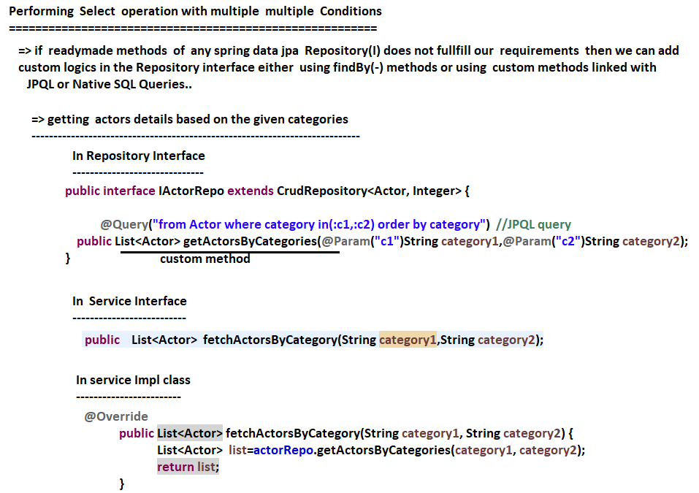

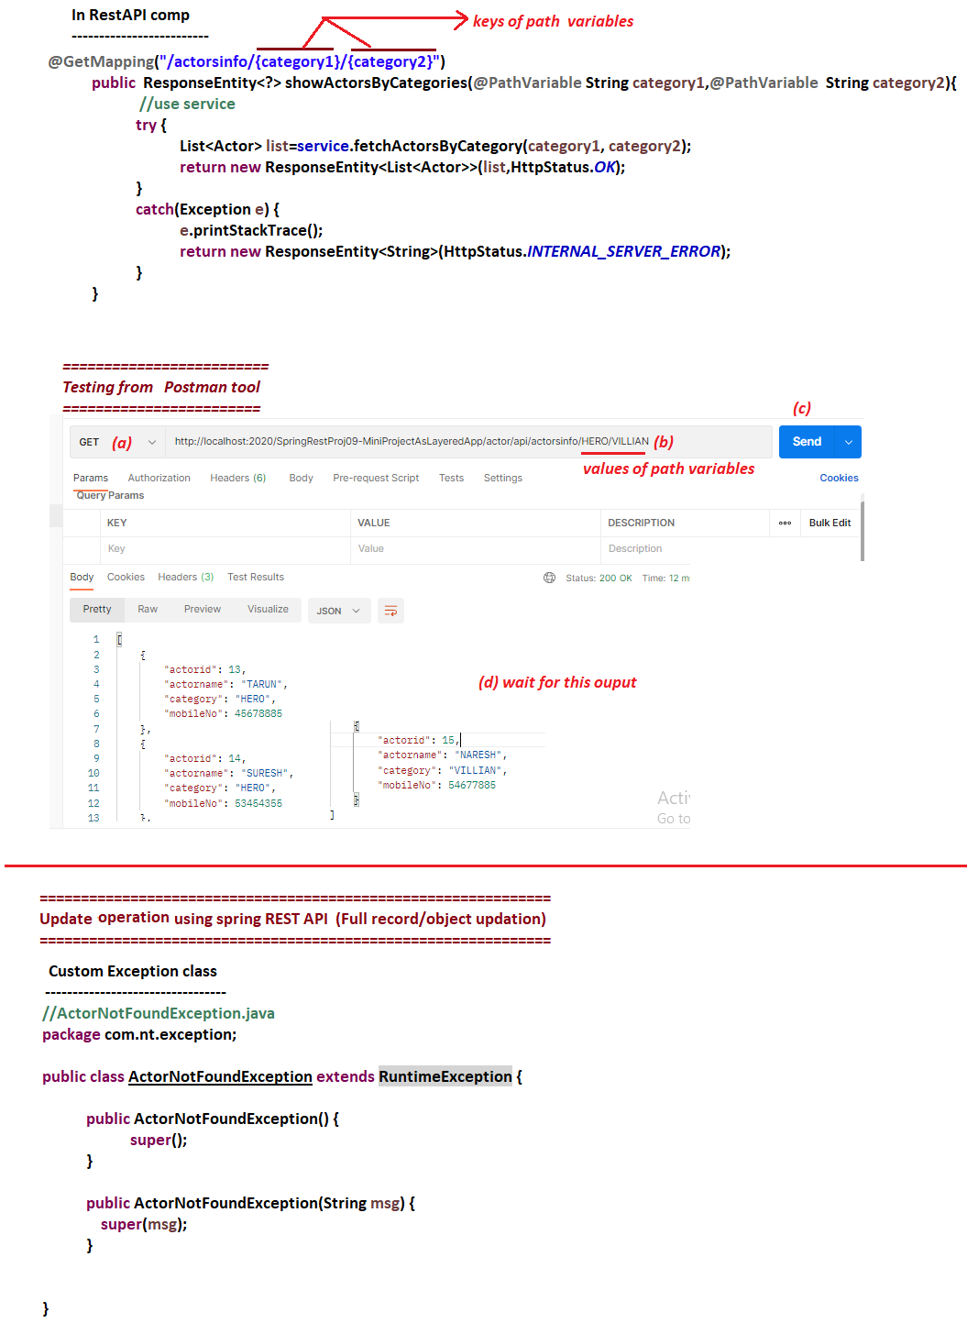

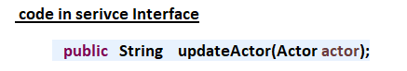

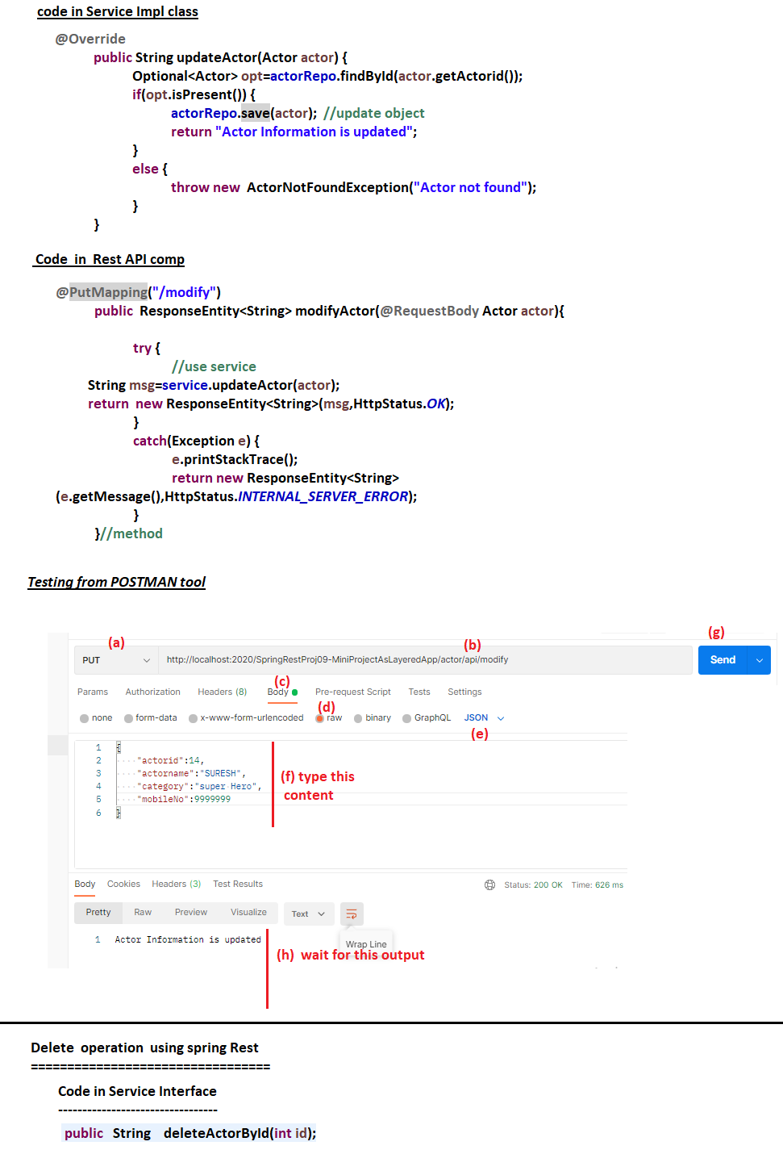

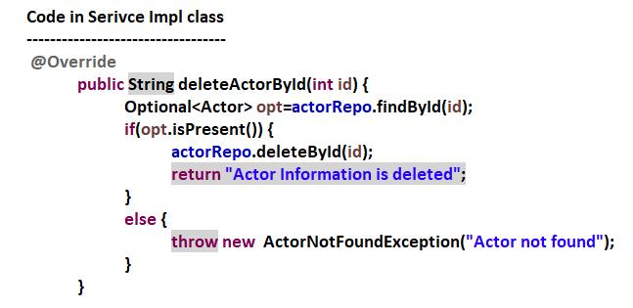

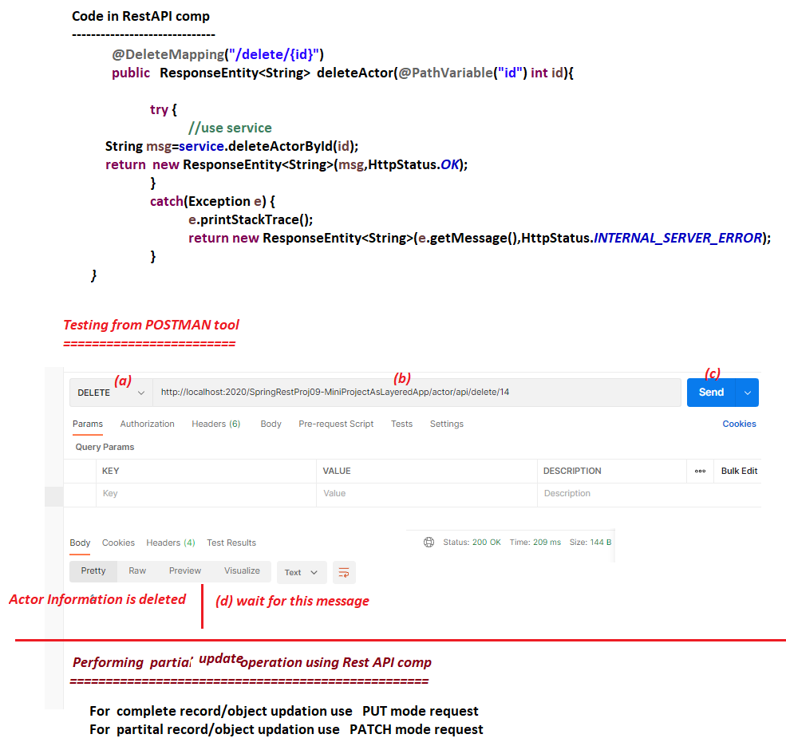

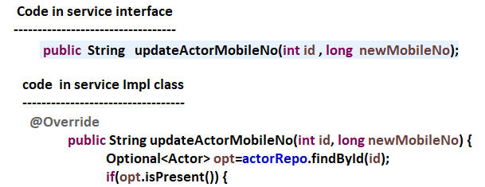

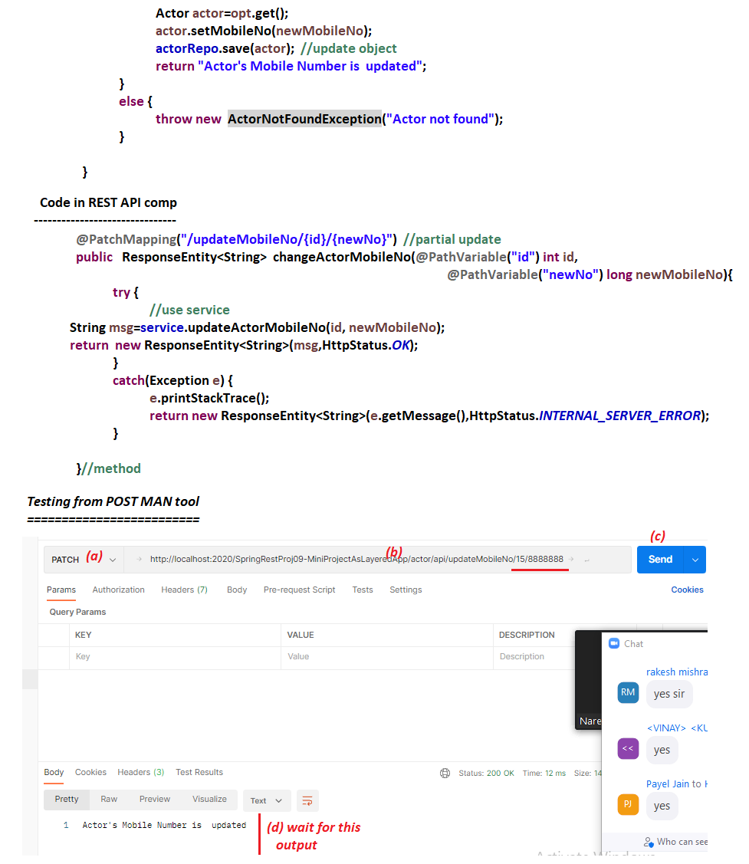

# NTSPBMS615-June 25th-2022- @ControlAdvice- ExceptionHandling

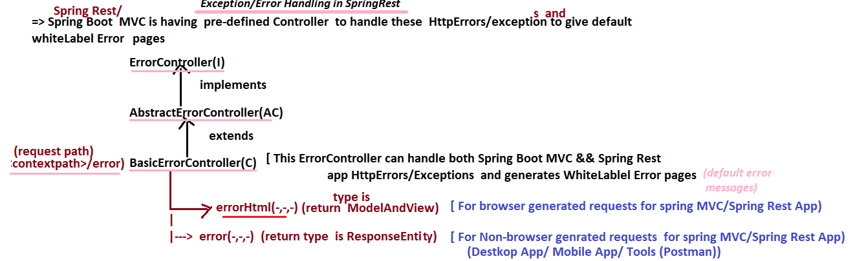

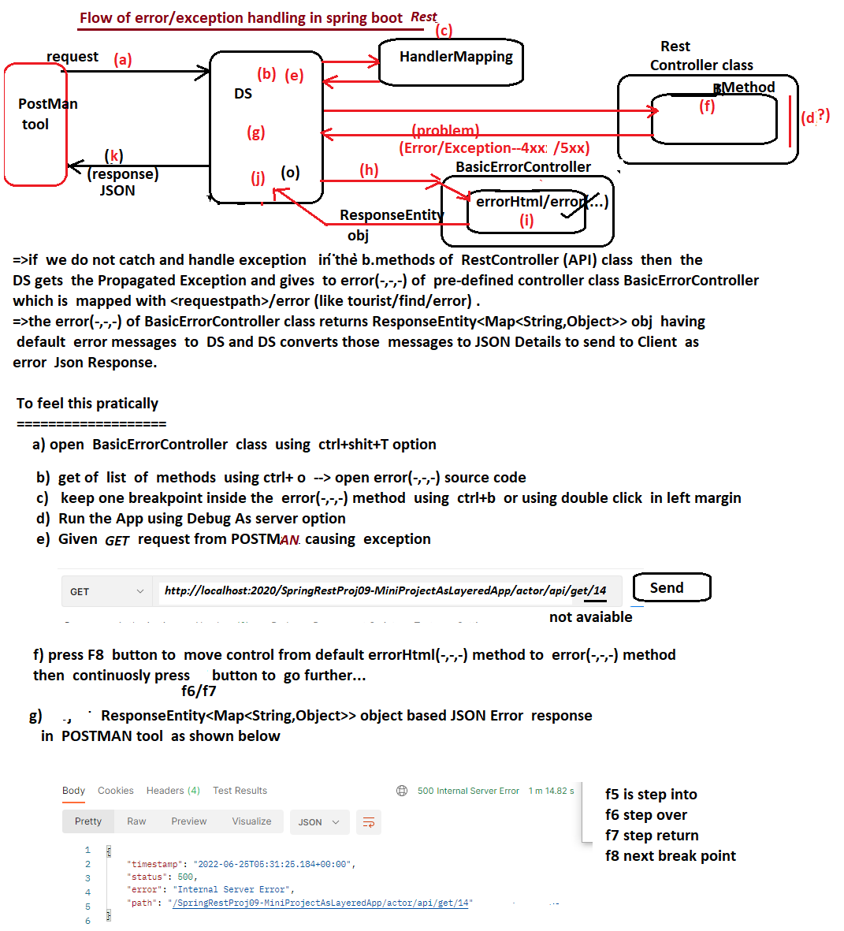

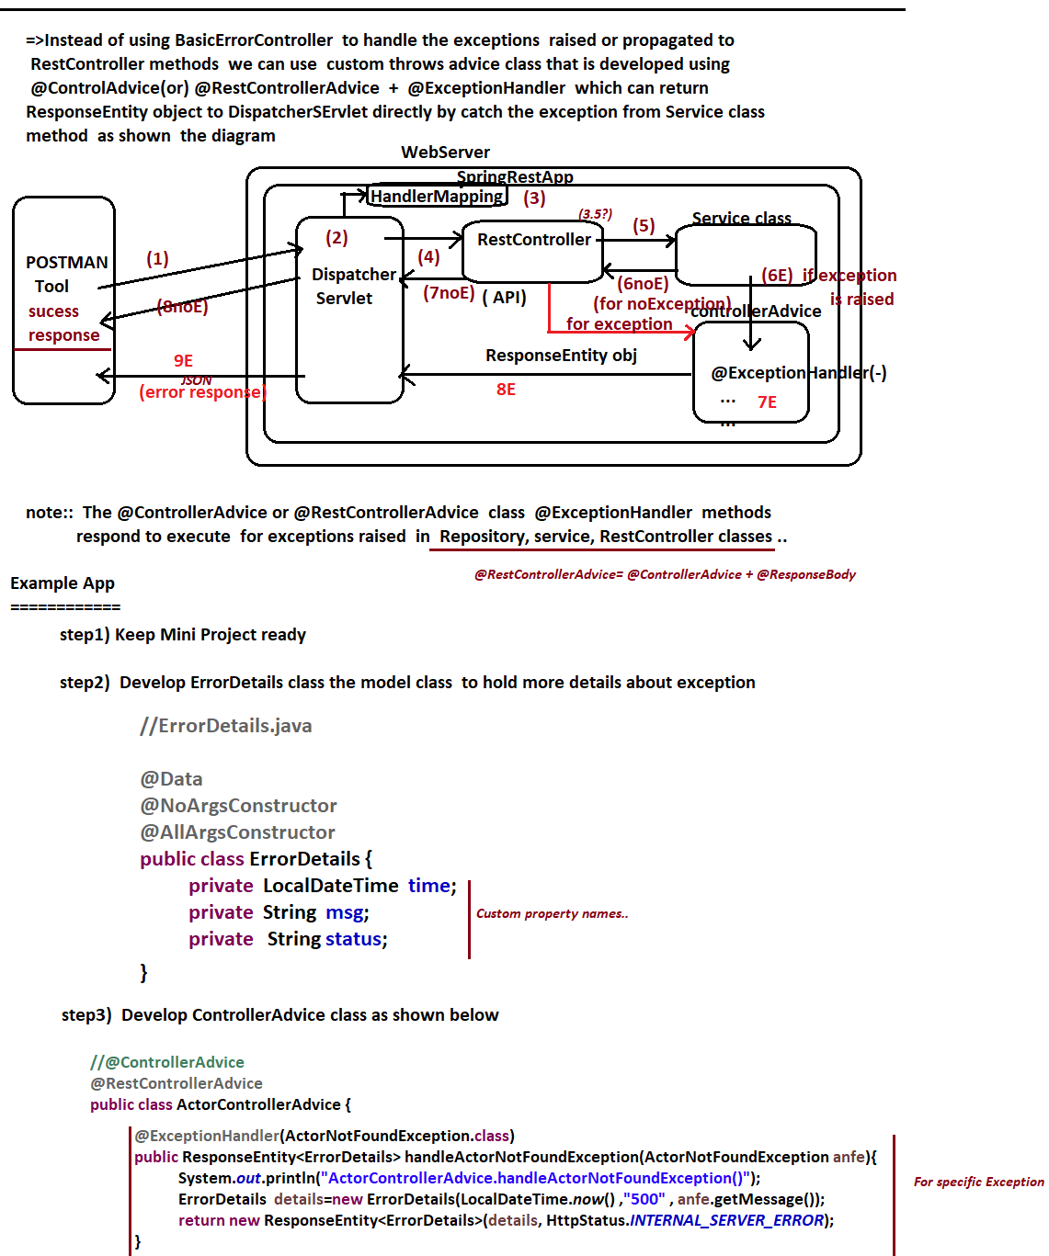

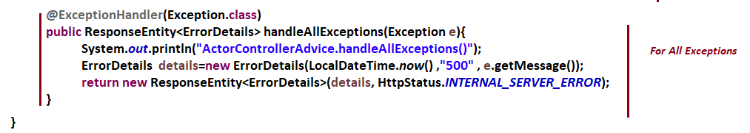



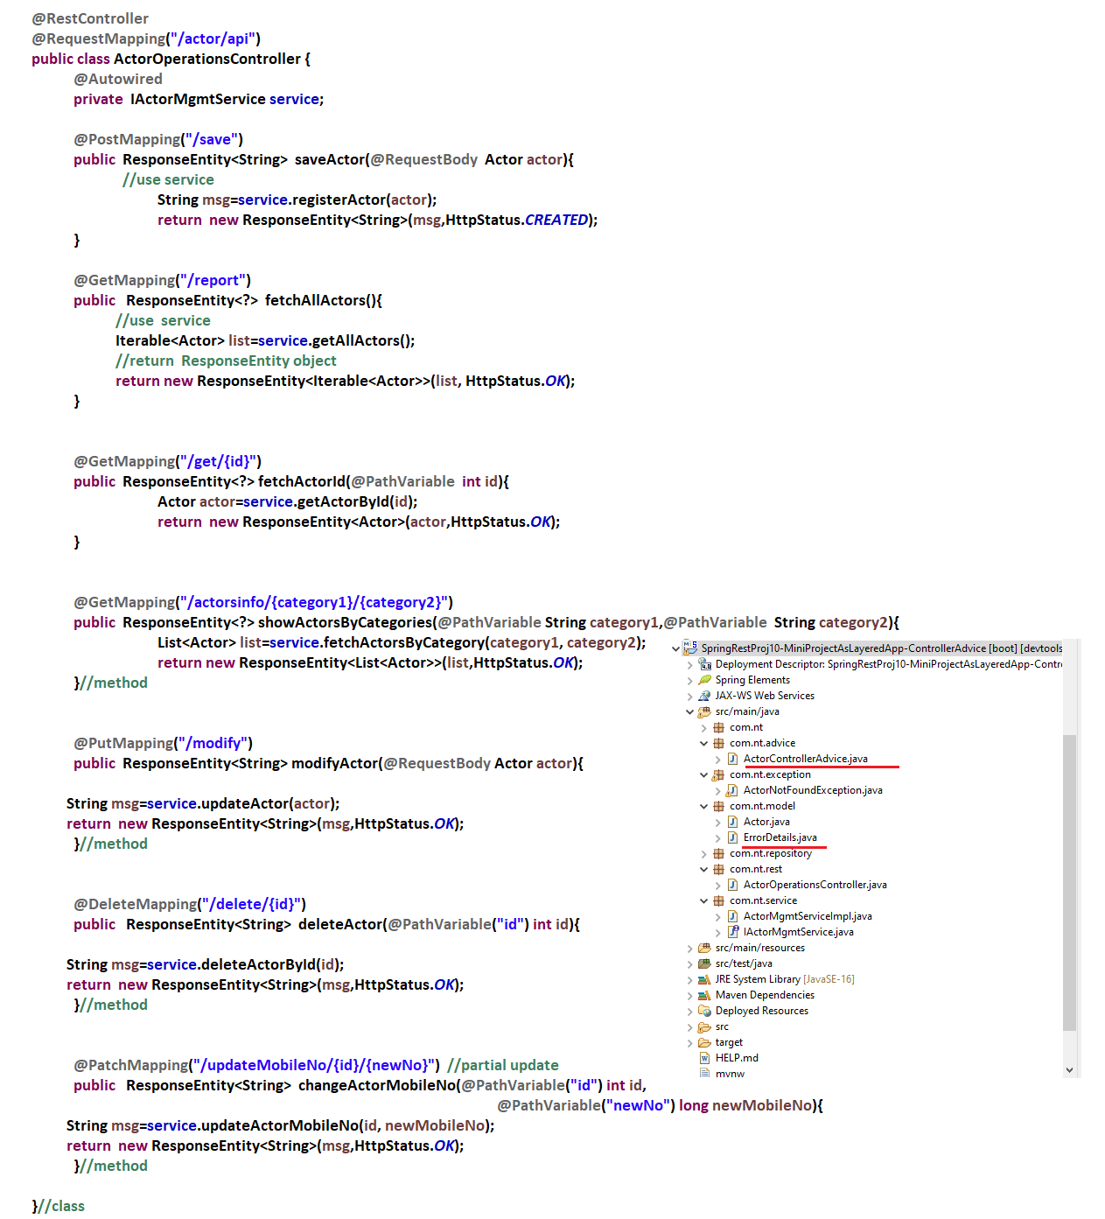

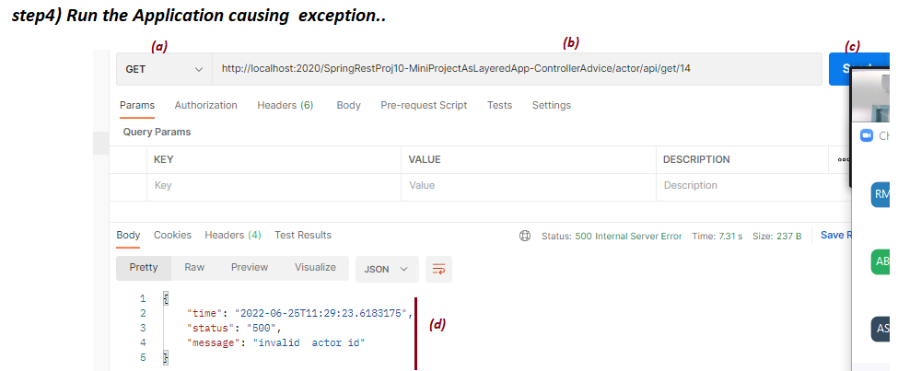

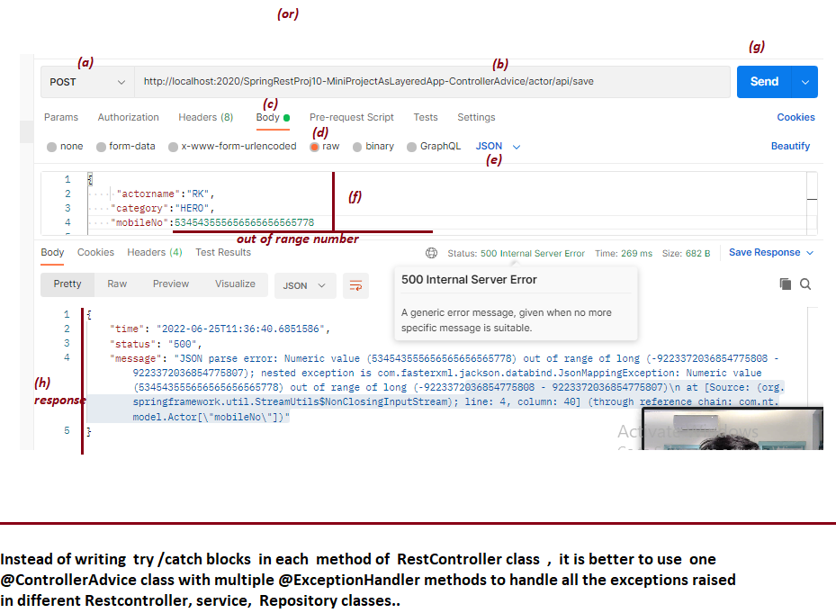

# NTSPBMS615- Swagger -Api documentation-june28th-2022

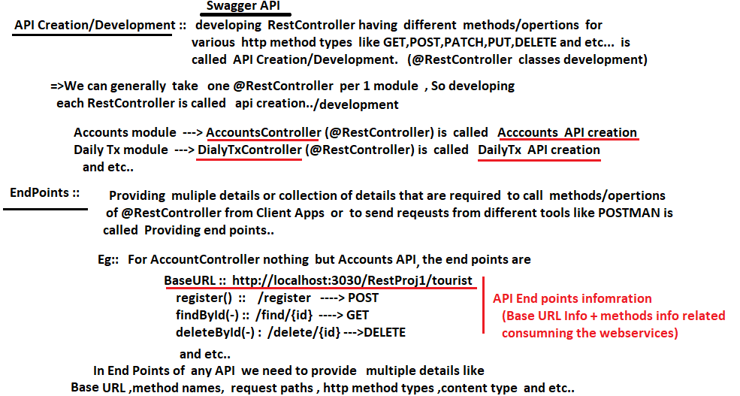

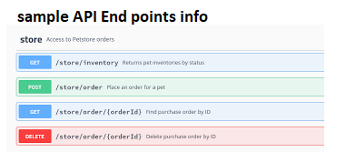

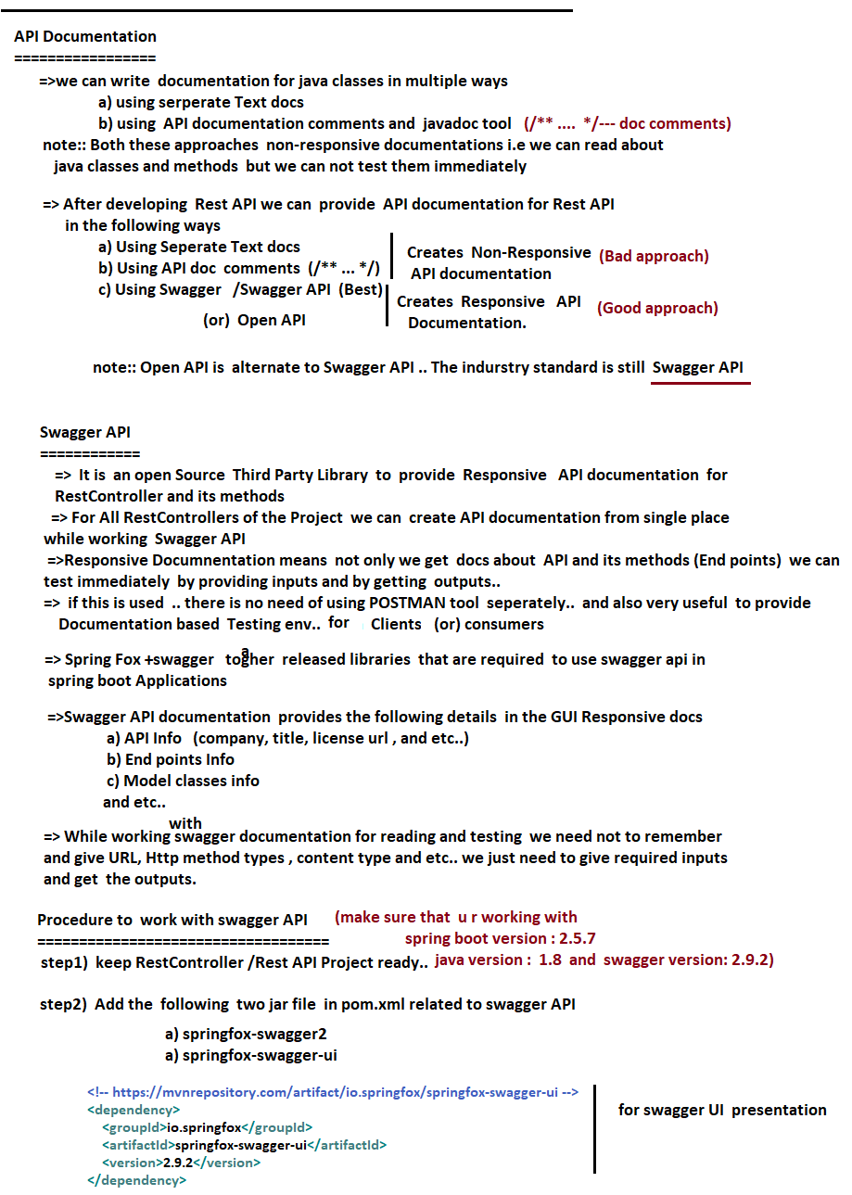

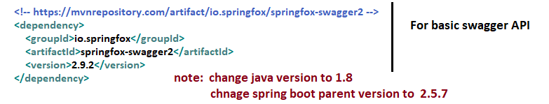

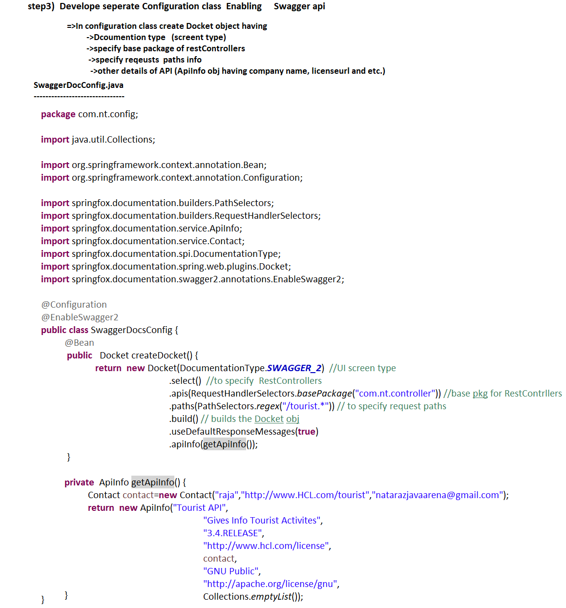

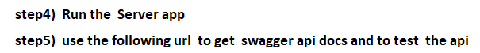

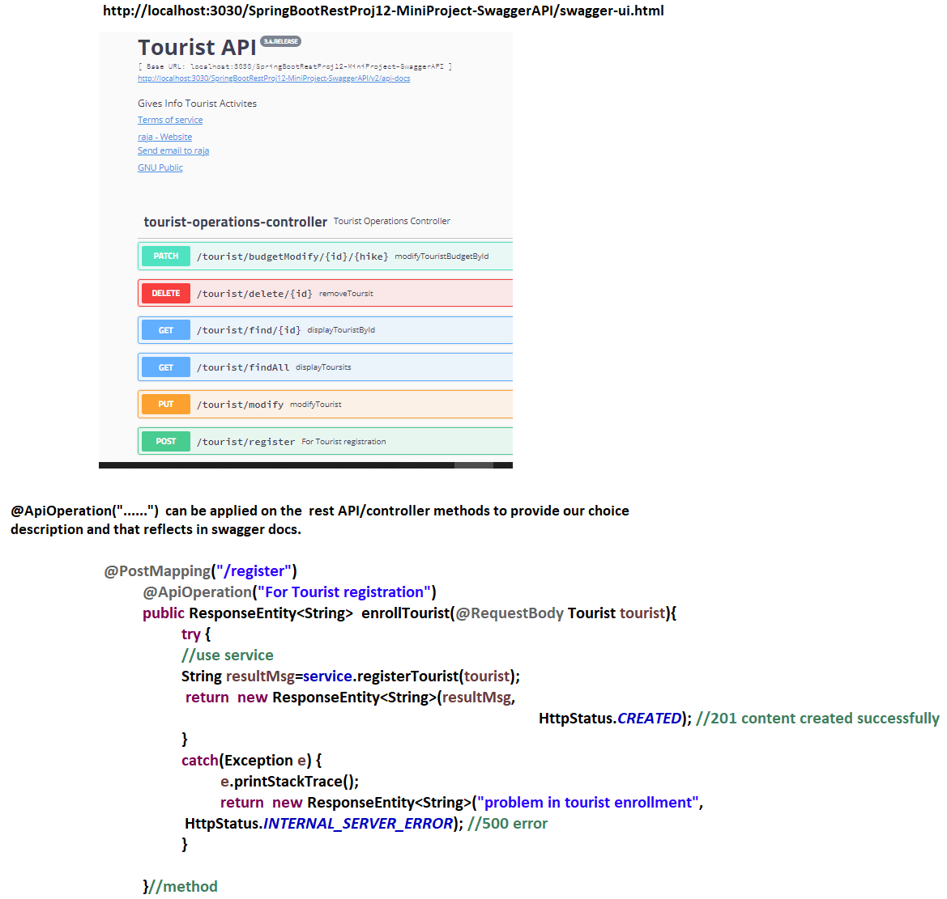

# NTSPBMS615- Rest Consumer using RestTemplate-June 30th-2022

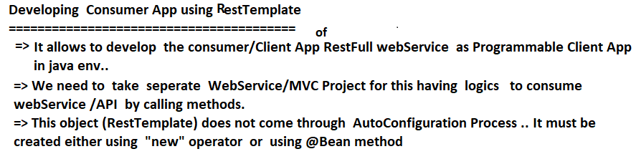

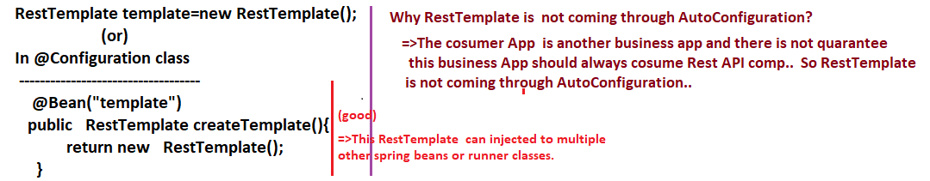

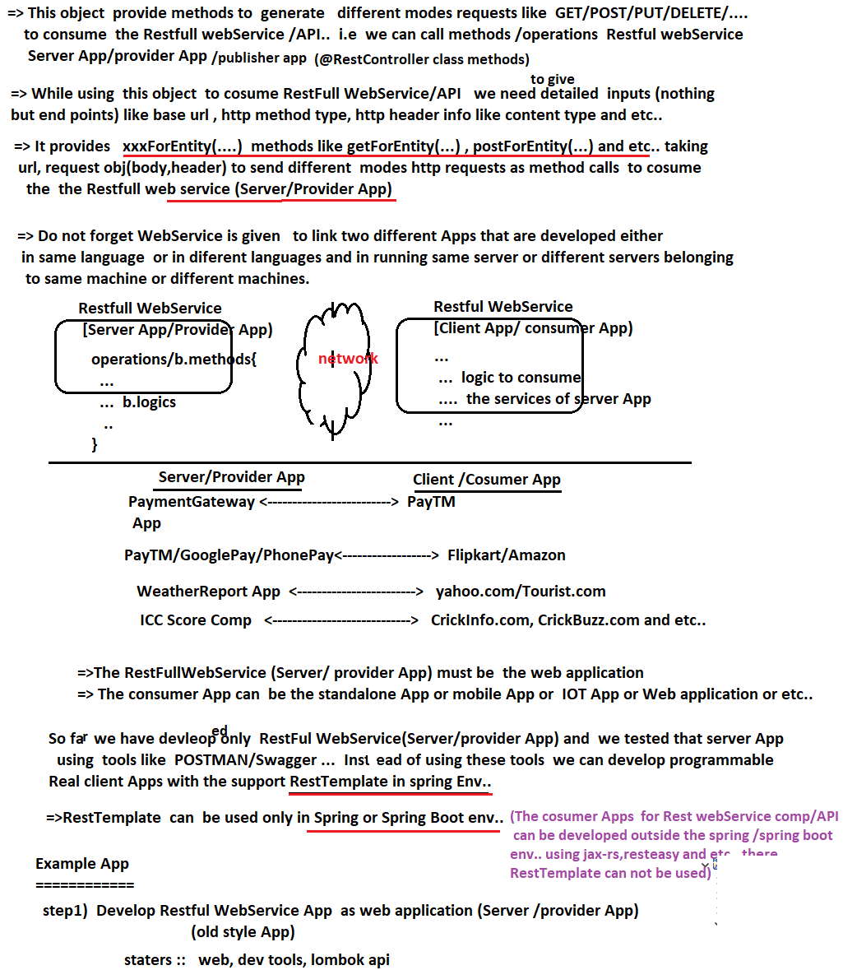

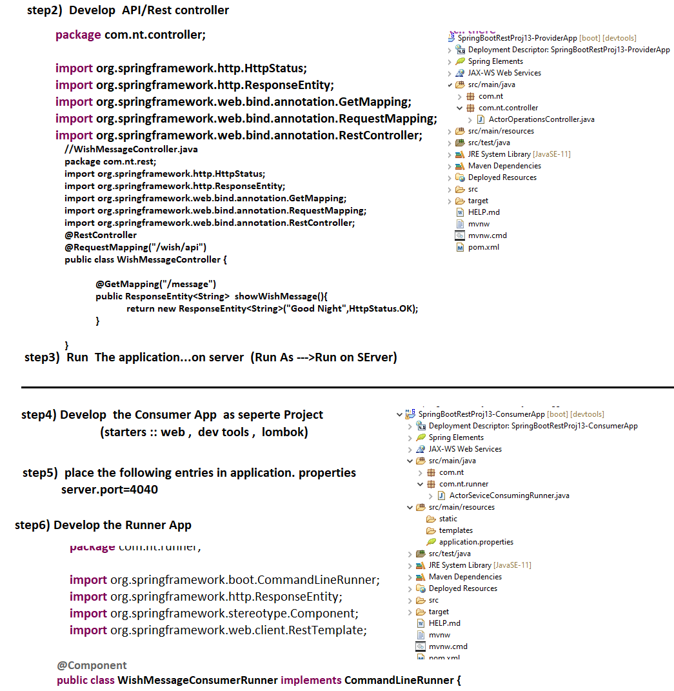

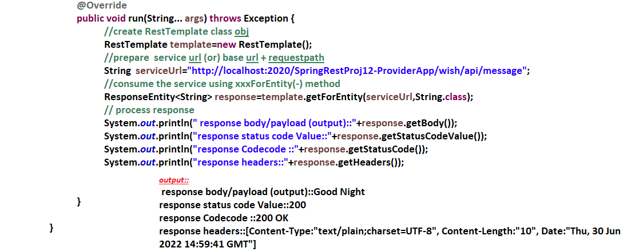

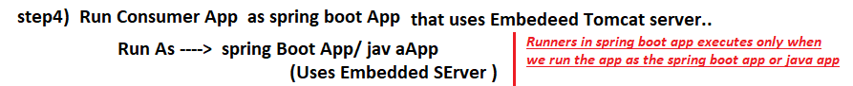

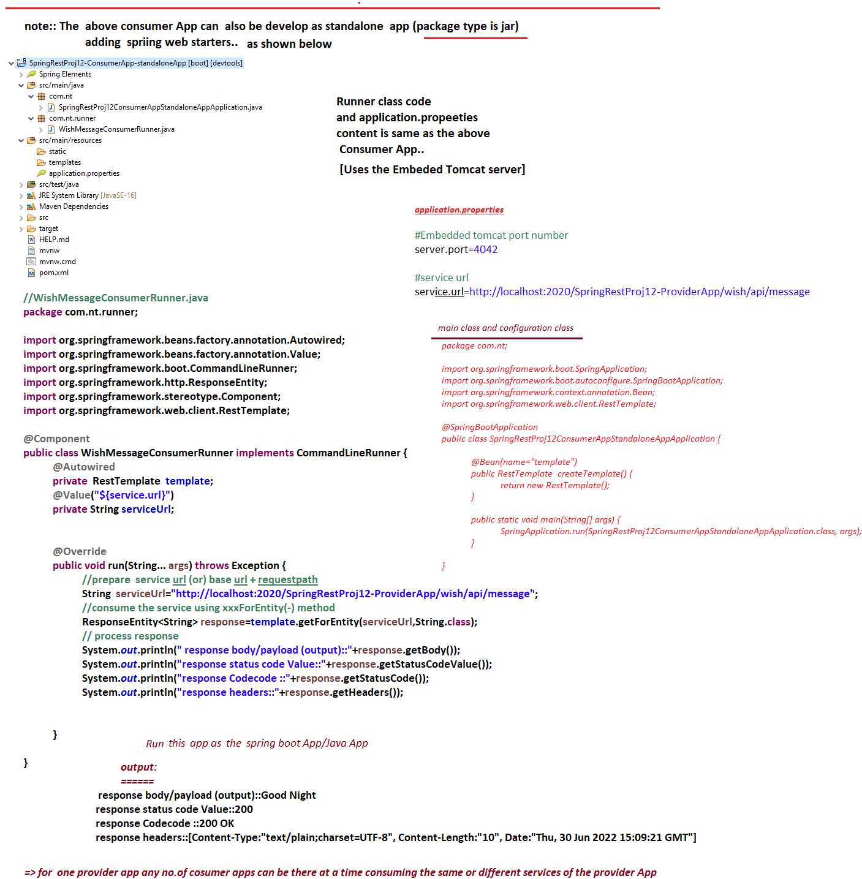

# NTSPBMS615- Rest Consumer using RestTemplate-July 1st-2022

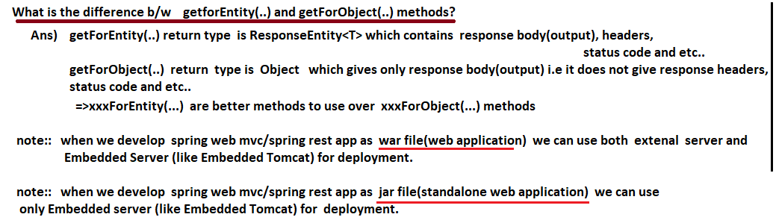

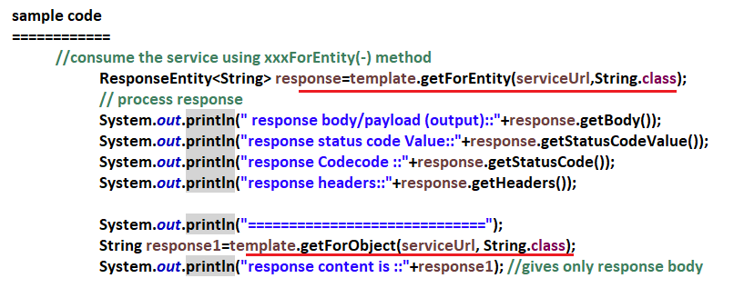

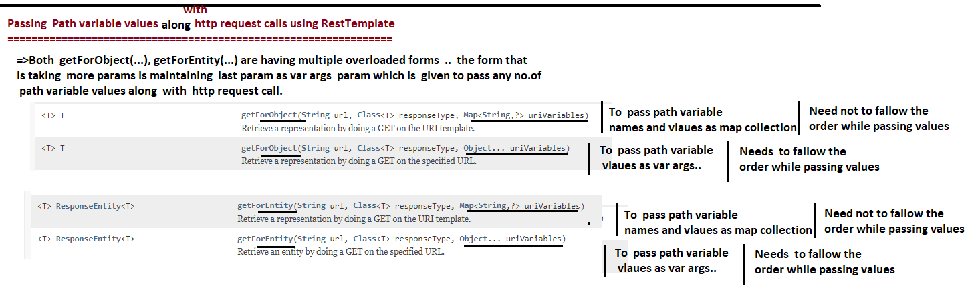

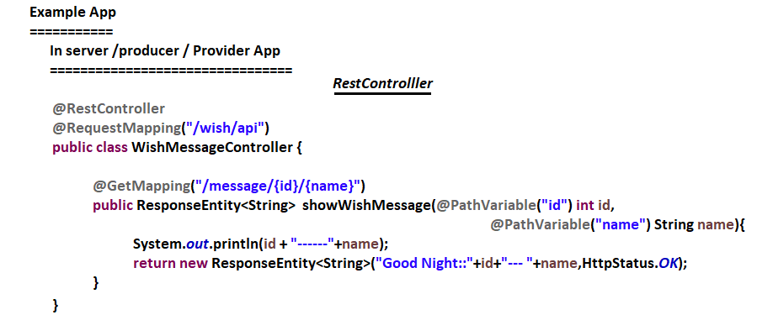

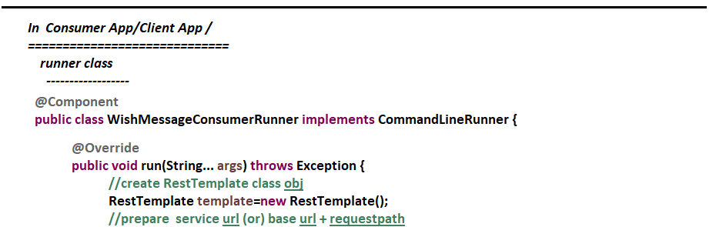

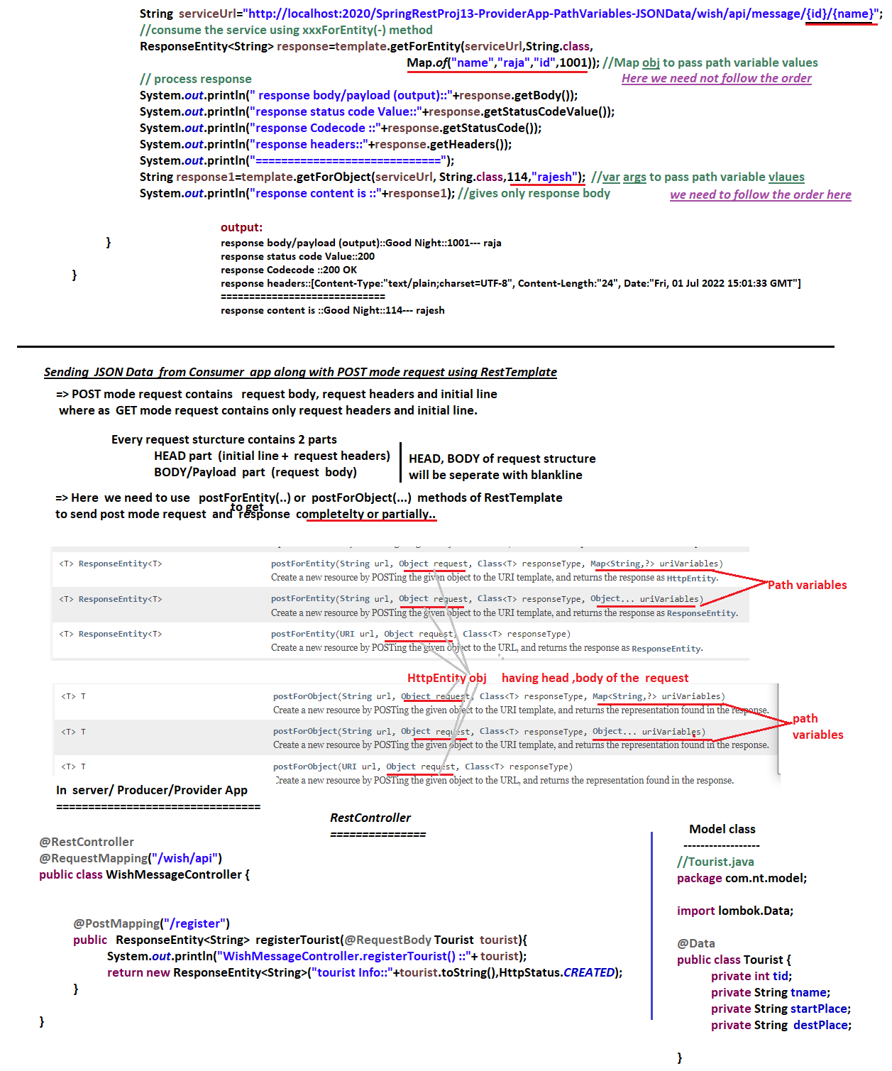

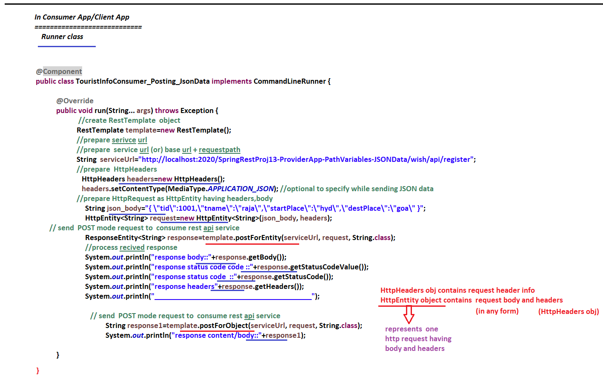

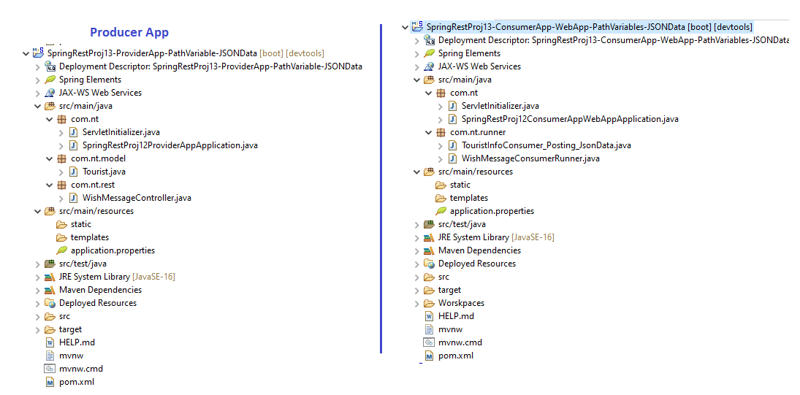

# NTSPBMS615- Rest Consumer using RestTemplate-July 2nd-2022-exchange(-) method

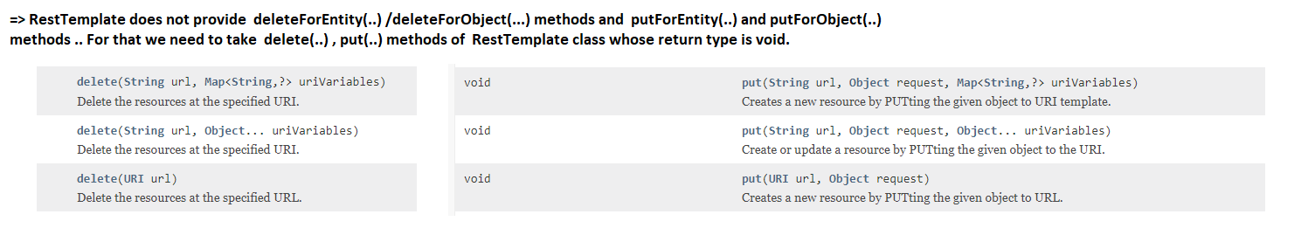

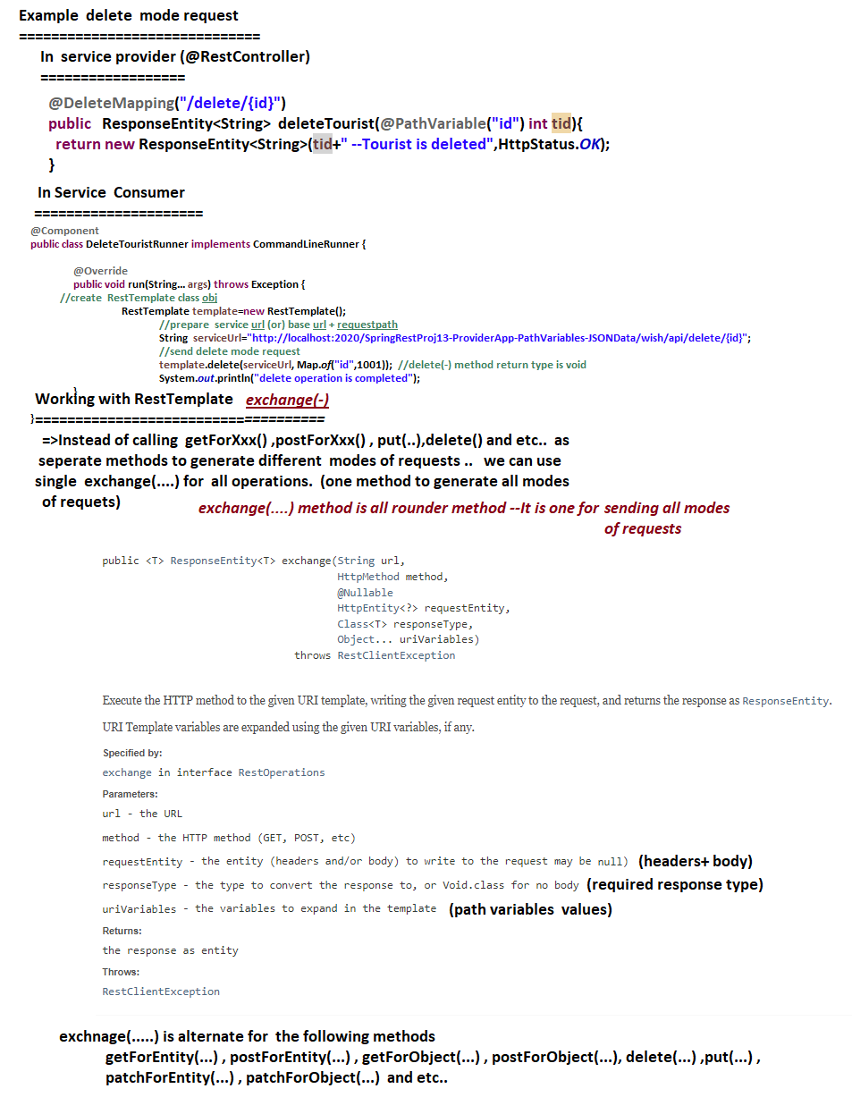

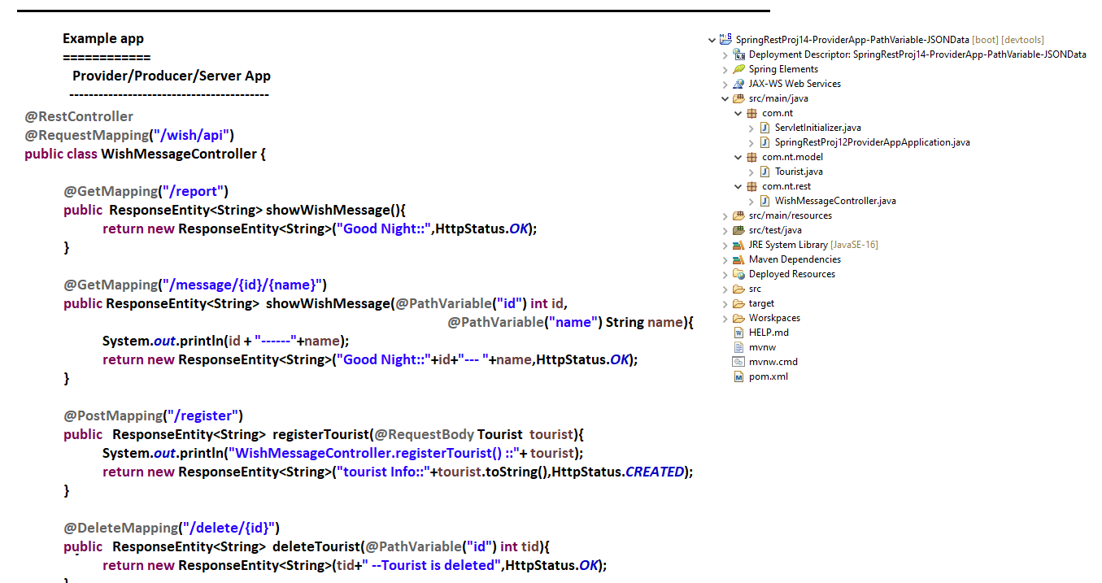

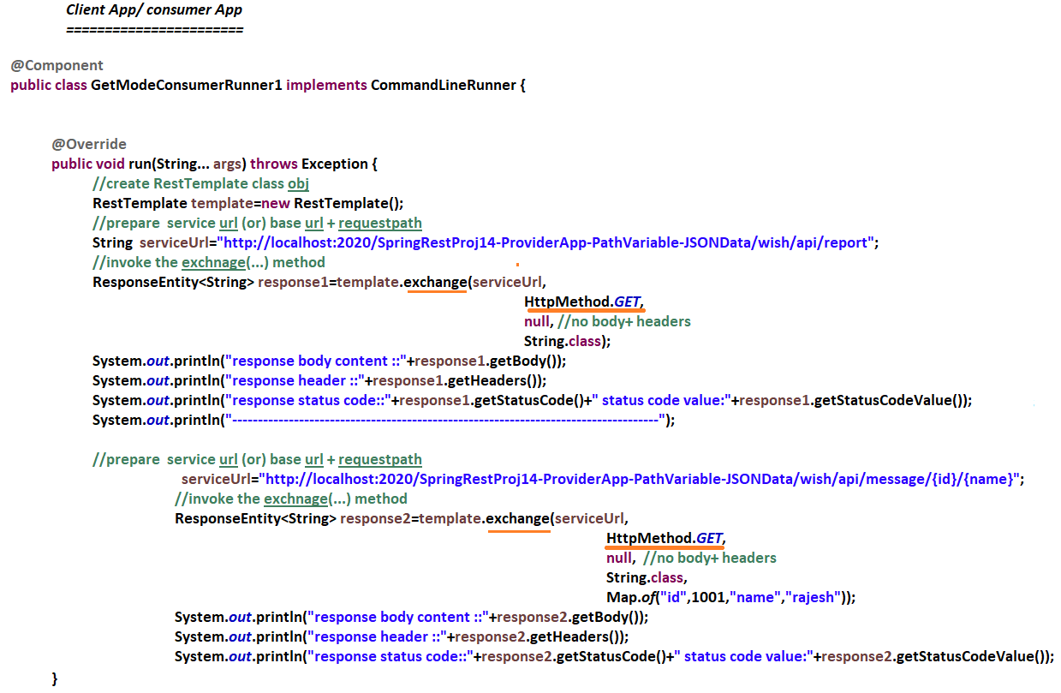

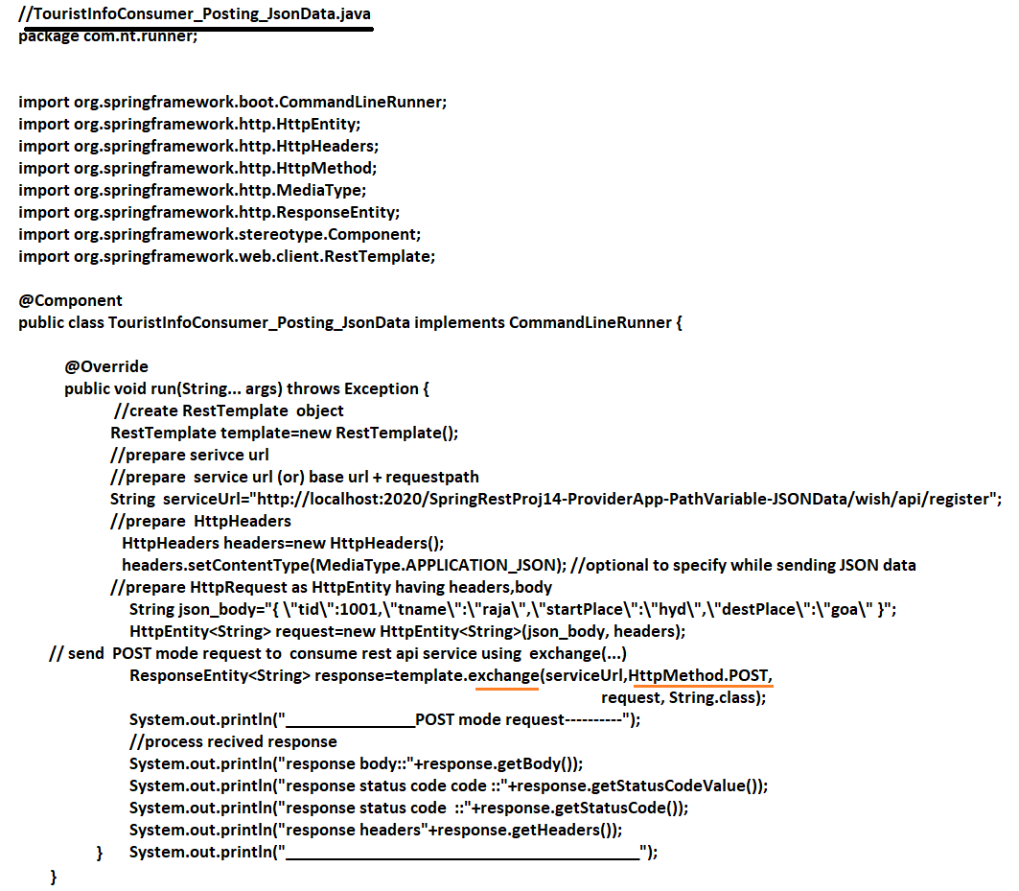

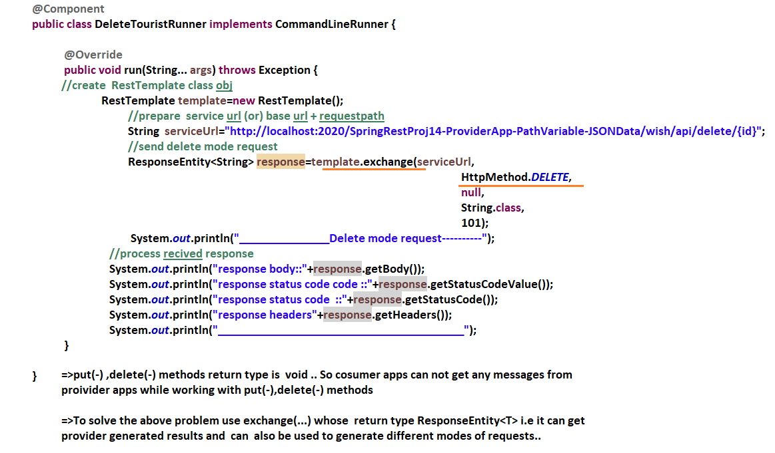

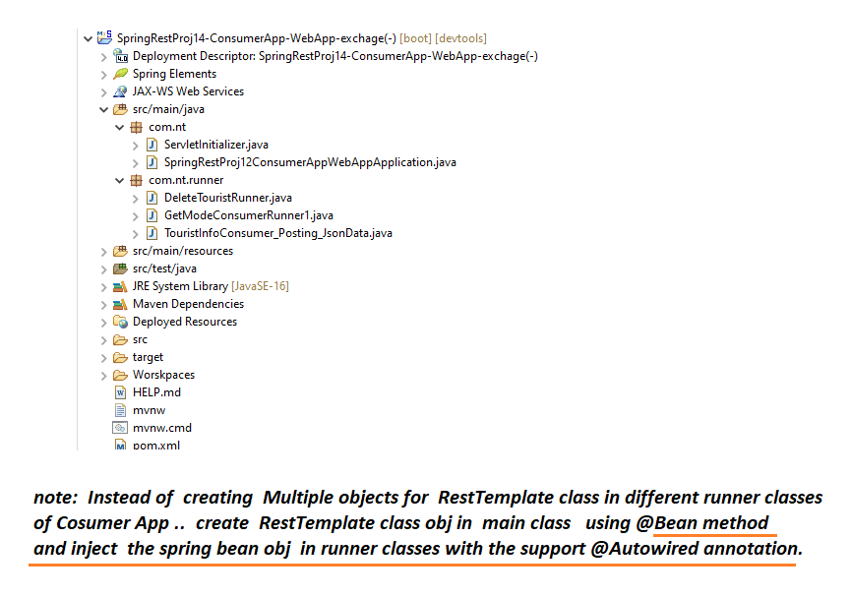

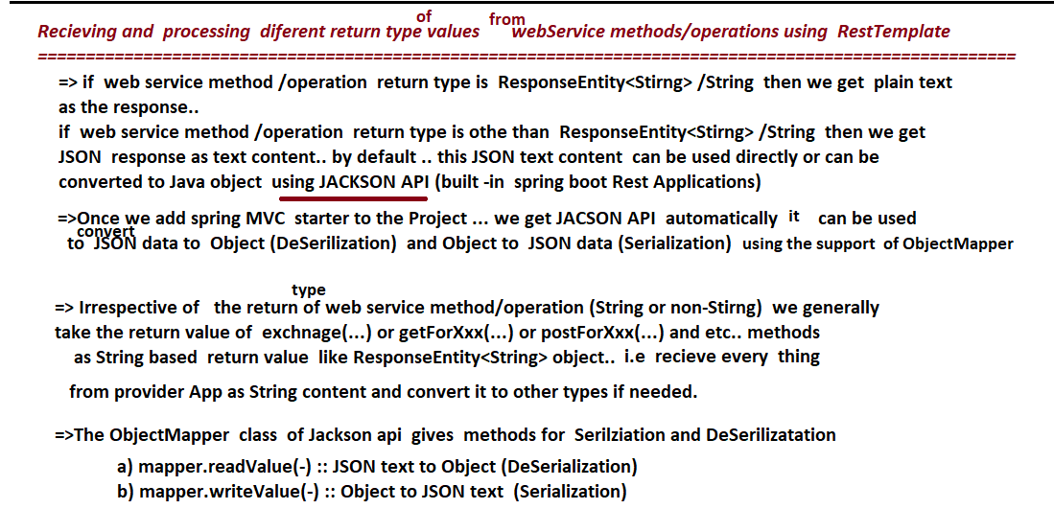

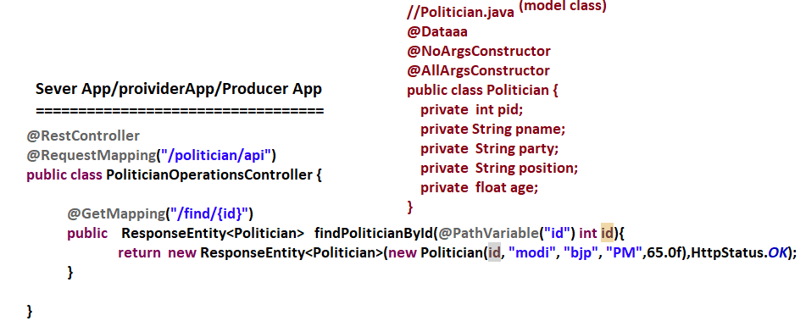

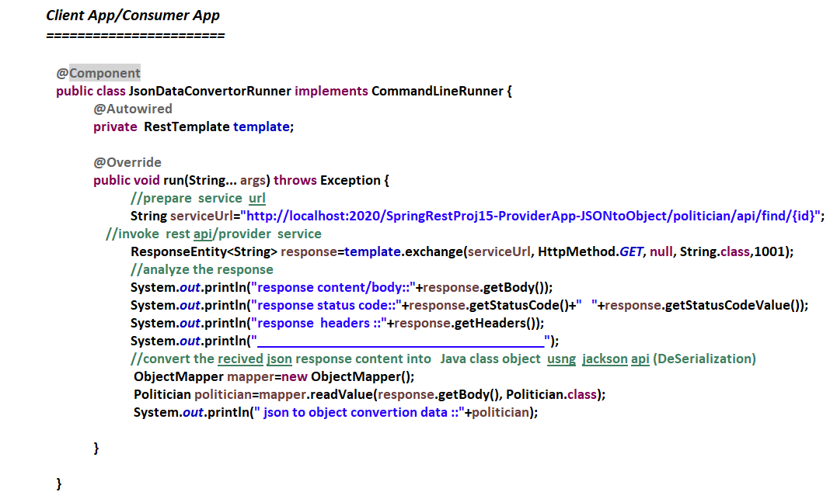

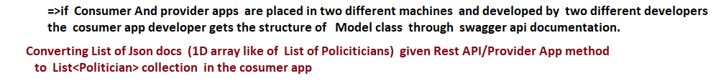

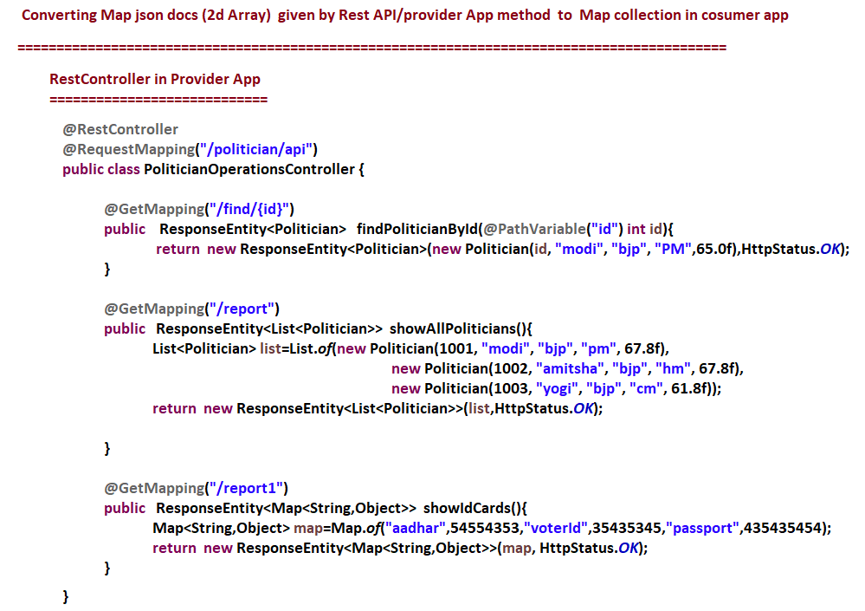

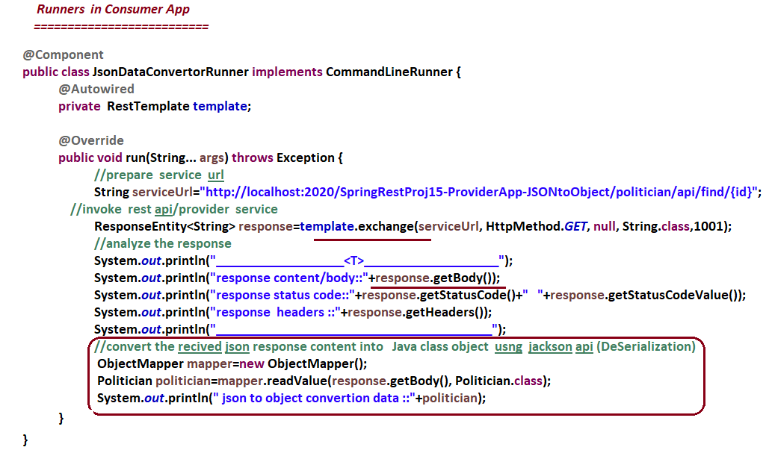

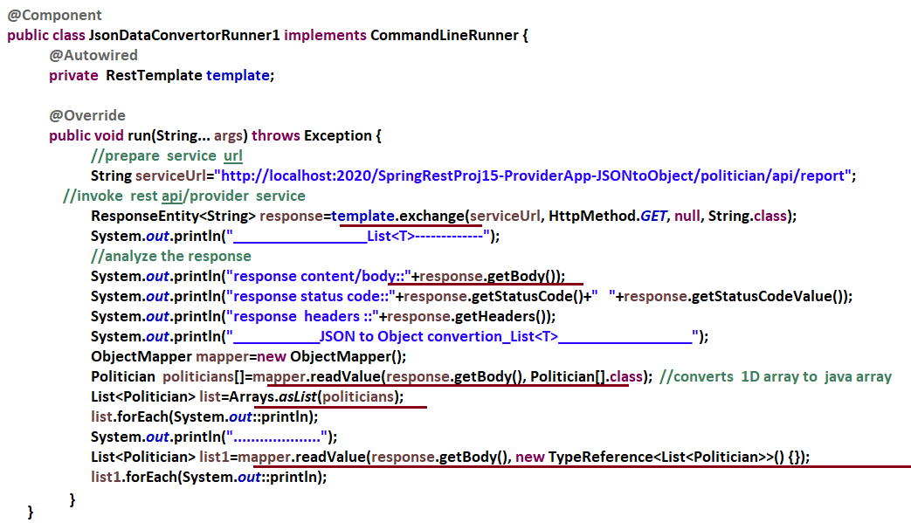

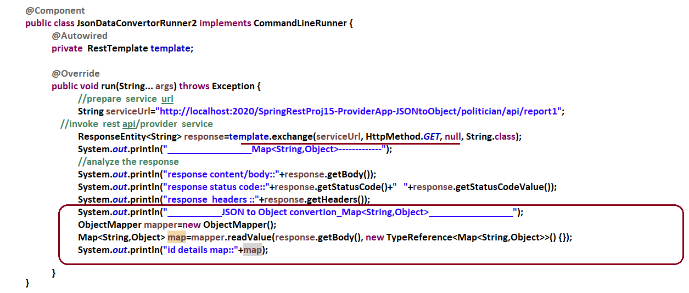

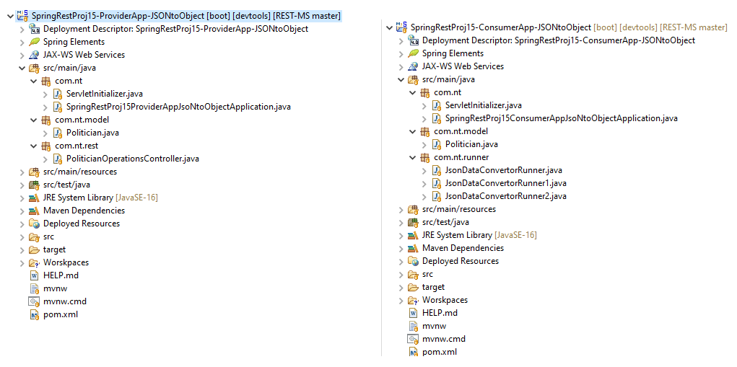

# NTSPBMS615- july 4th-Spring MVC and spring Rest Comminication

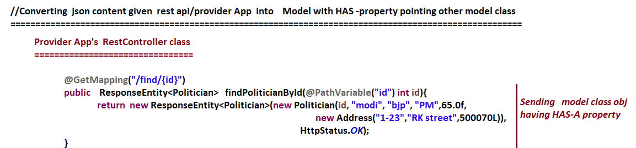

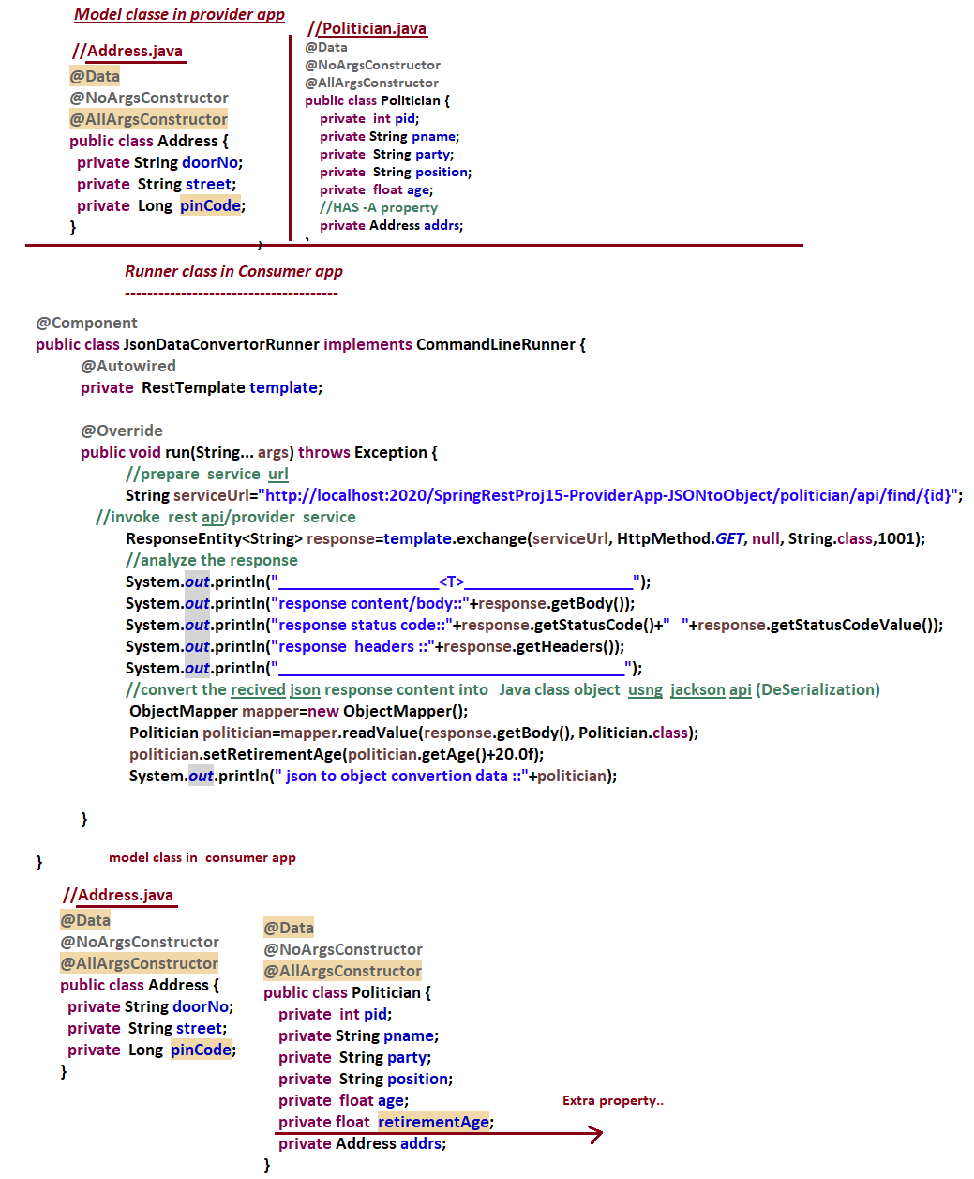

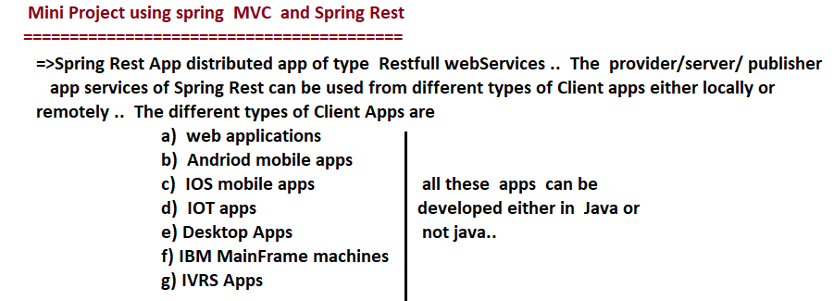

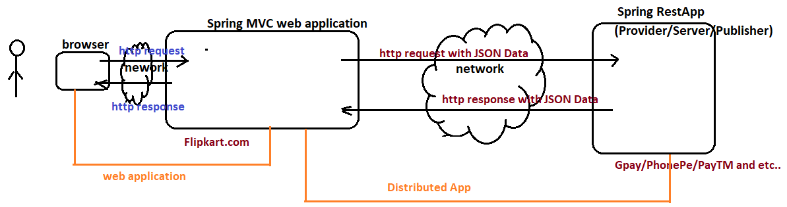

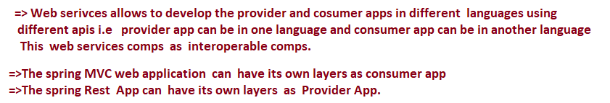

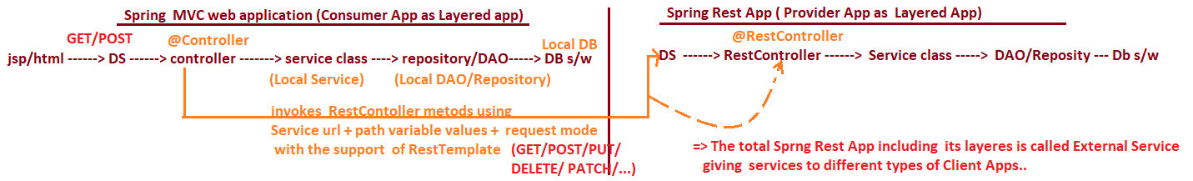

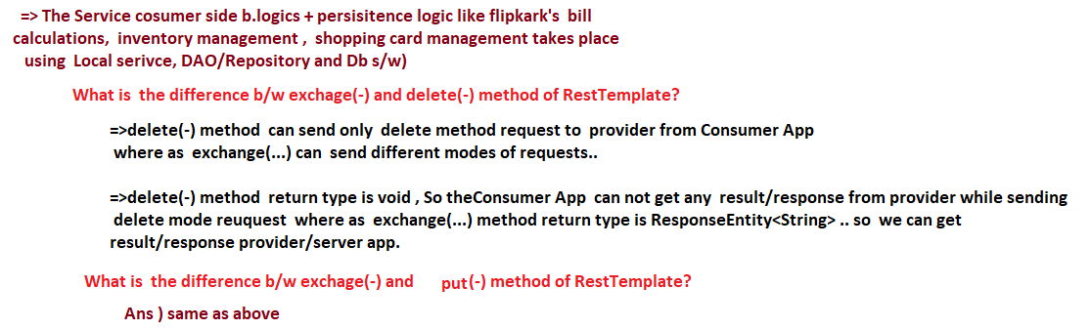

# NTSPBMS615- july 9th-Spring MVC and spring Rest Comminication

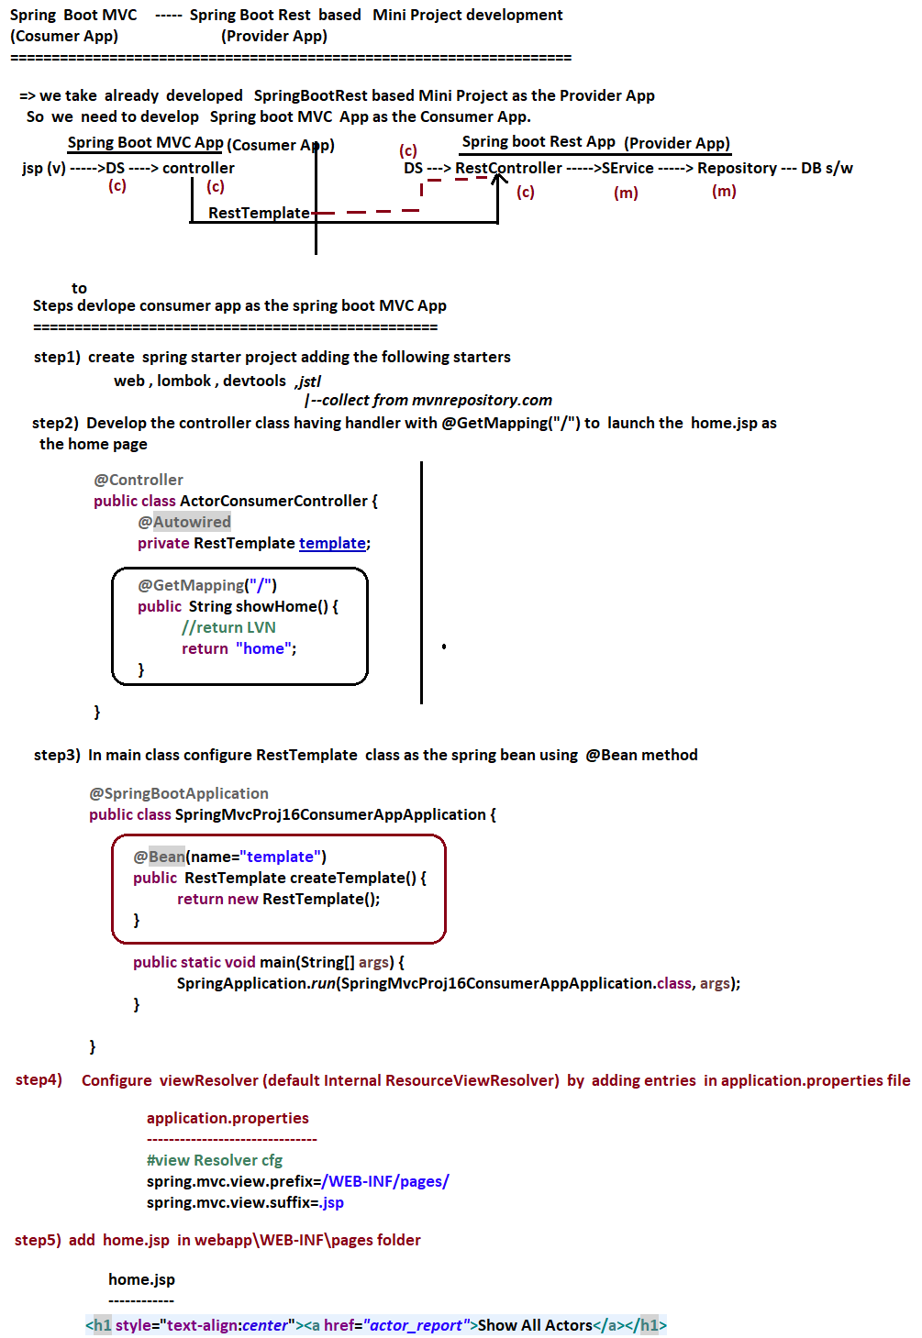



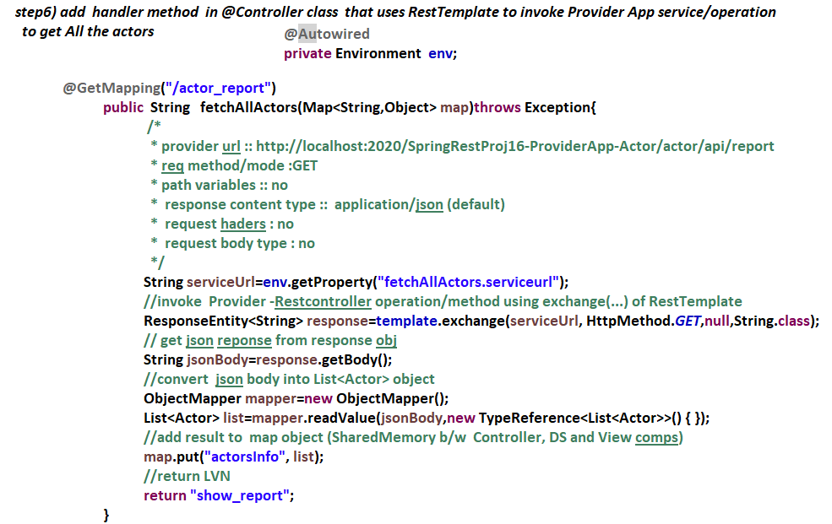

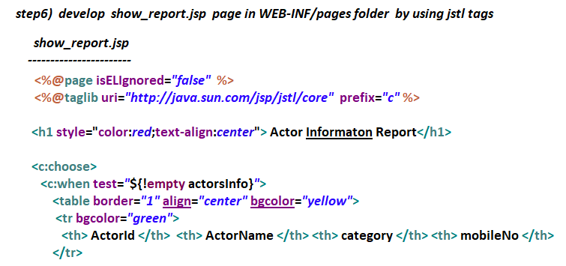

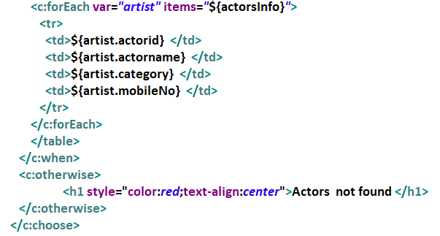



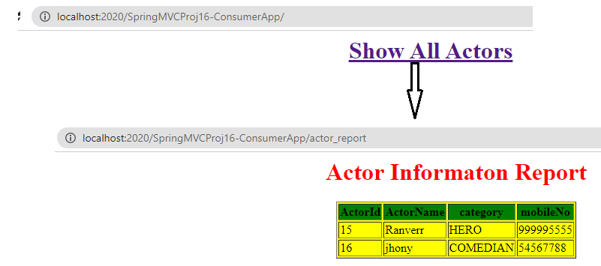

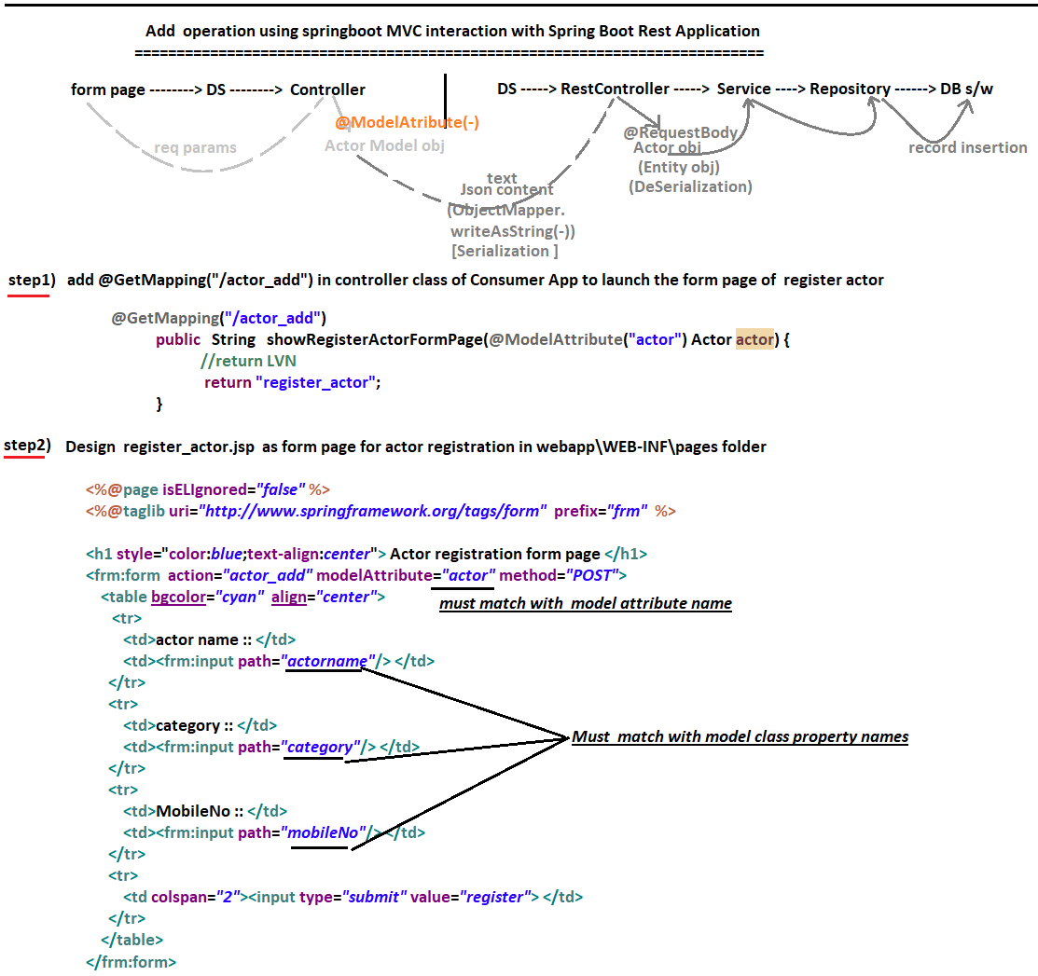

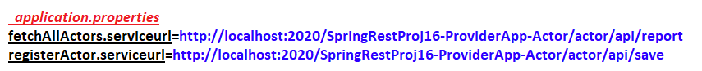

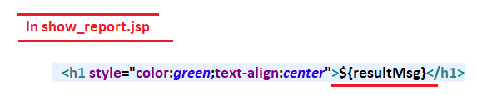

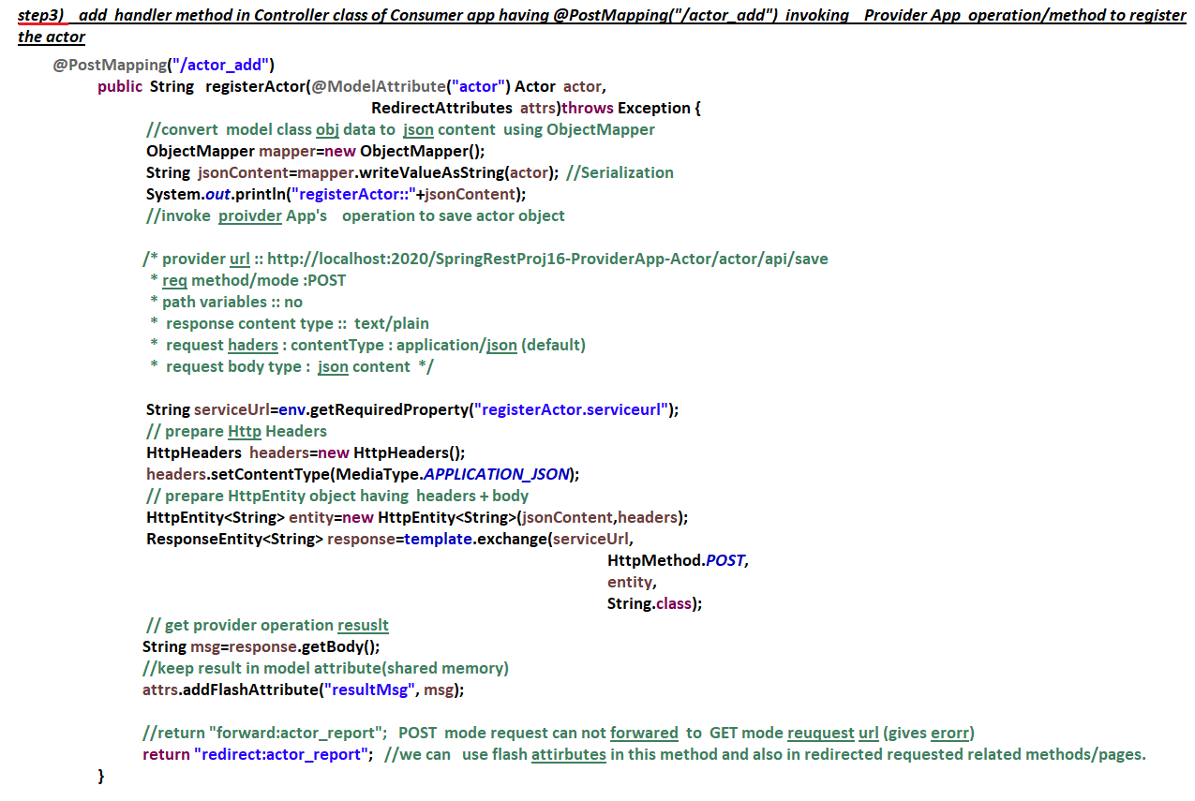

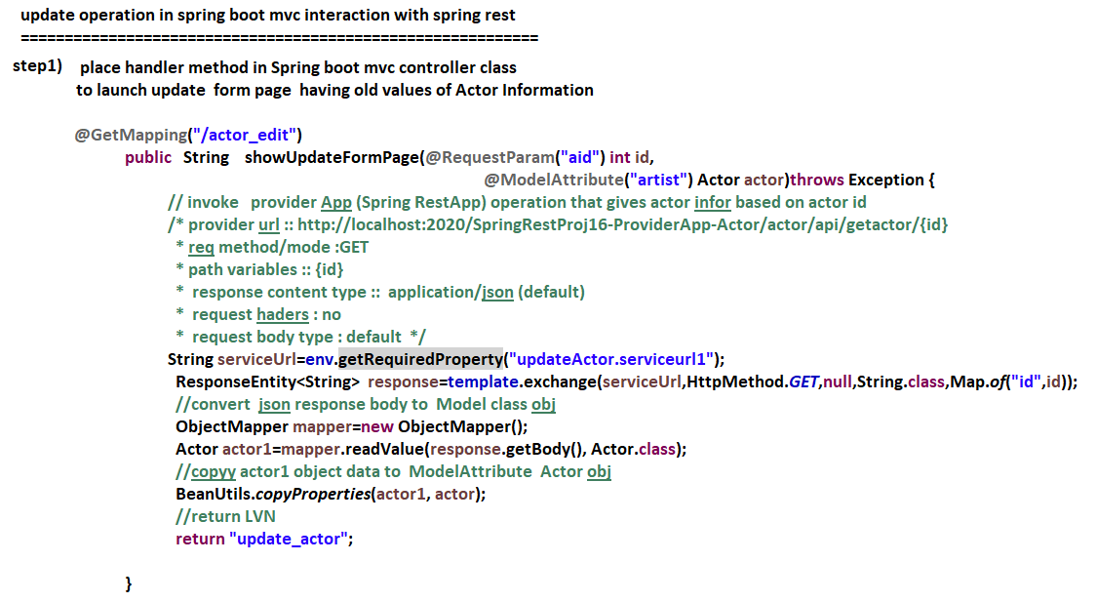

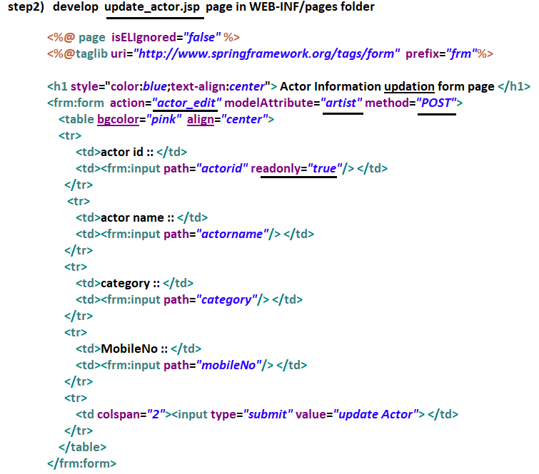

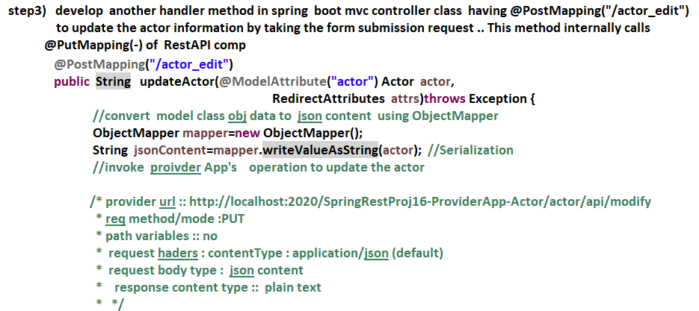

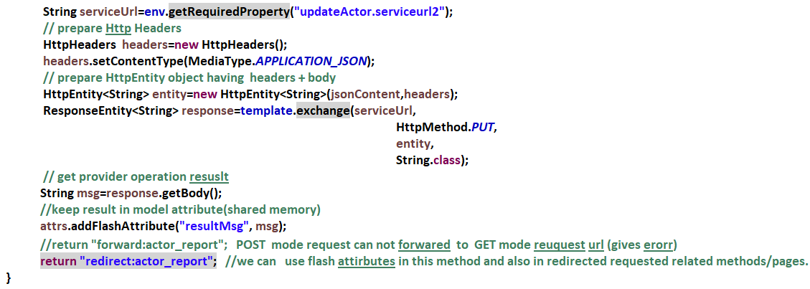

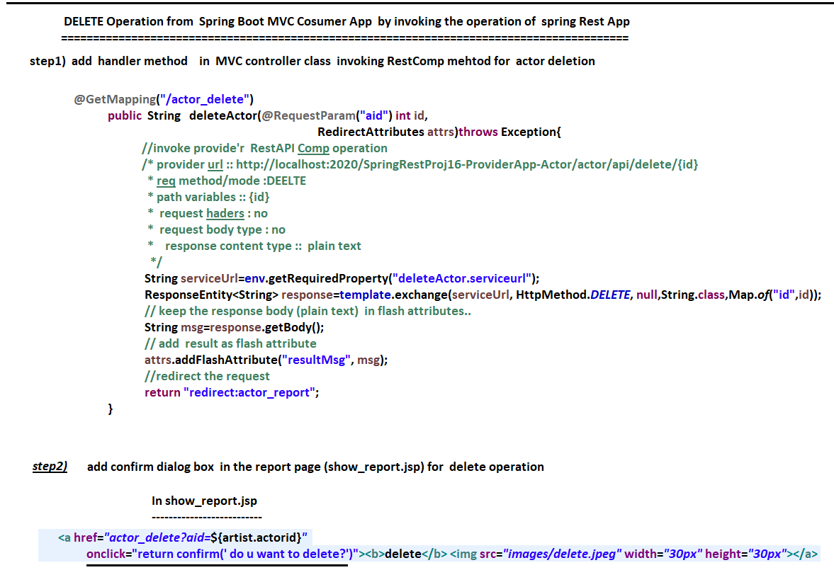

**Spring Cloud**

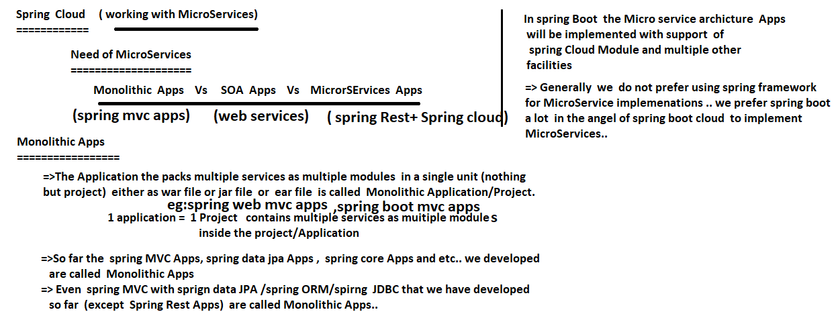

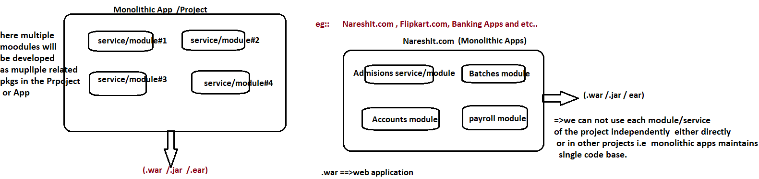

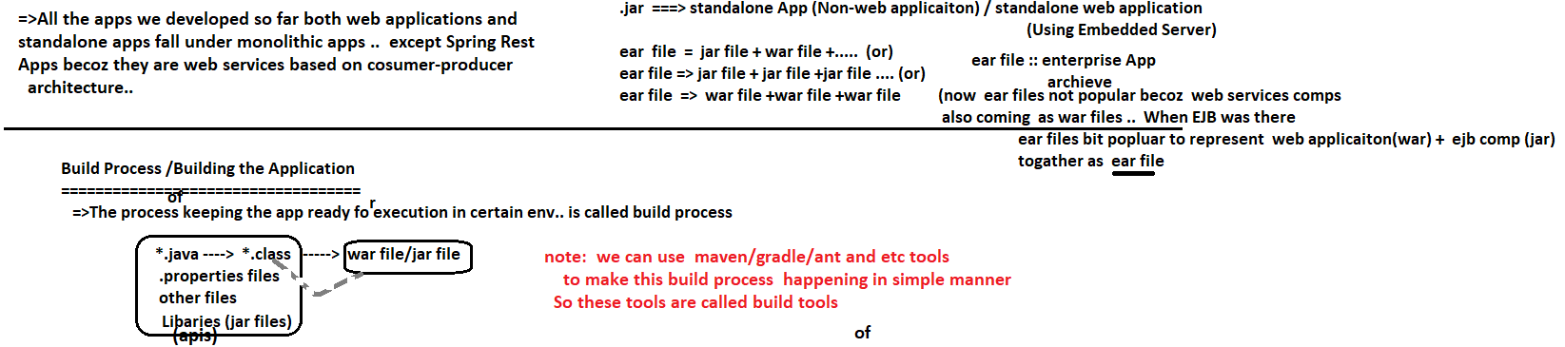



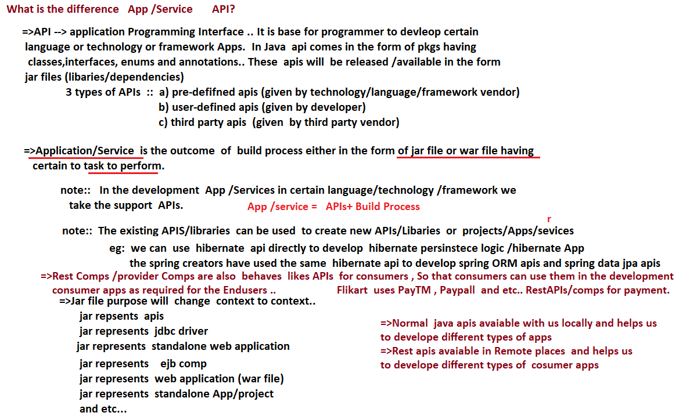

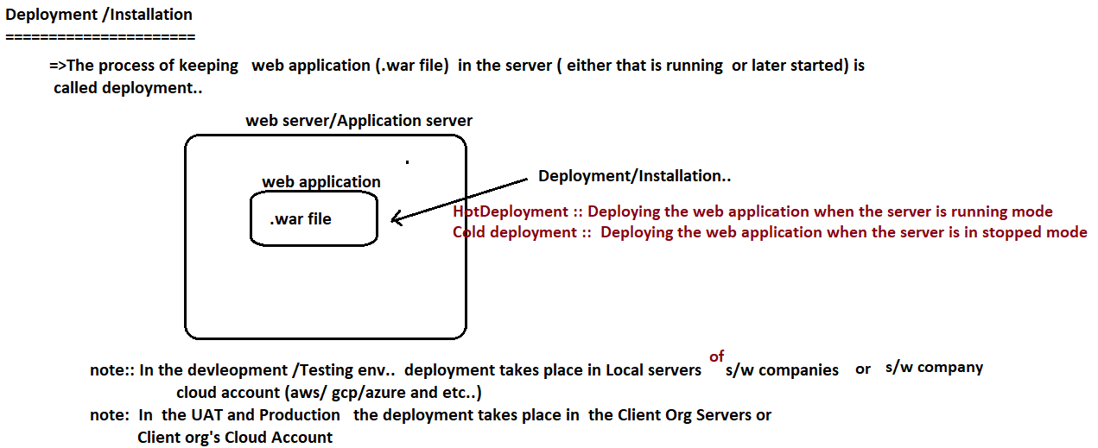

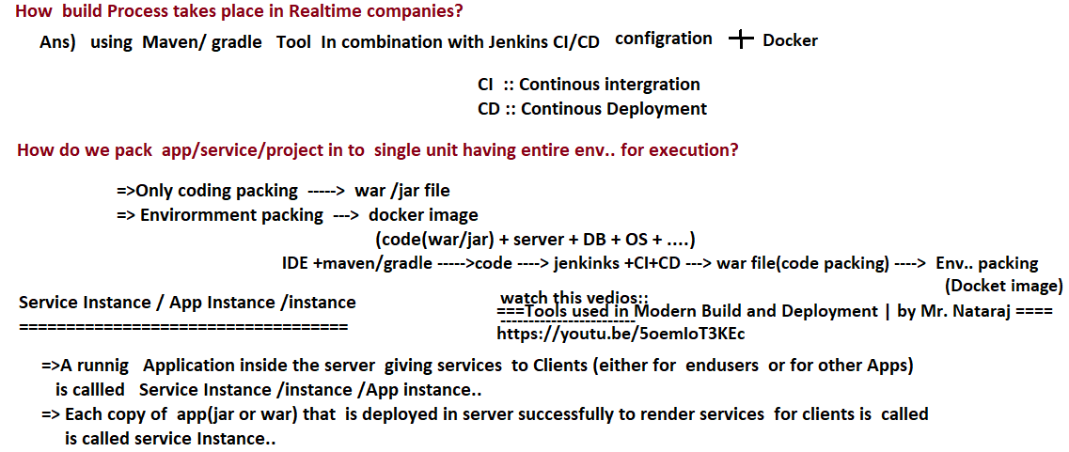

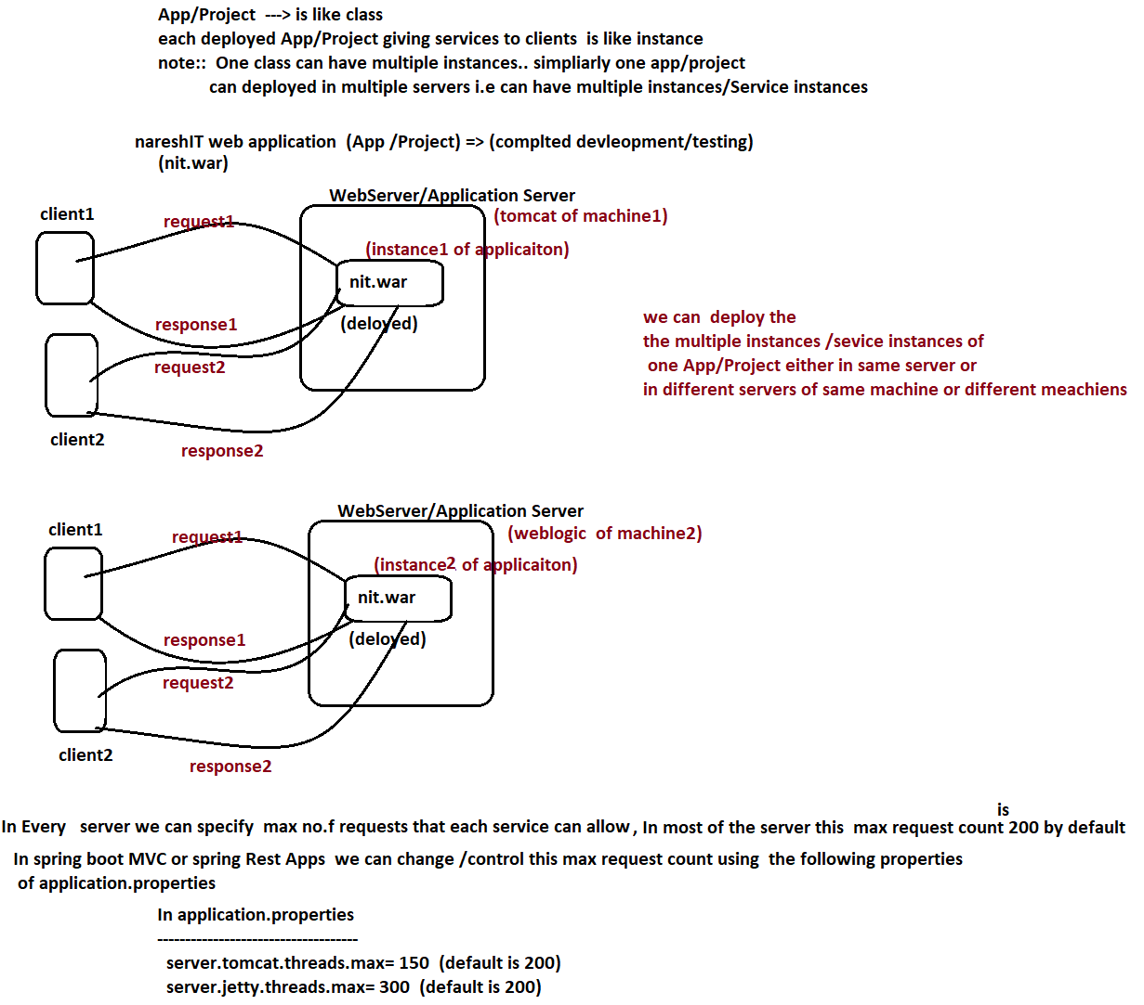

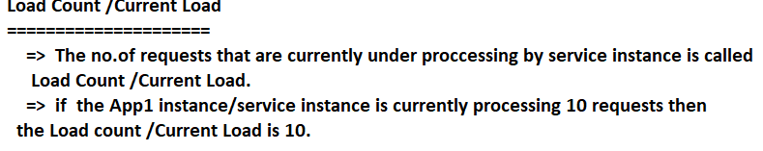

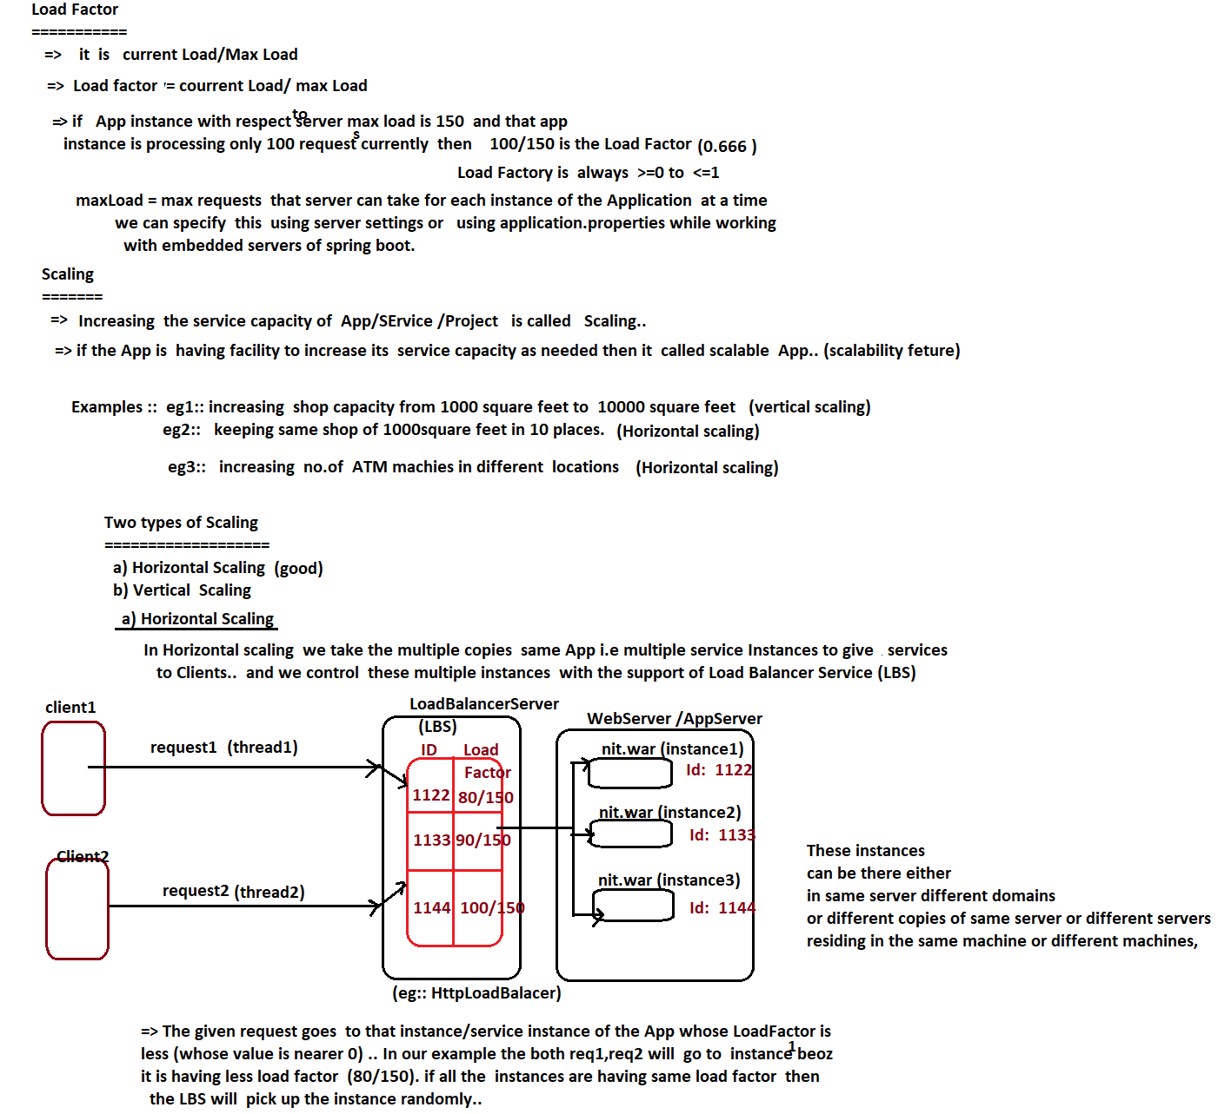

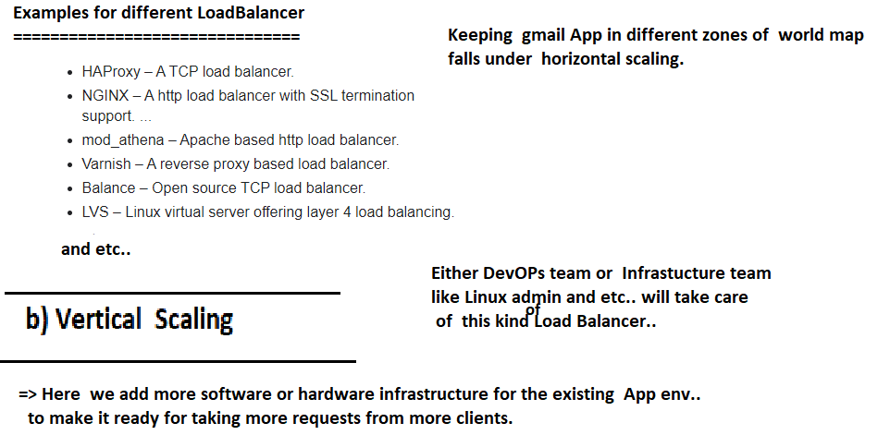

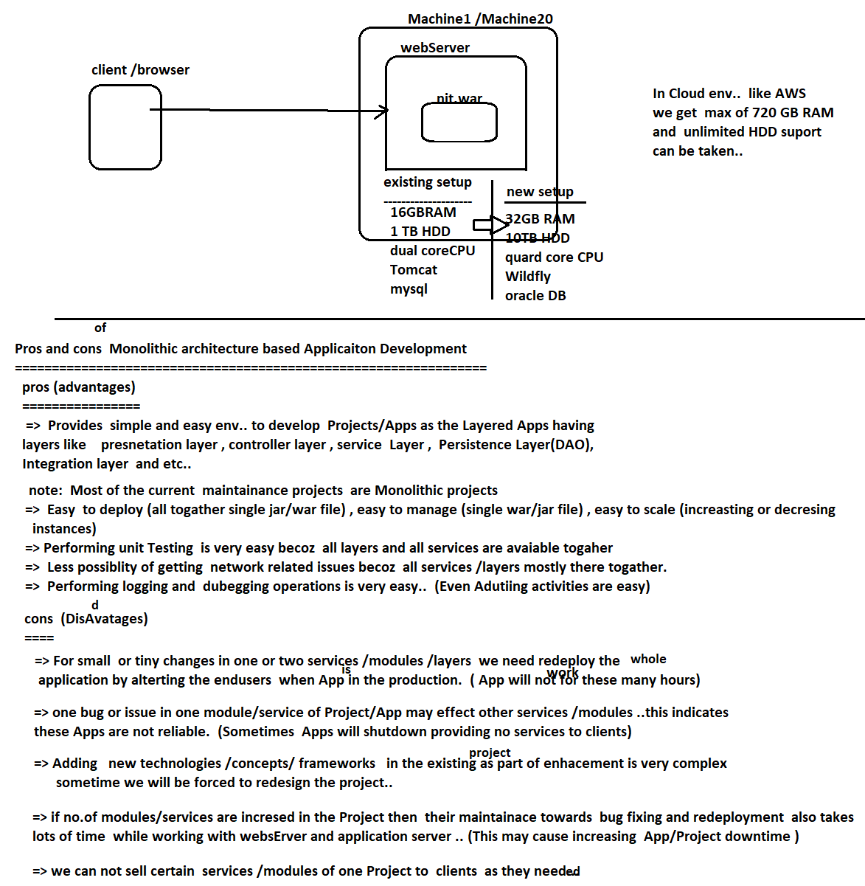

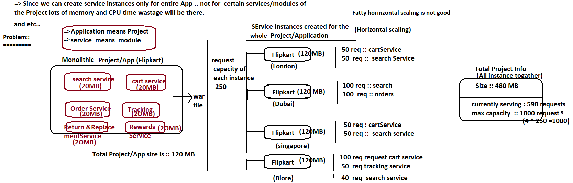

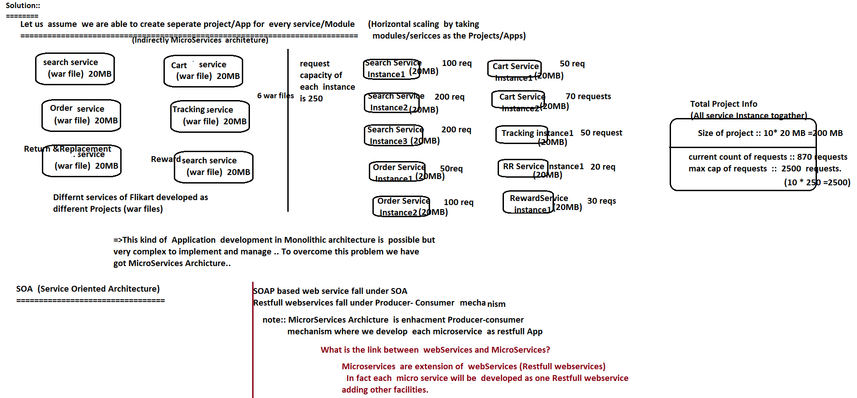

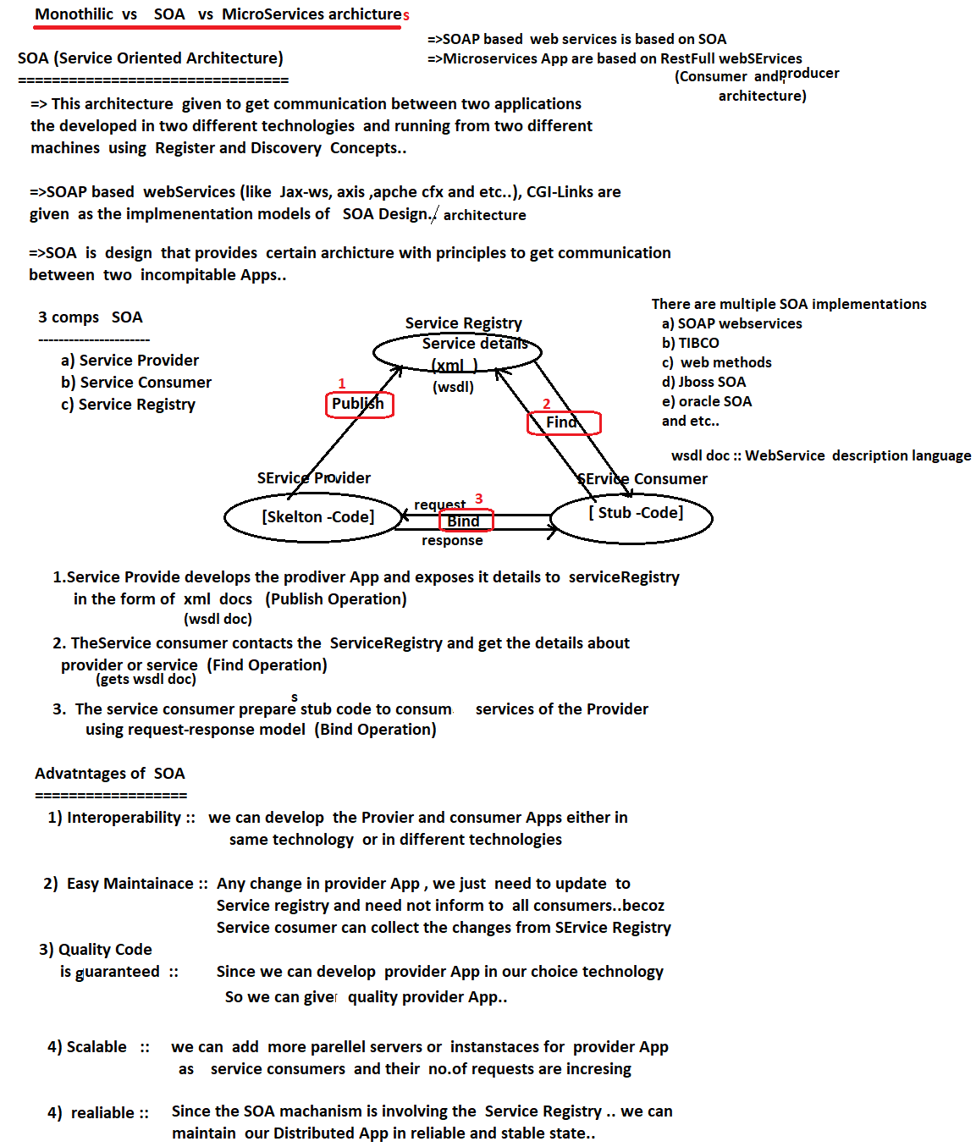

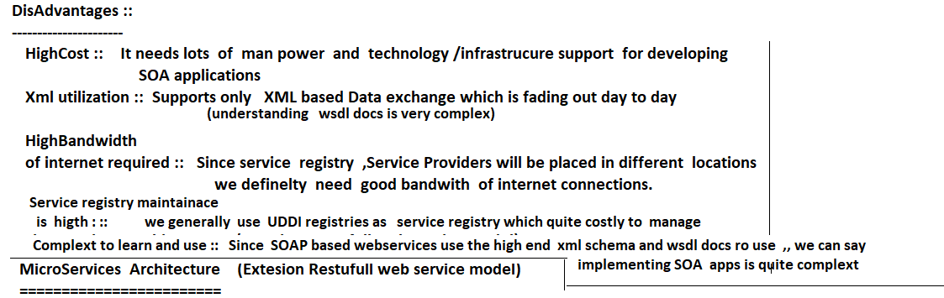



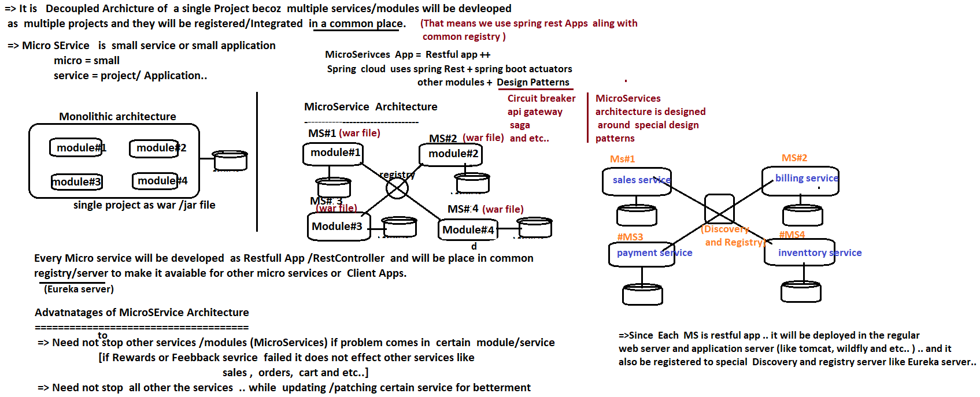

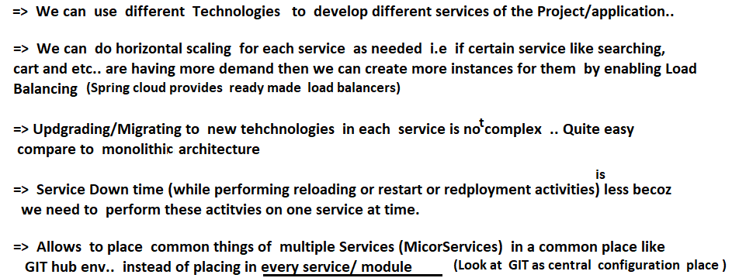



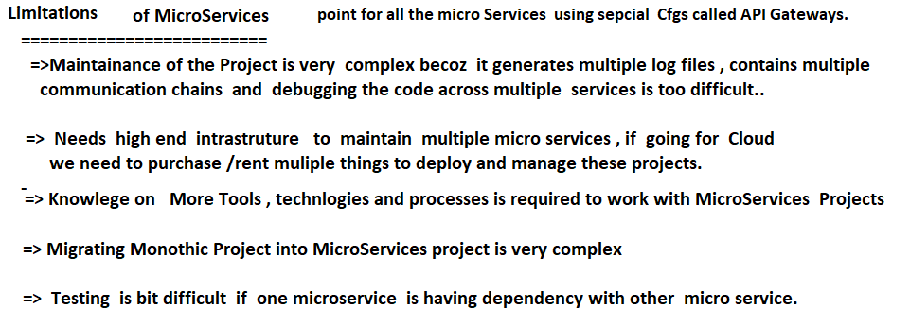



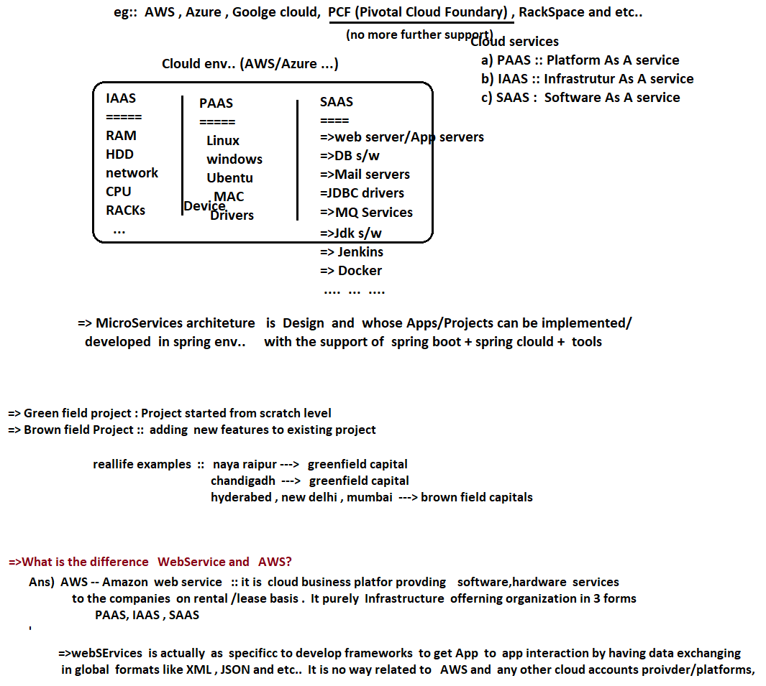

# NTSPBMS615- July 16th-2022- Spring Cloud-MicroServiceARchitecture

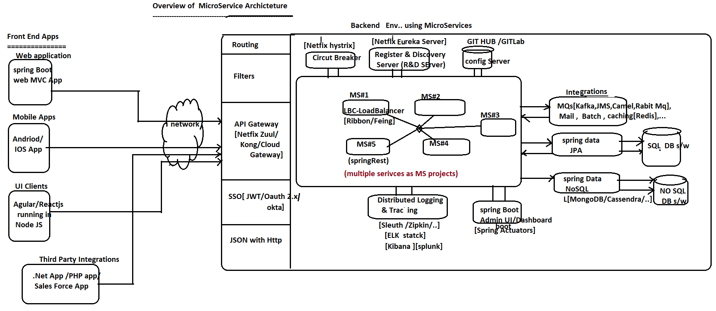

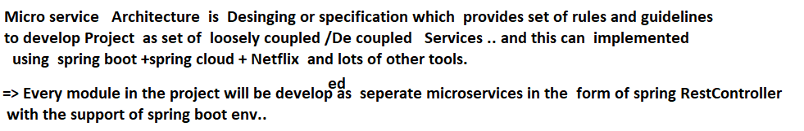

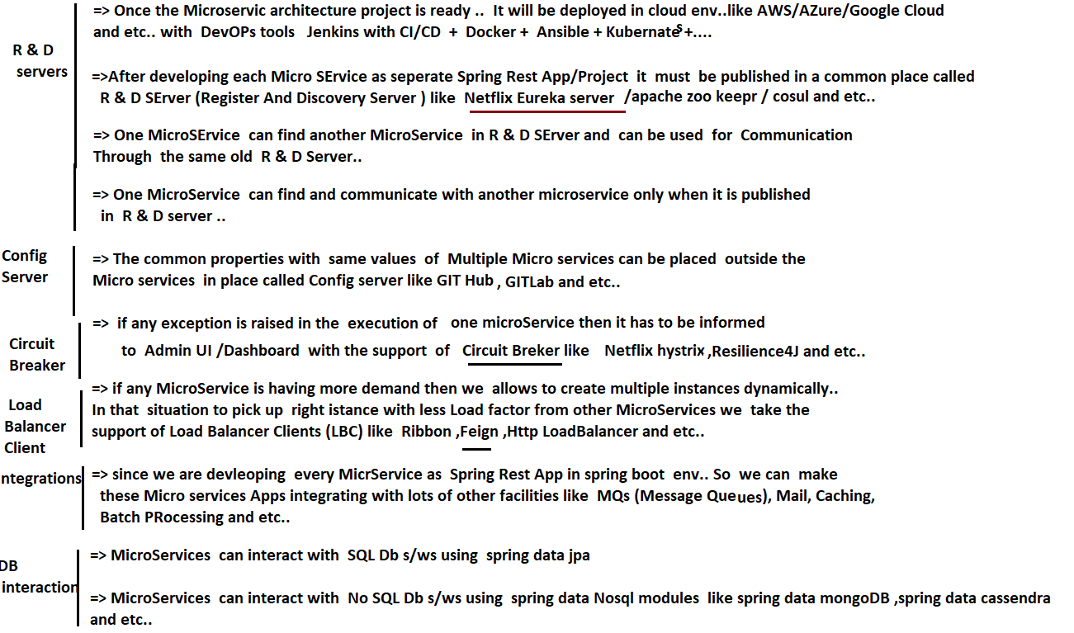

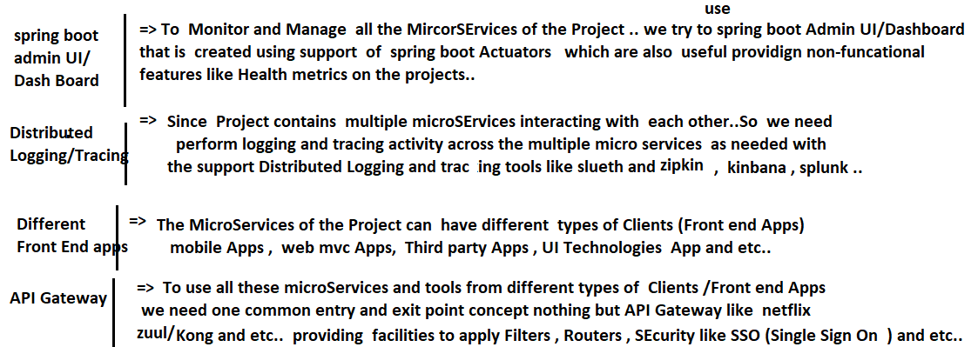

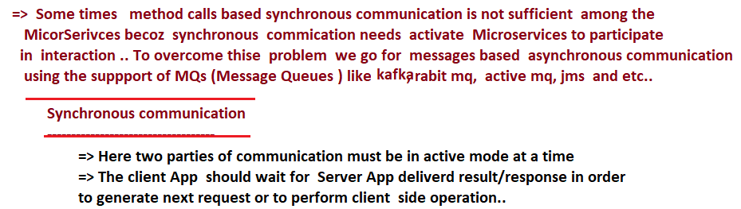

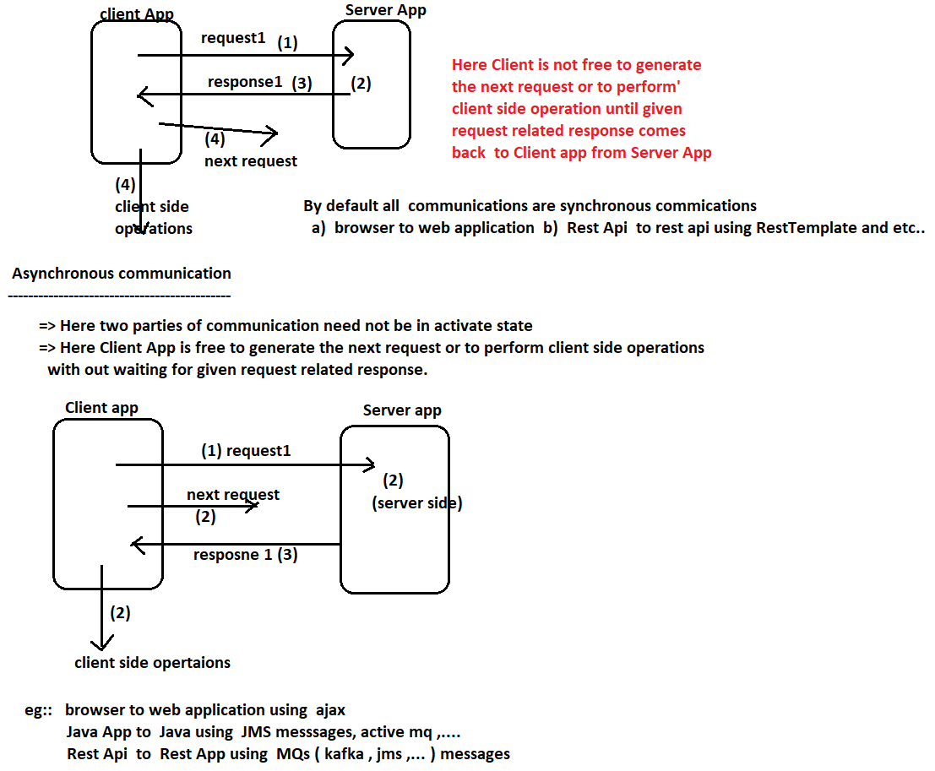

# NTSPBMS615- July 18th-2022- Spring Cloud-Eureka server

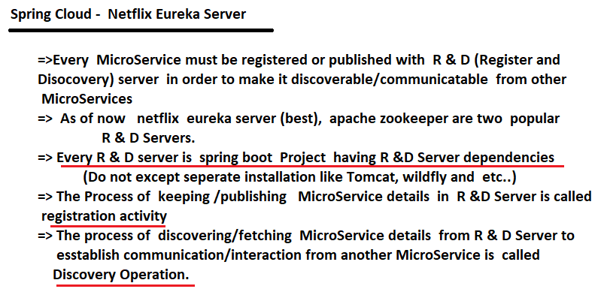



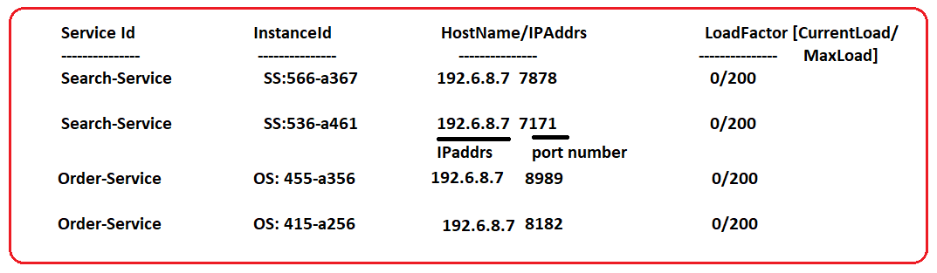



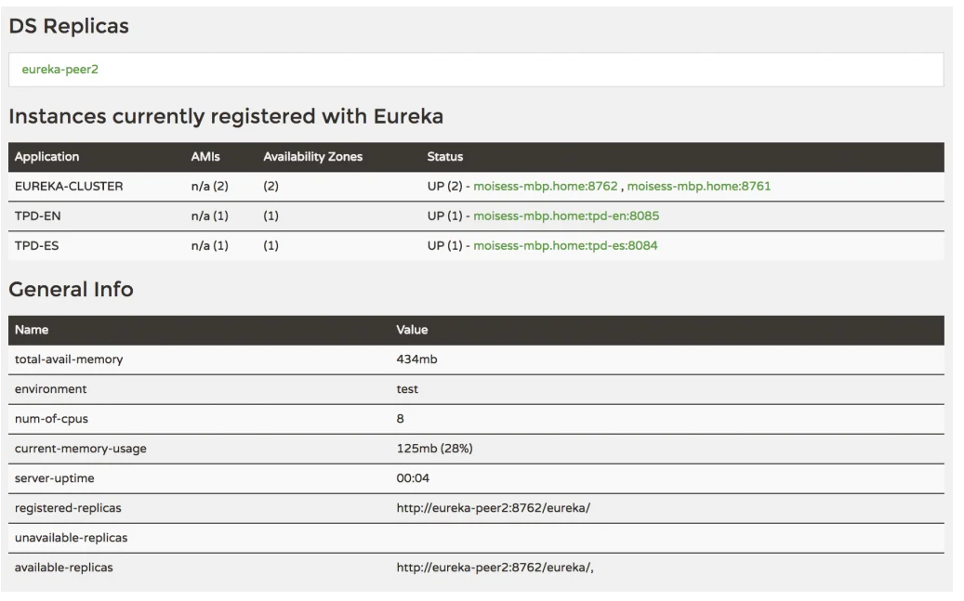

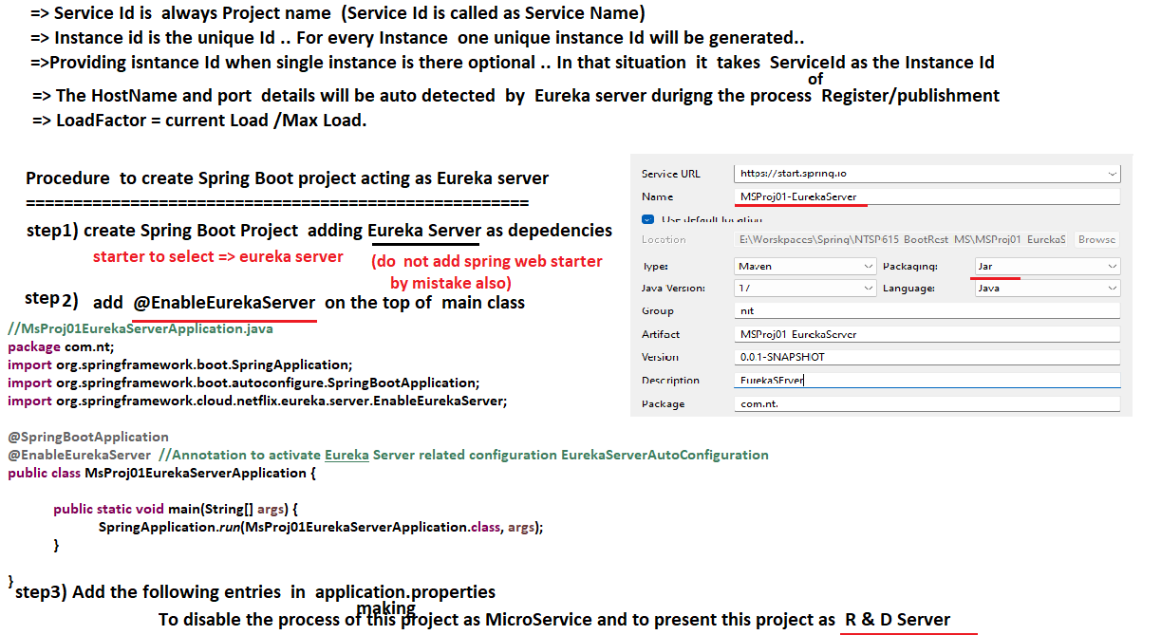

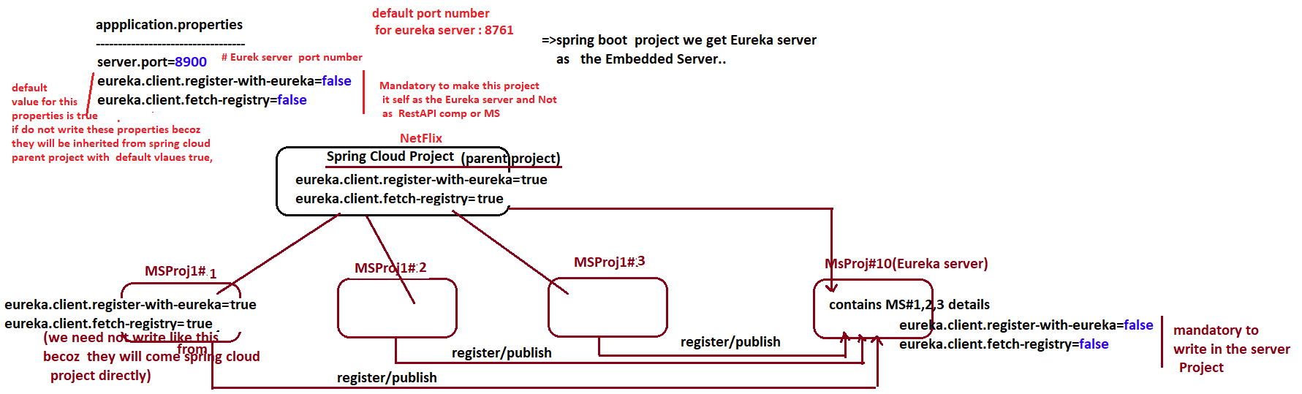

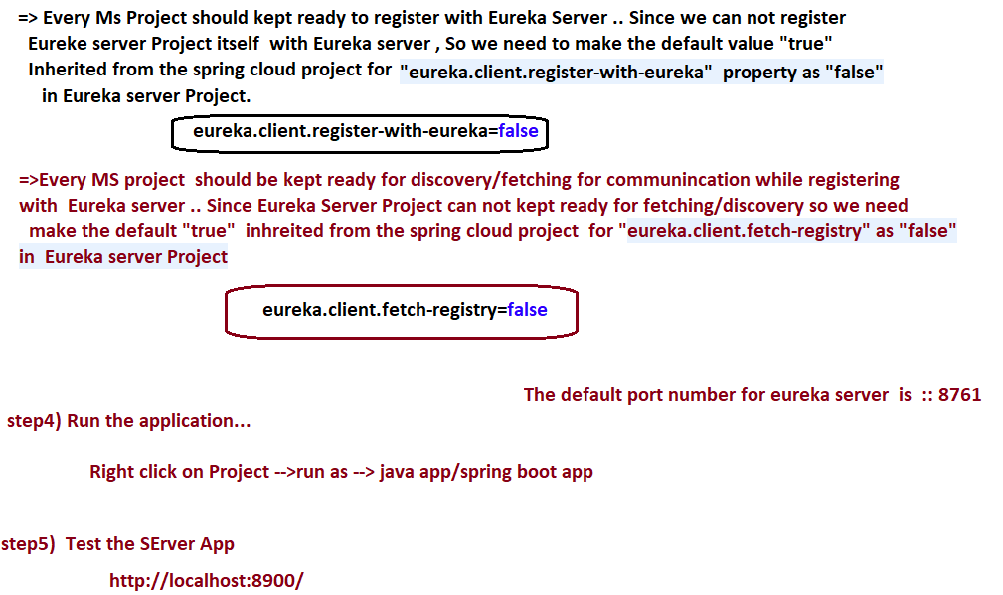

# NTSPBMS615- July 19th-2022- publishing MSProject to EurekaServer

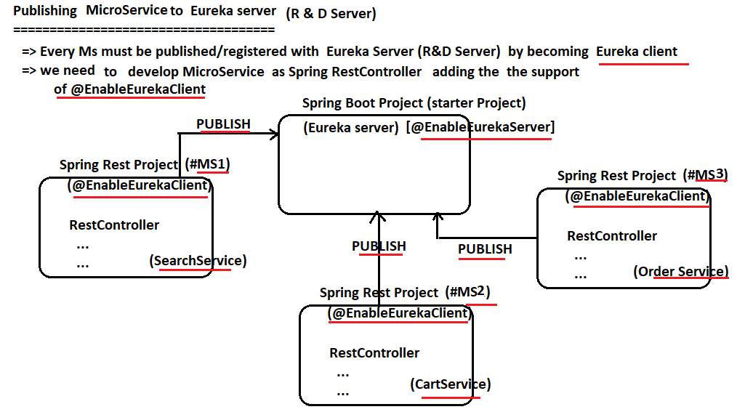

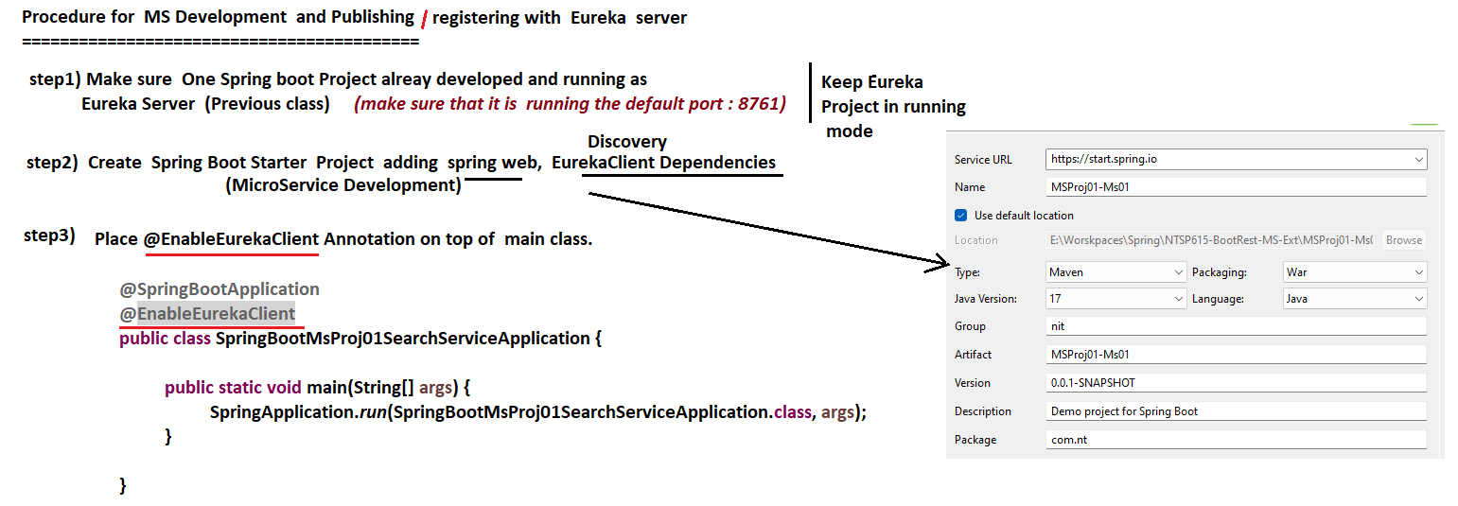

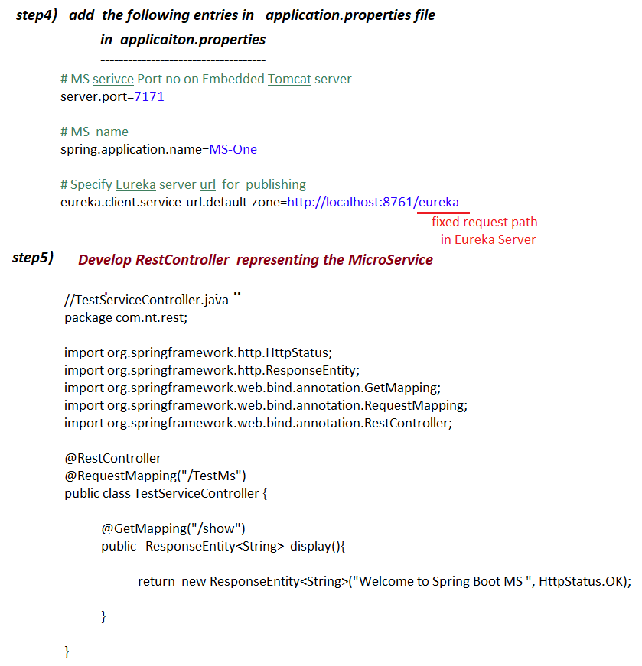

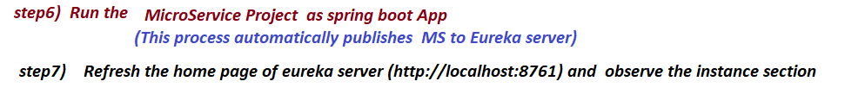

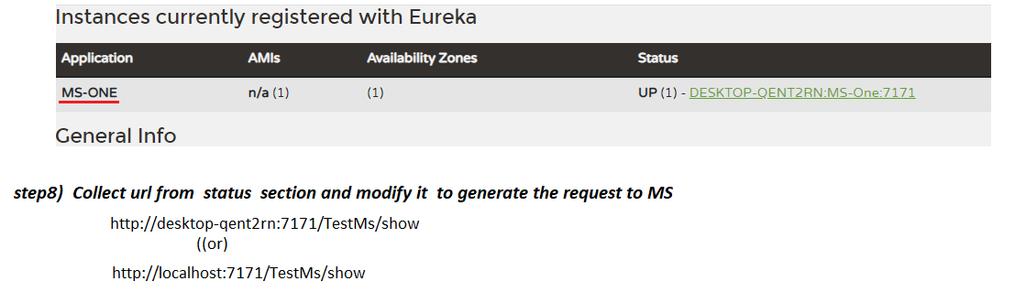

# NTSPBMS615- July 20th-2022- Inter Communication of MS

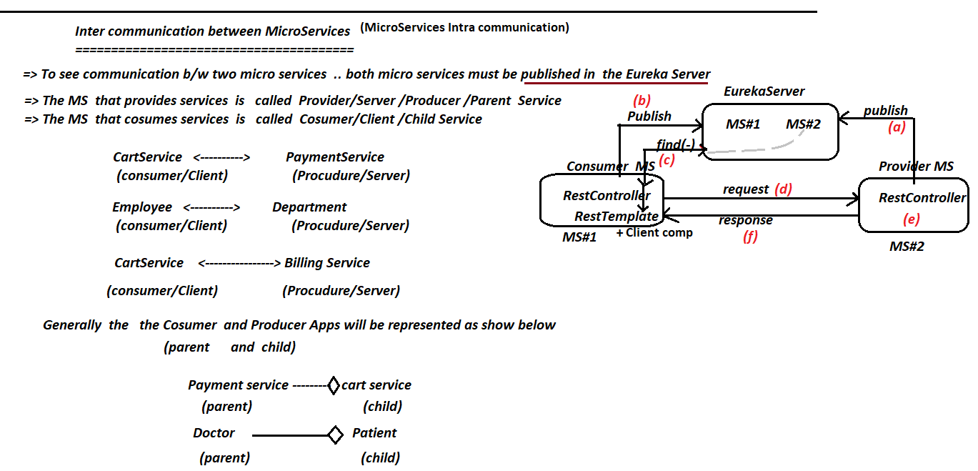

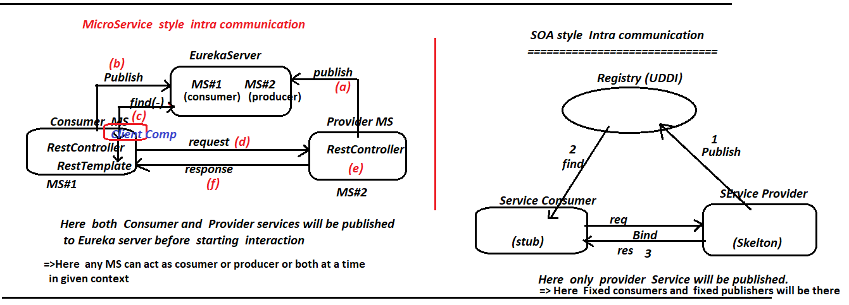

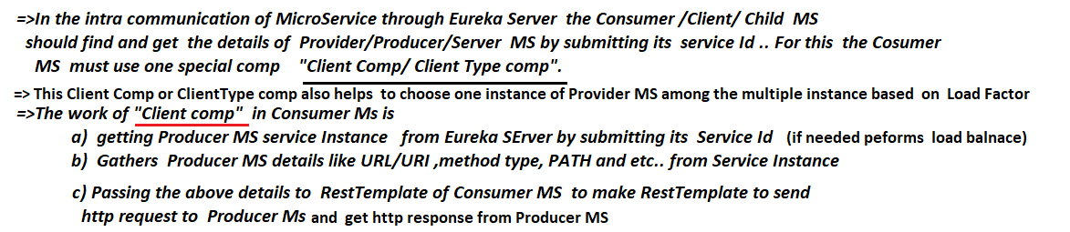

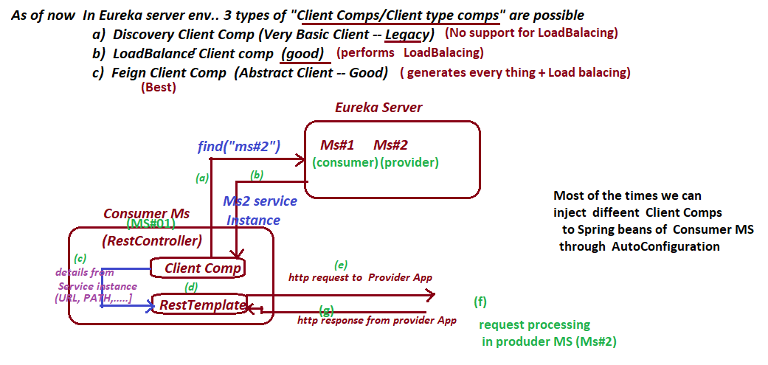

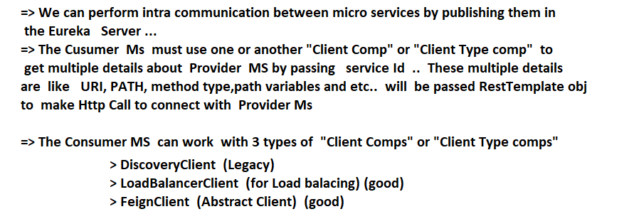

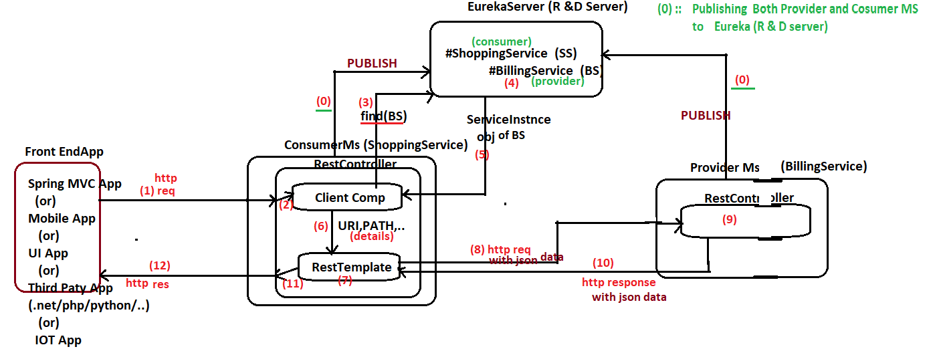

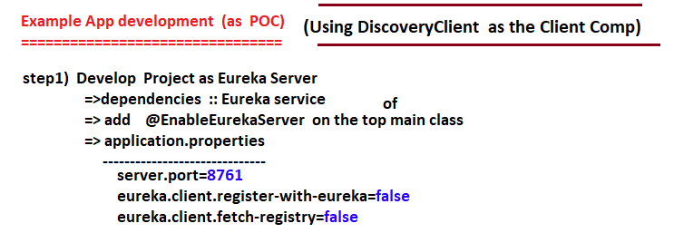

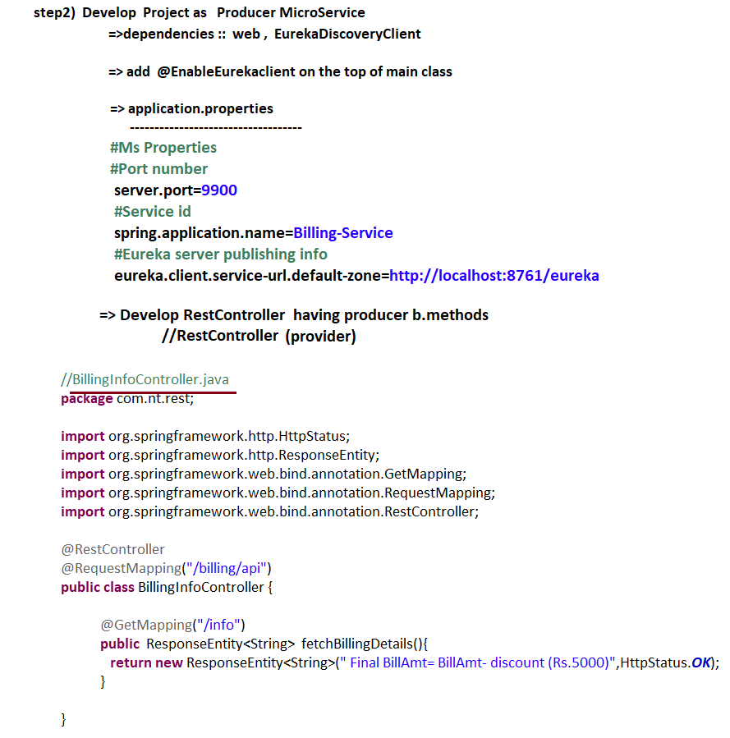

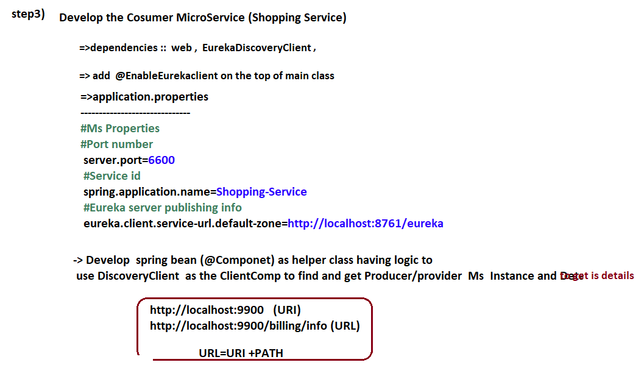

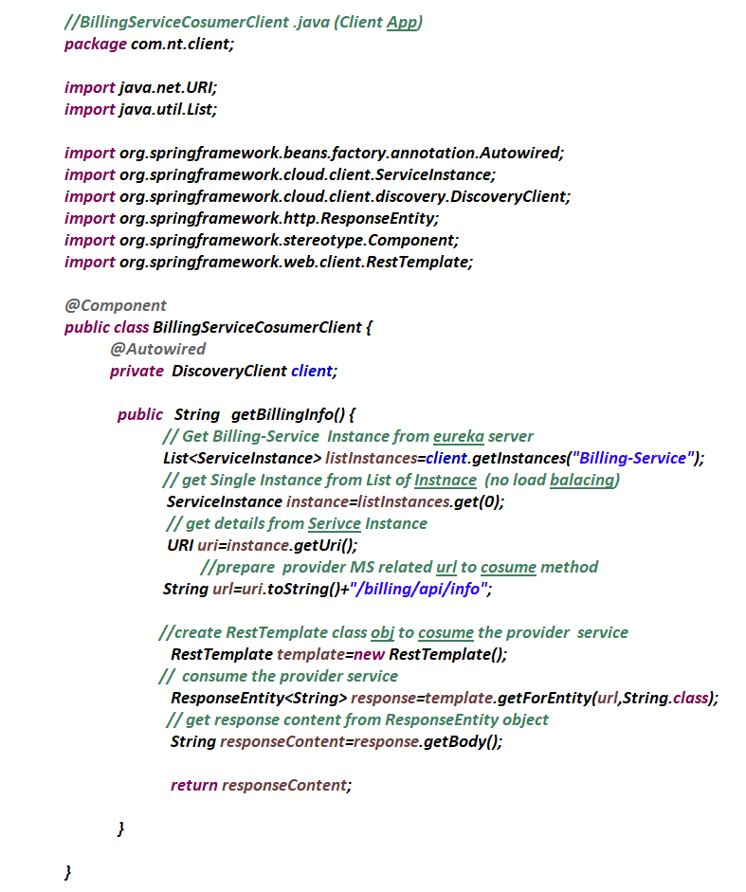

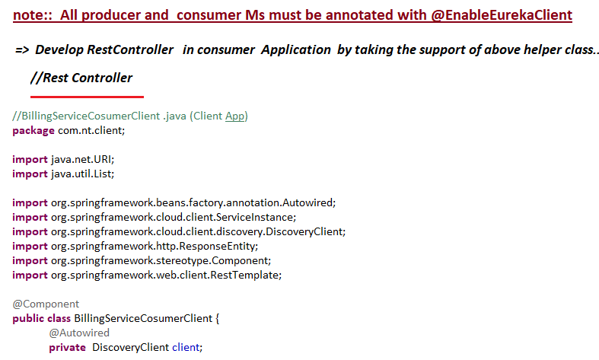

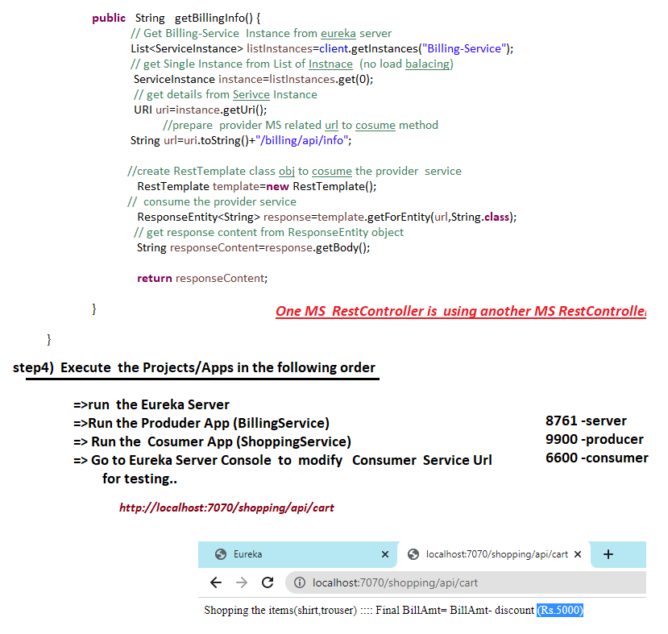

# NTSPBMS615- July 23rd-2022- Intra MS communication using LBC

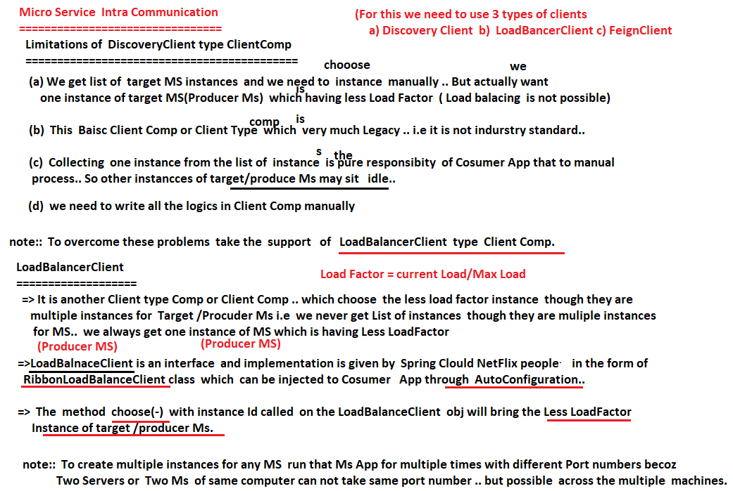

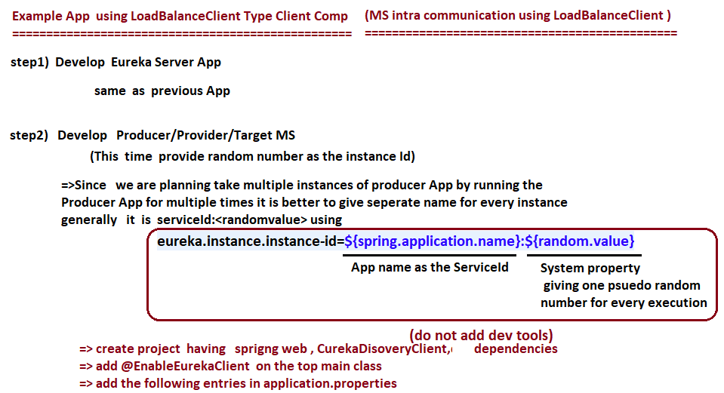

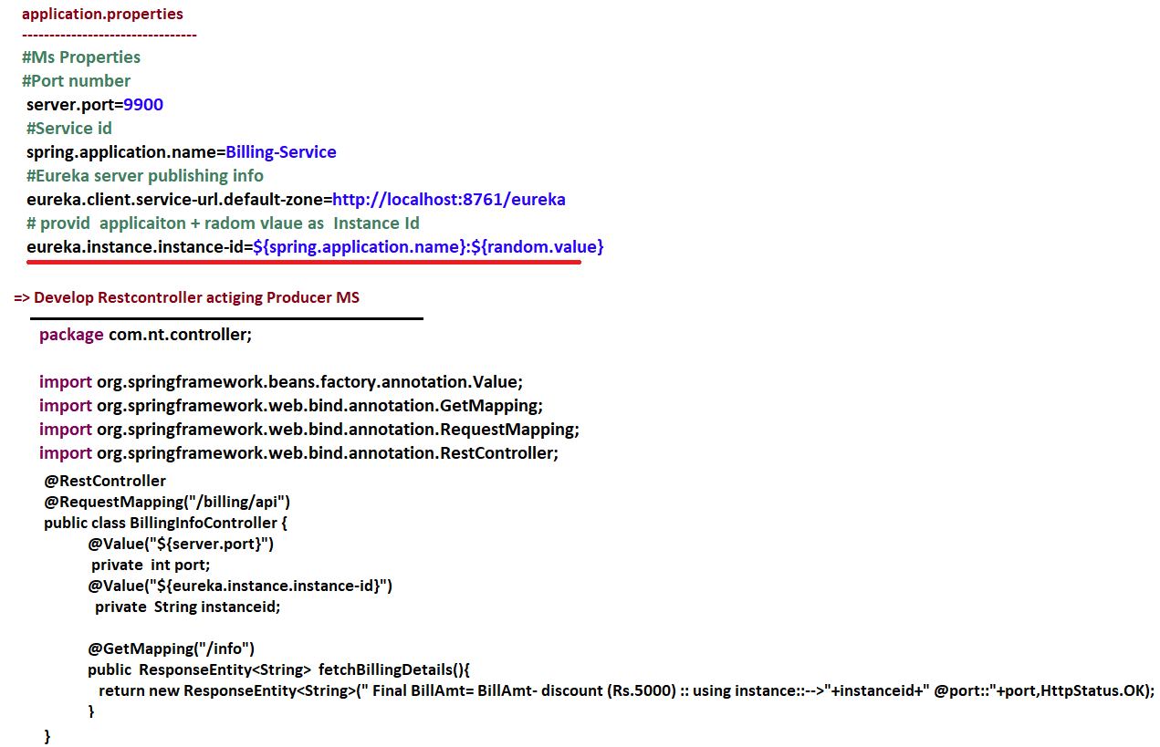

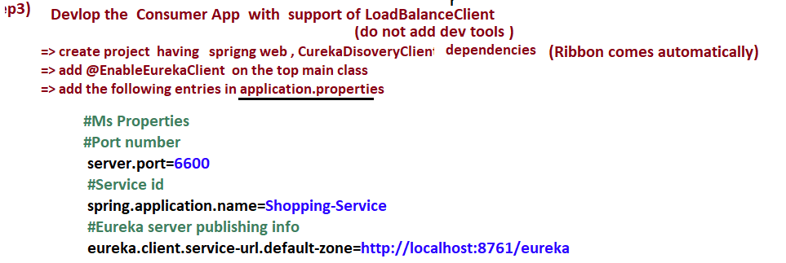

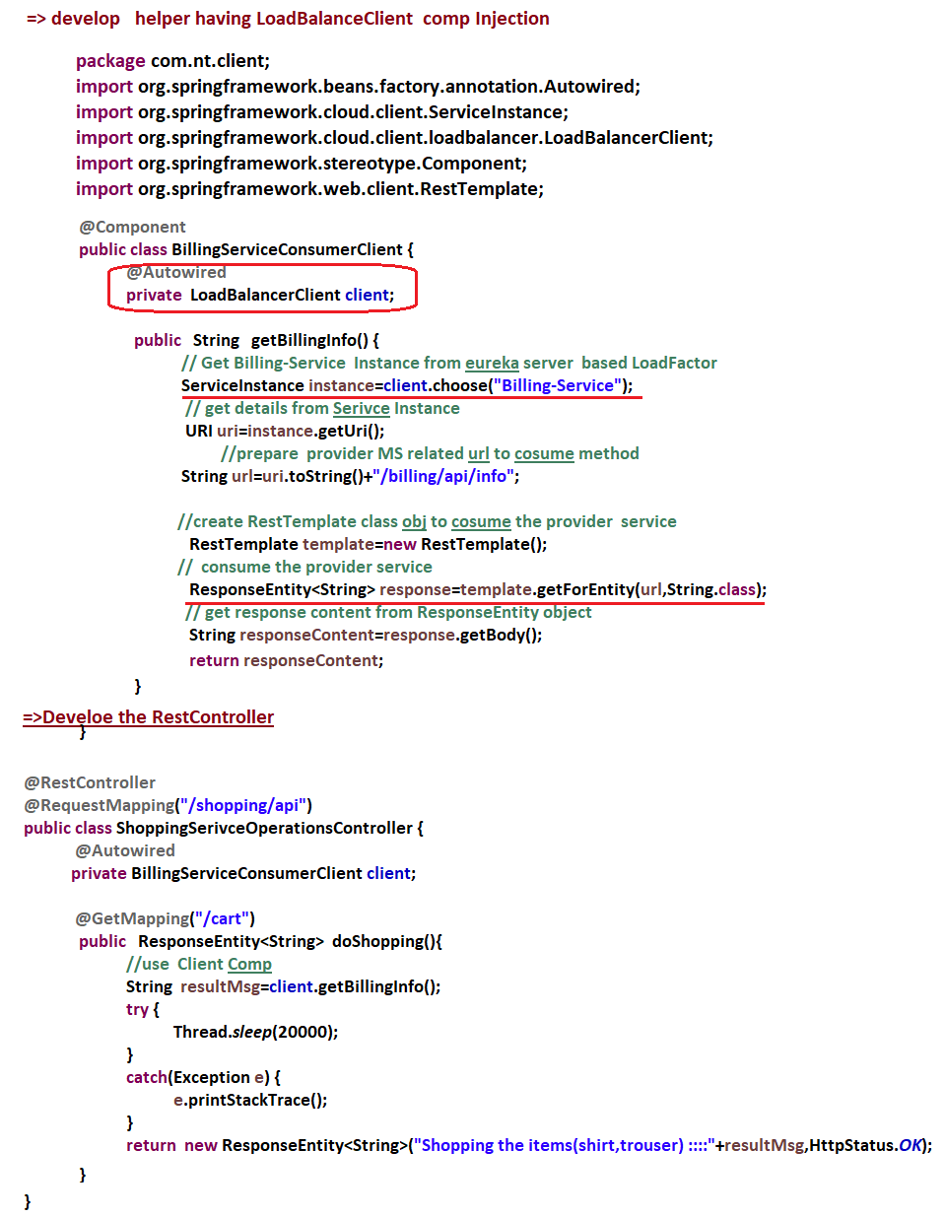

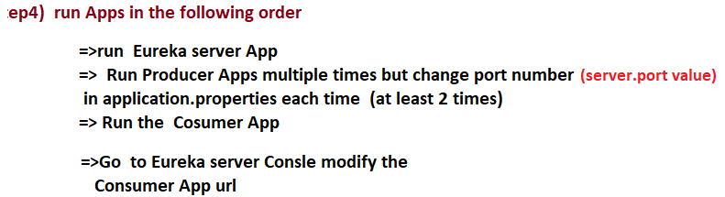

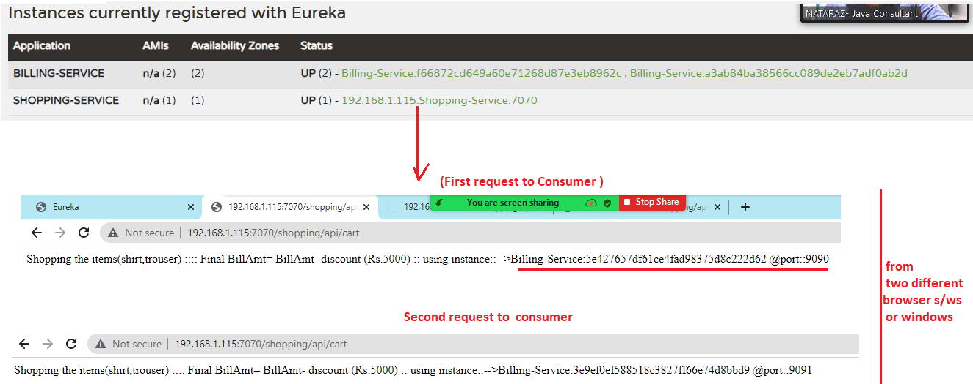

# NTSPBMS615- July 24th-2022- Intra MS communication using Feign Client

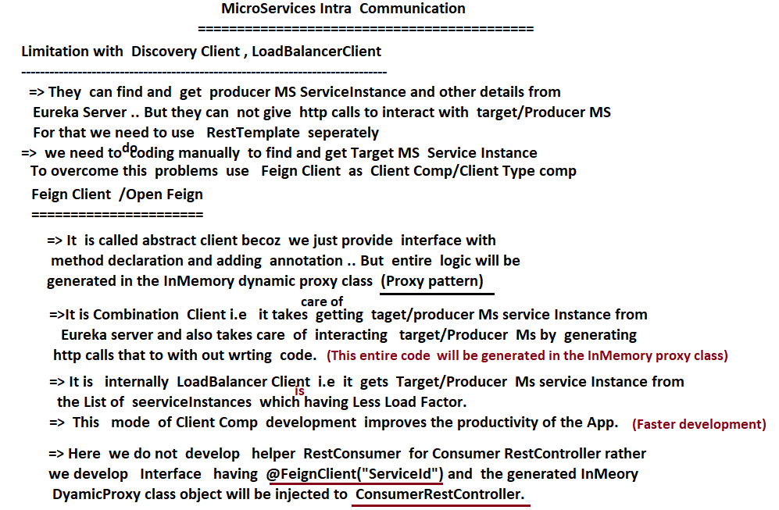

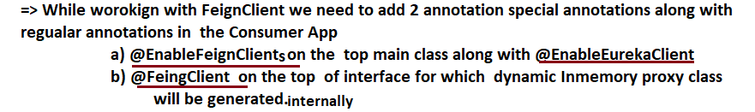

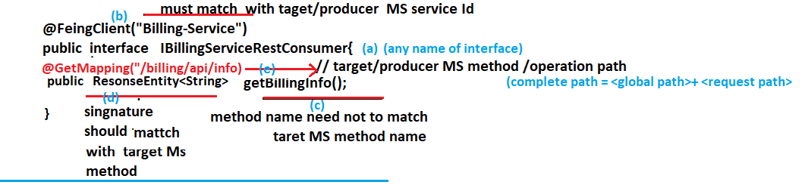

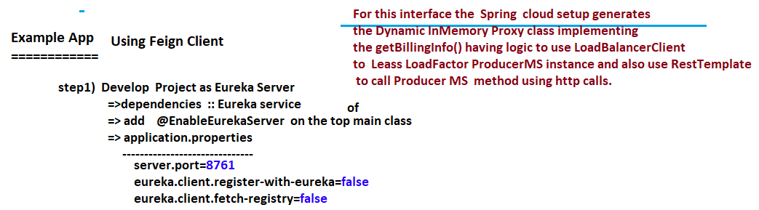

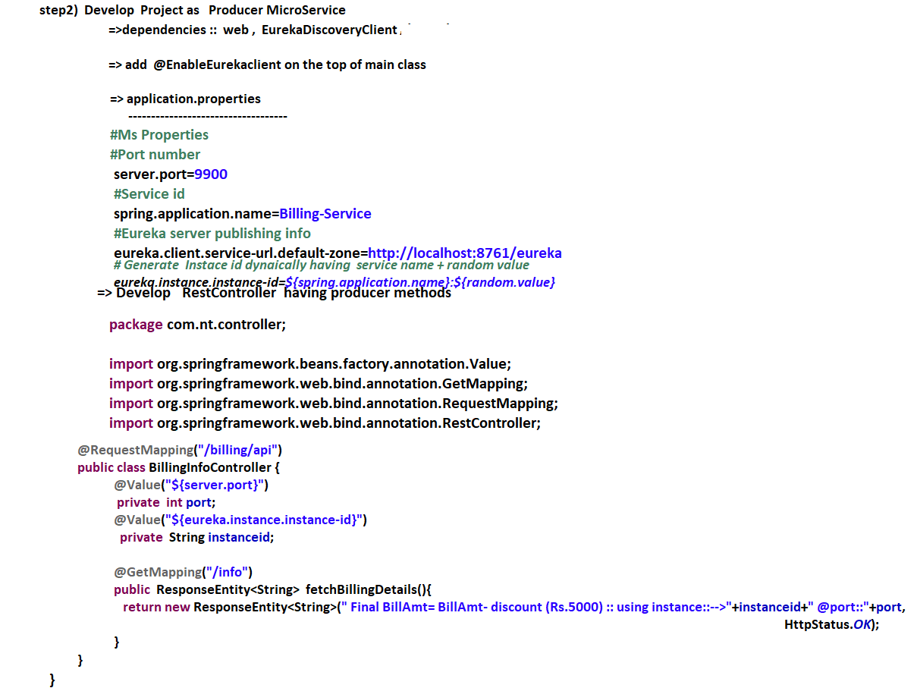

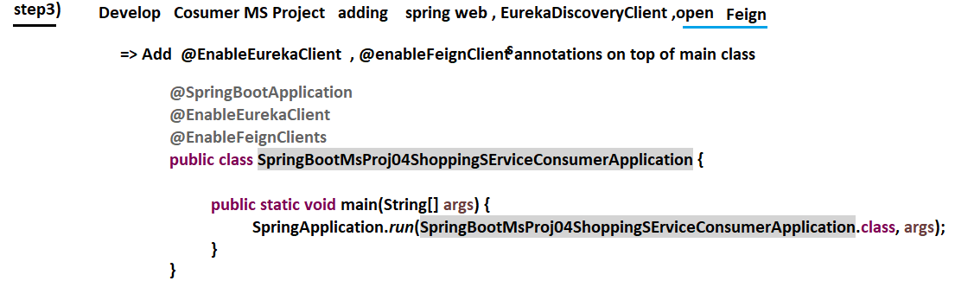

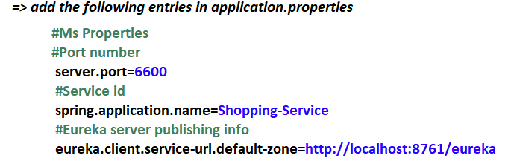

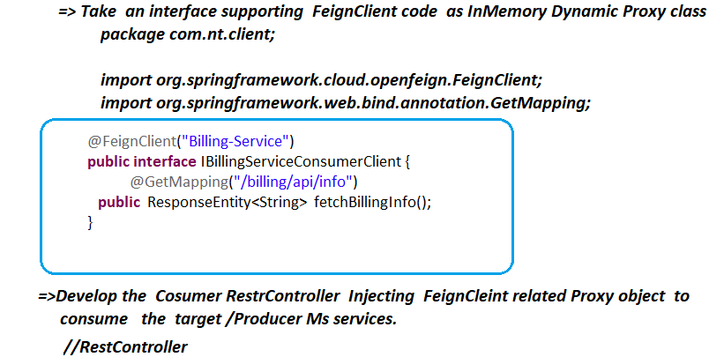

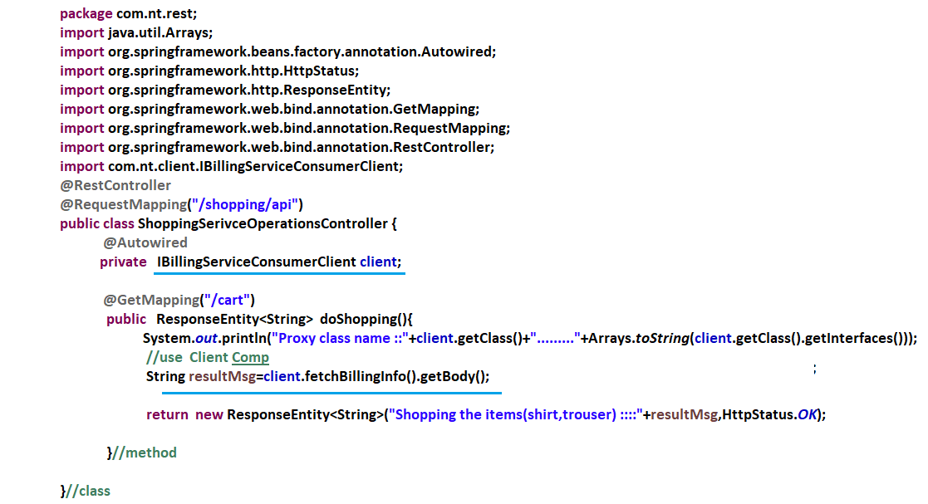

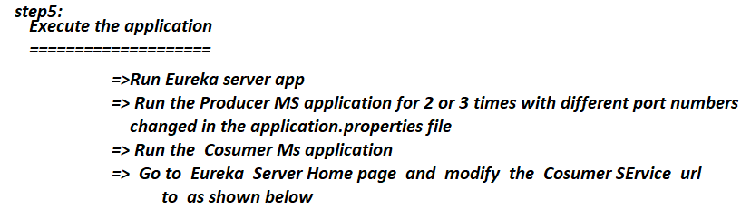

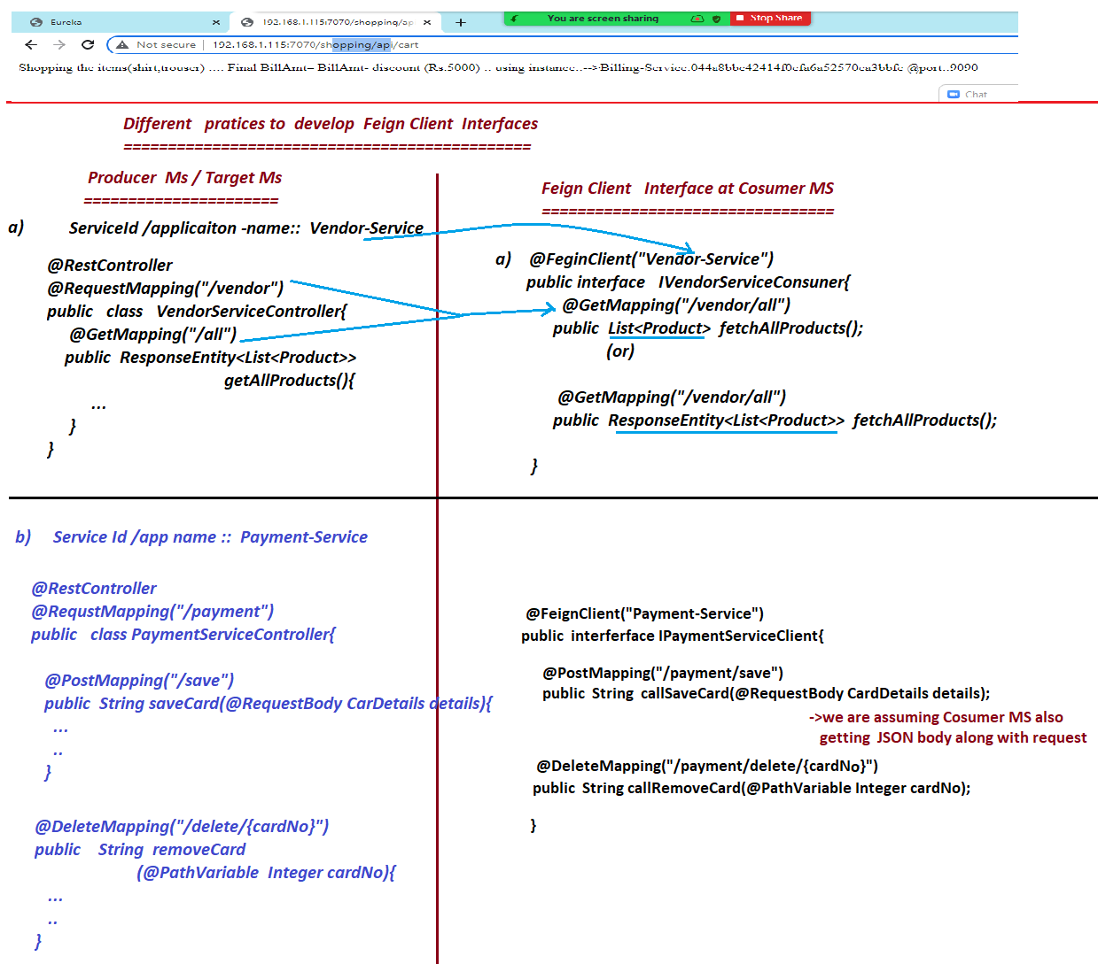

# NTSPBMS615- July25th- 27th-2022- Config Server

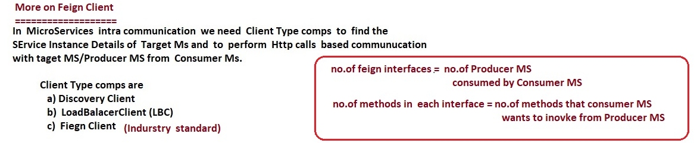

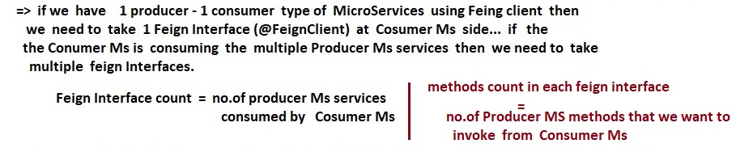

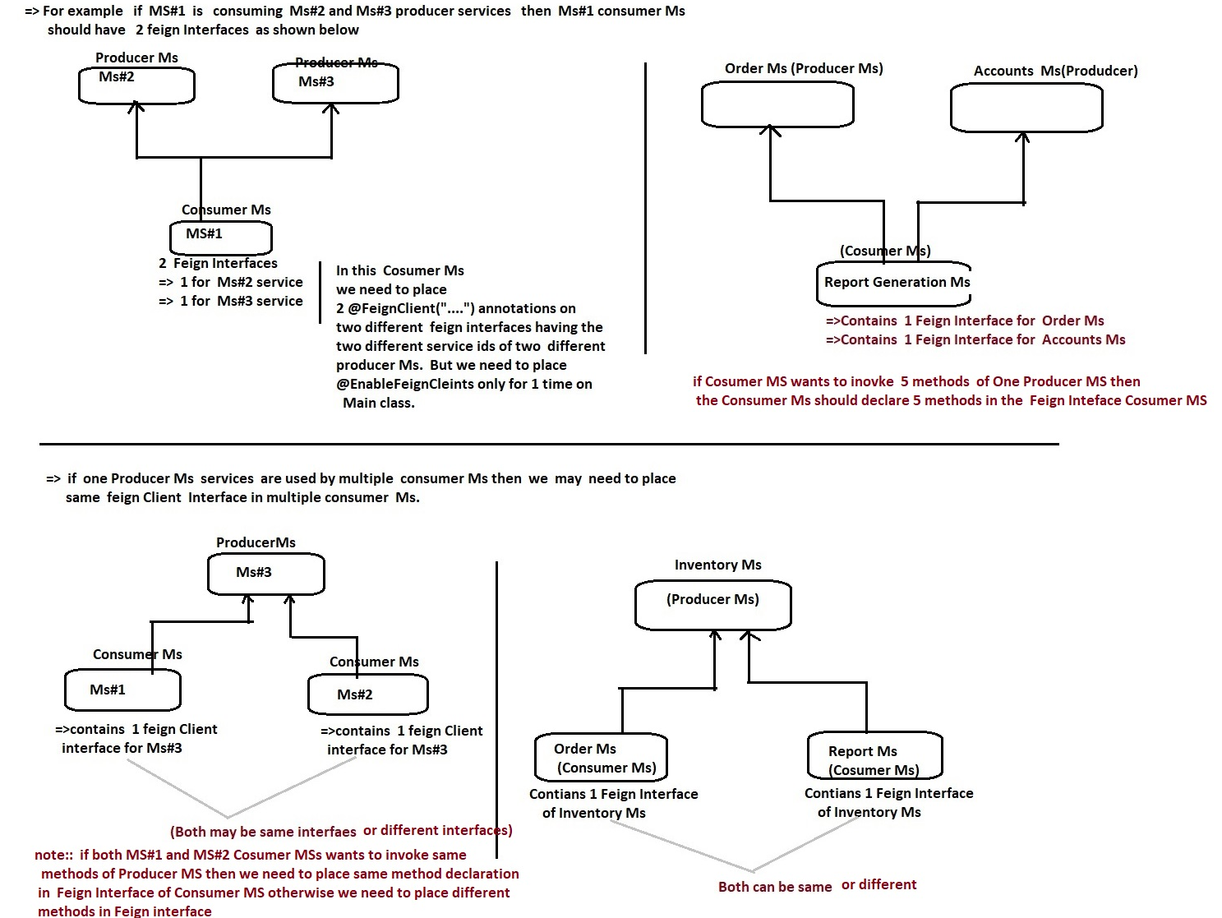

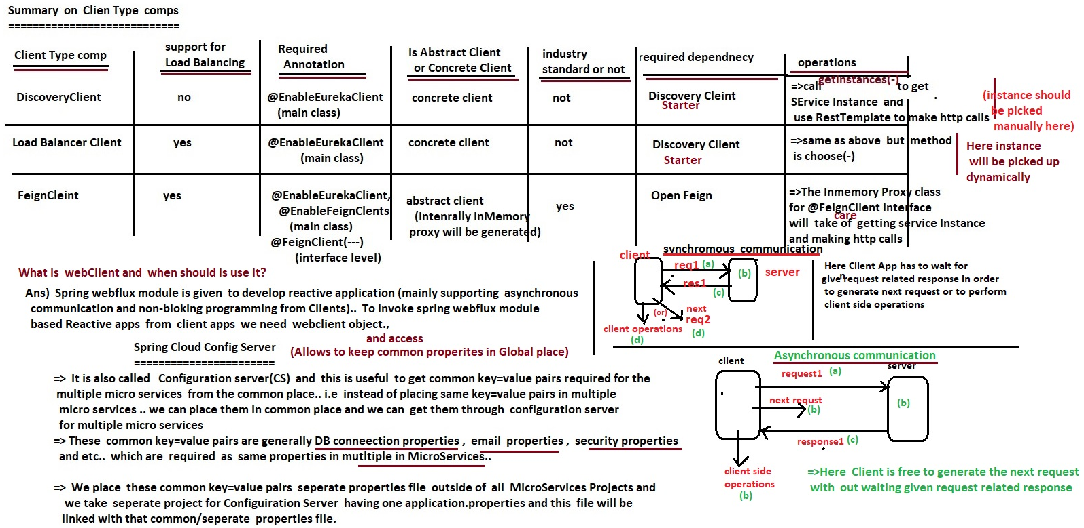

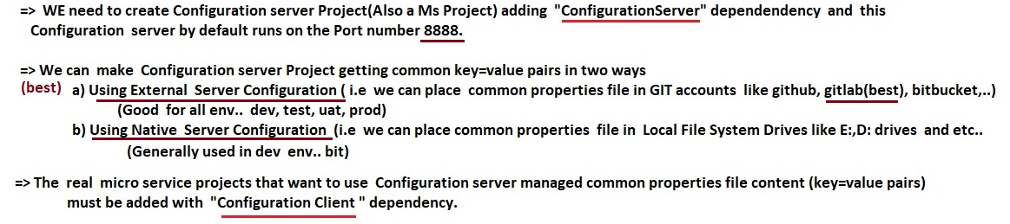

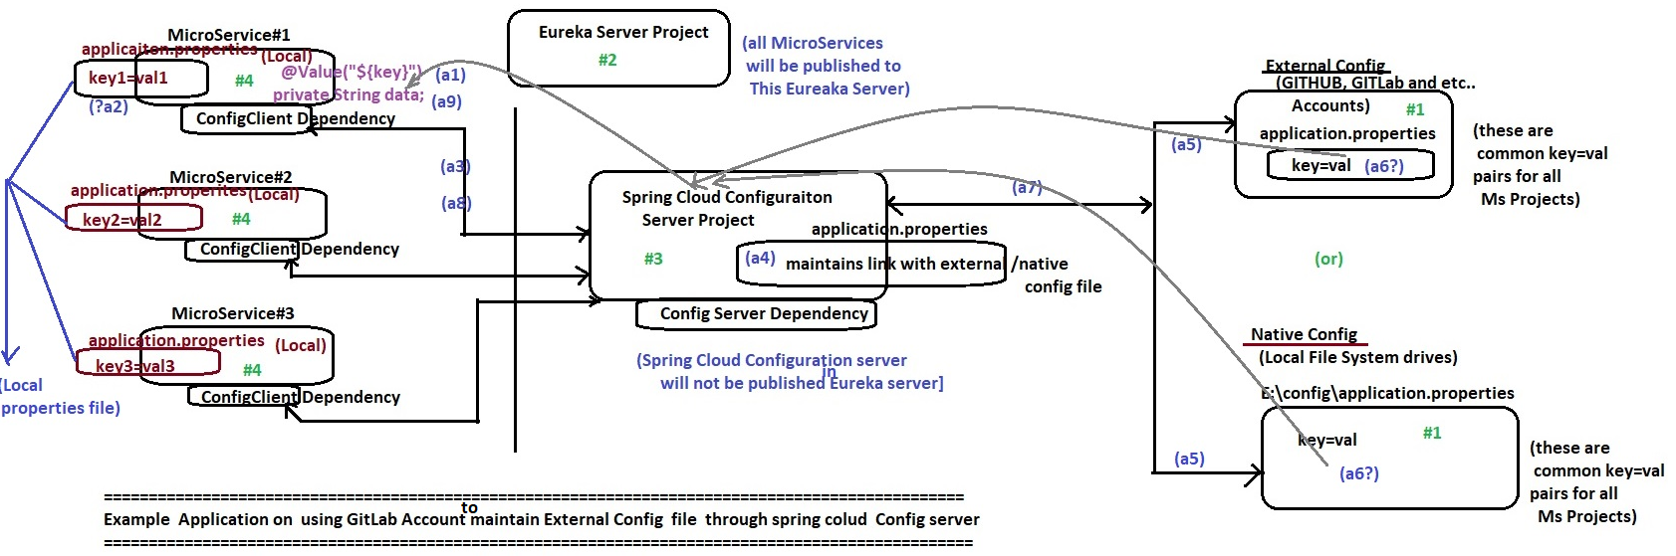

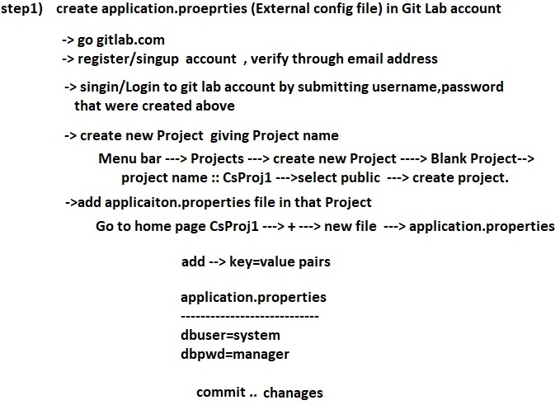

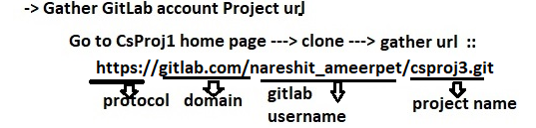

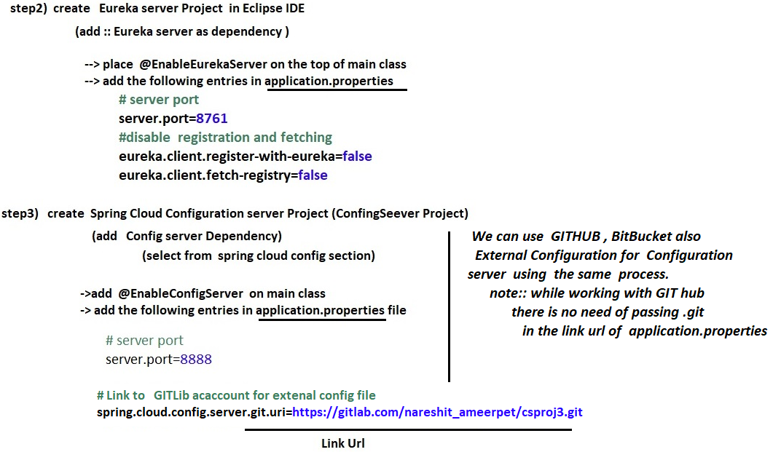

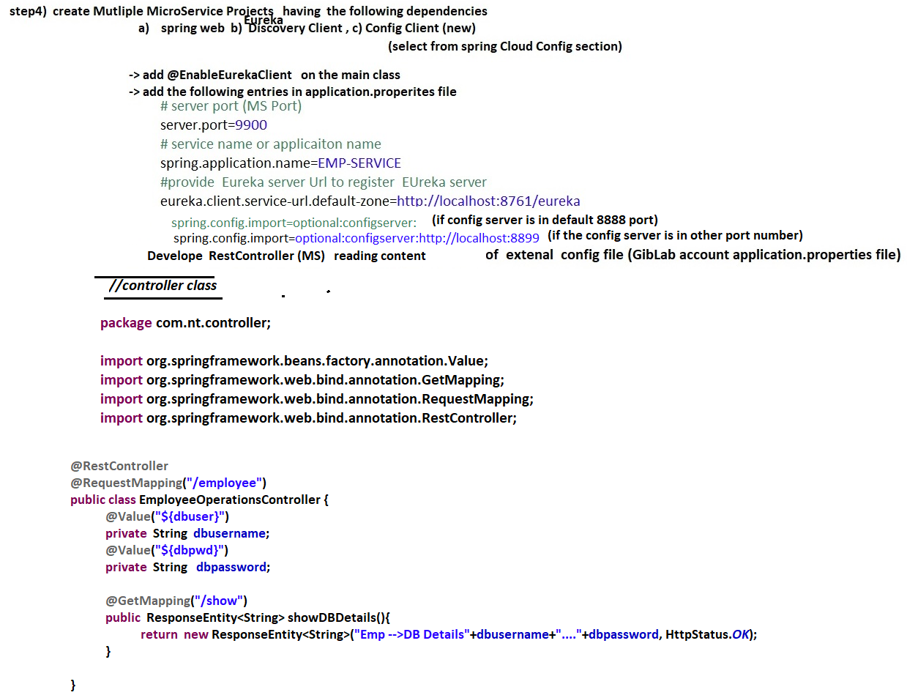

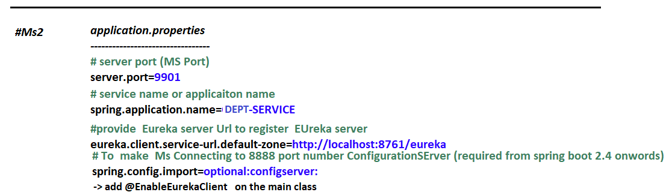

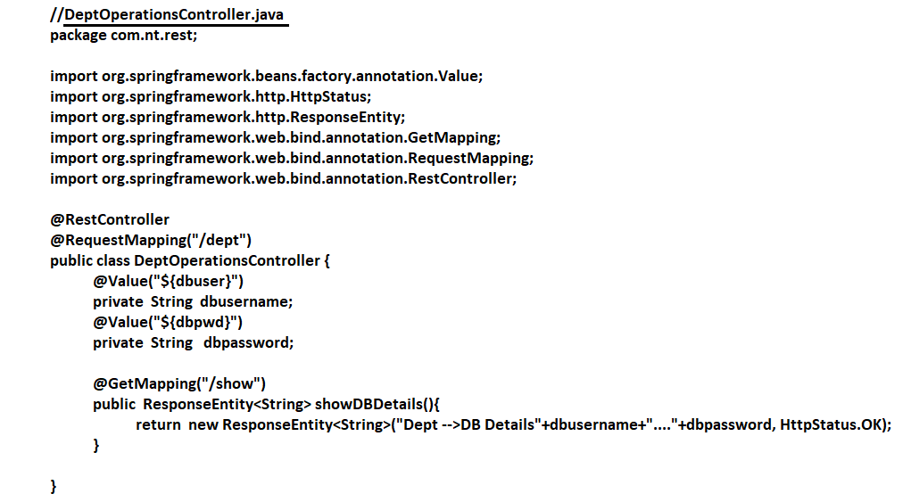

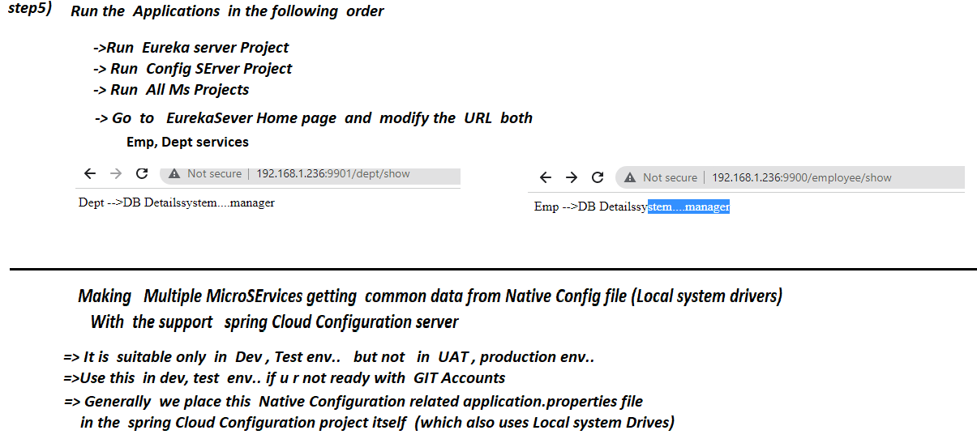

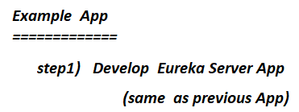

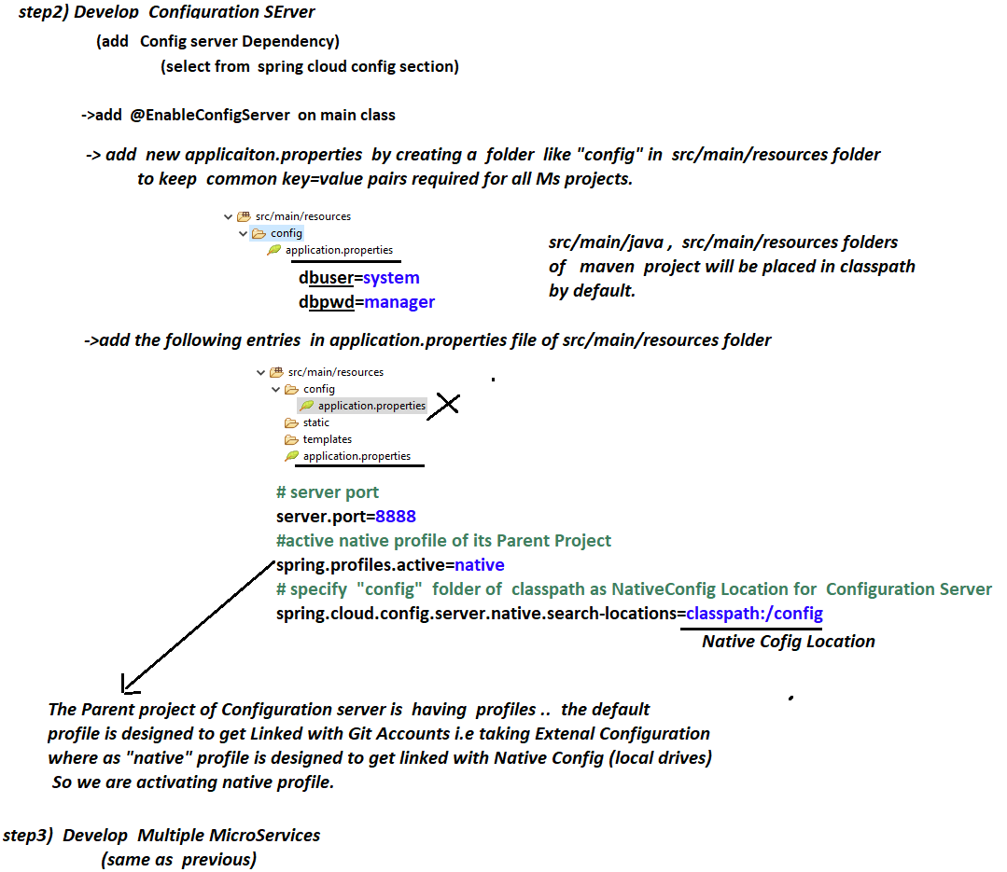

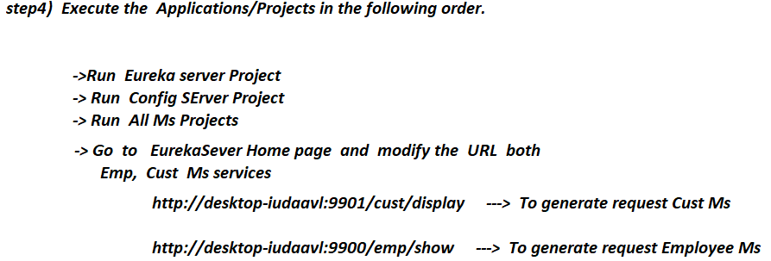

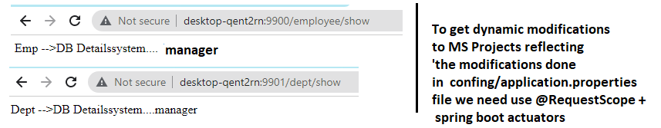

# NTSPBMS615- July 28th-2022- Config Server

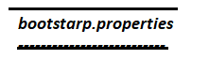

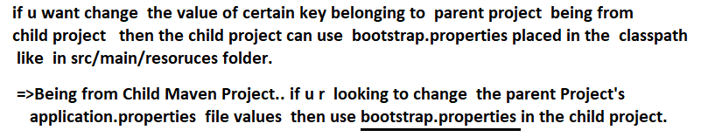

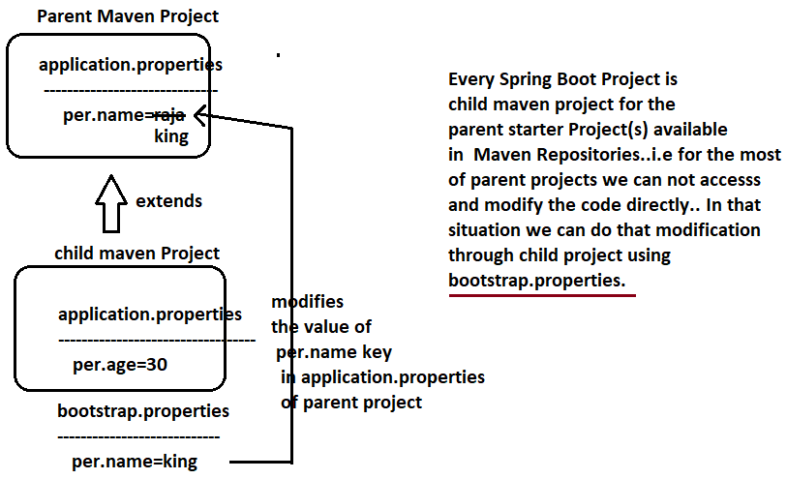

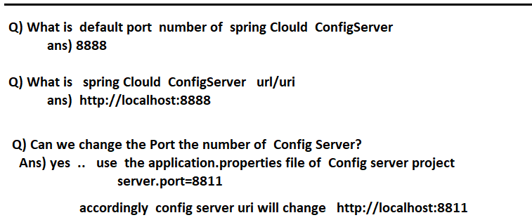

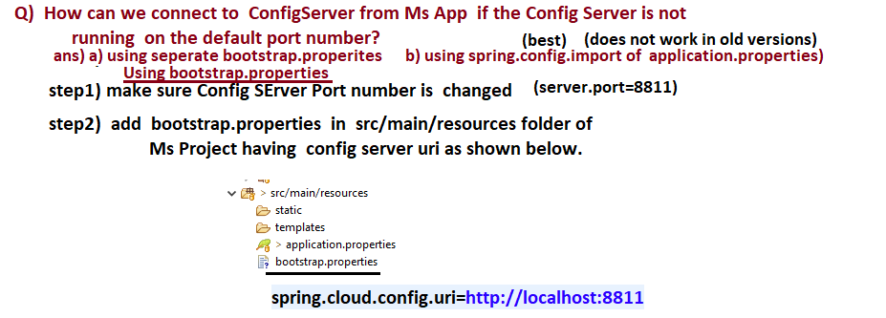

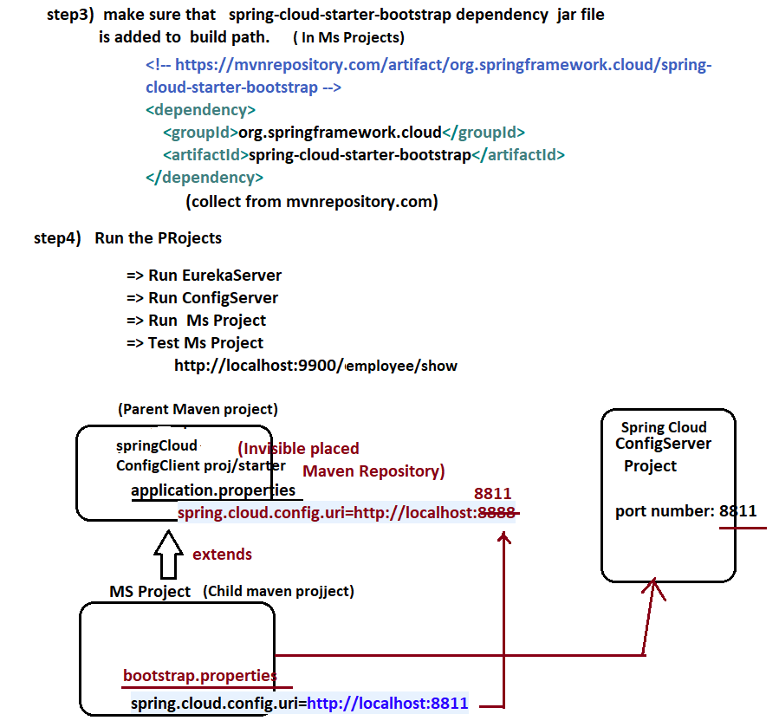

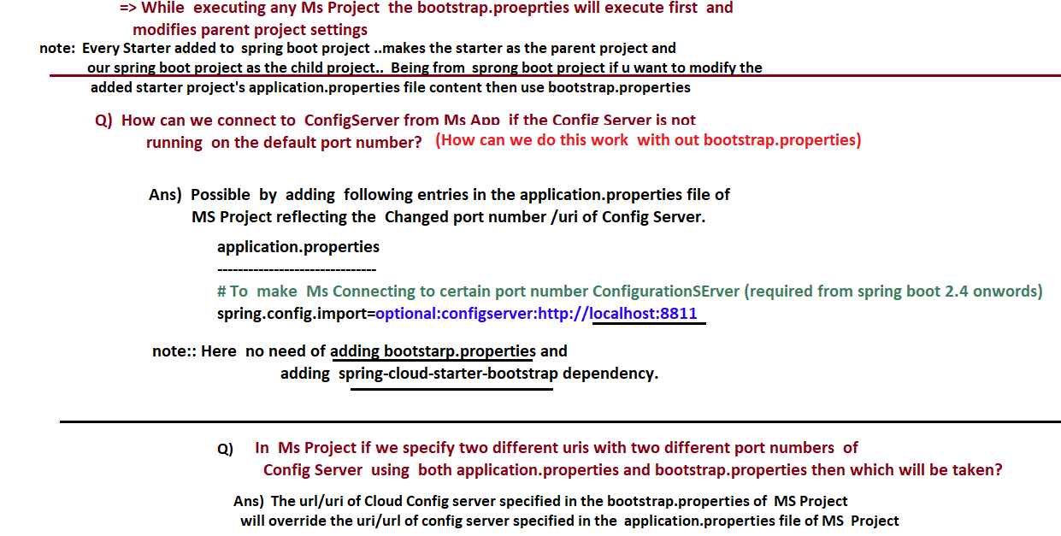



# NTSPBMS615- July 29th-2022- @RefreshScope-Spring Boot actuators

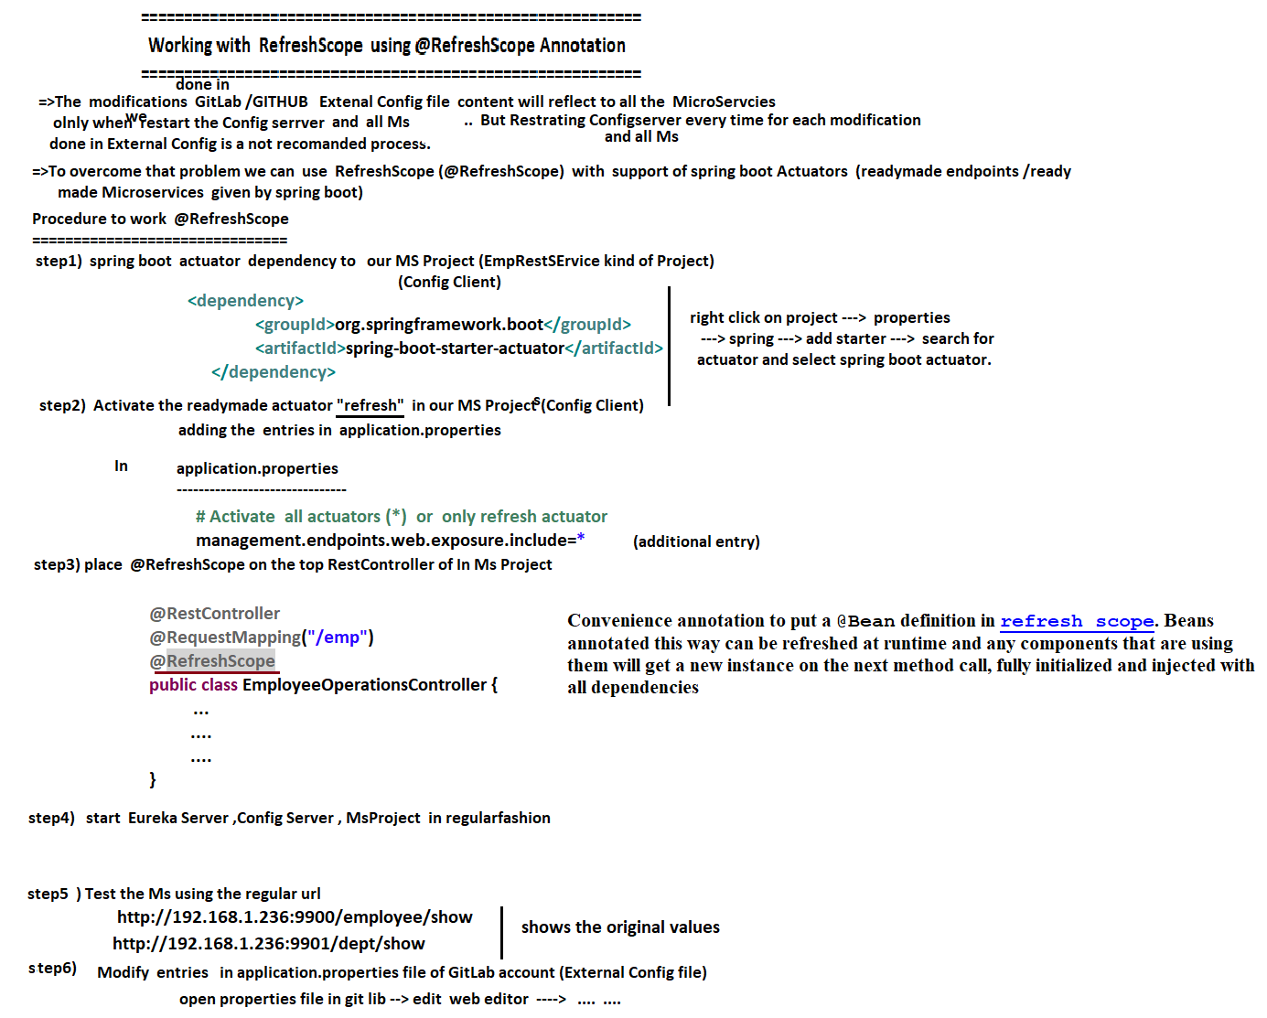

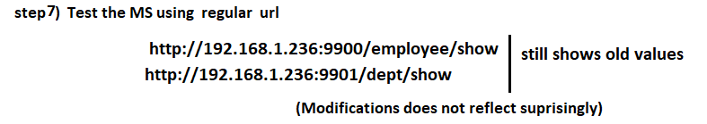

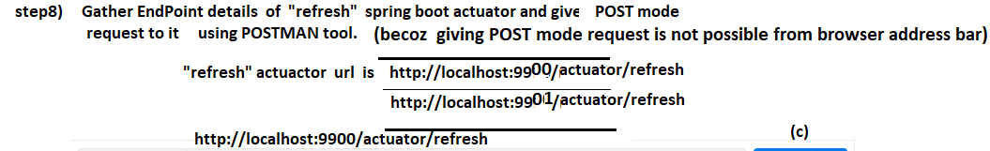

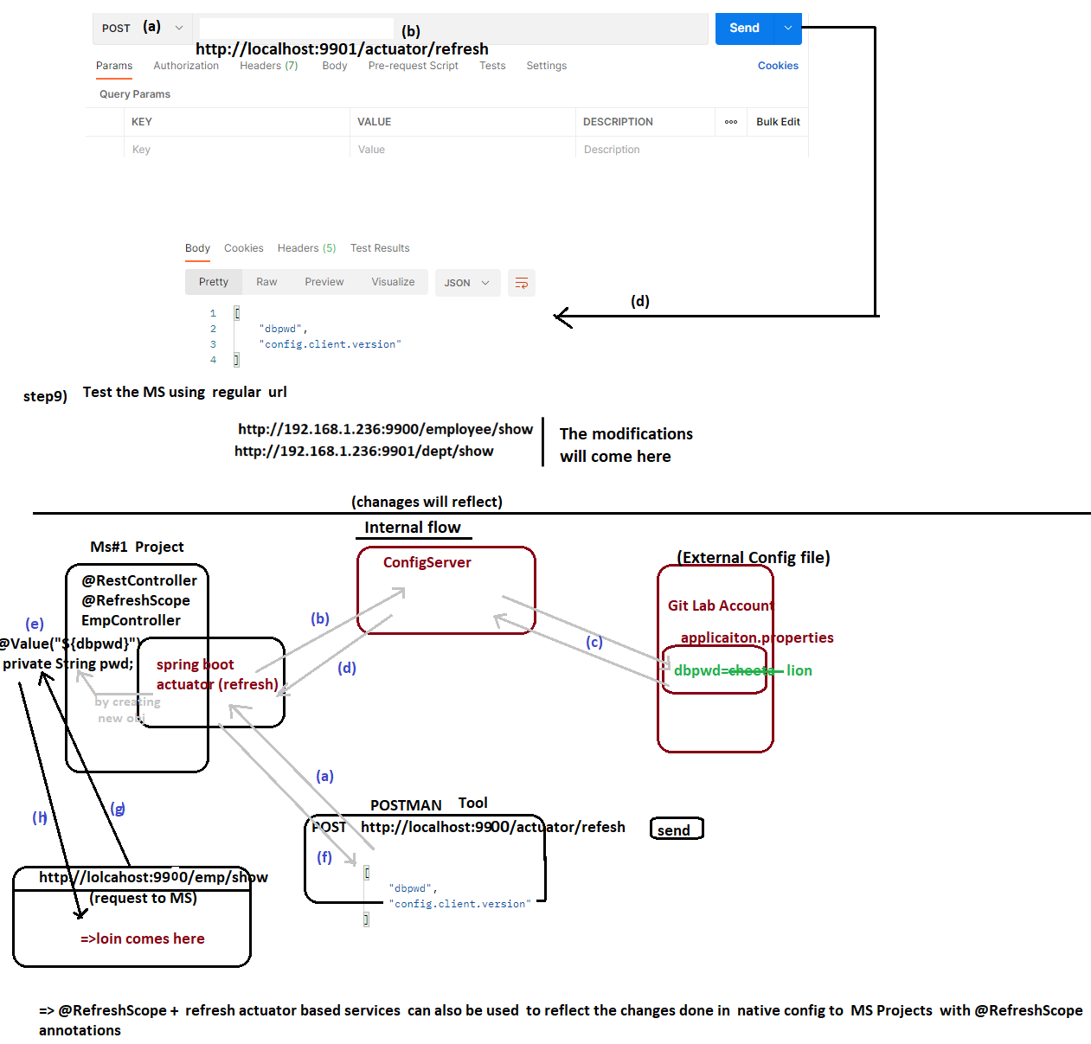

# NTSPBMS615- July 31st july - spring boot actuators

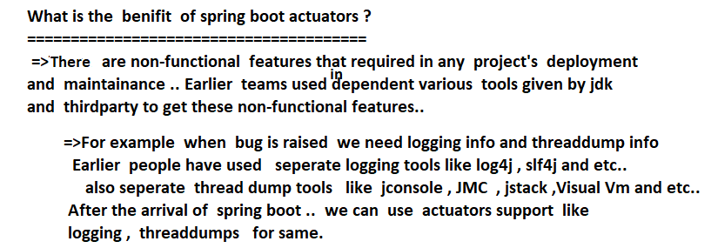

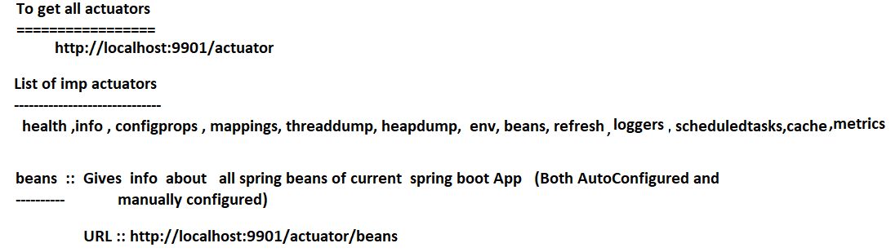

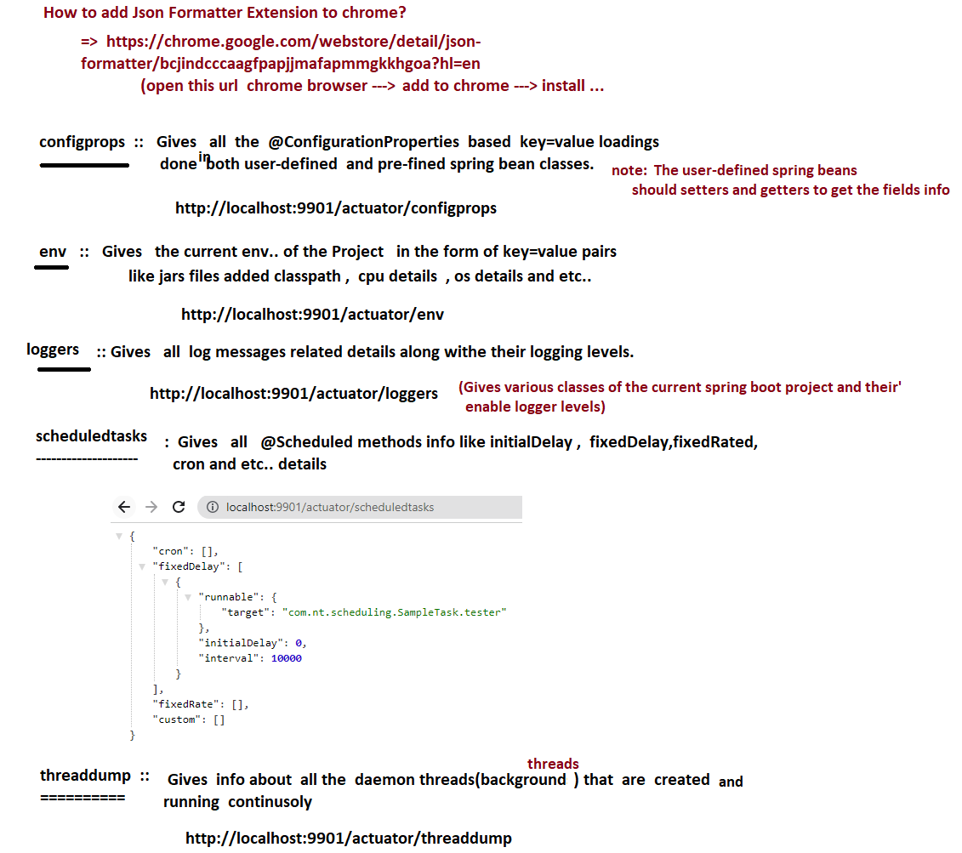

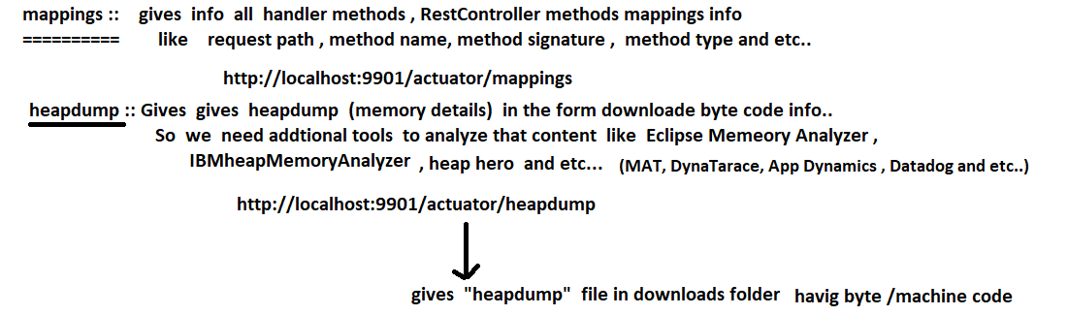

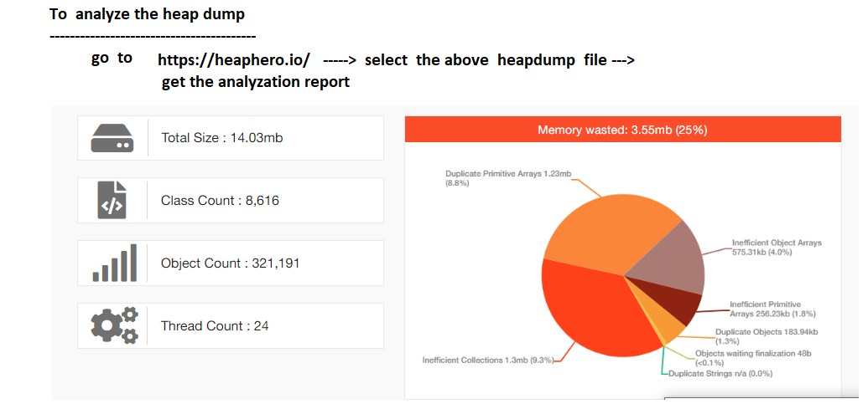

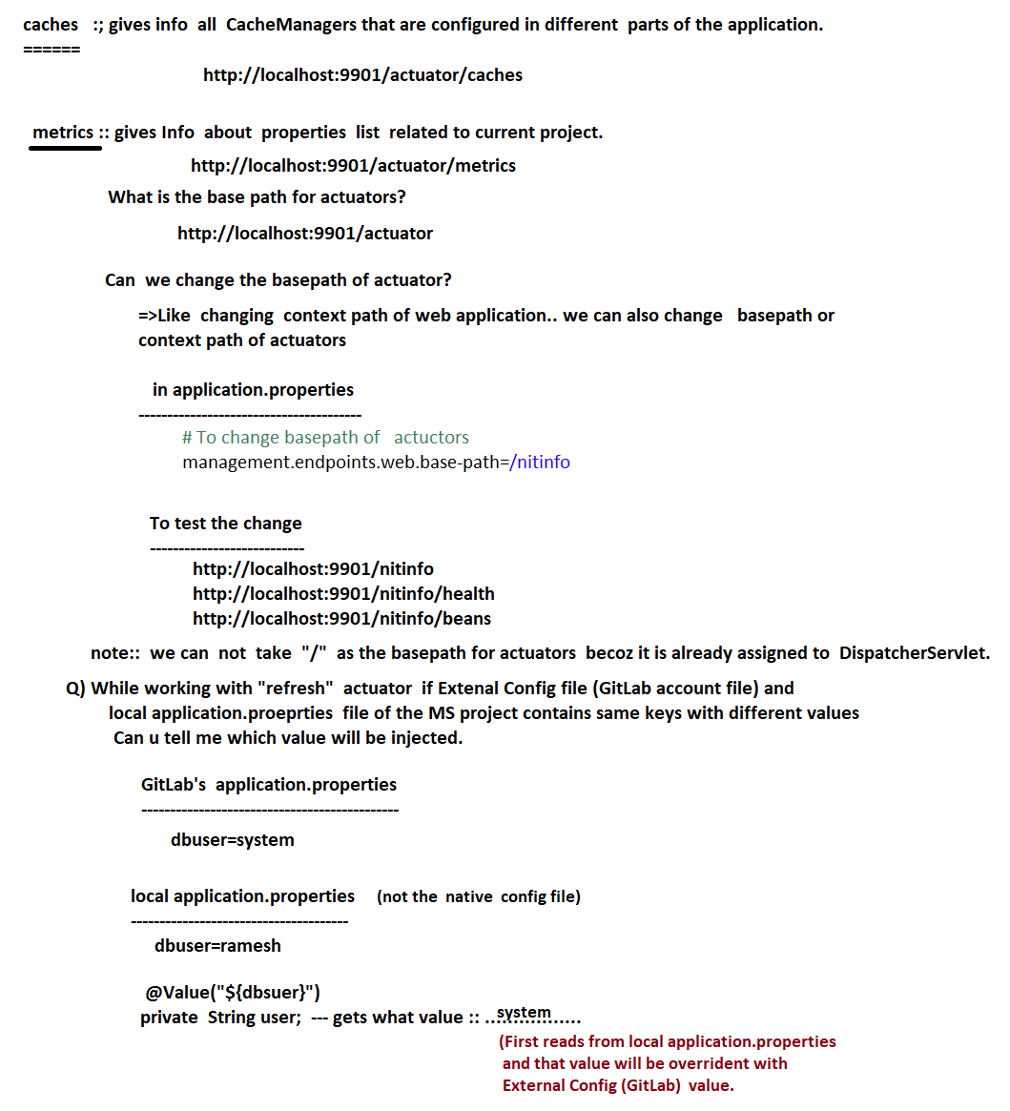

# NTSPBMS615- aug 2nd 2022 - Circuit breker

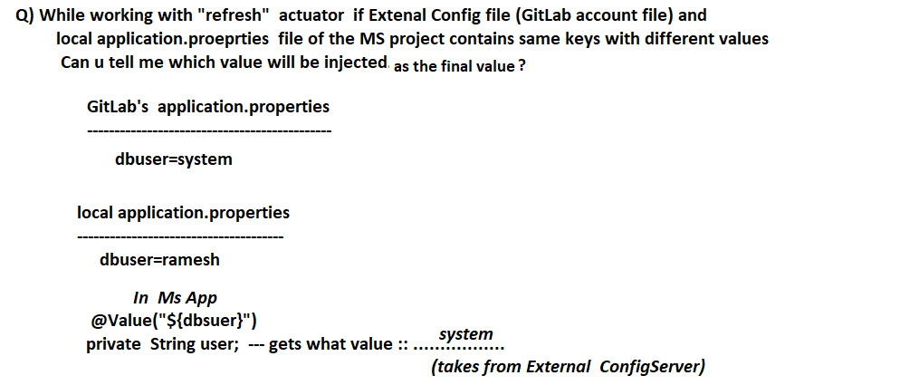

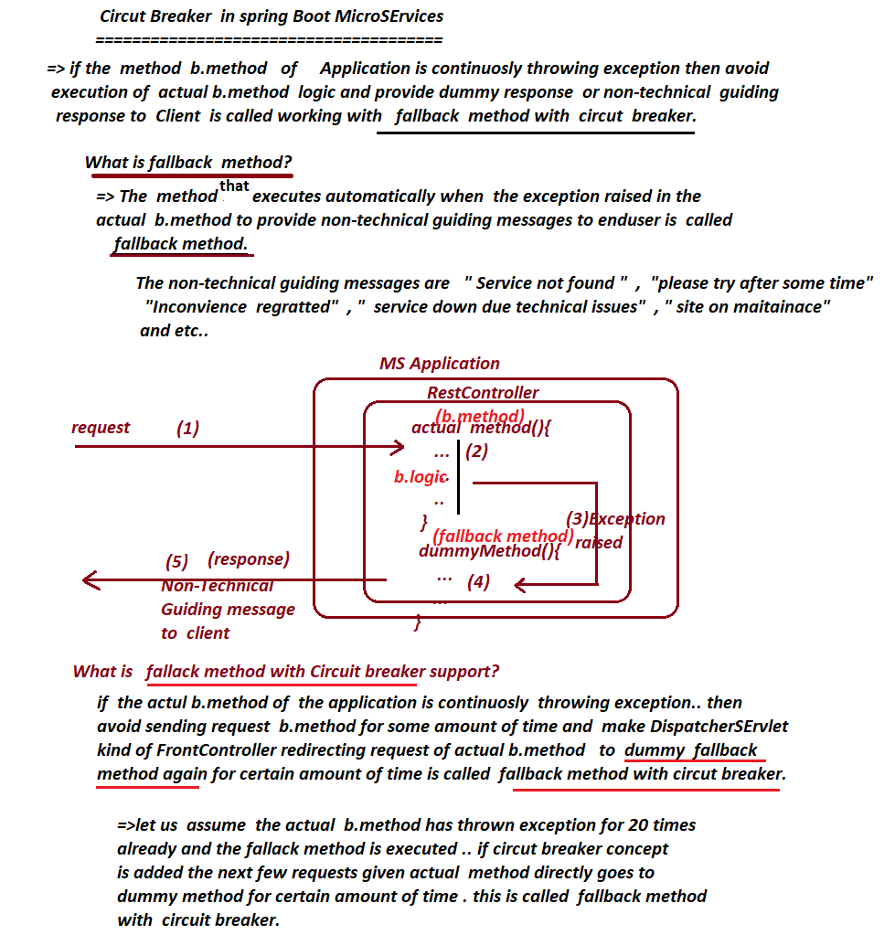

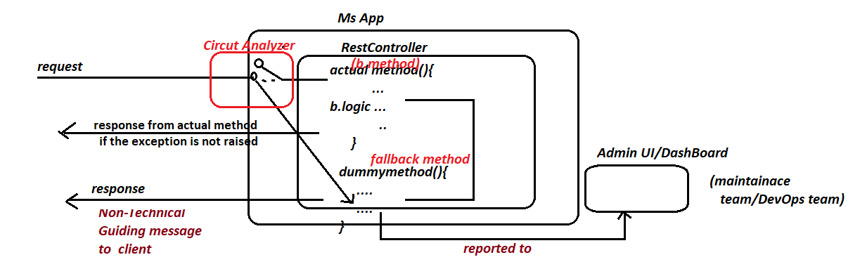

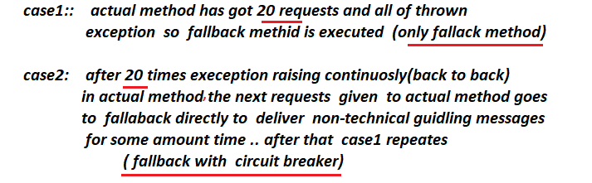

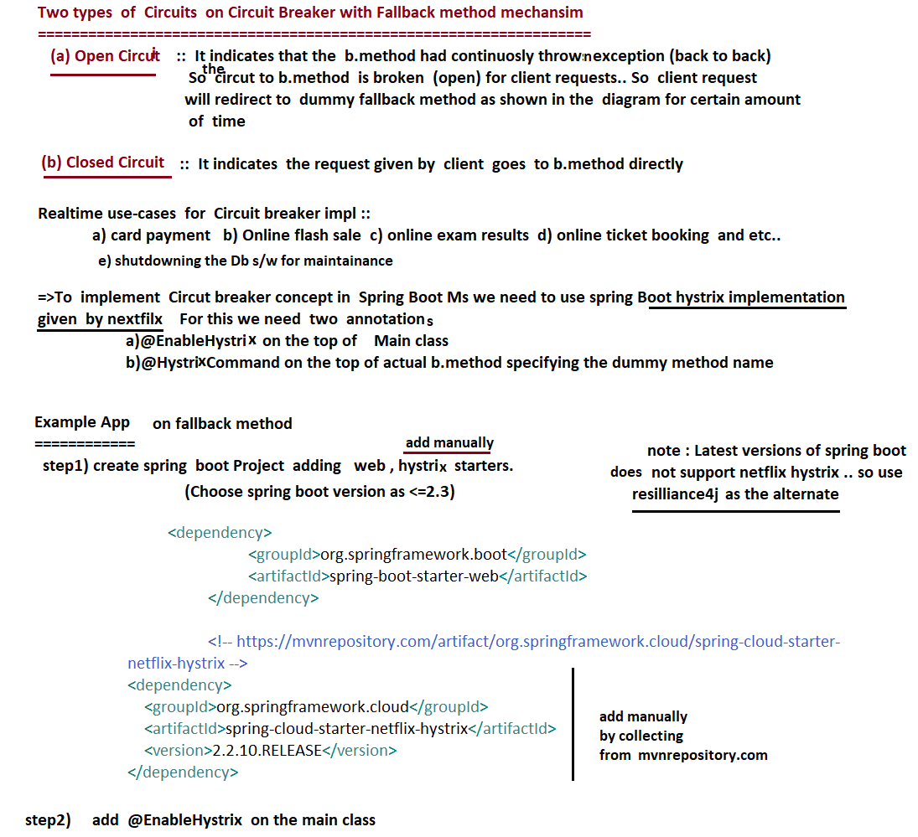

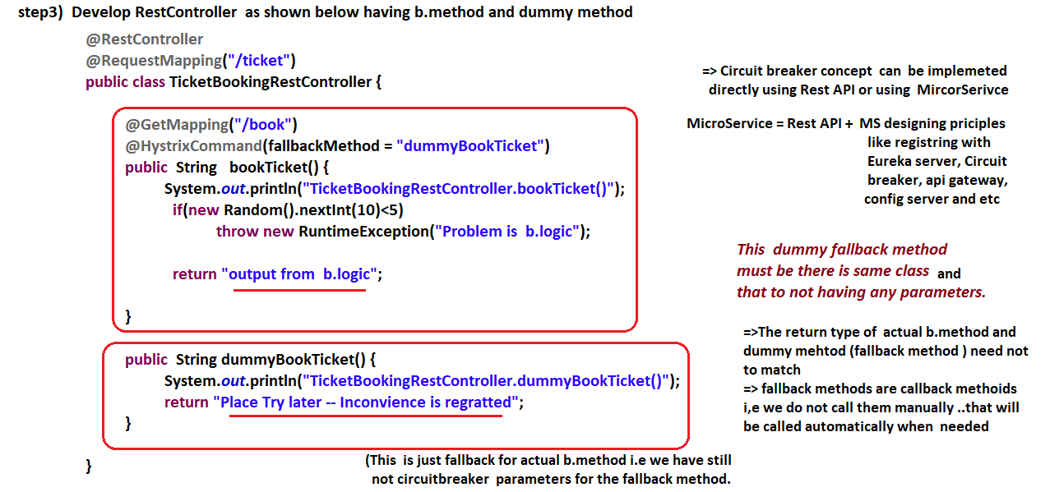

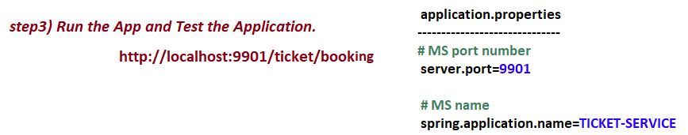

# NTSPBMS615- aug 3rd 2022 - Circuit breaker

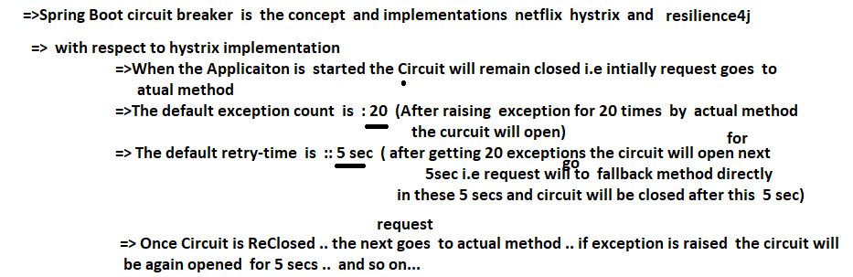

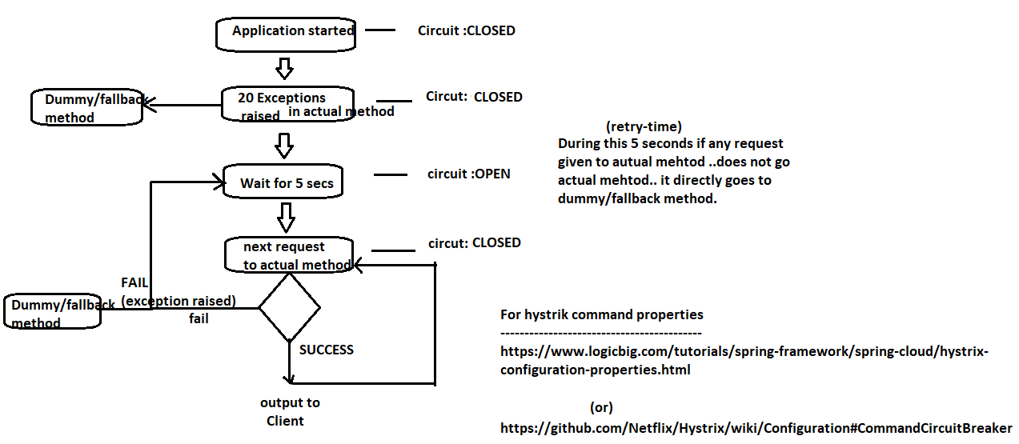

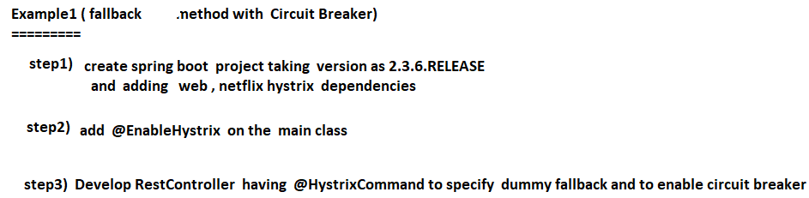

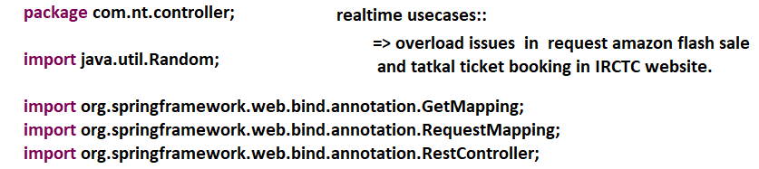

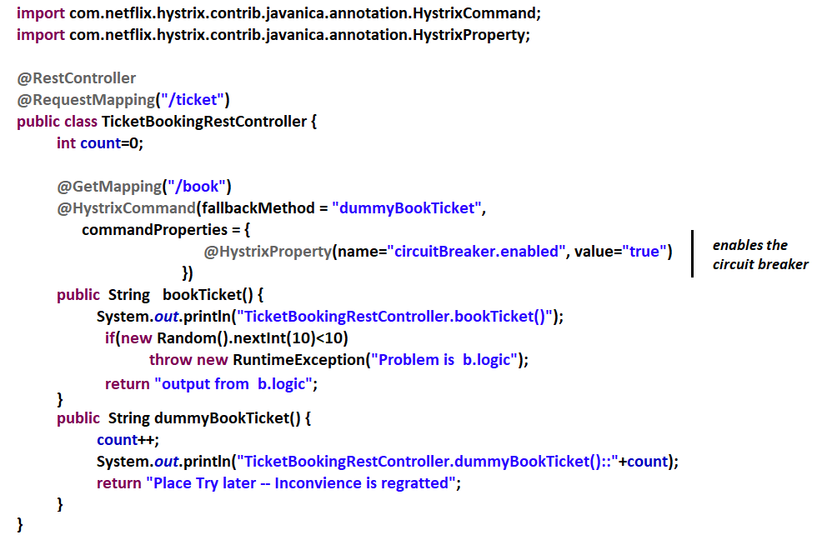

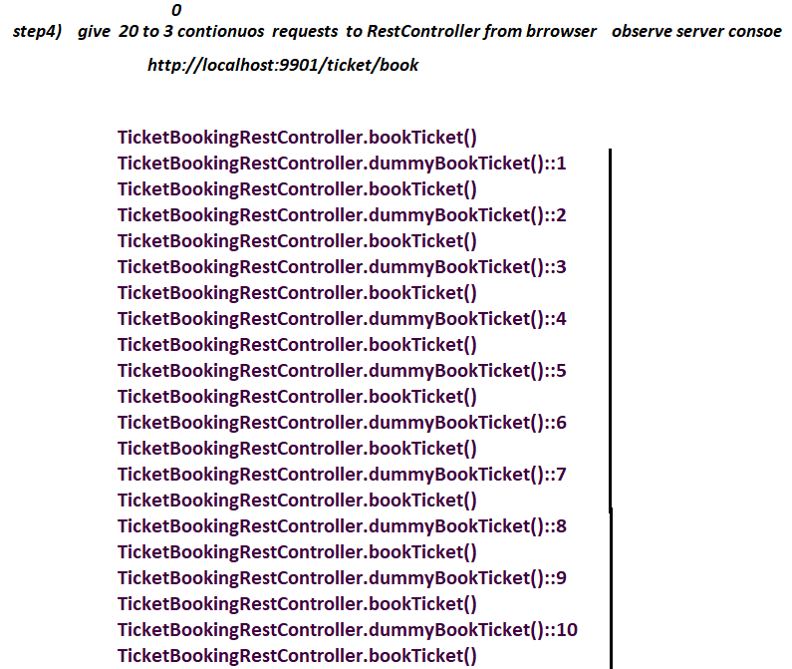

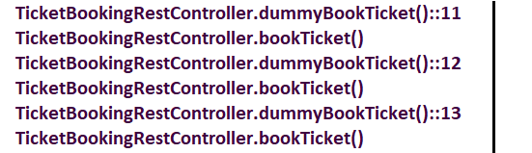

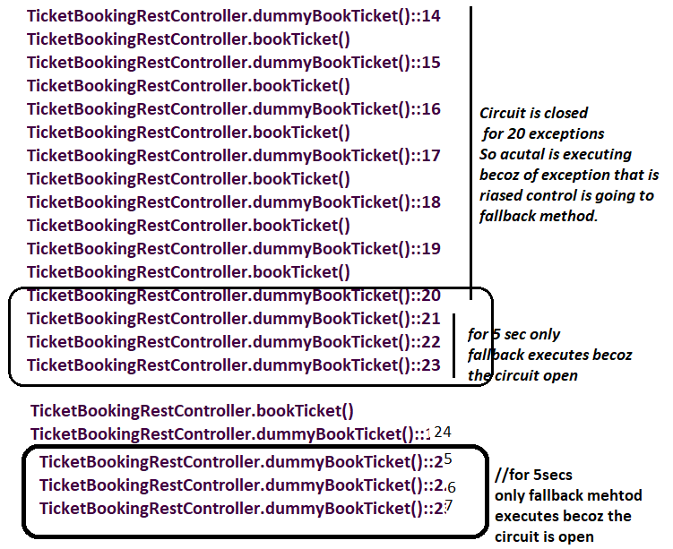

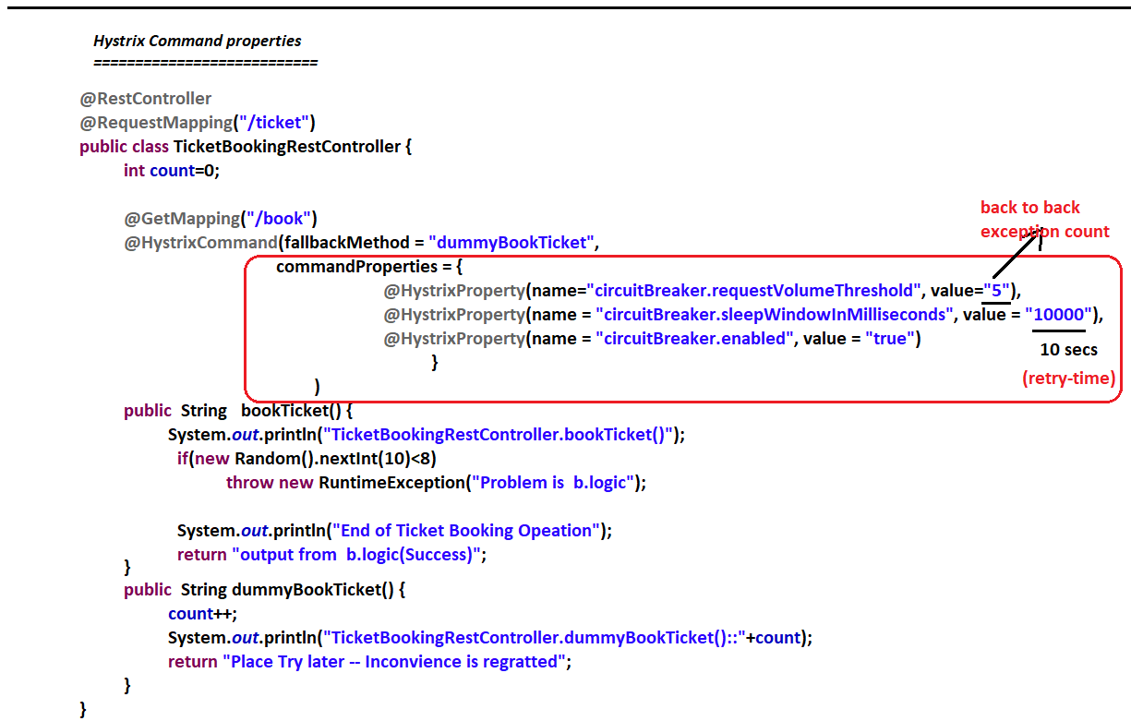

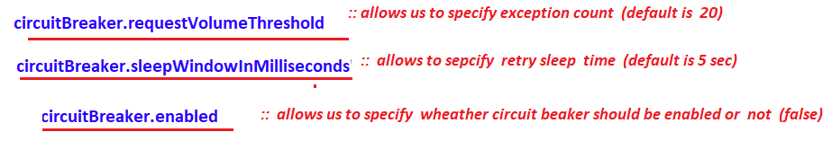

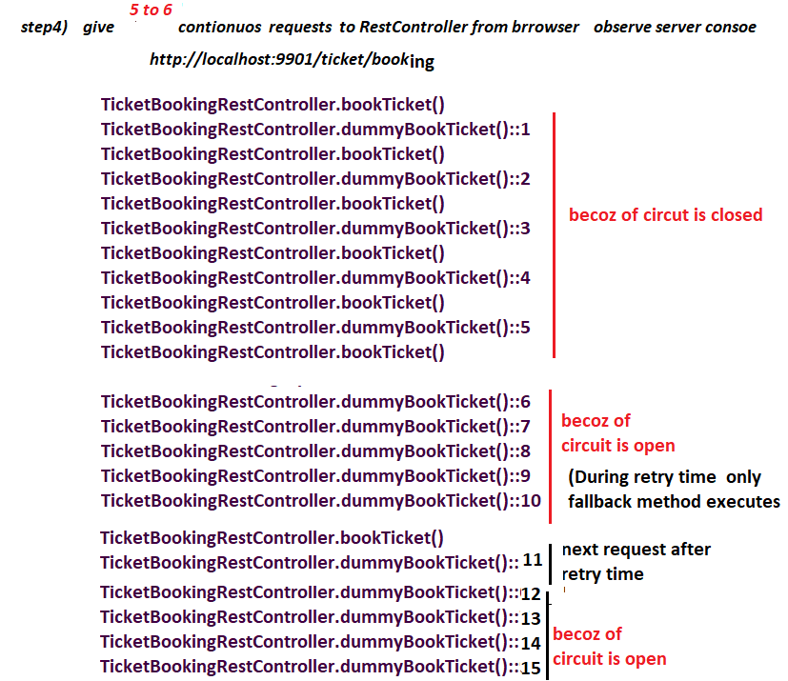

# NTSPBMS615- Hystrix DashBoard -aug 4th-2022

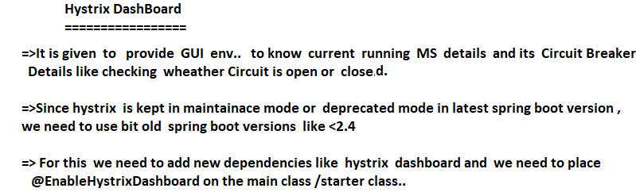

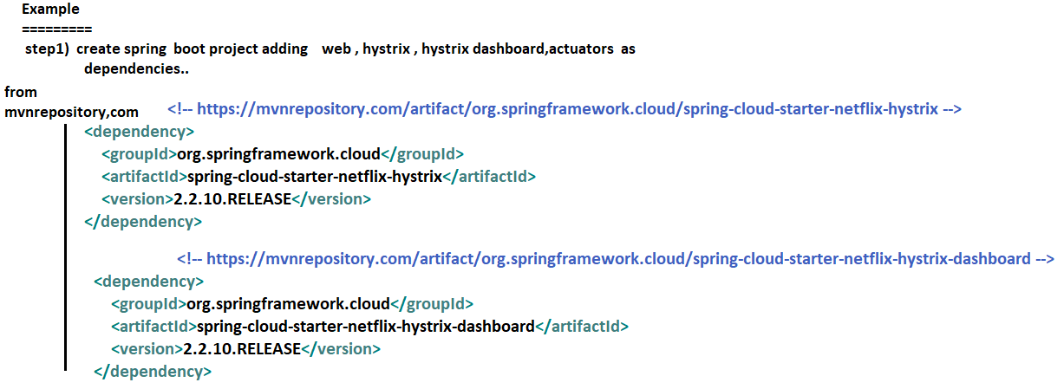

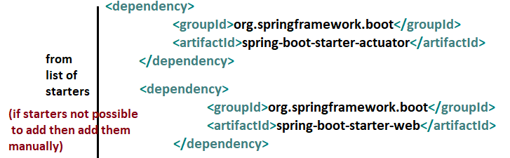

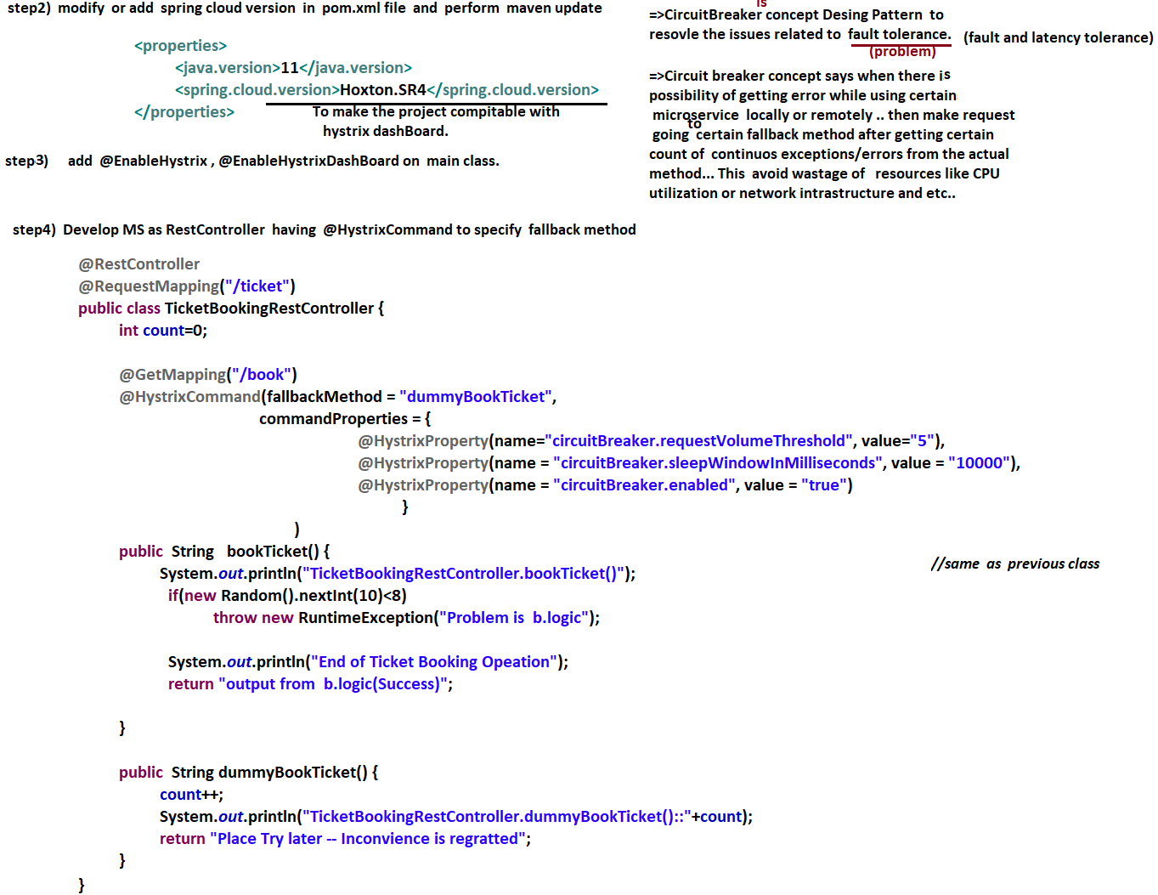

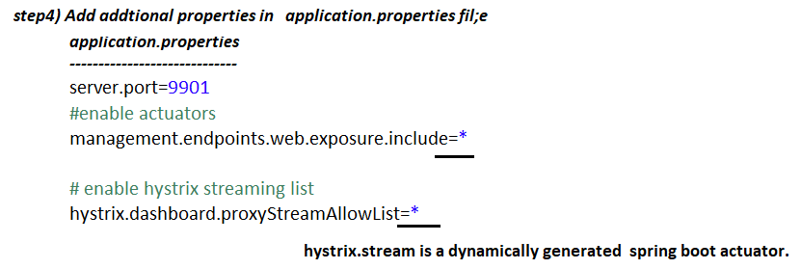

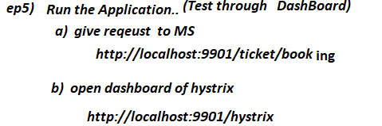

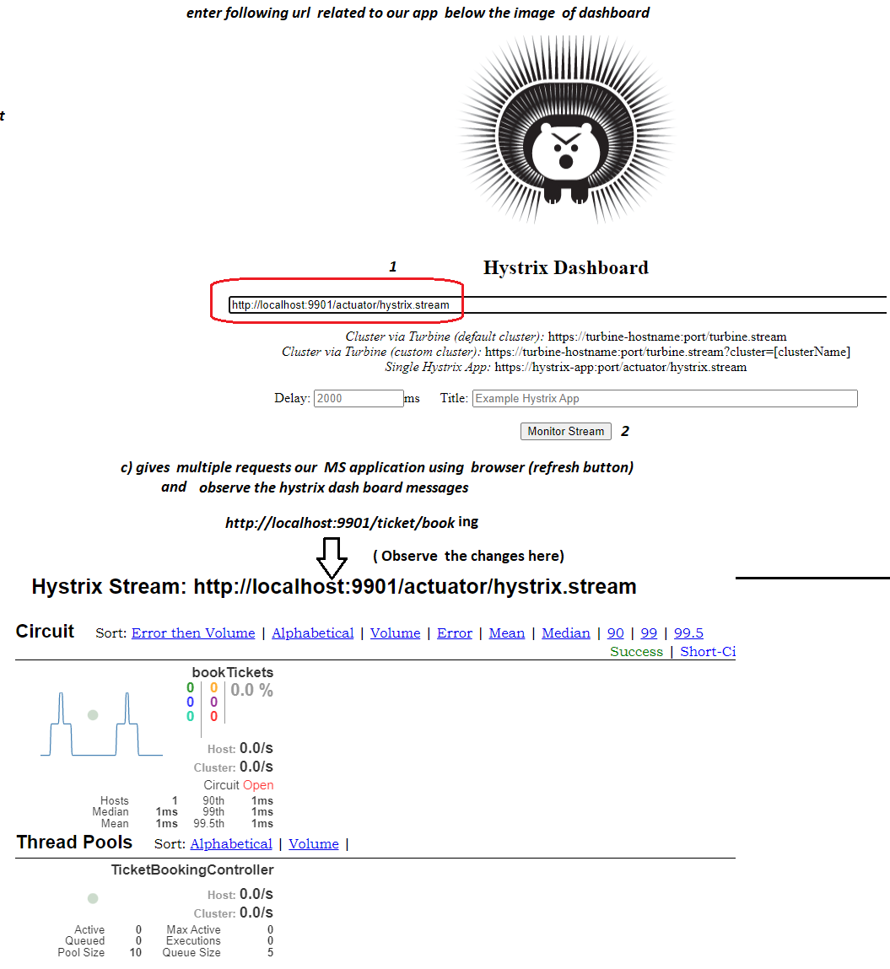

# NTSPBMS615- aug 5th 2022 Distributed Tracking&Logging Using slueth -zipkin

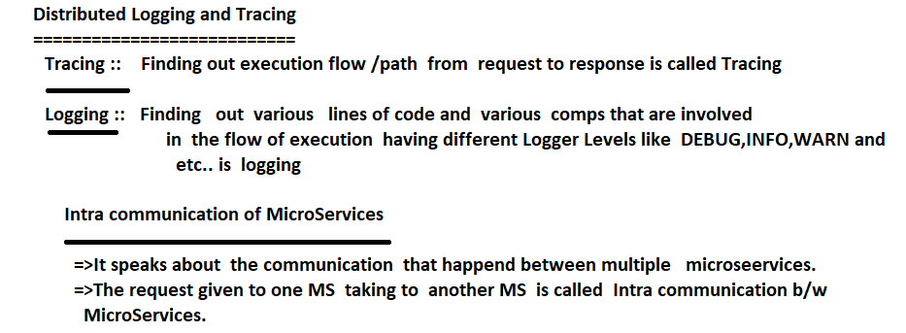

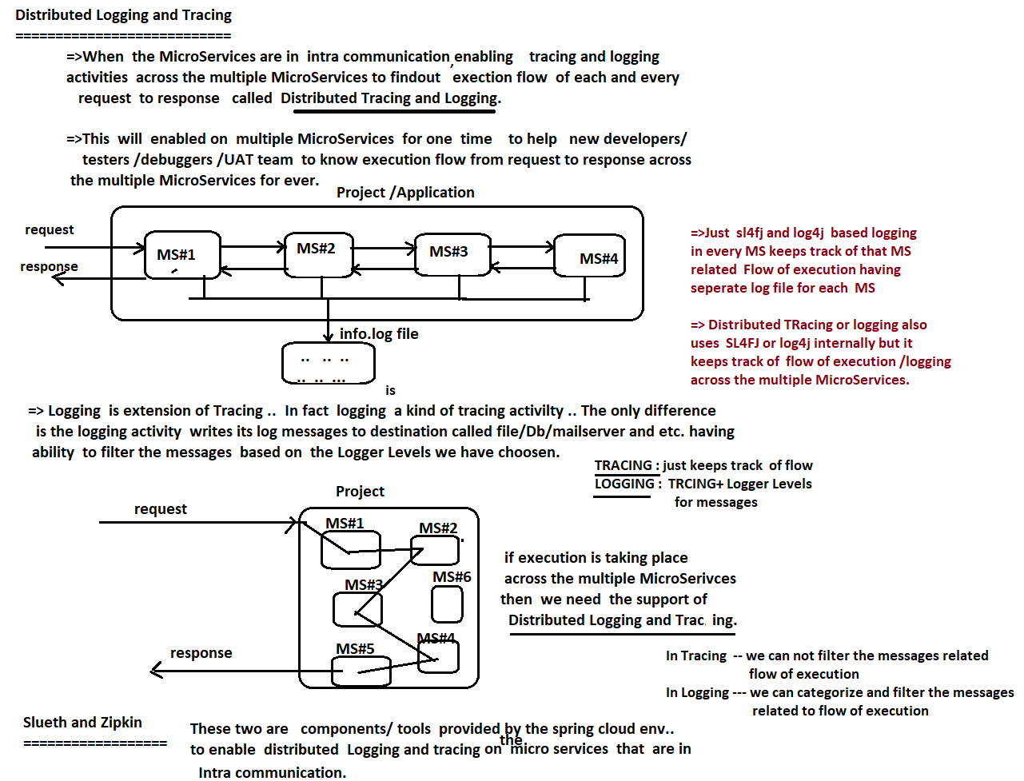

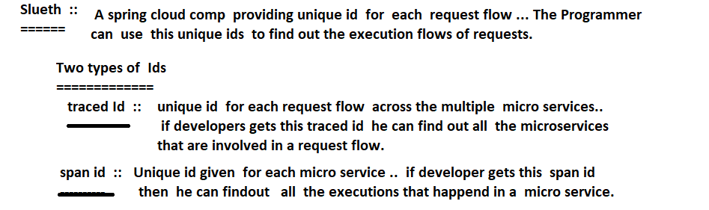

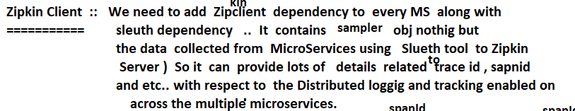

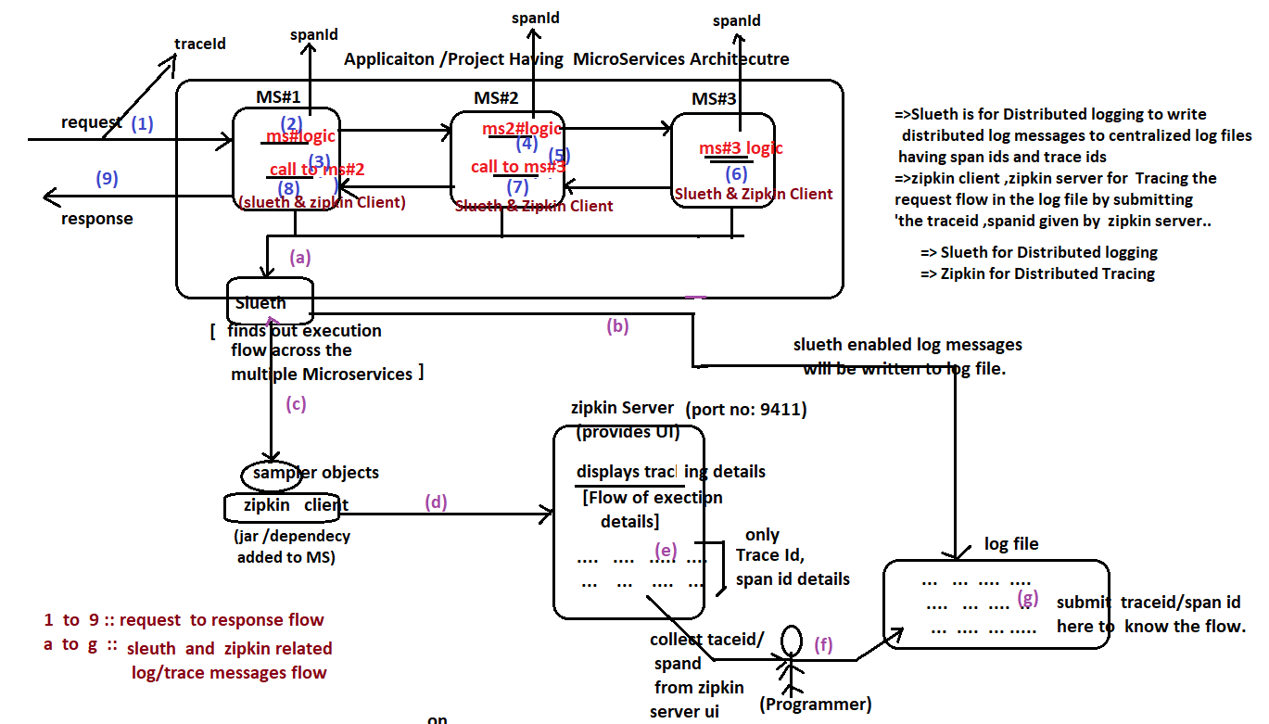

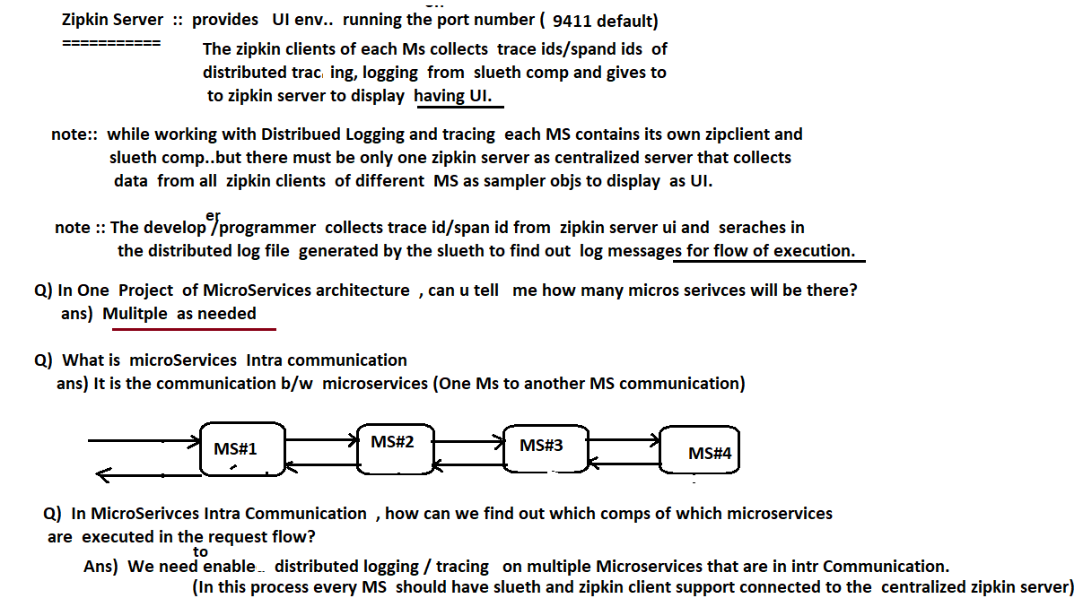

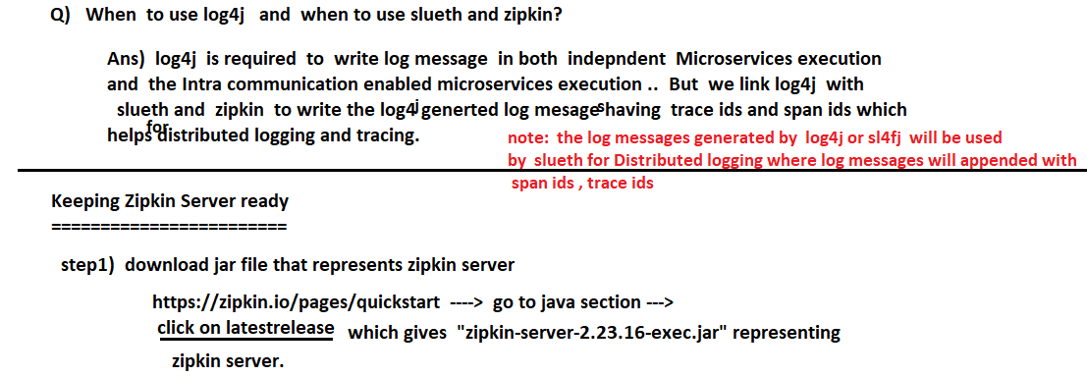

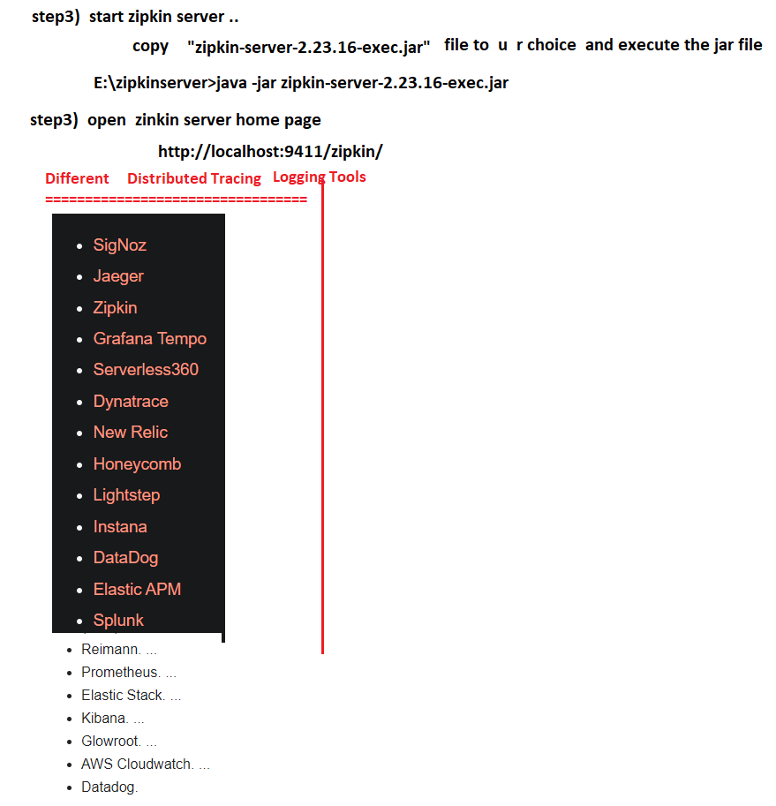

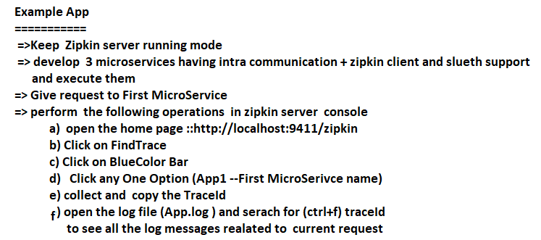

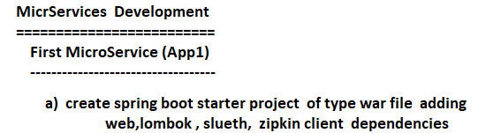

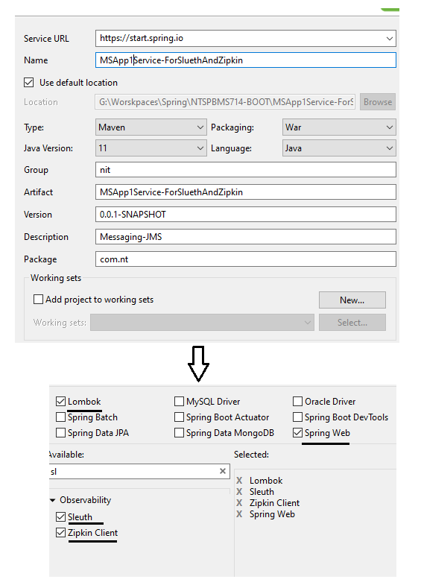

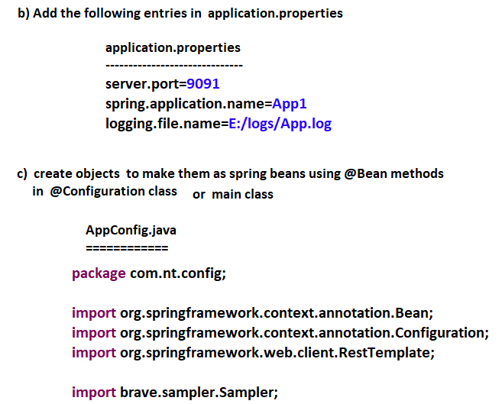

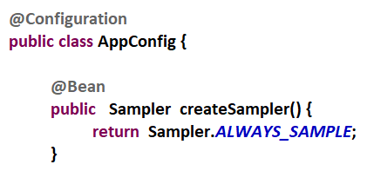

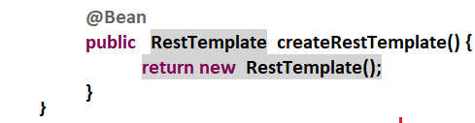

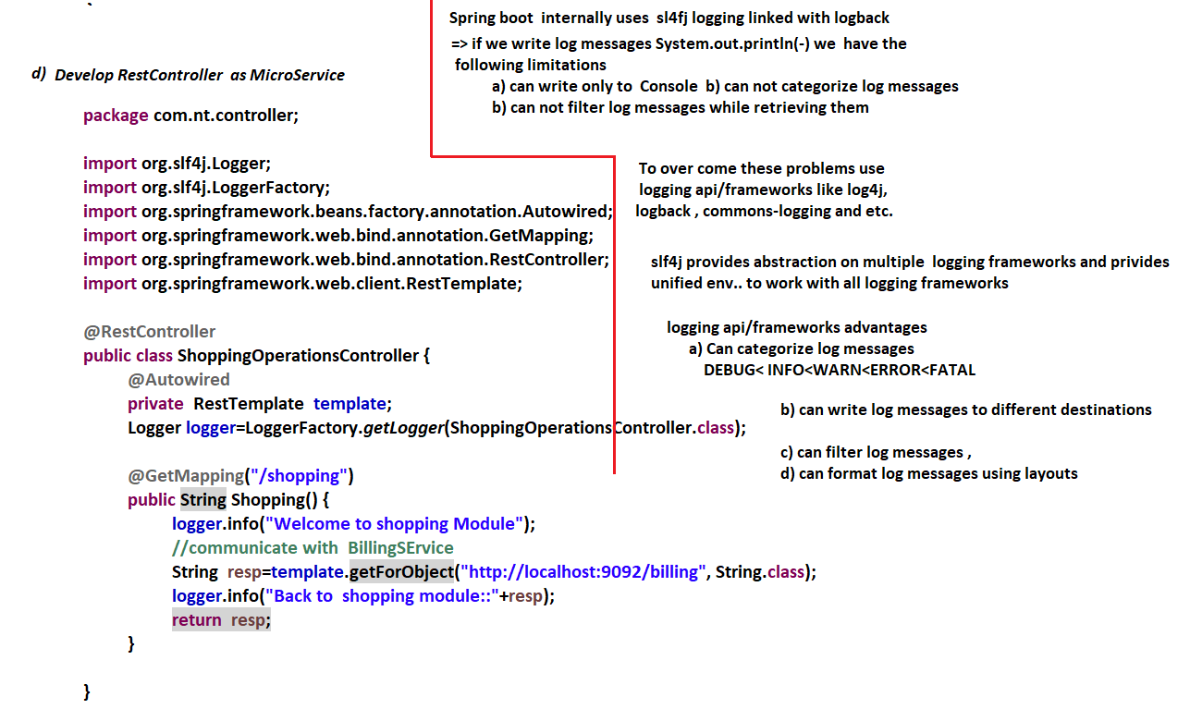

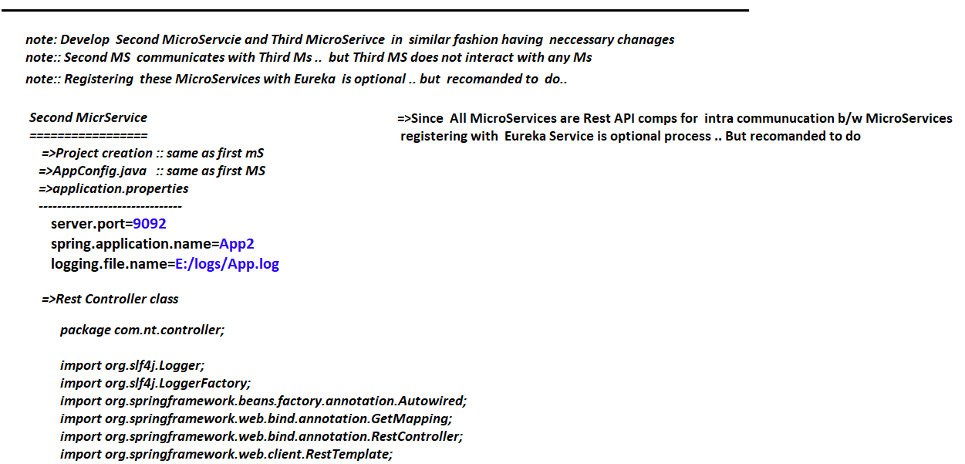

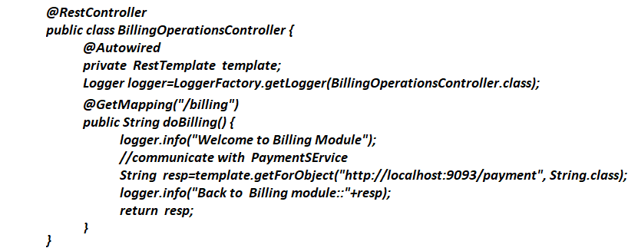

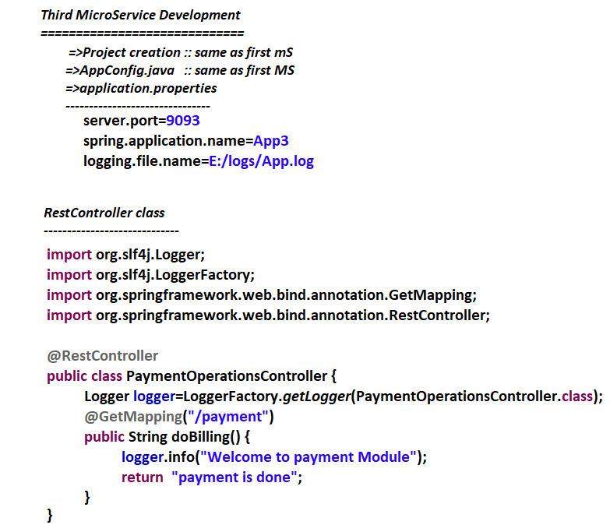

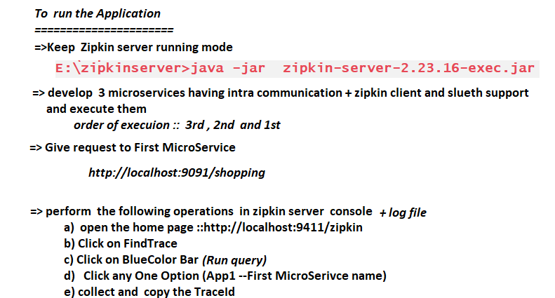

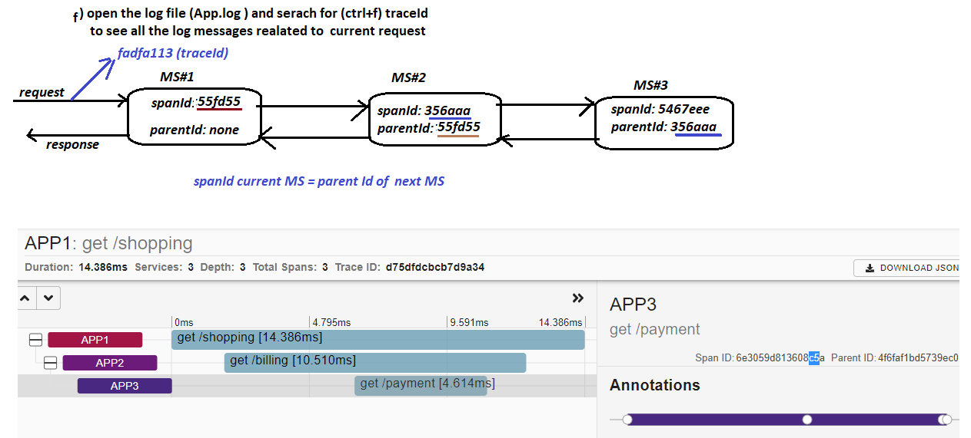

# NTSPBMS615 - API Gateway -zuul -Aug 8-2022

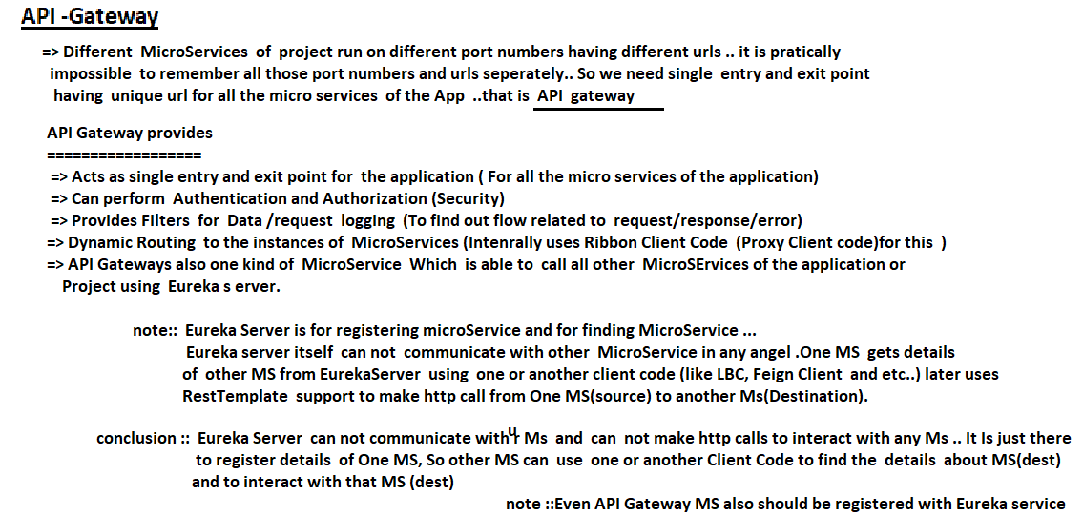

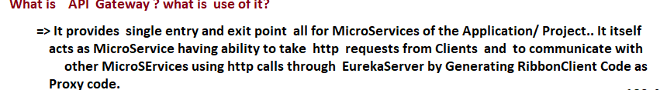

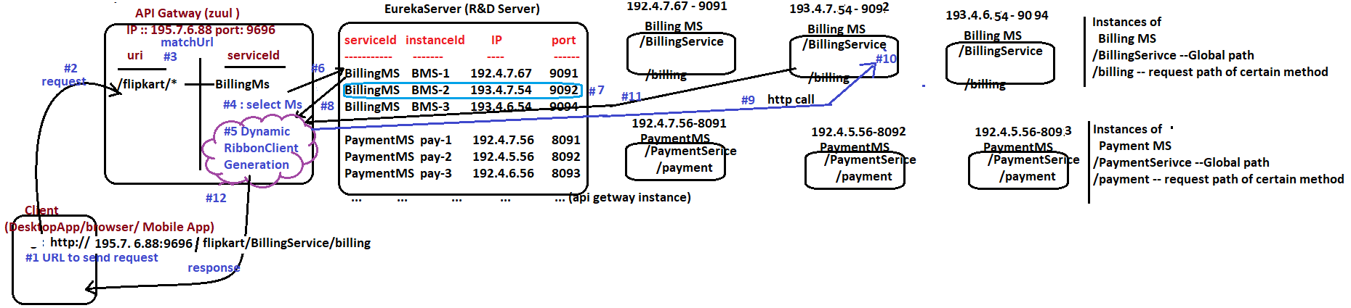

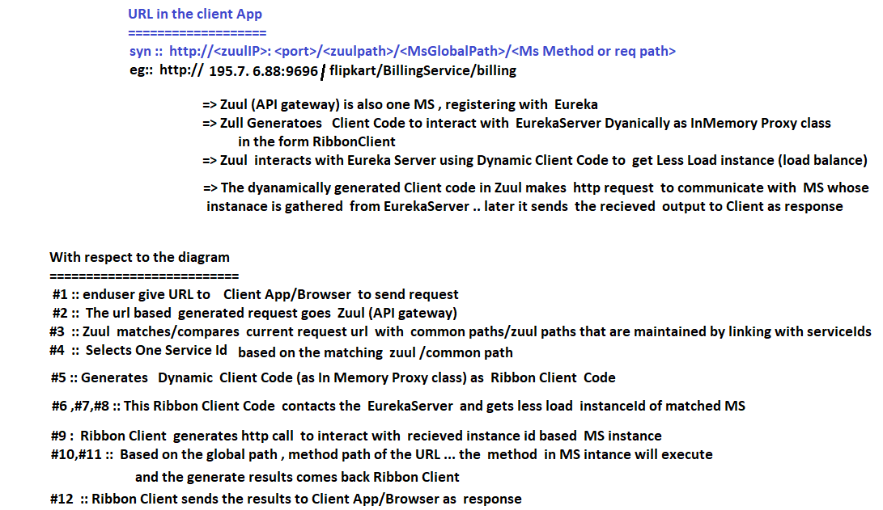

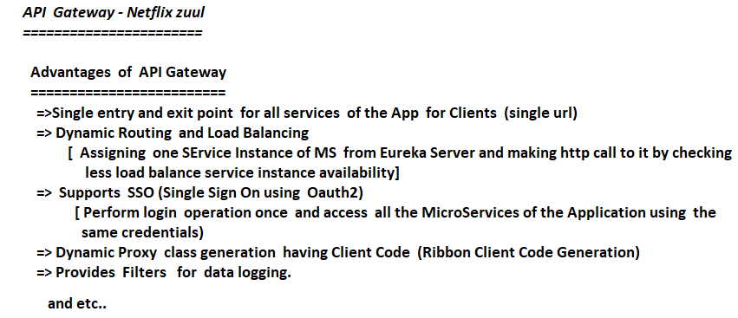

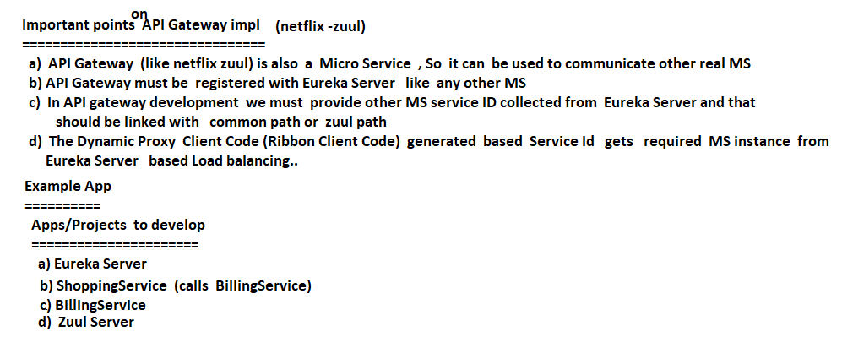

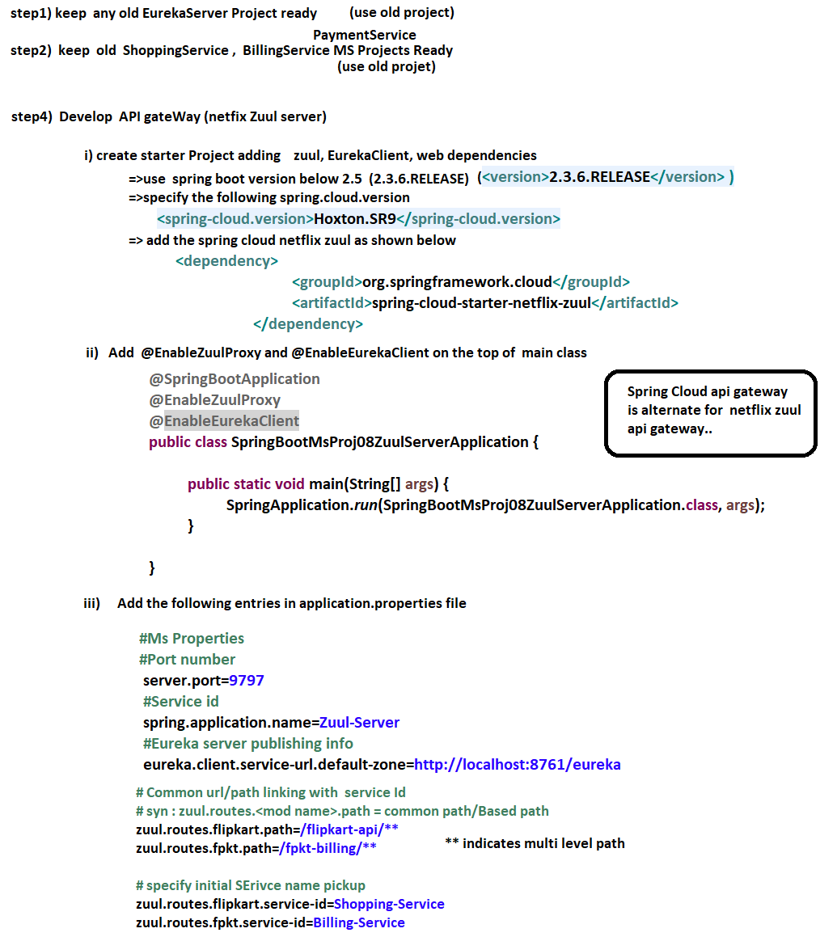

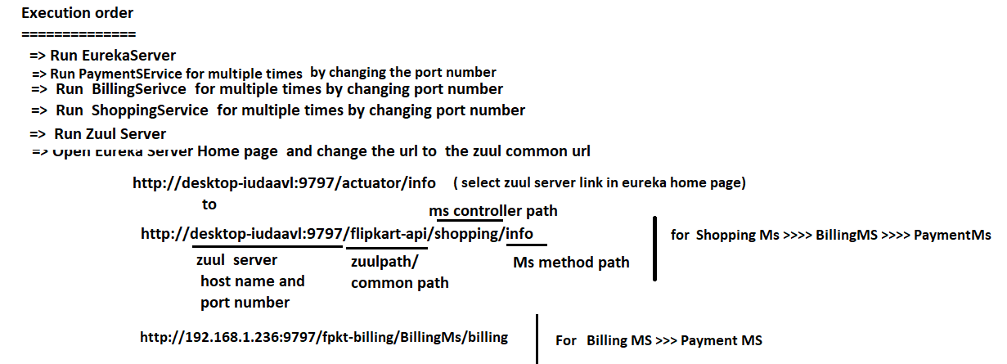

# NTSPBMS615- API Gateway -zuul Filters -Aug 10th-13th2022

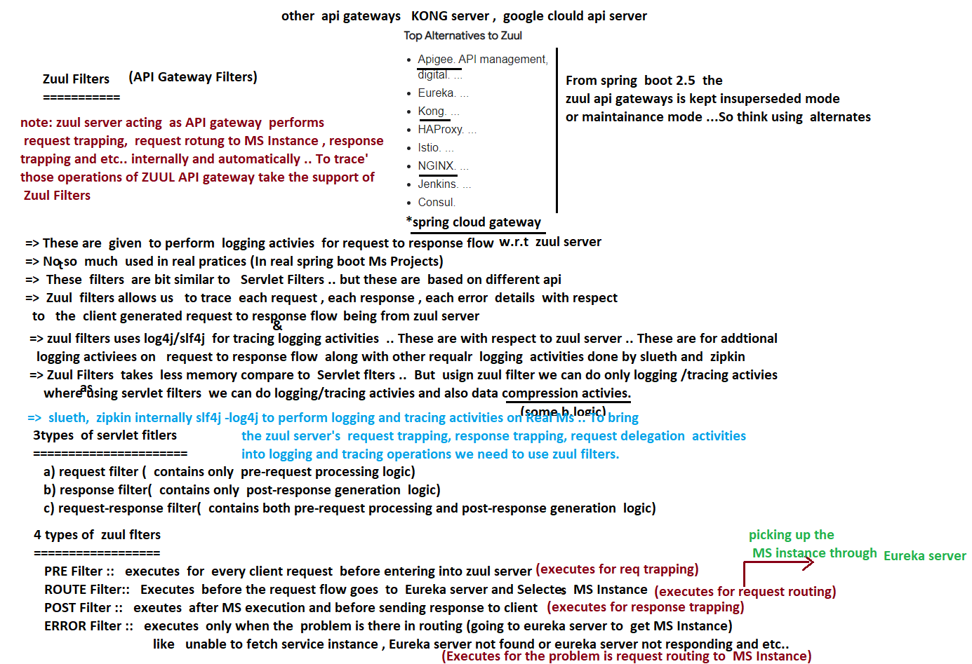

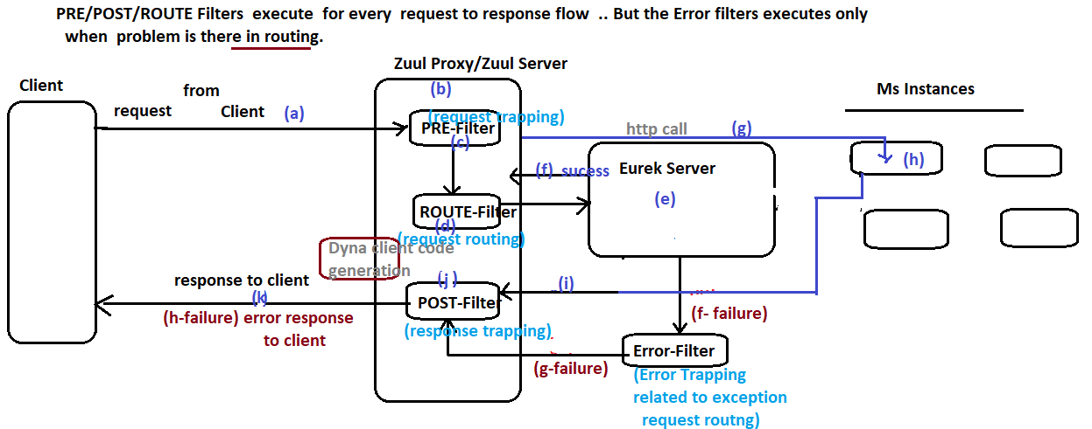

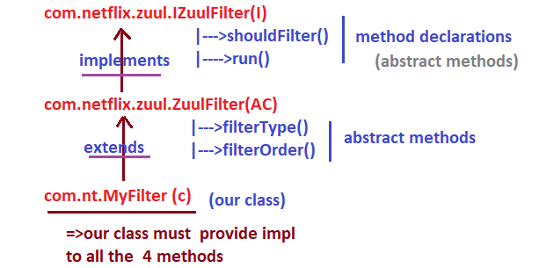

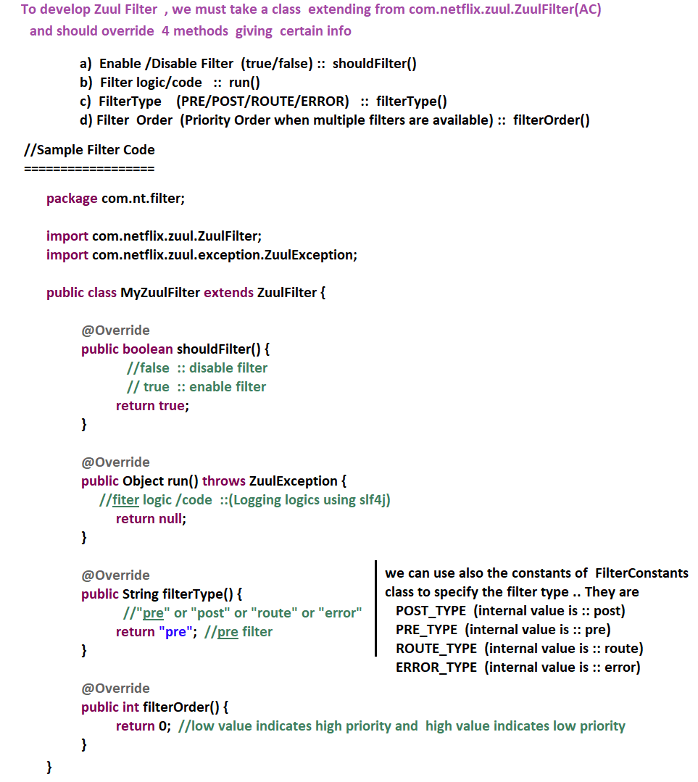

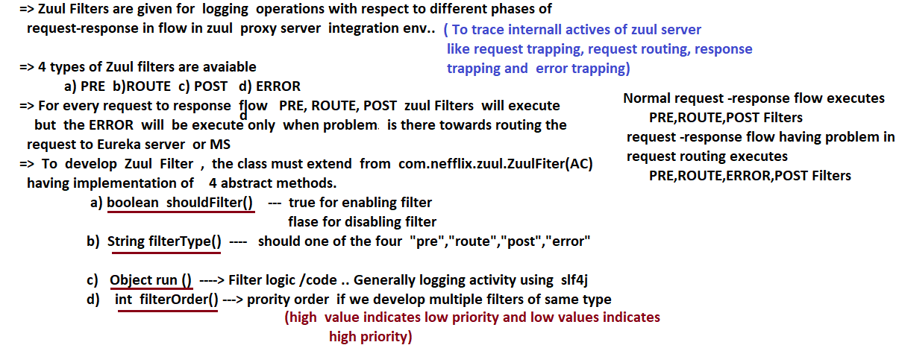

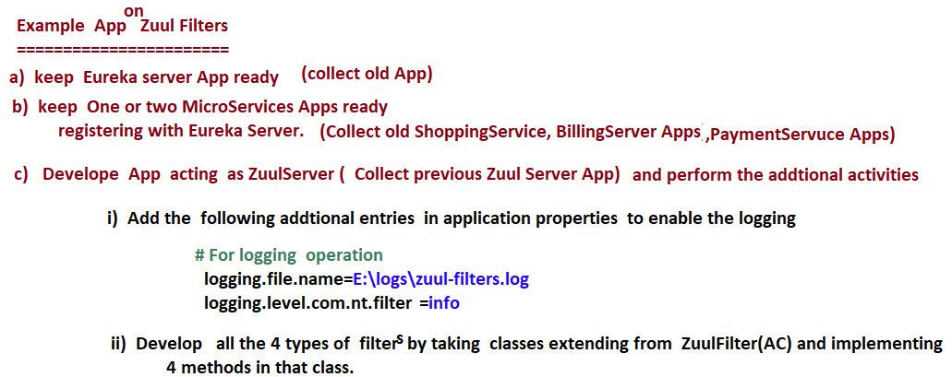

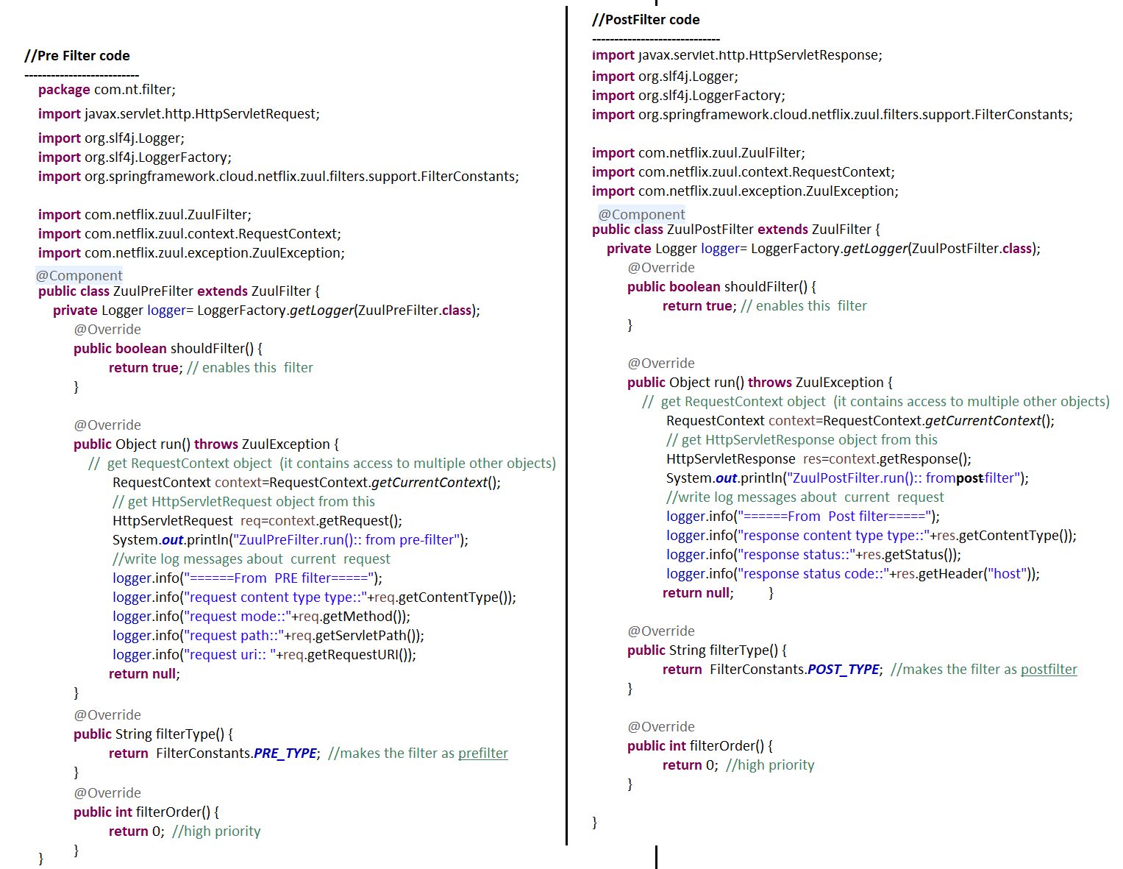

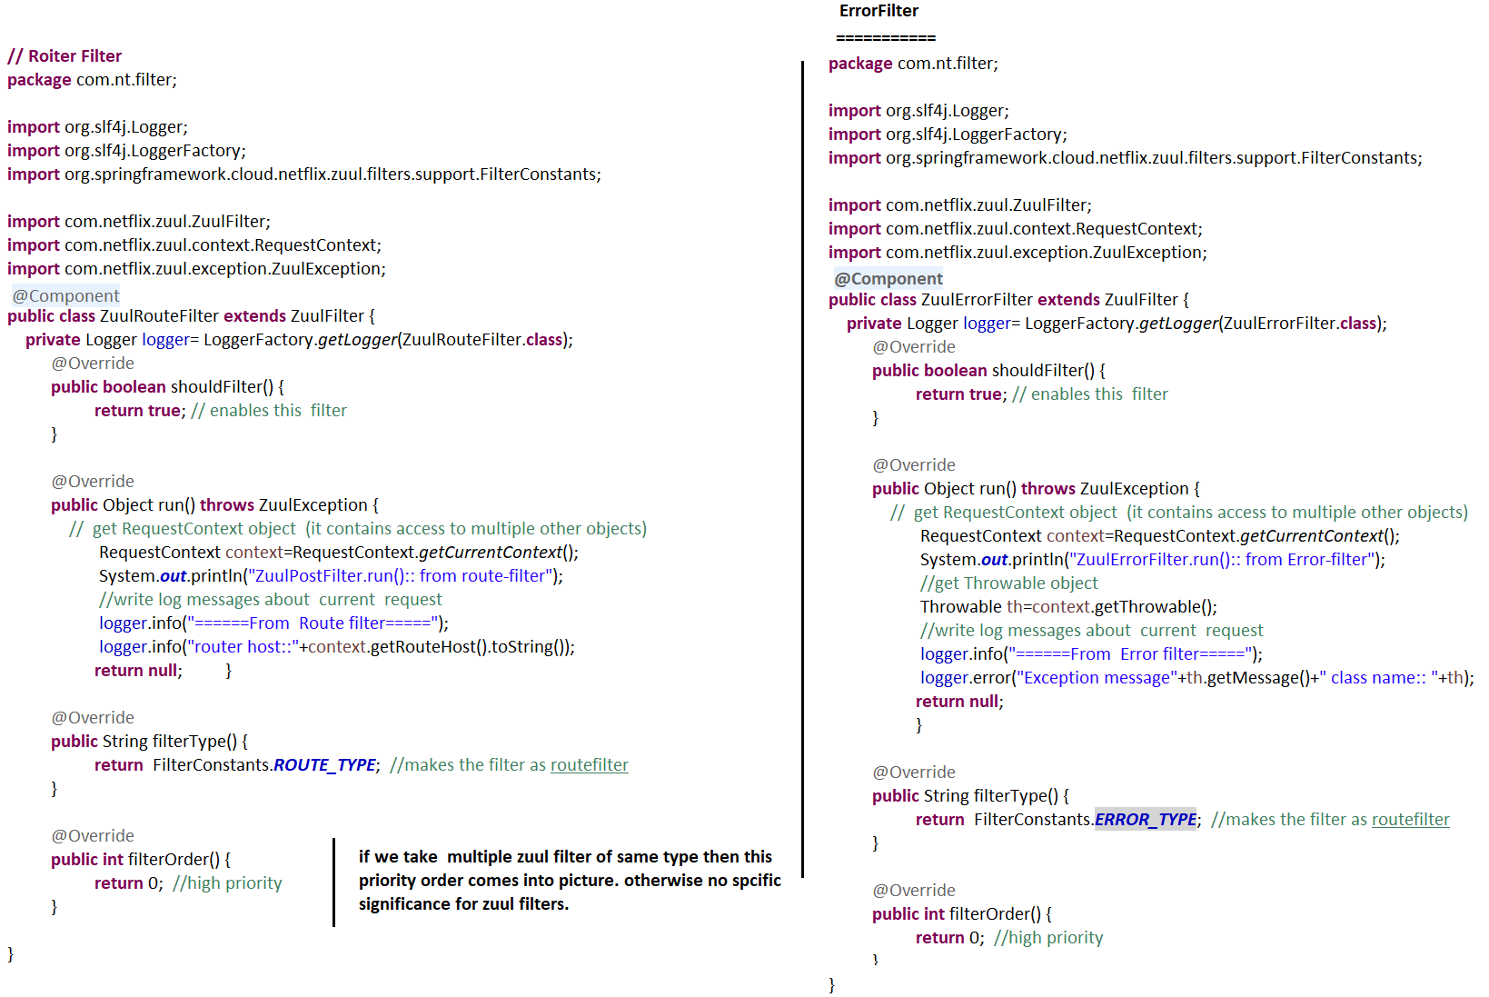

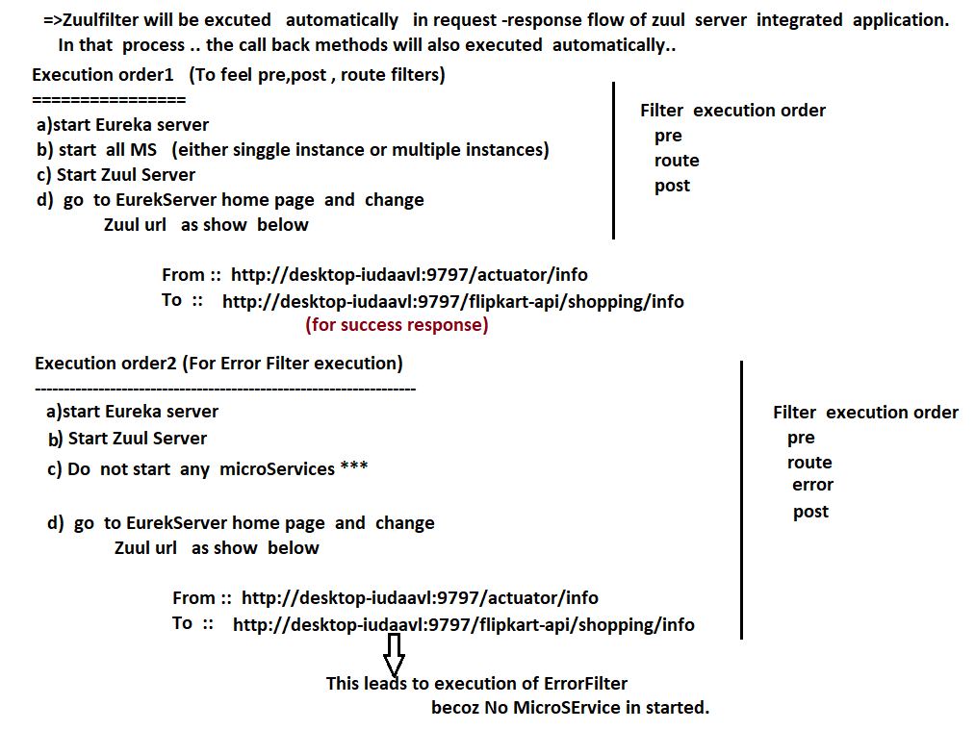

# NTSPBMS615-Intro to spring security -aug14th

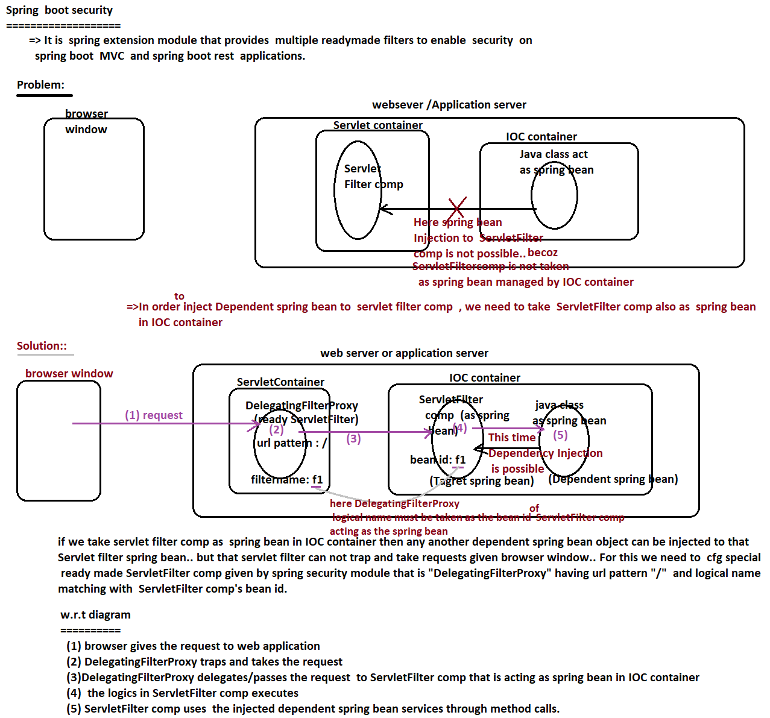

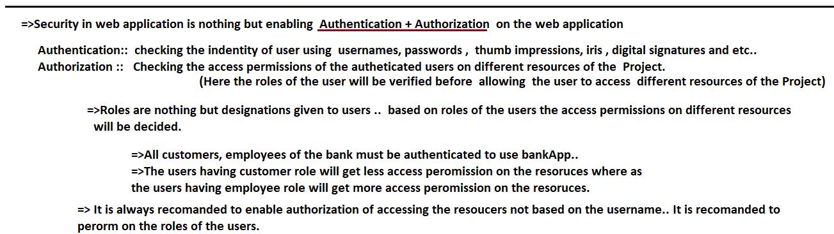

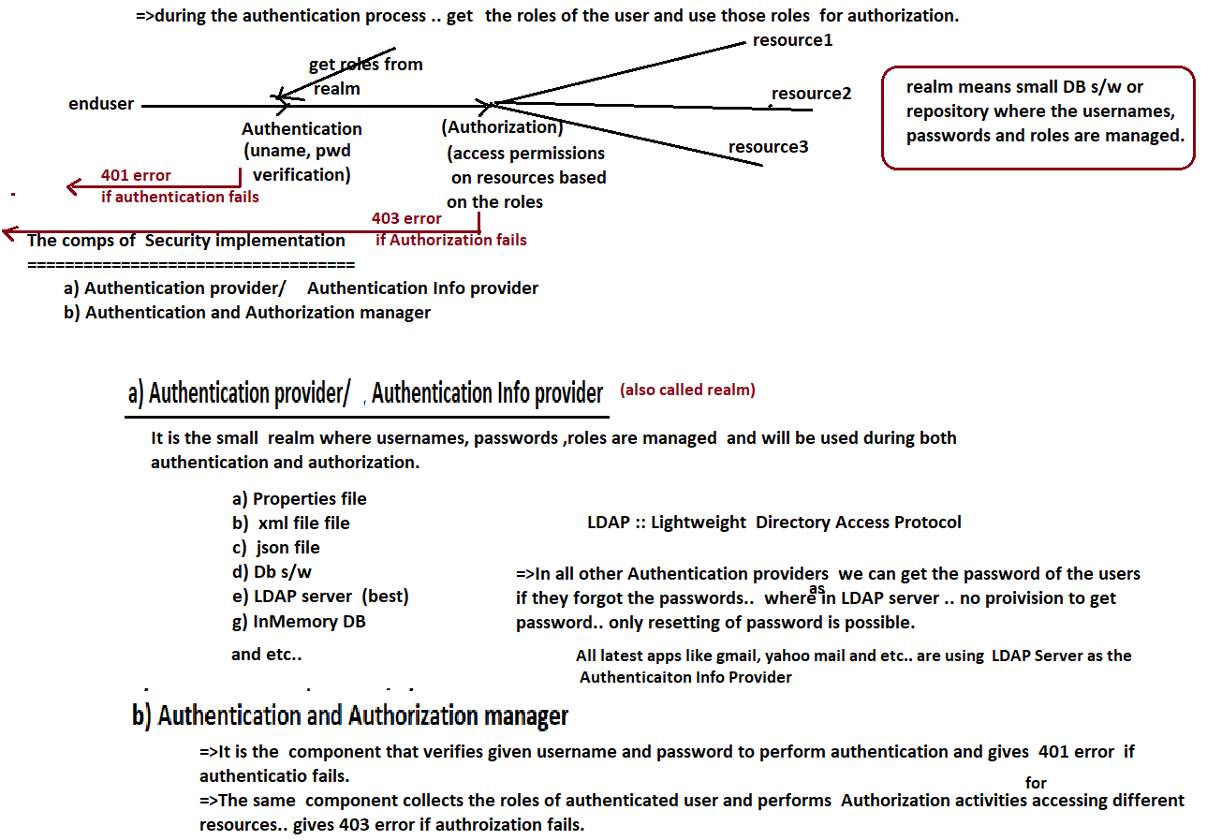

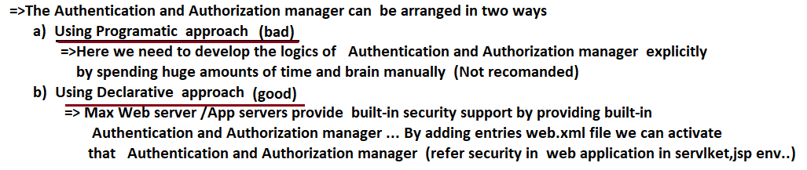

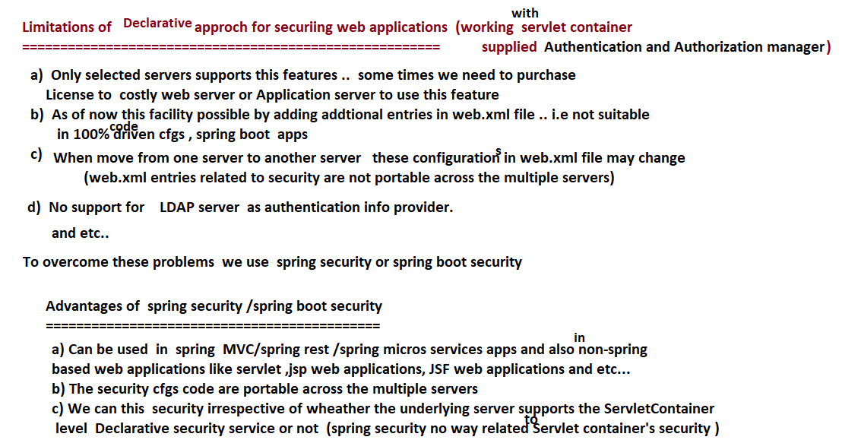

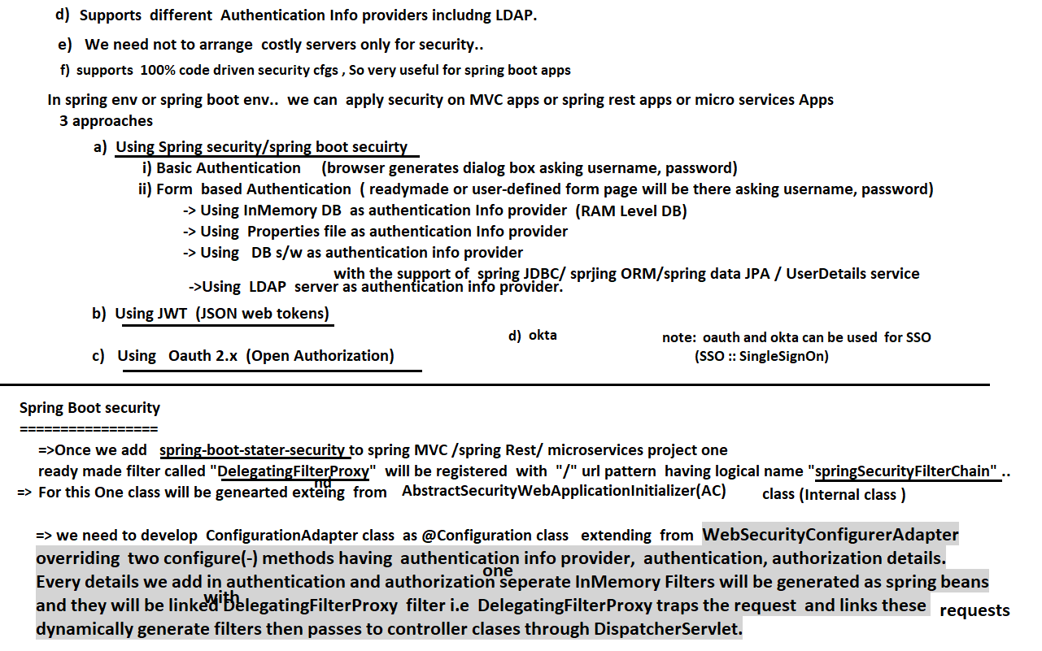

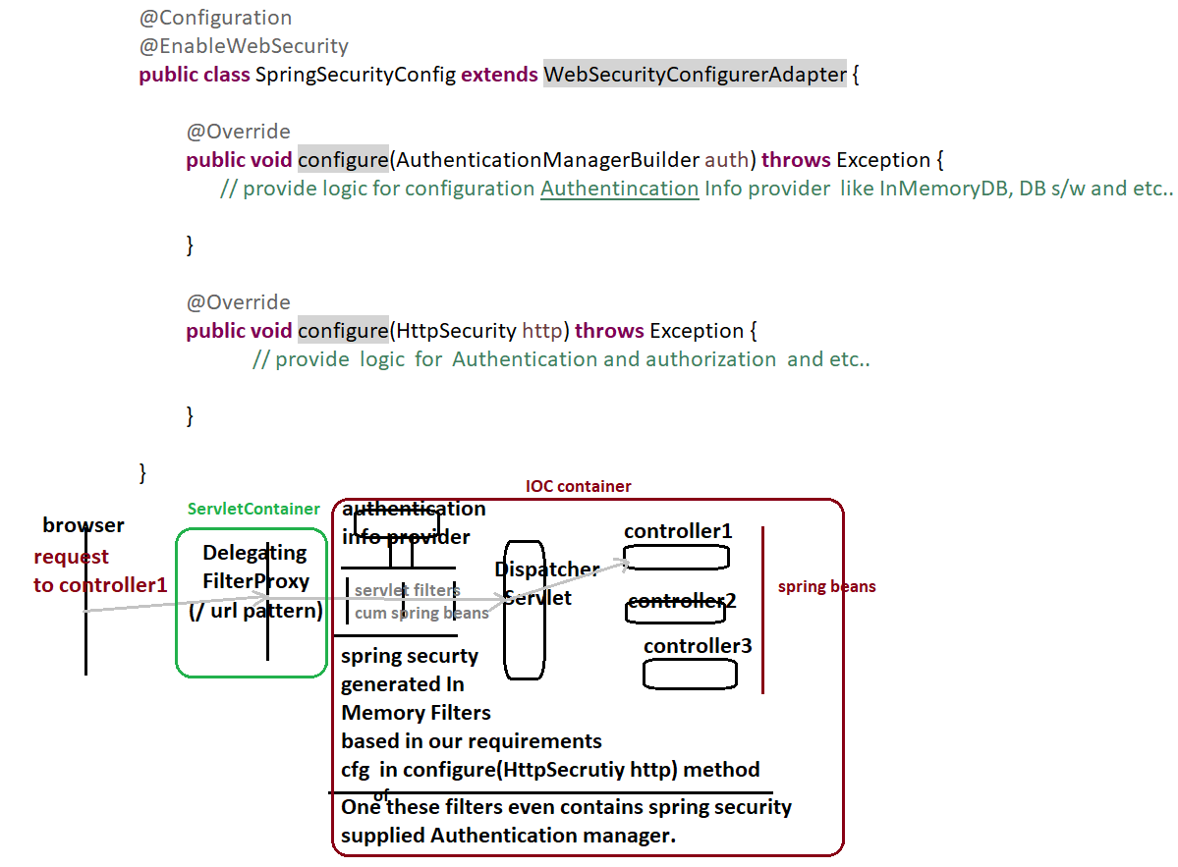

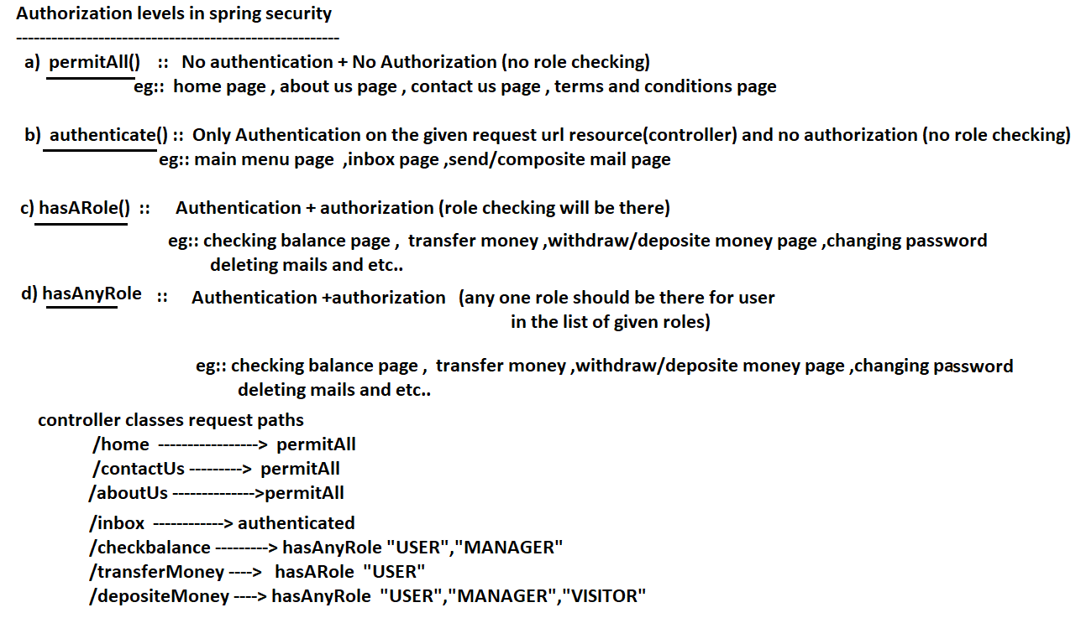

# NTSPBMS615-Example App on Spring Boot Security -Aug 16th

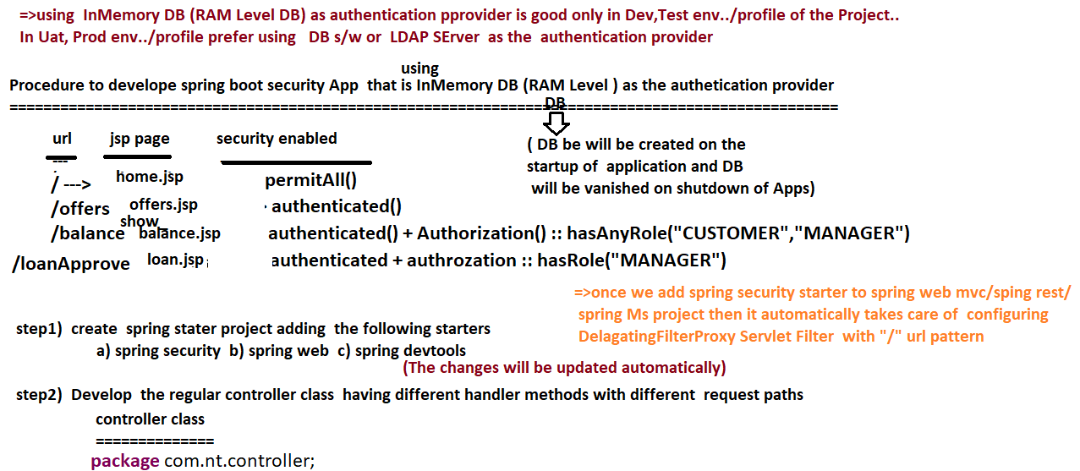



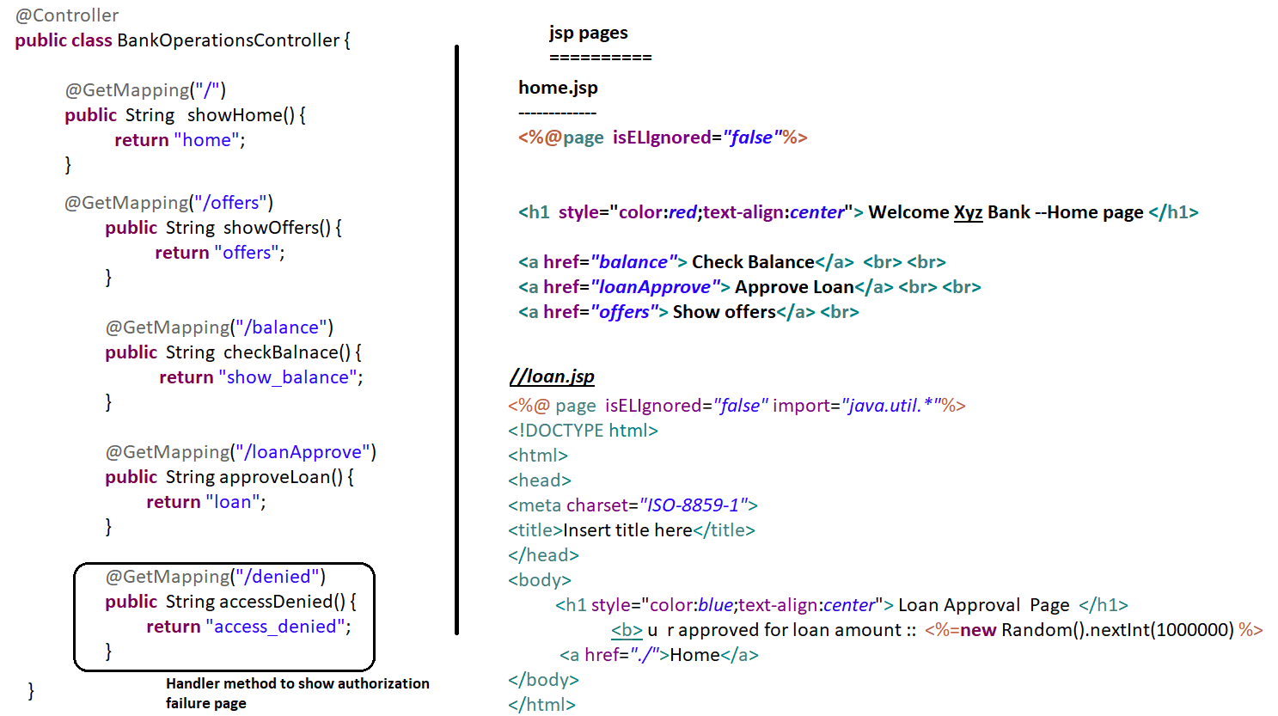

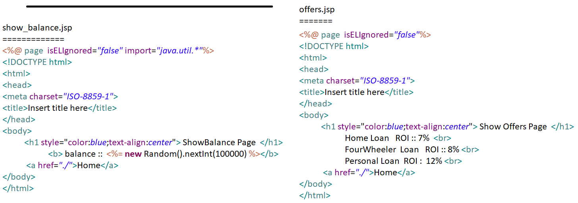

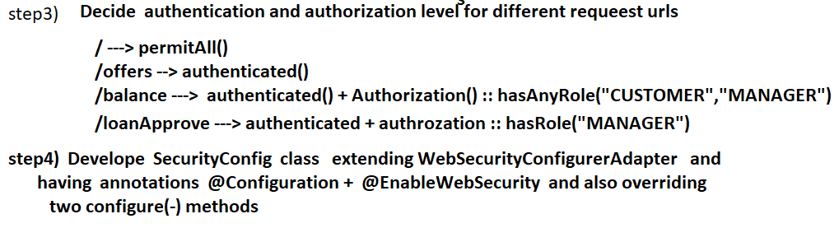

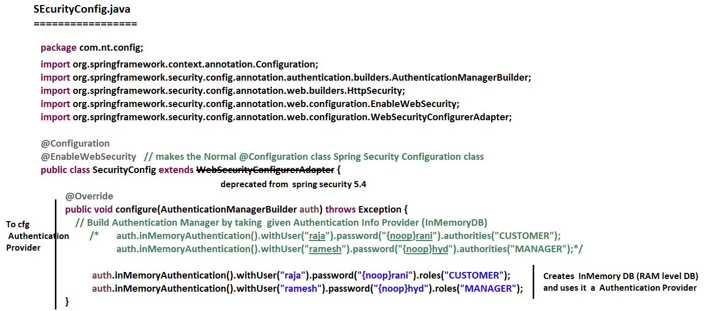

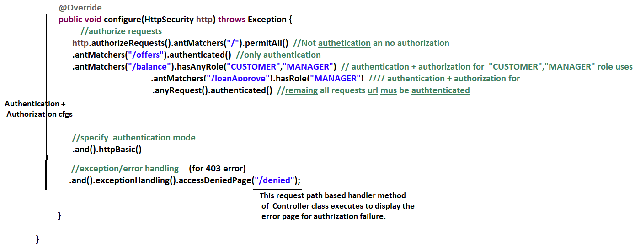

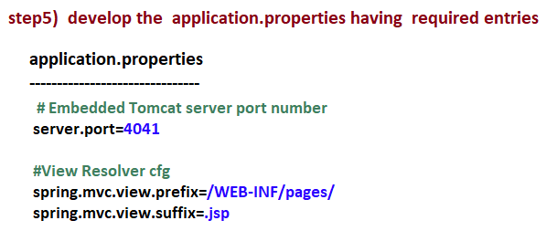

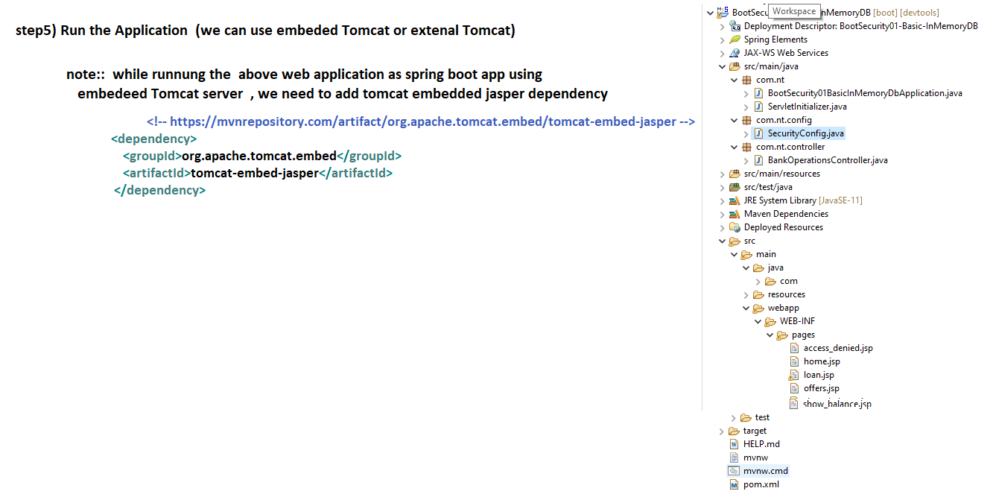

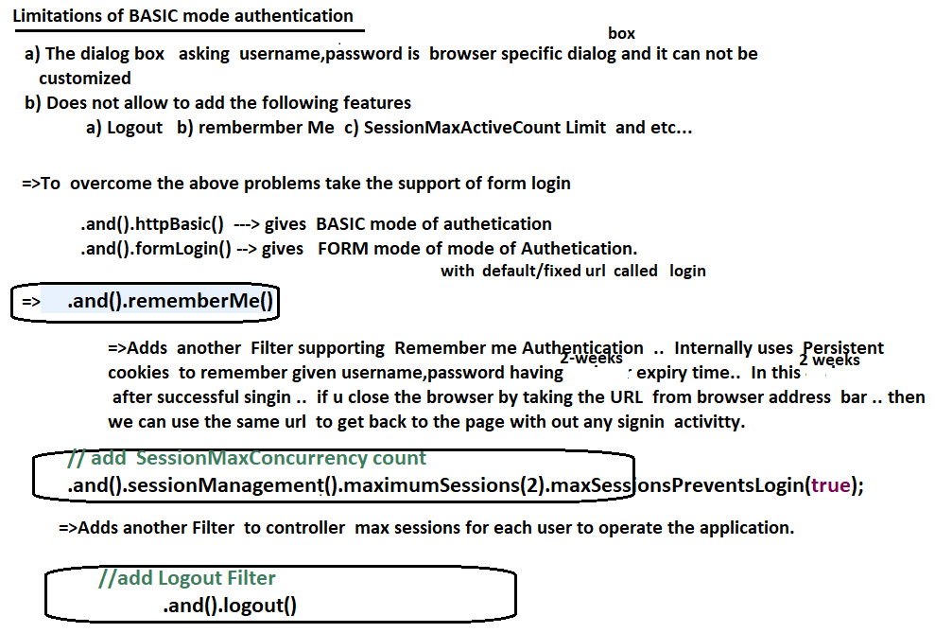

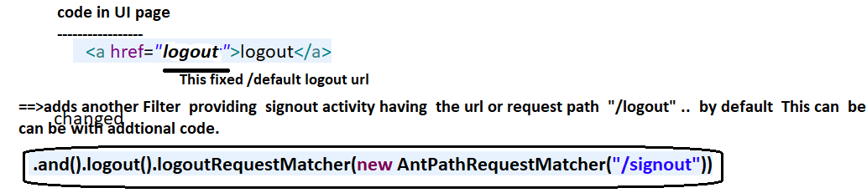

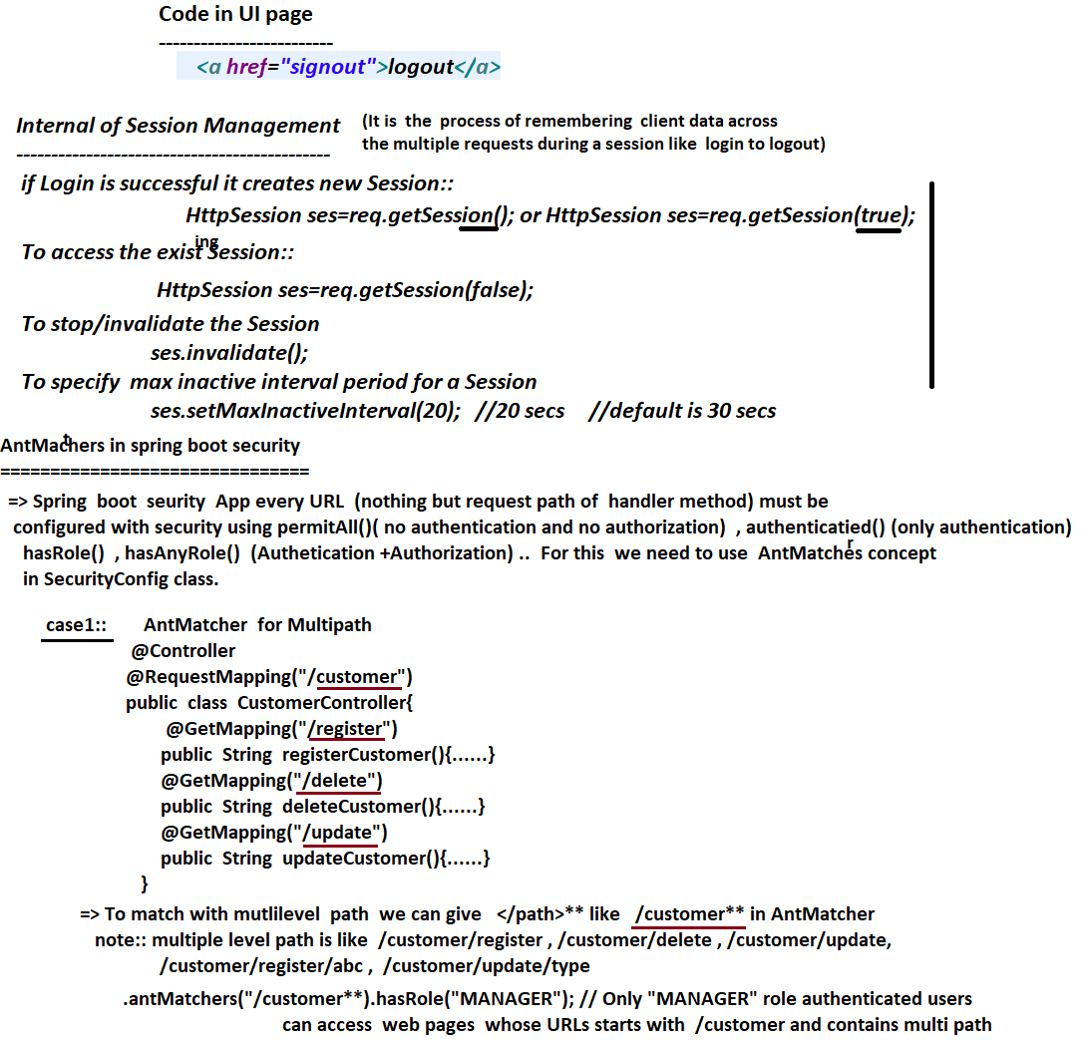

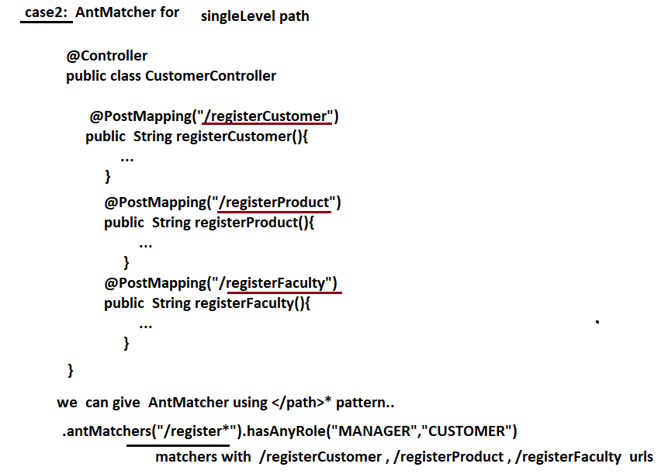

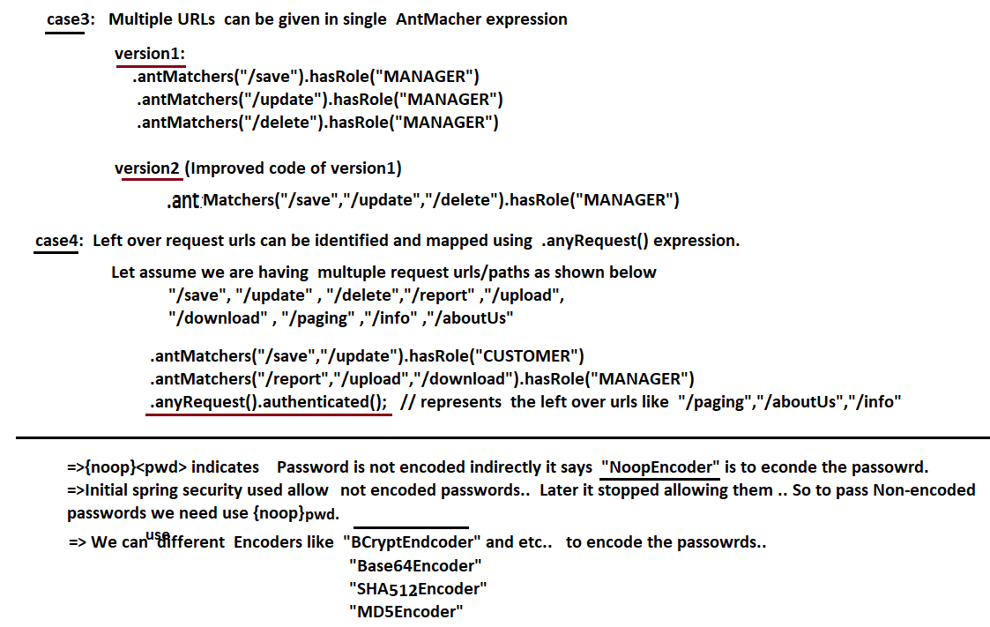

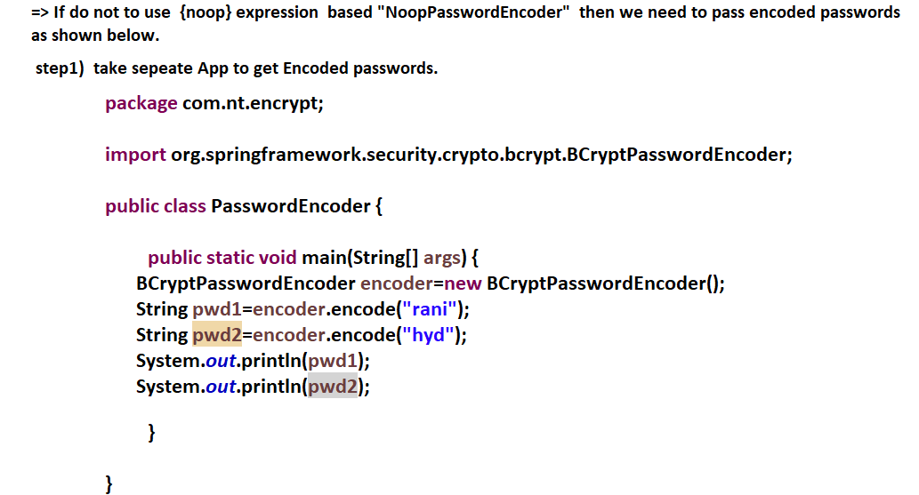





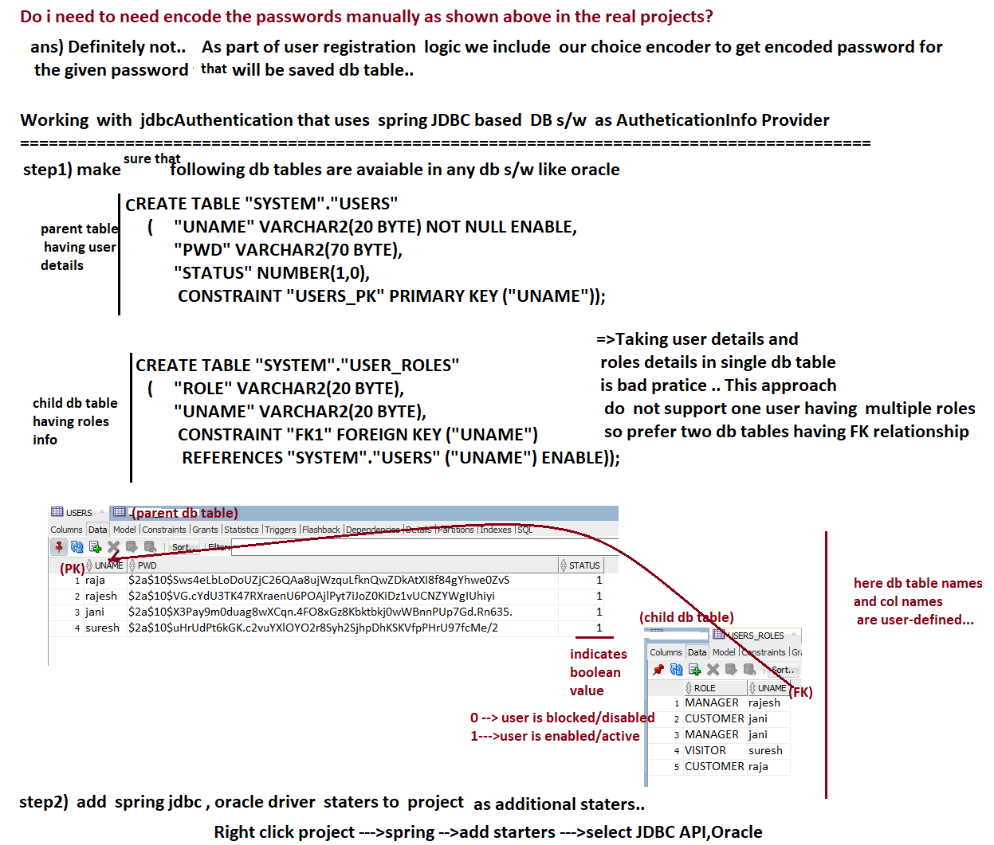

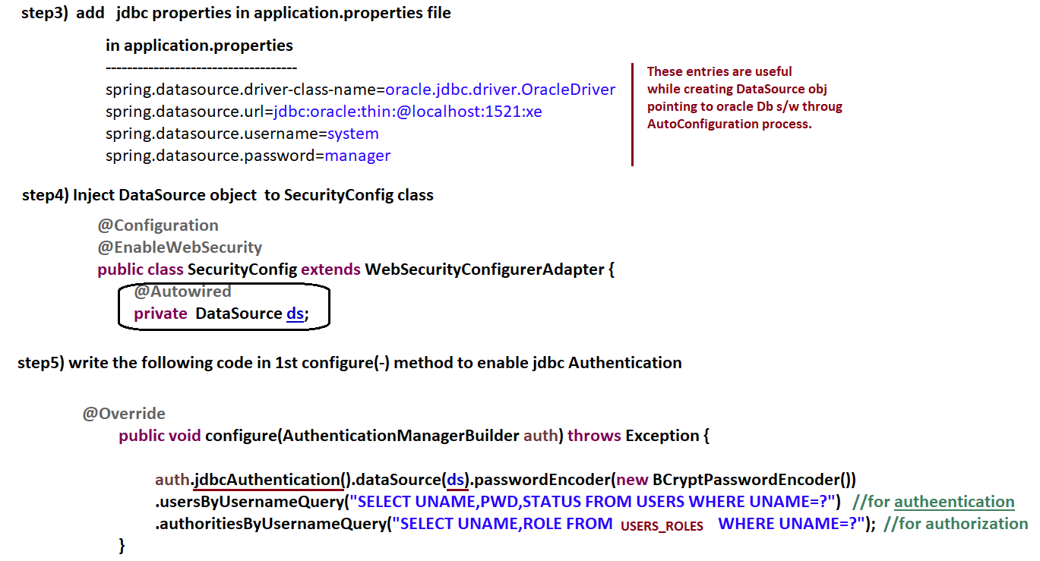

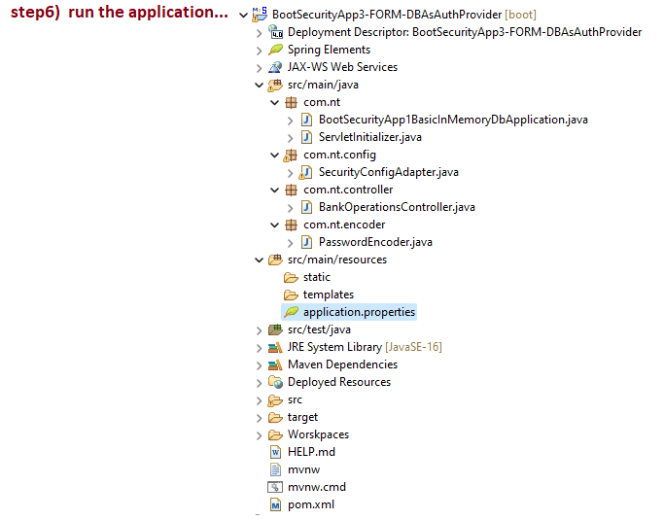

# NTSPBMS615-Spring Boot Security with Spring data JPA -aug21st NTSPBMS615-Spring Boot Security with Spring data JPA -aug22nd

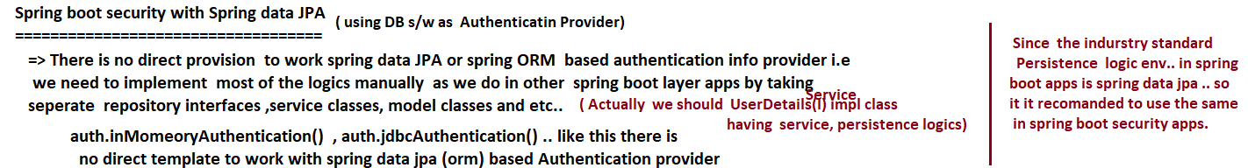

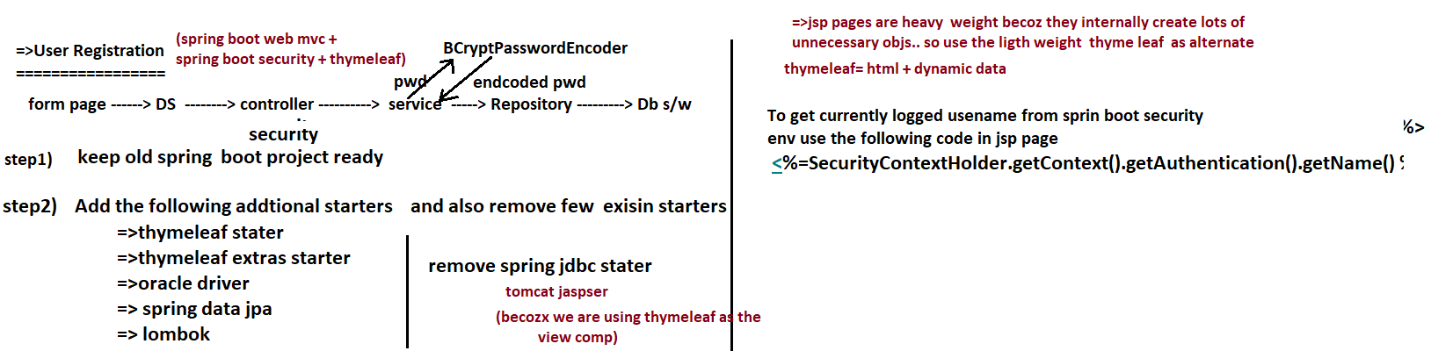

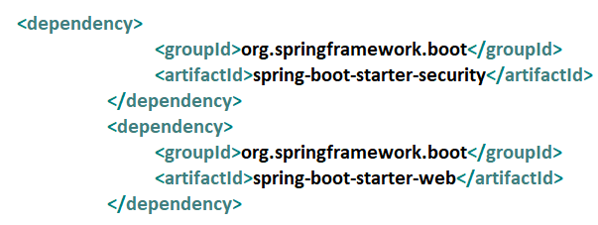

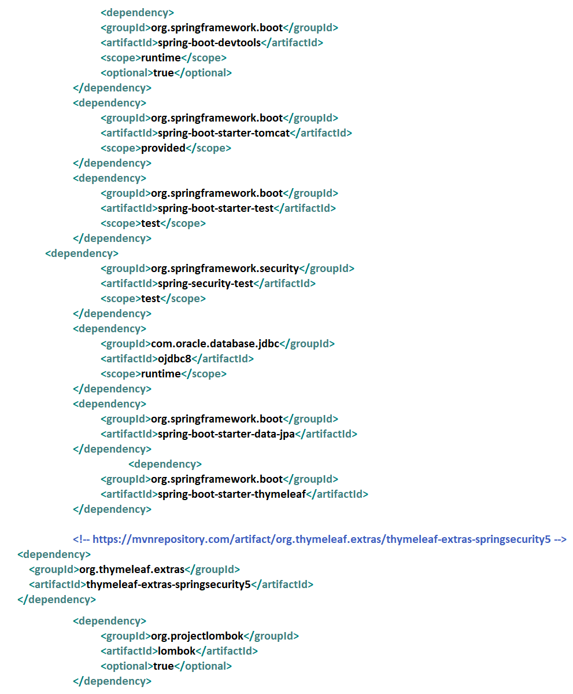

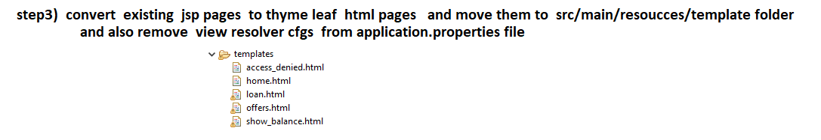

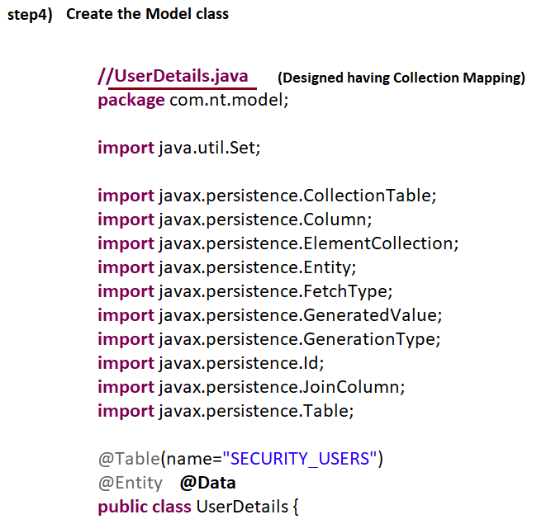

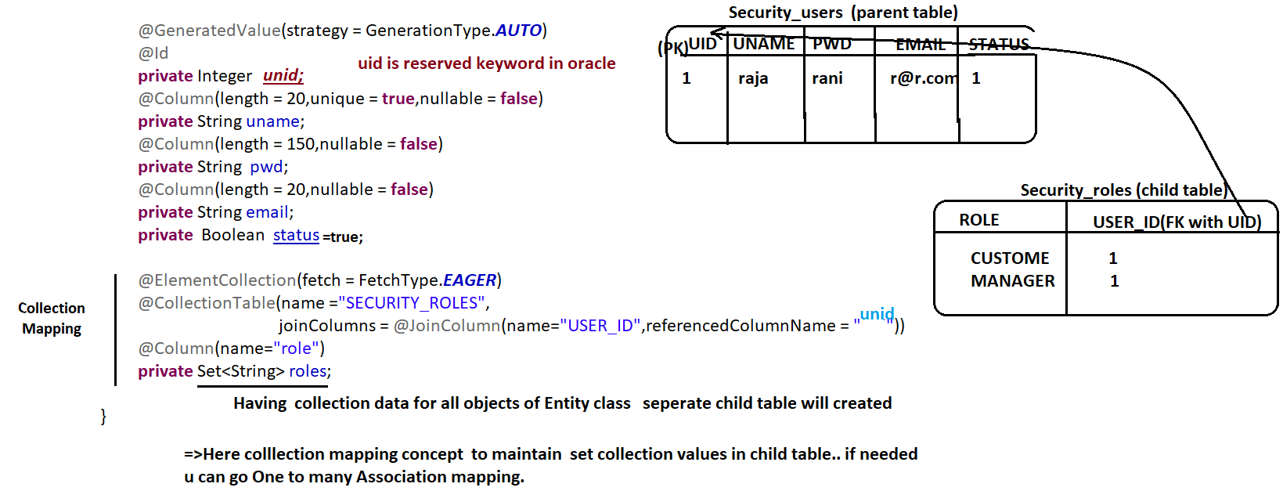

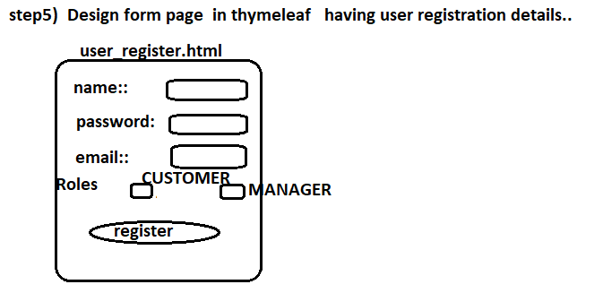

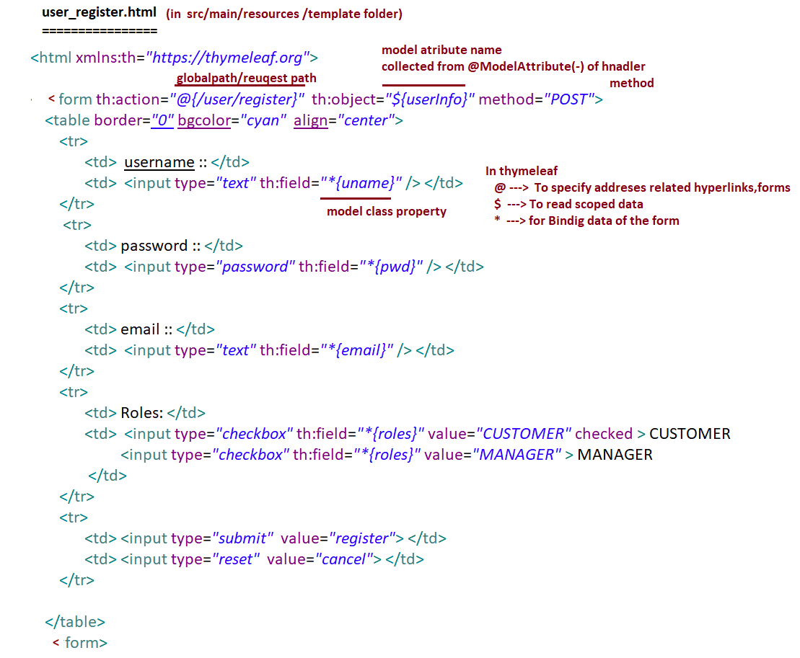

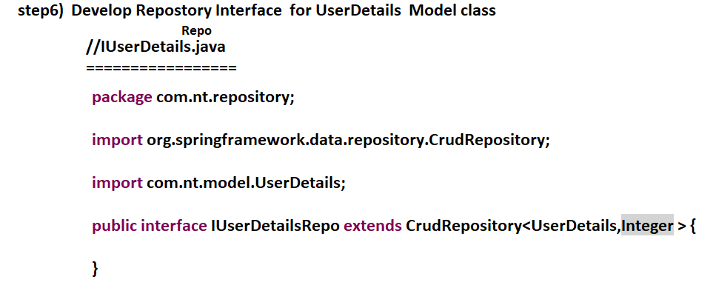

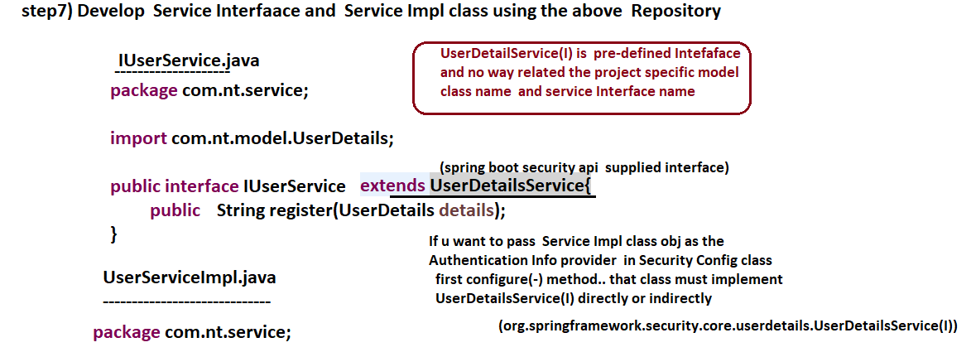

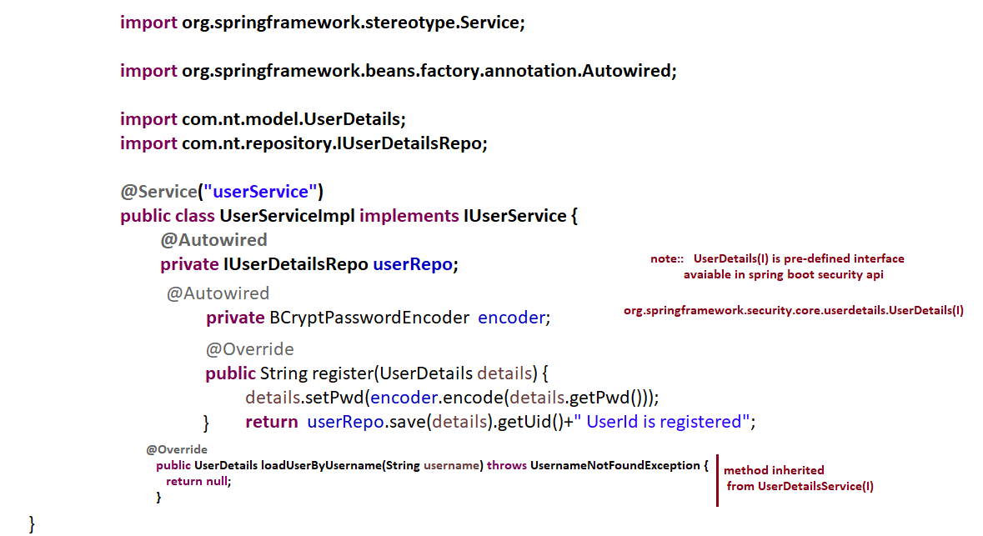

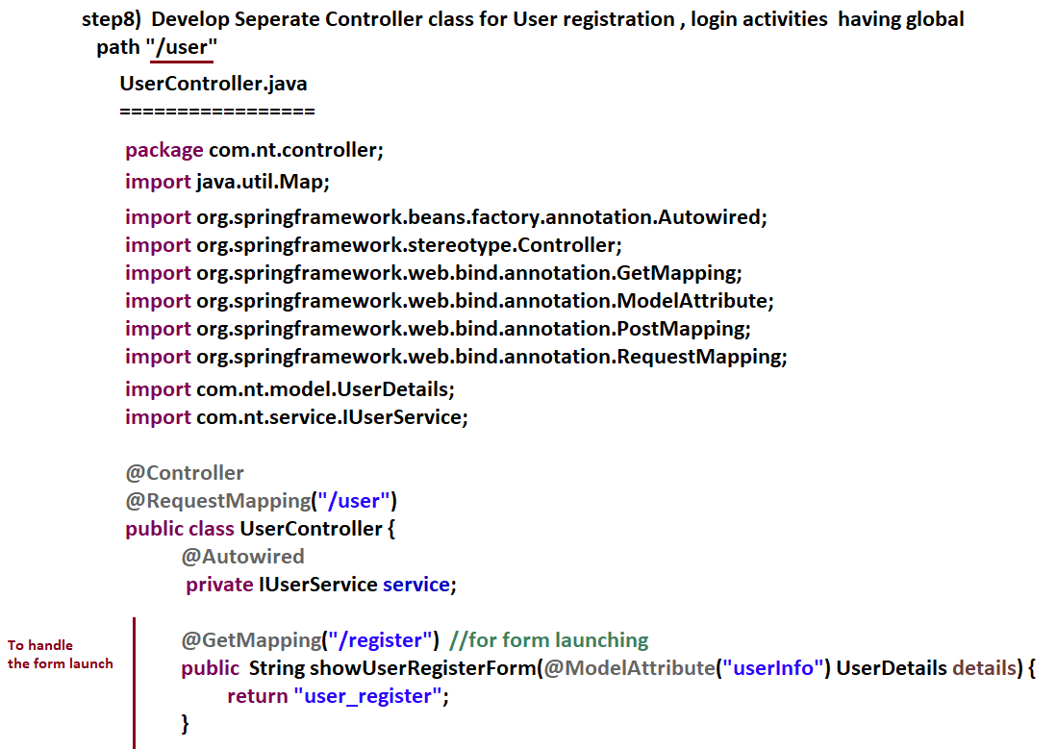

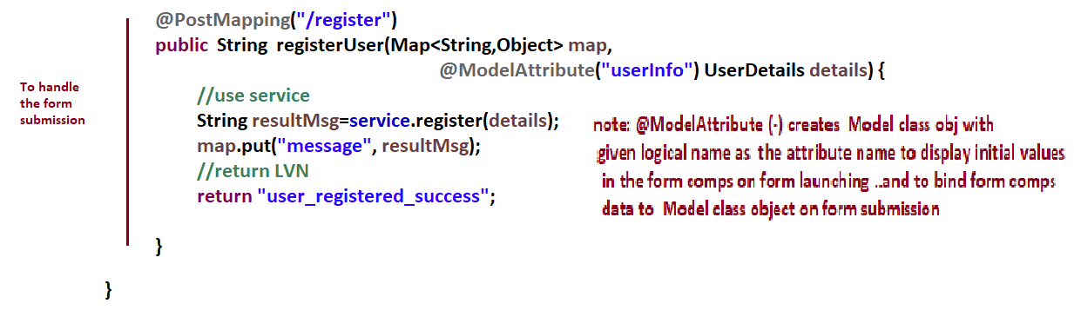

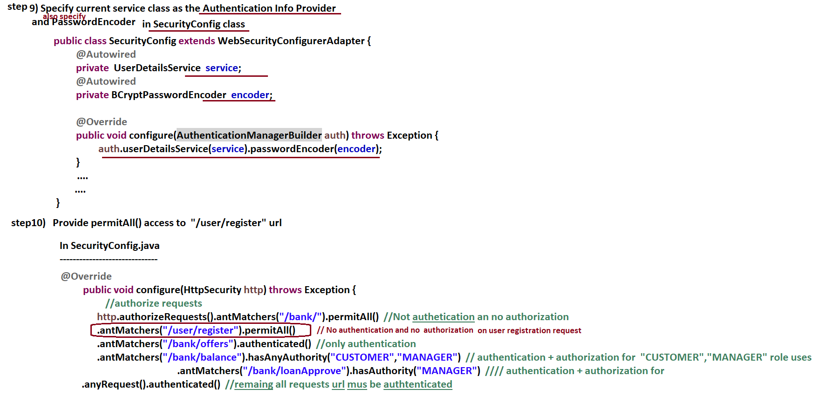

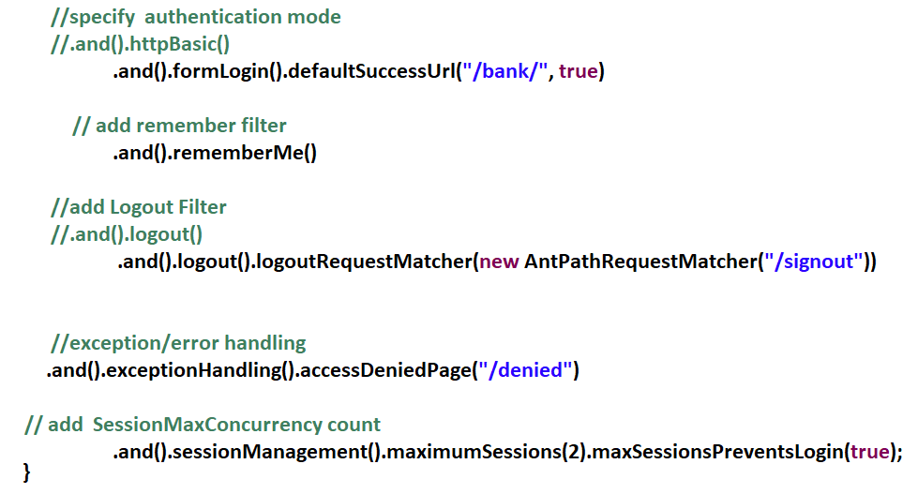

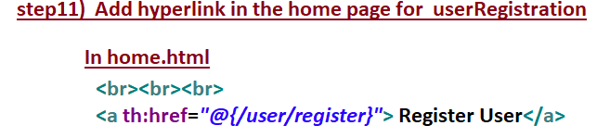

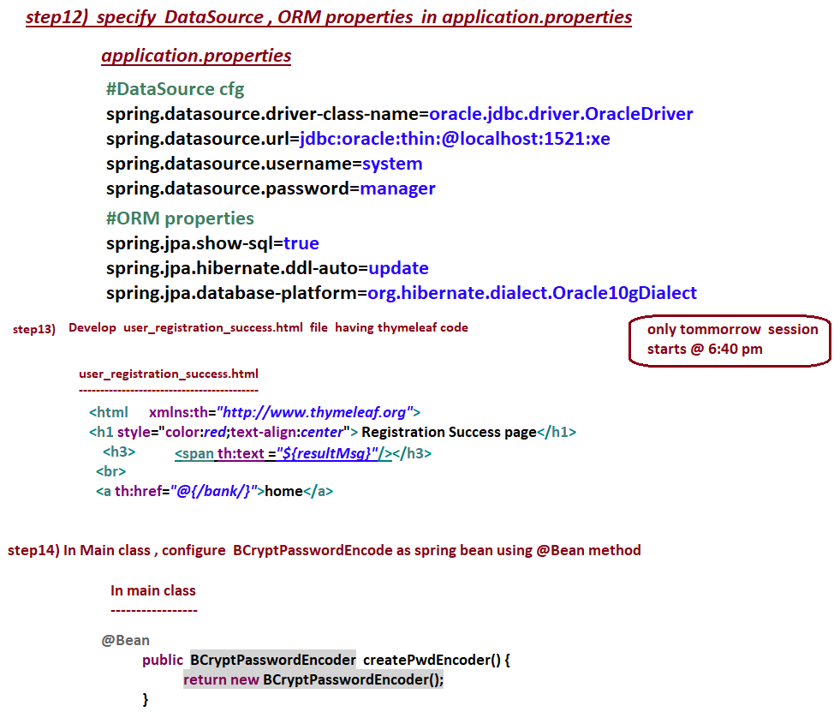

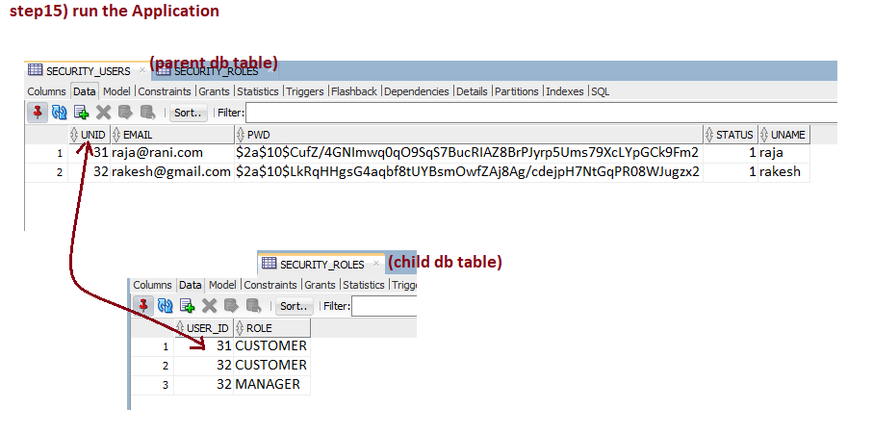

# NTSPBMS615- Aug 23rd -2022-Spring Boot Security with Spring data JPA

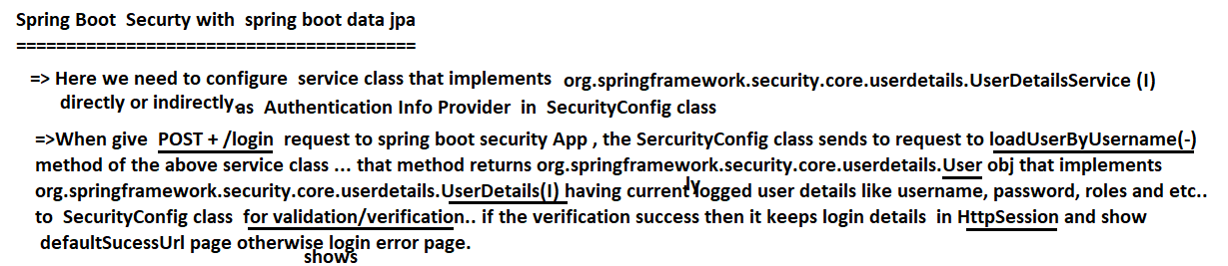

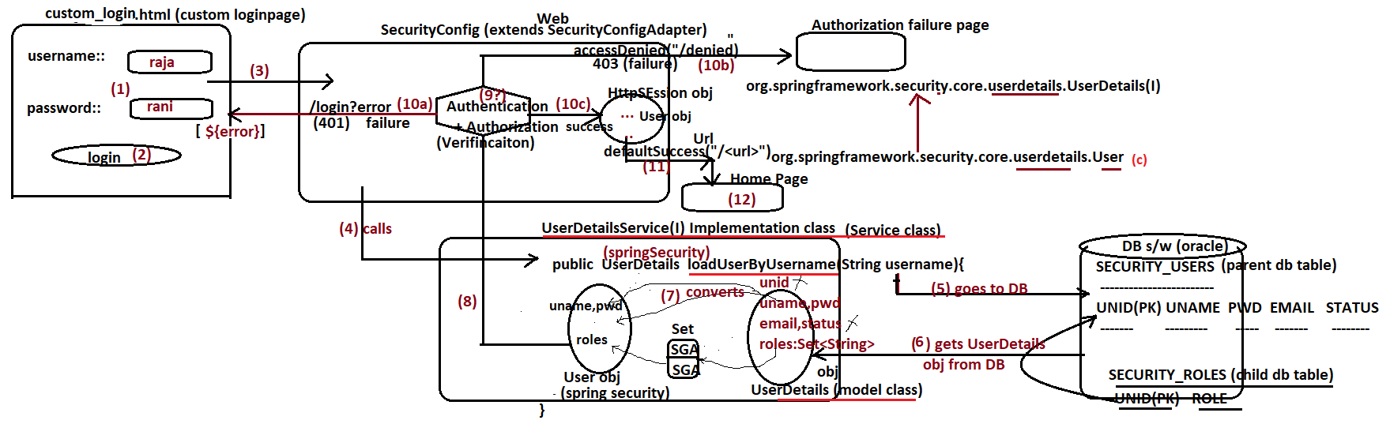

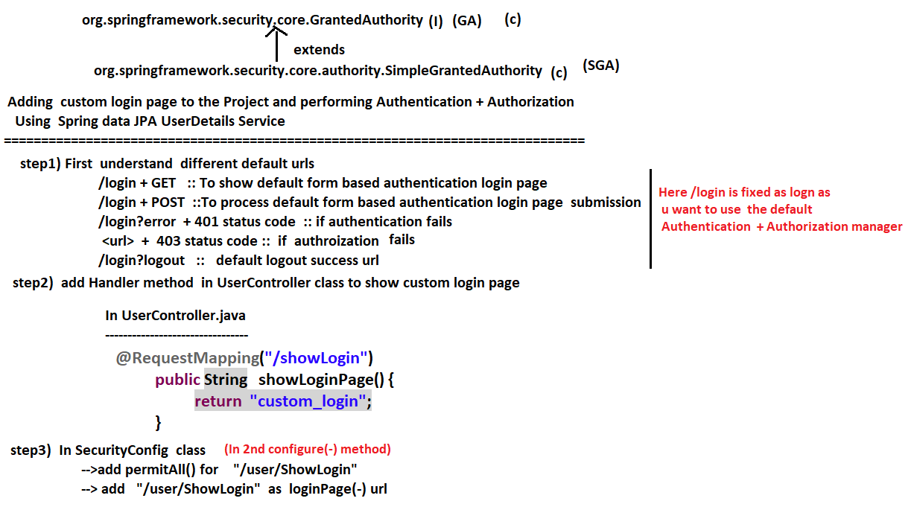

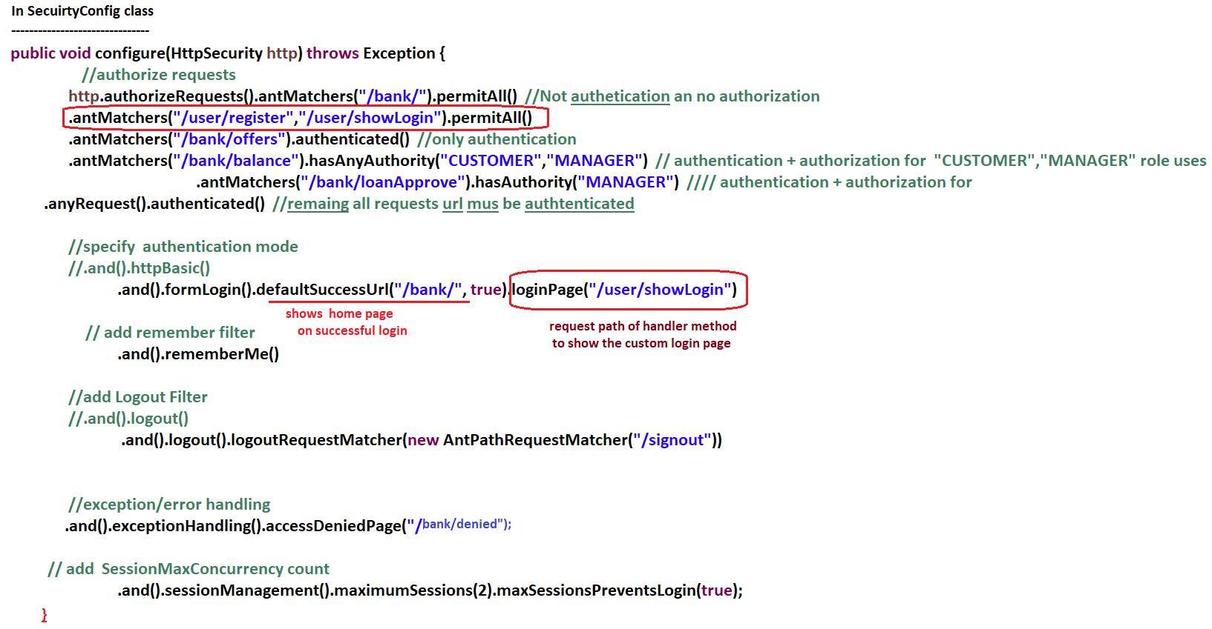

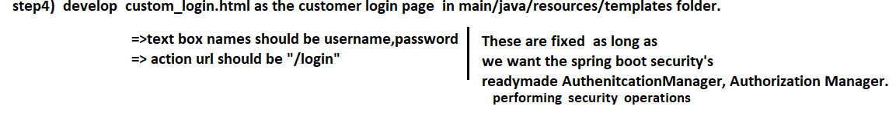

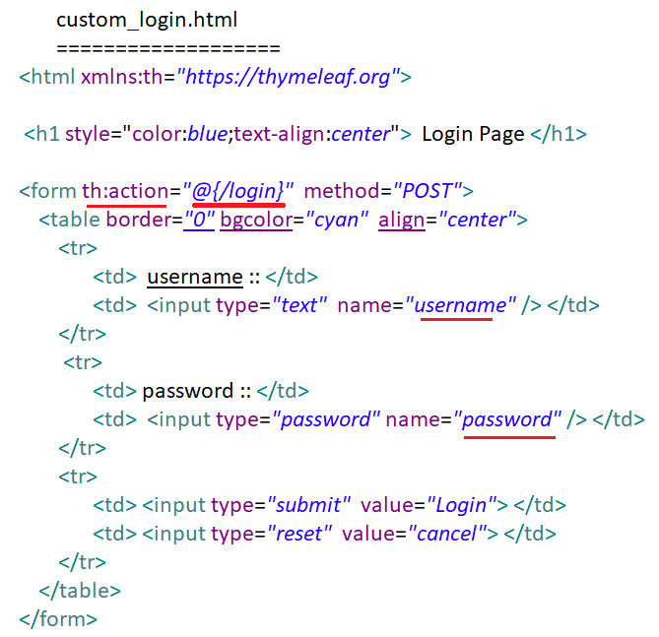

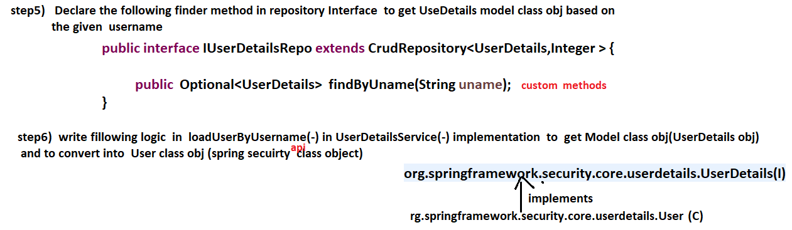

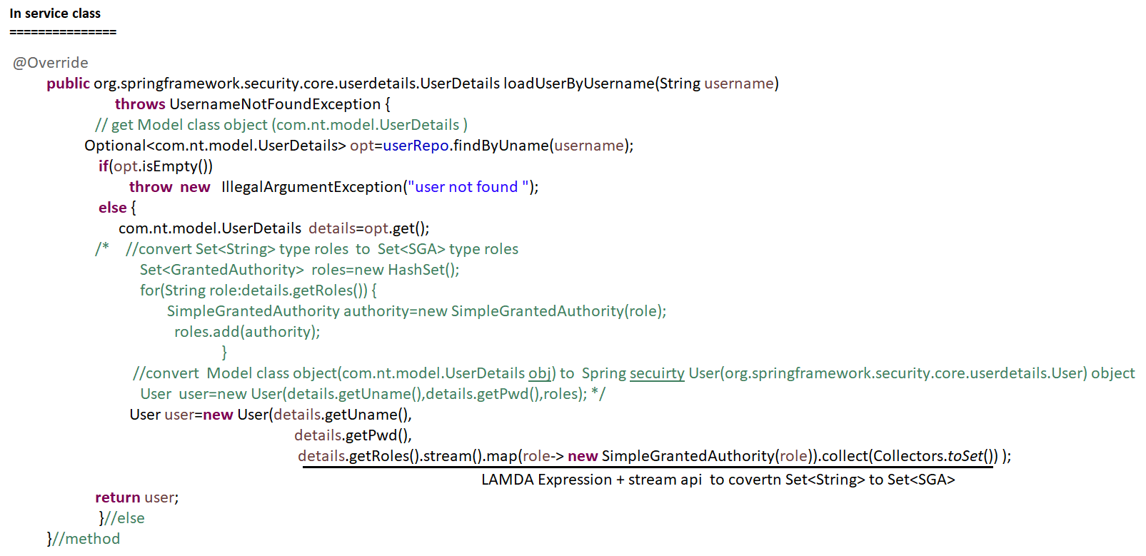

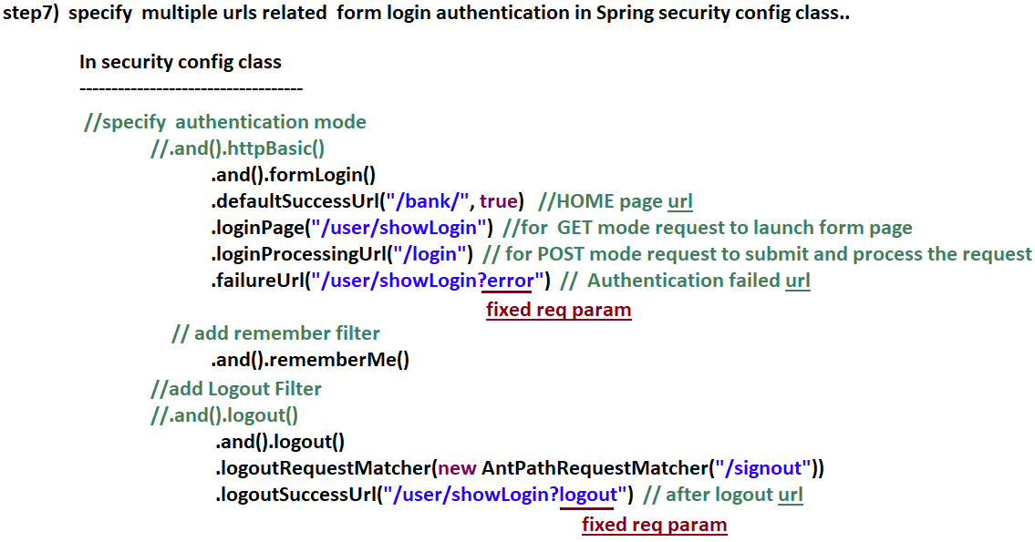

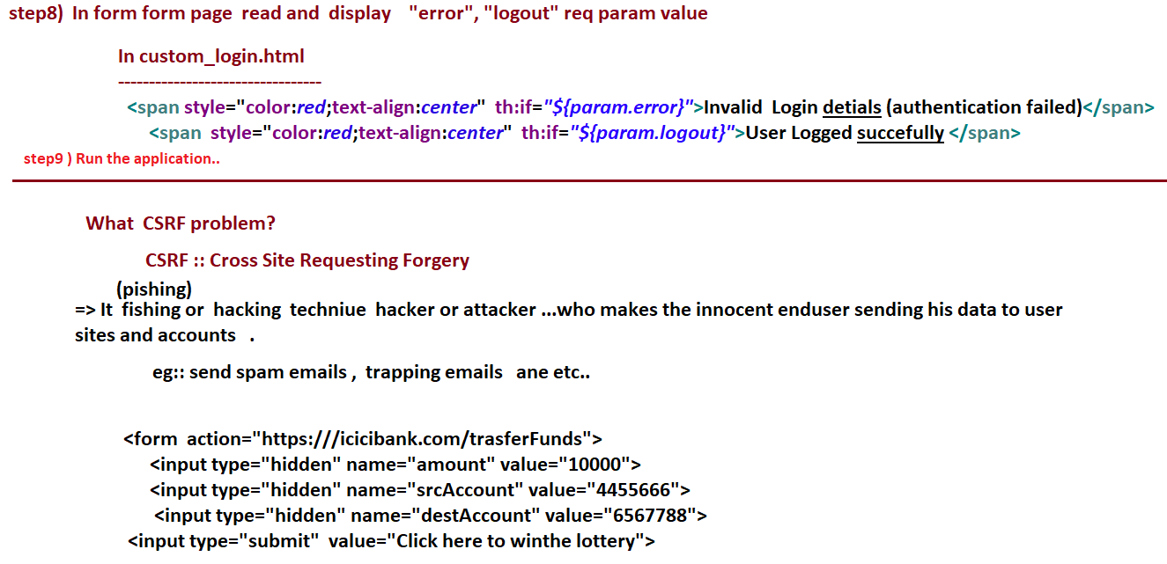

# NTSPBMS615- Aug 24th -2022-Spring Boot Security -CSRF Problem and Solution

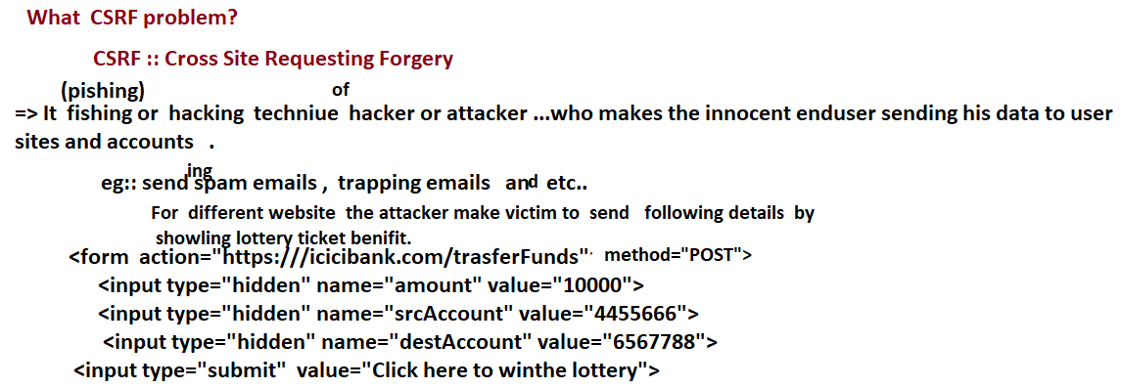

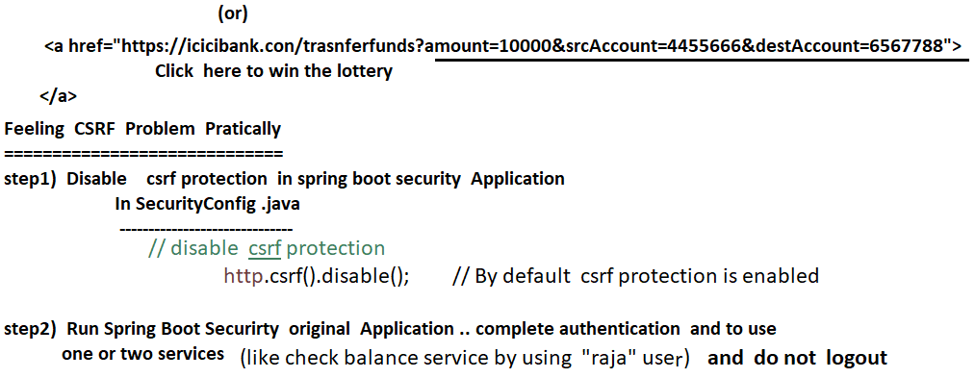

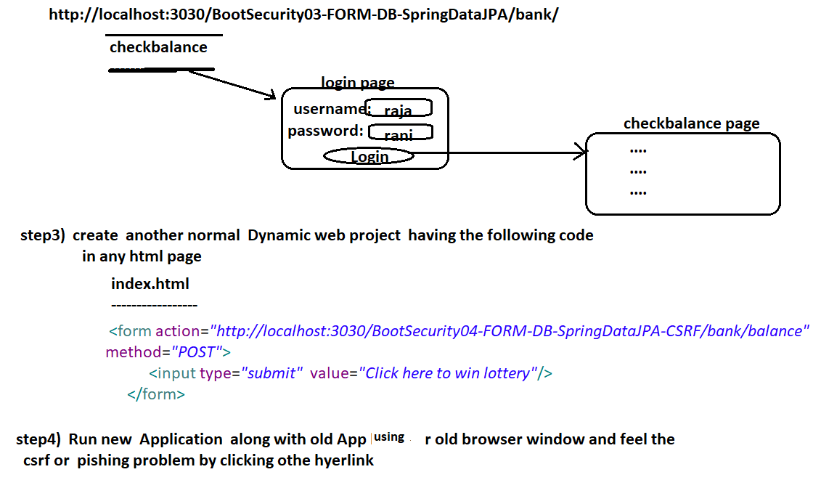

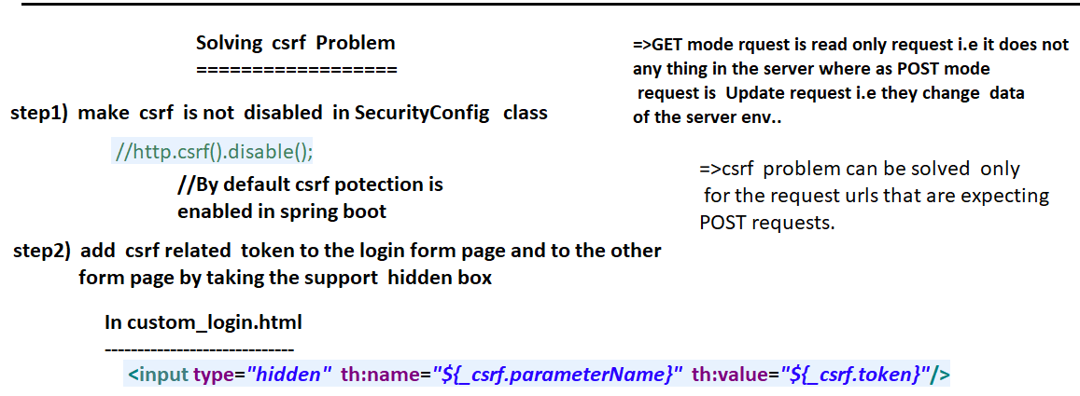

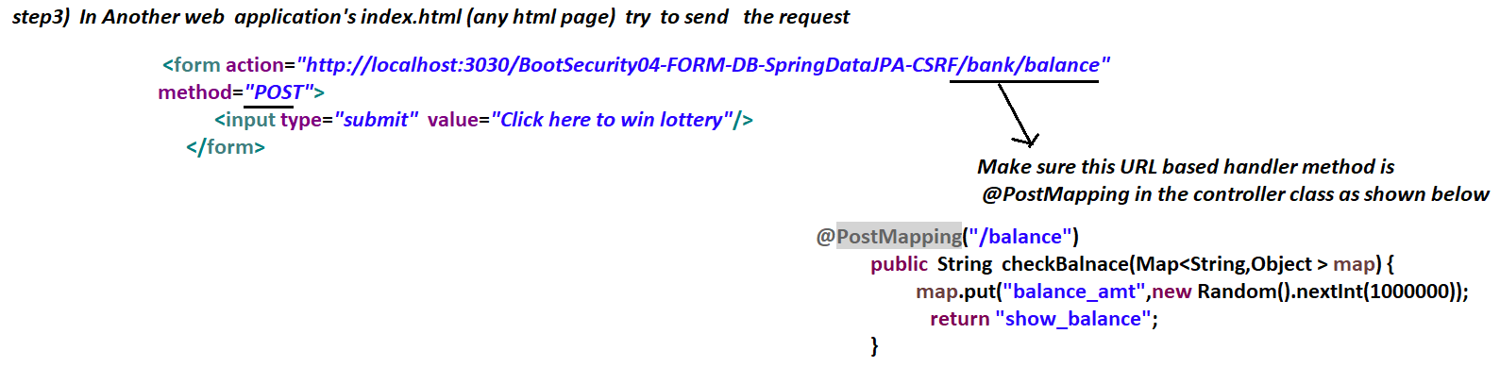

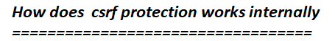

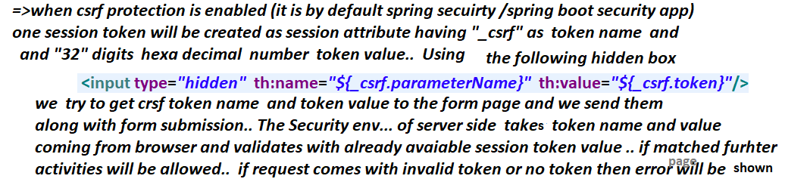

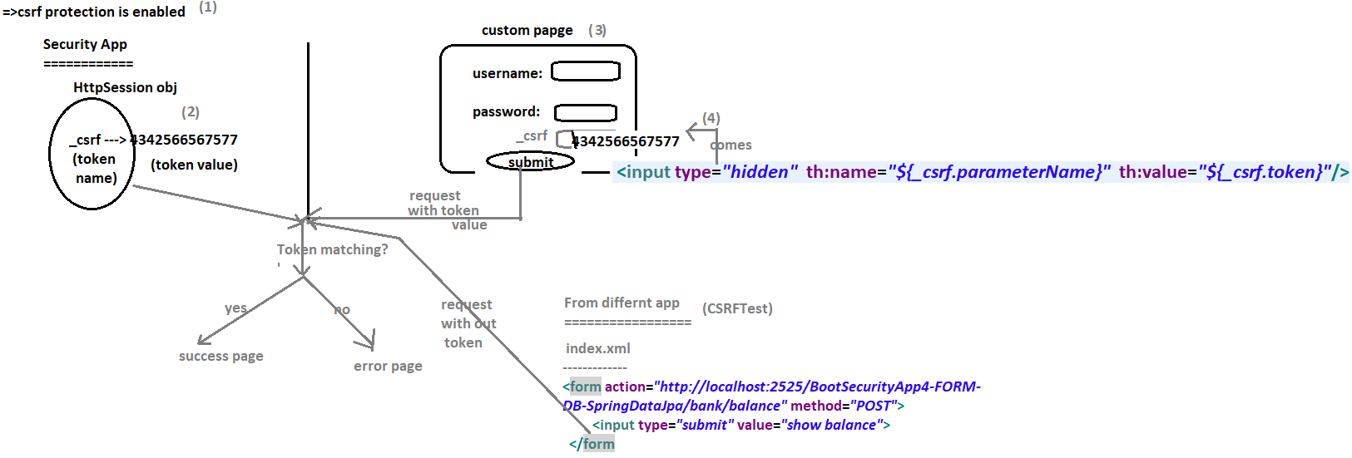

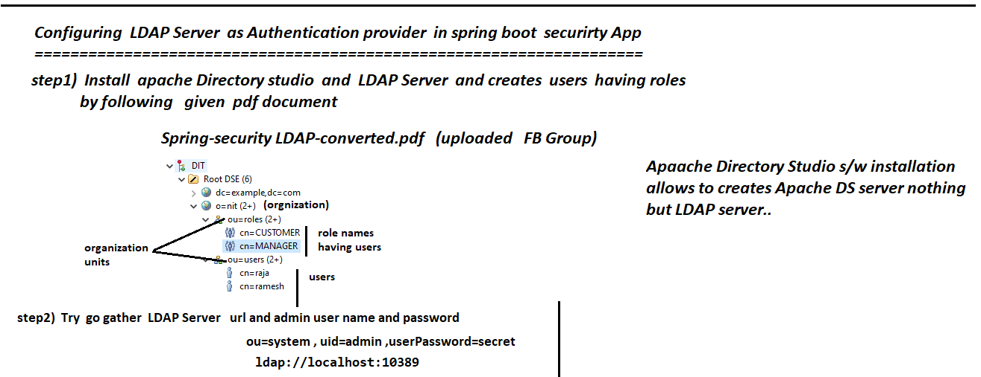

NTSPBMS615- Aug 25th -2022-Spring Boot Security - Working with LDAP Server

# NTSPBMS615- Aug 25th -26th-2022-Spring Boot Security - Working with LDAP Server

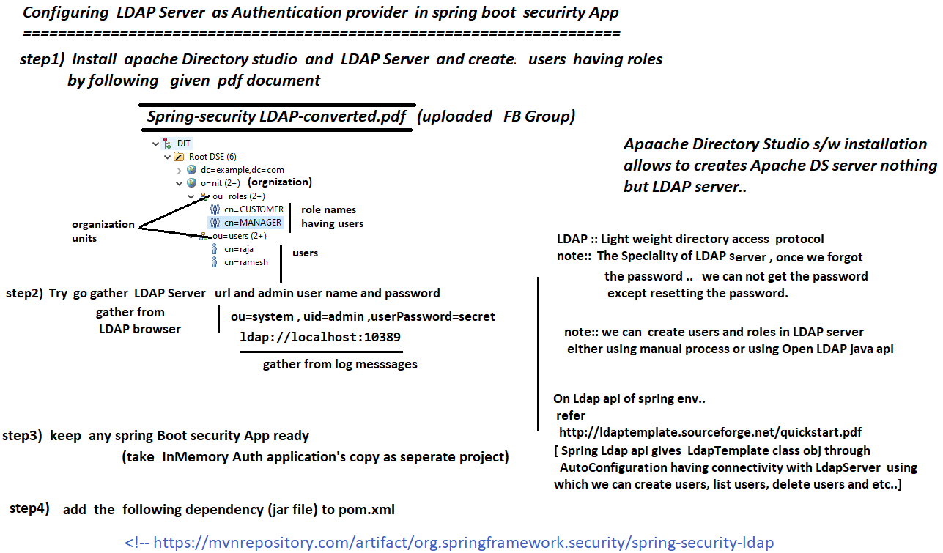

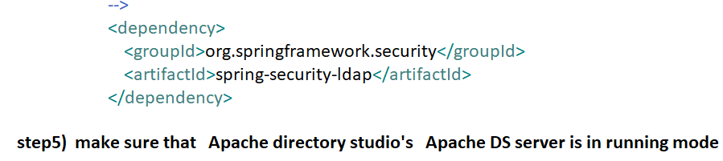

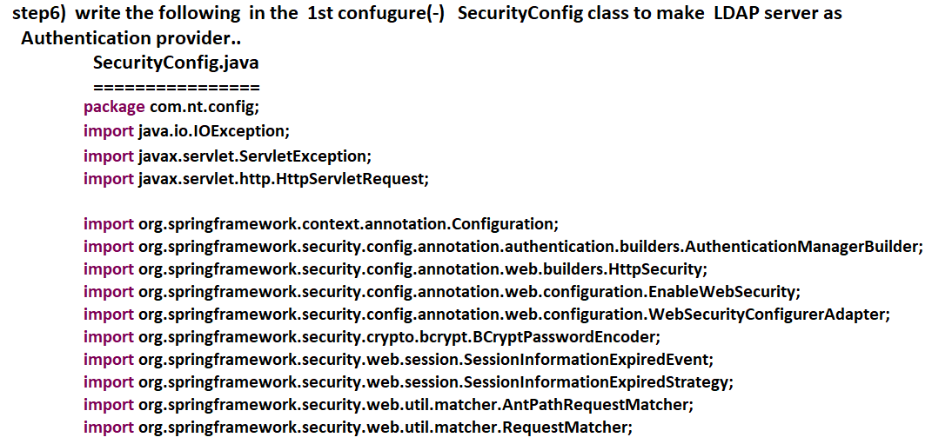

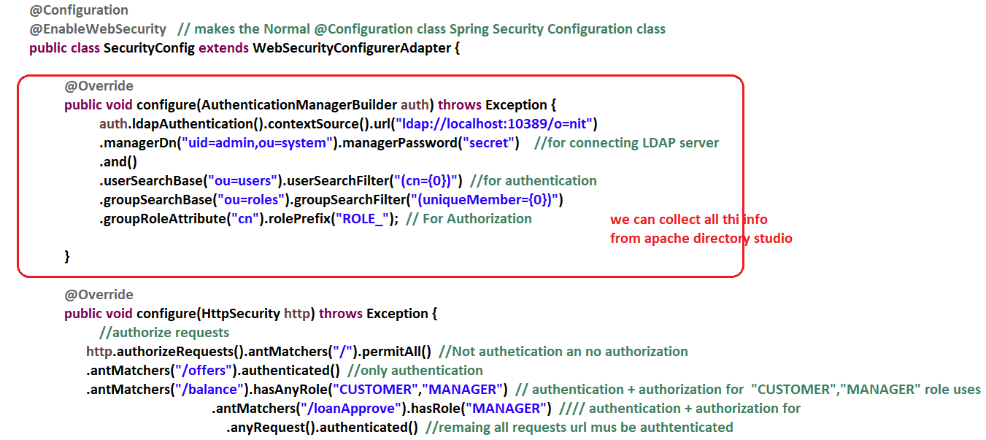

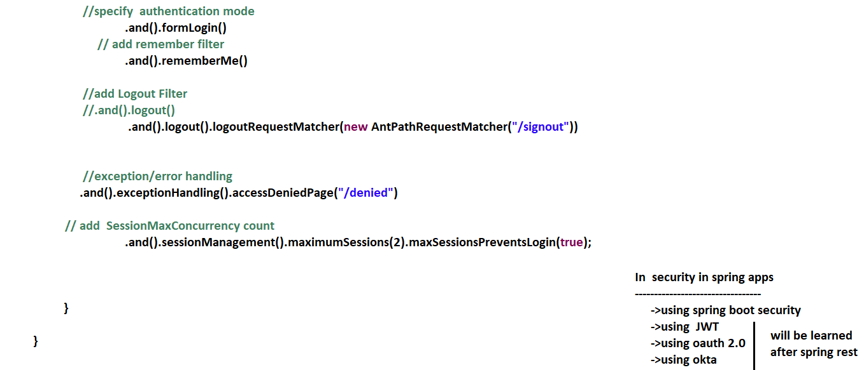

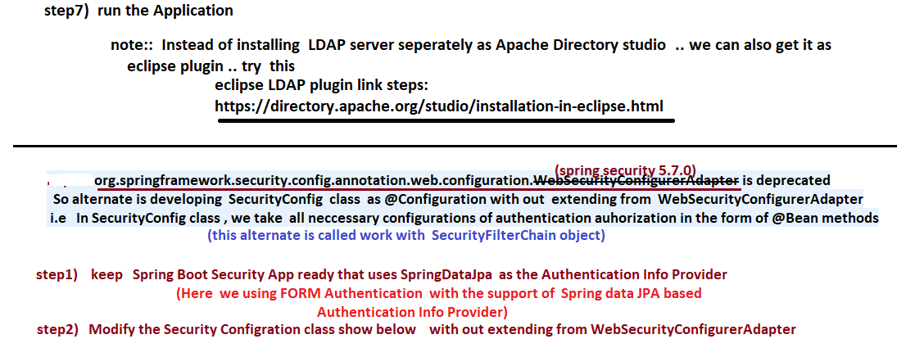

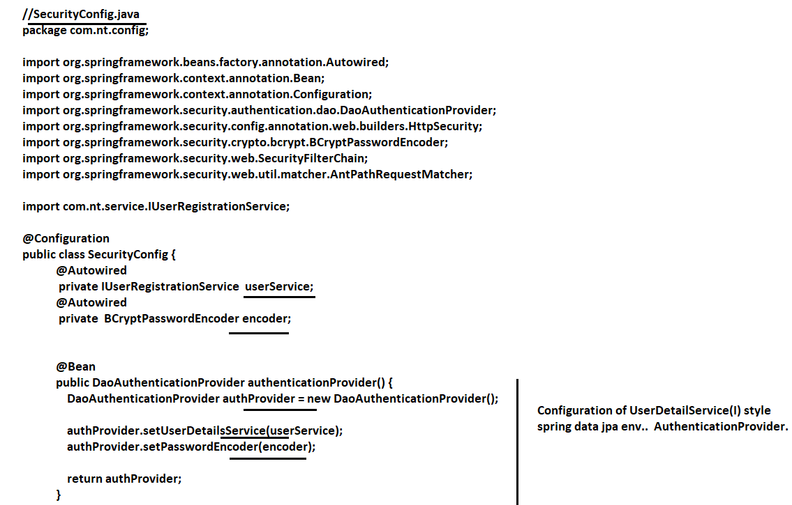

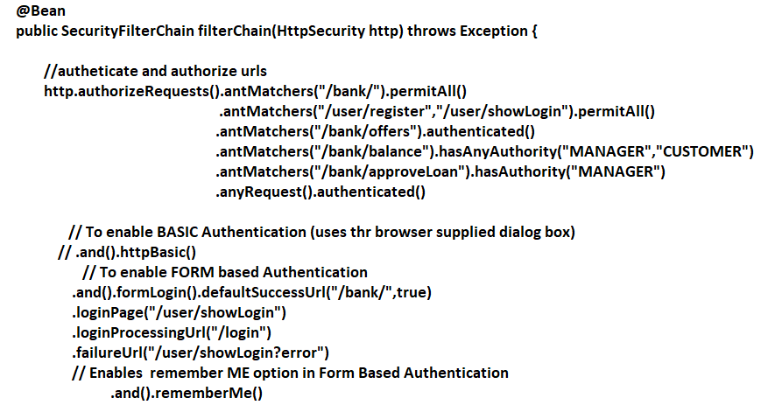

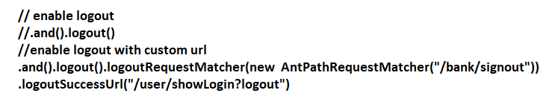

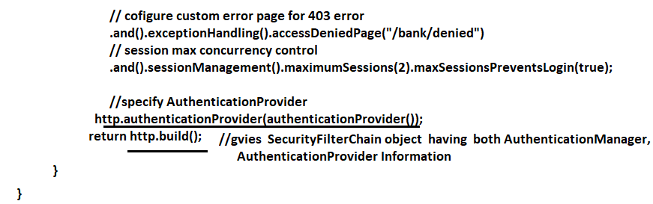

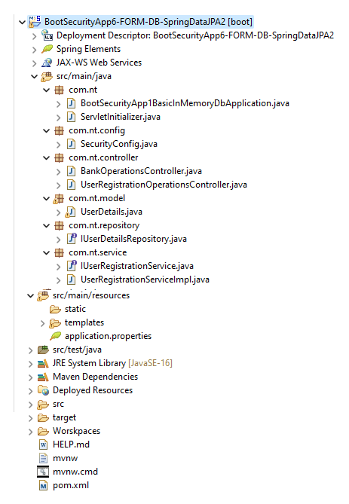

# NTSPBMS615- OAuth2.x Intro -- Aug 27th-2022

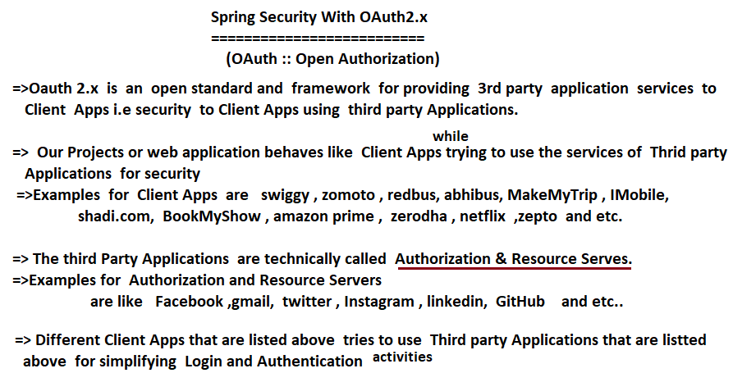

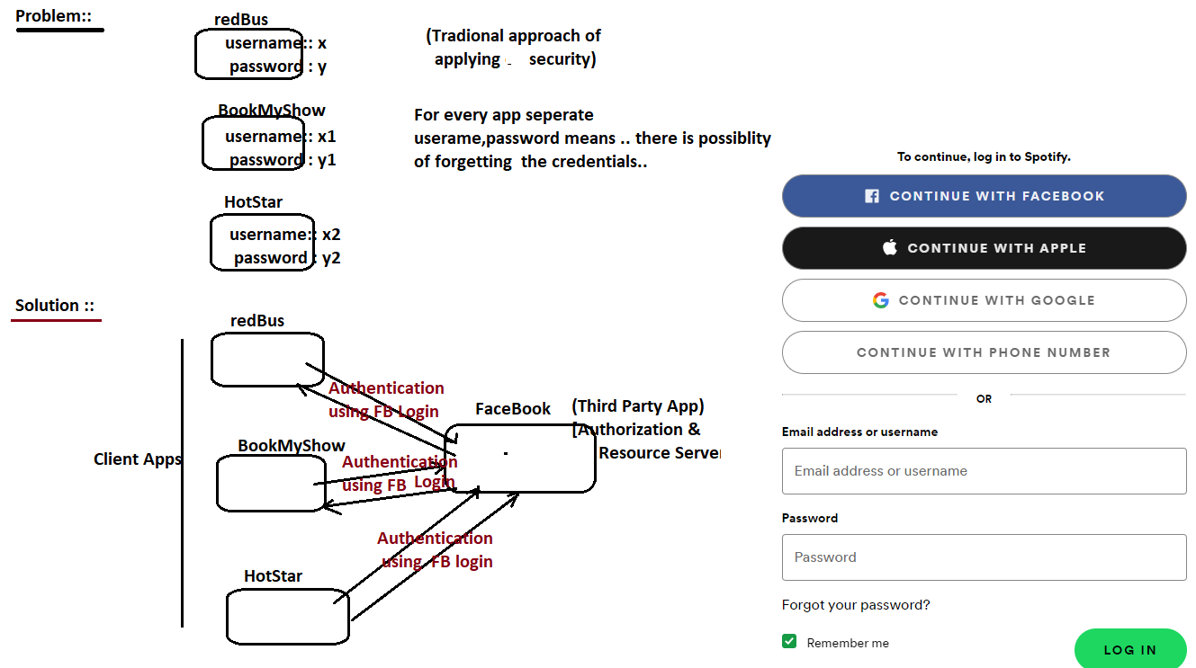

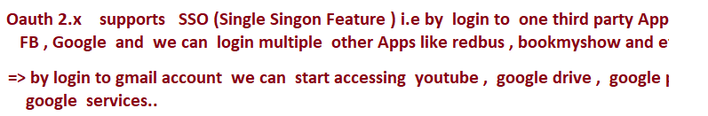

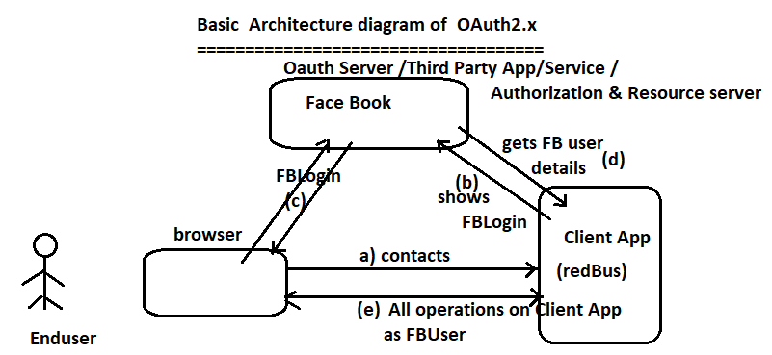

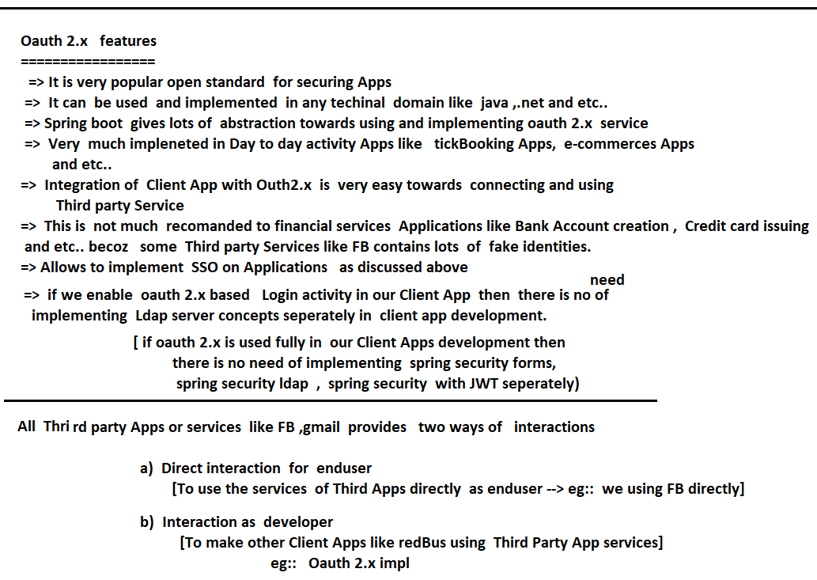

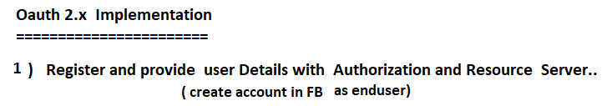

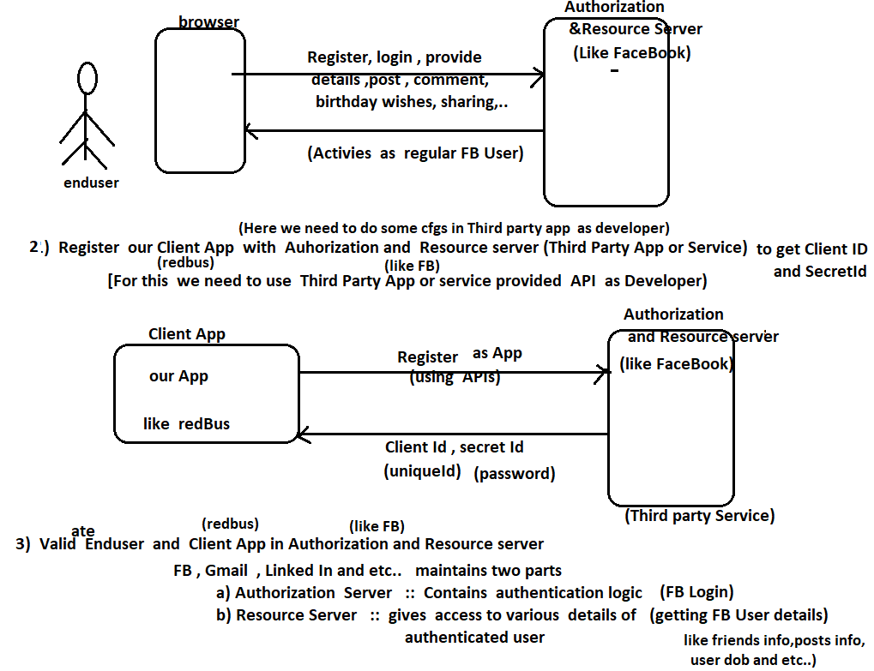

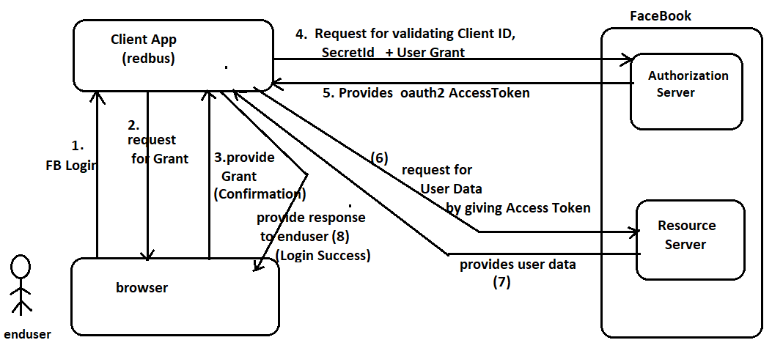

# NTSPBMS615- OAuth2.x Implementation -- Aug 30th-2022

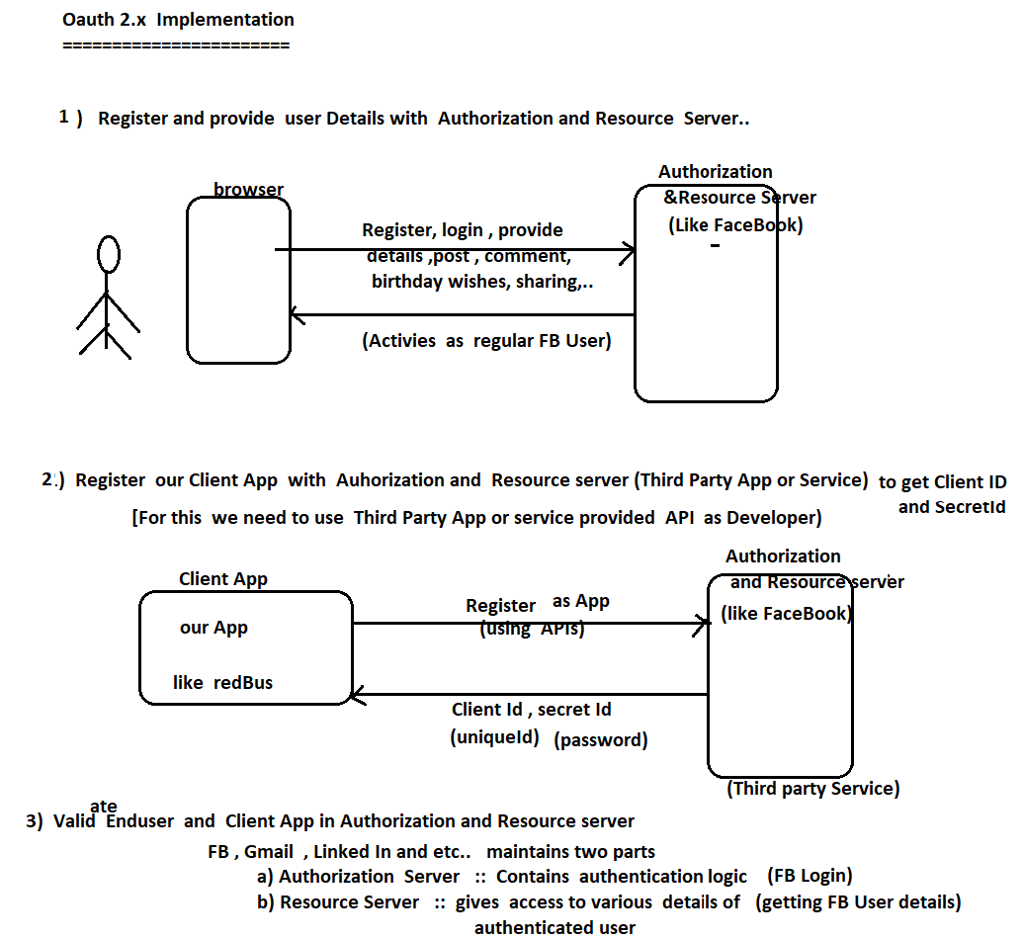

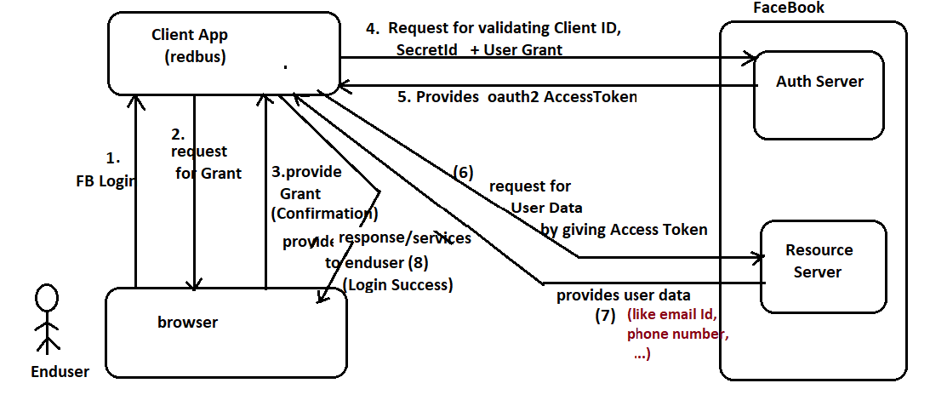

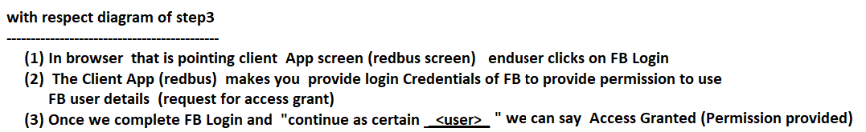

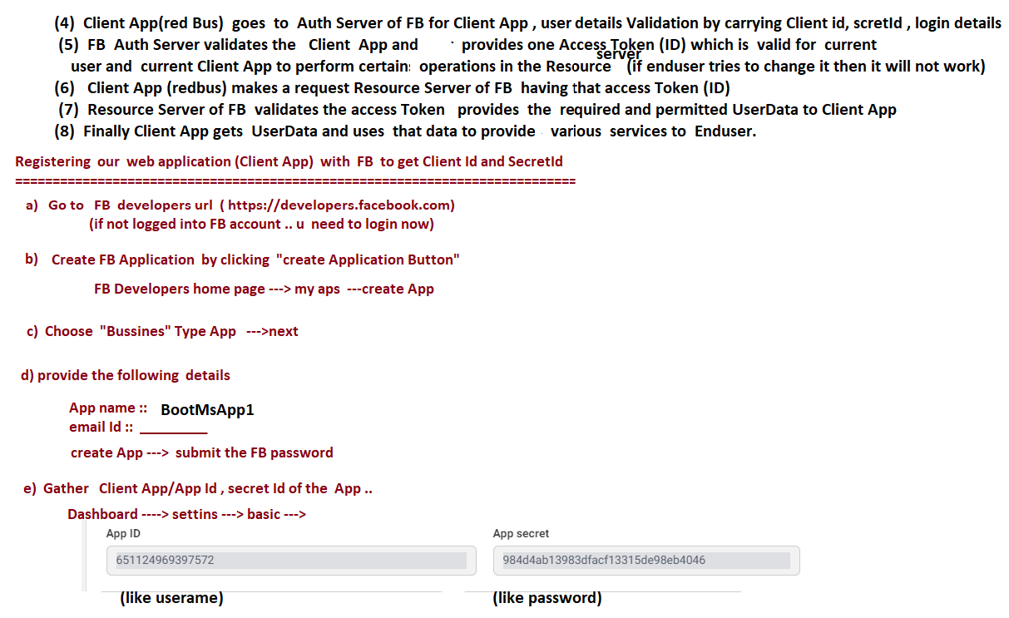

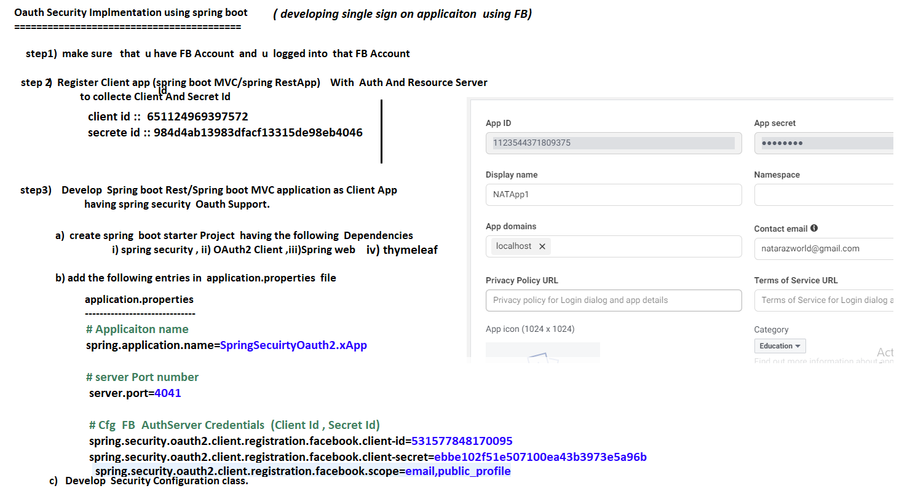

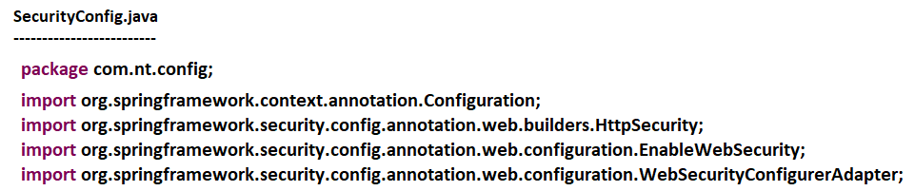

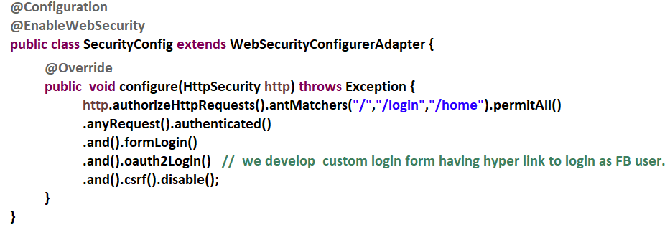

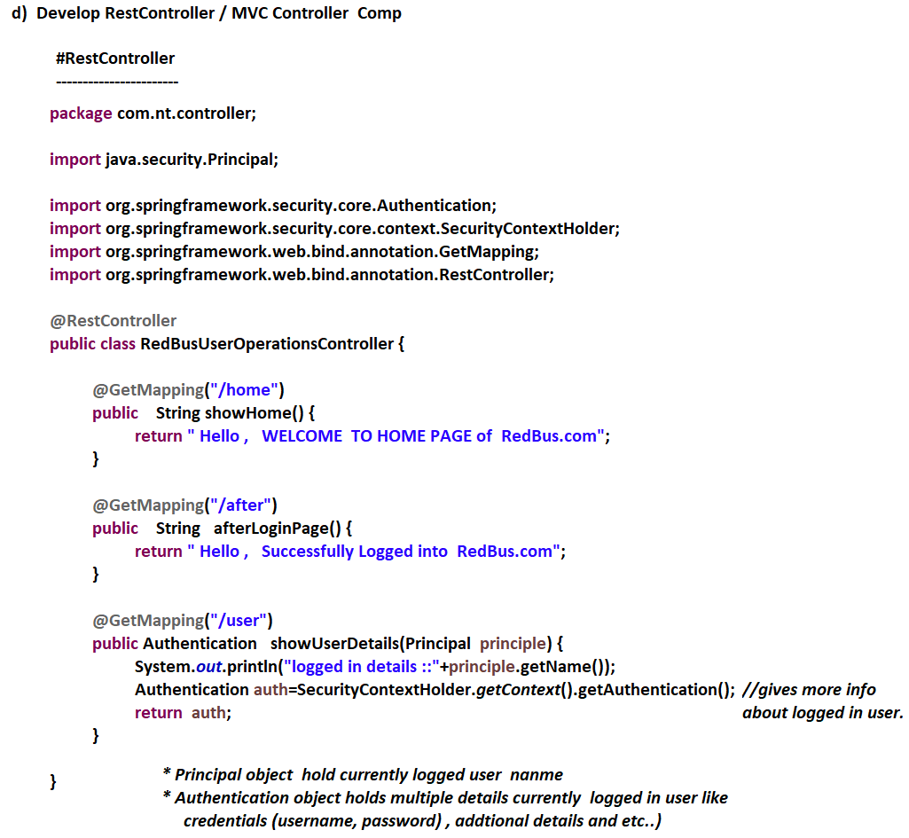

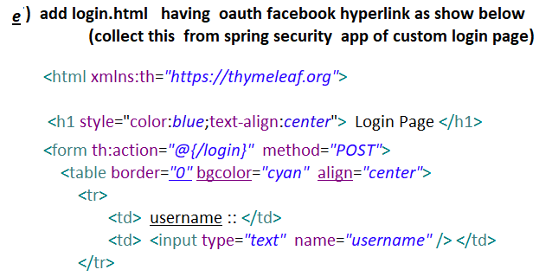

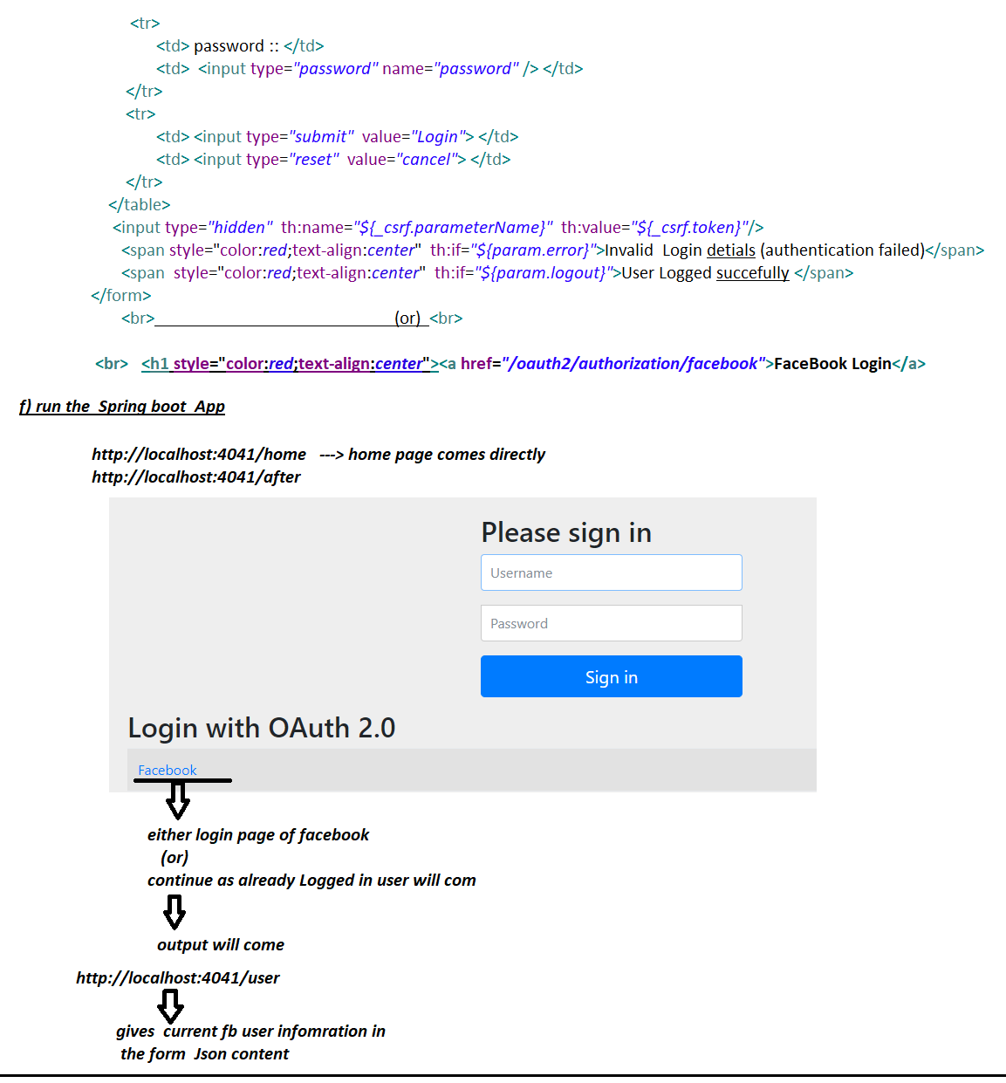

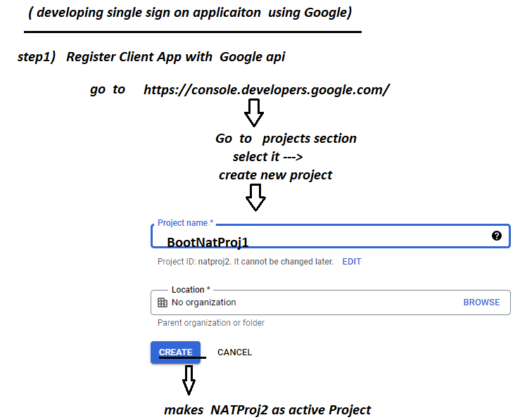

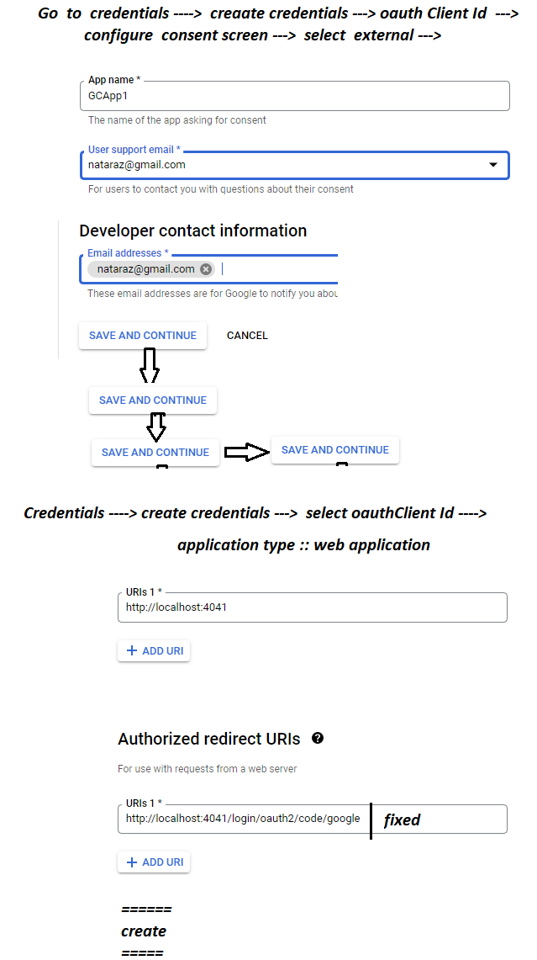

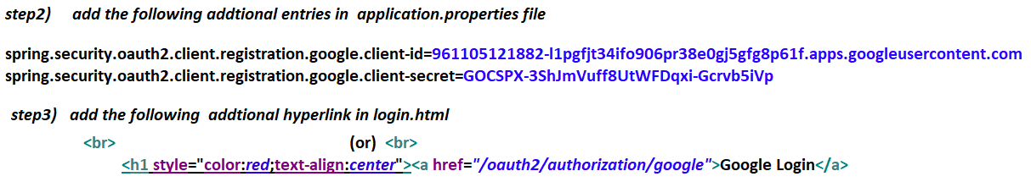

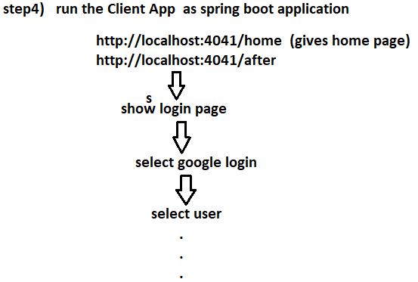

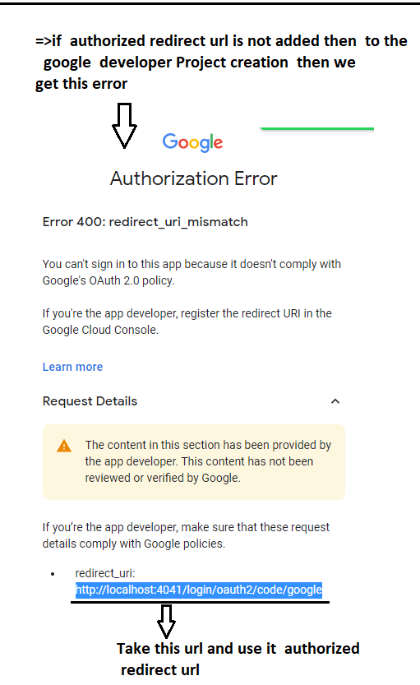

# NTSPBMS615- Messaging Intro - sept2nd-2022

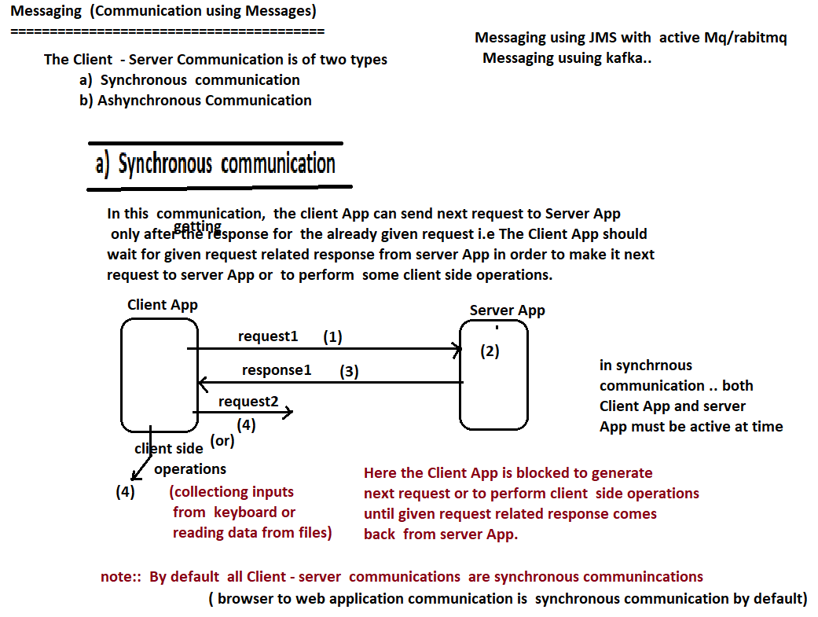

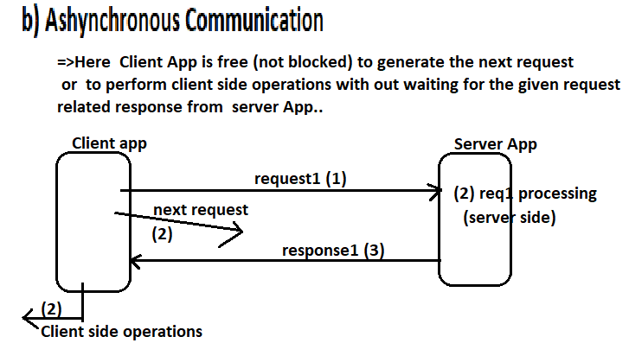

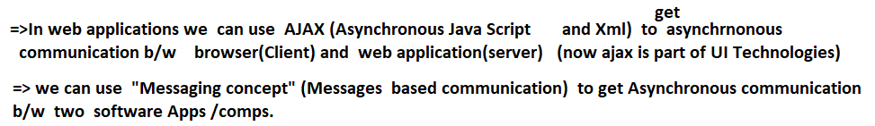

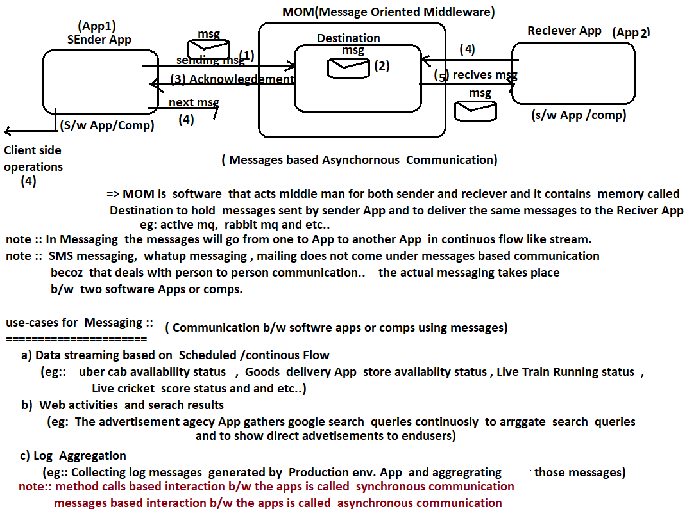

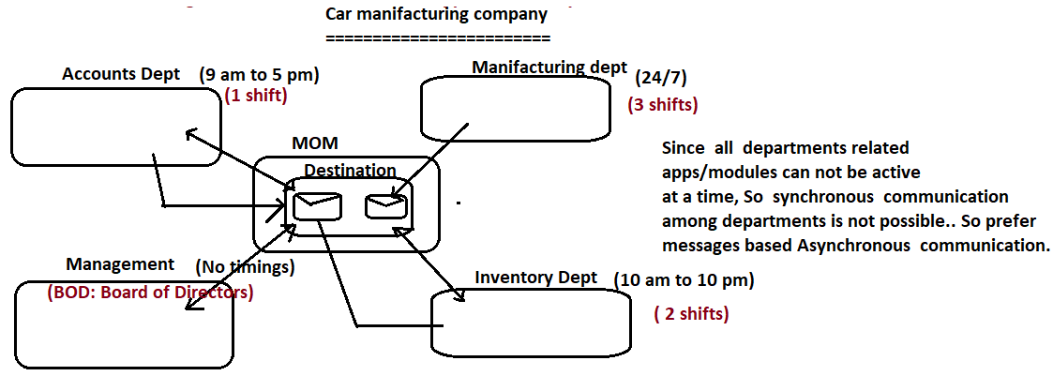

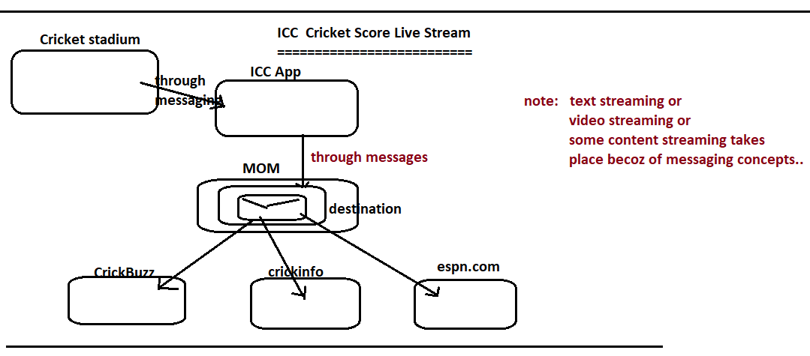

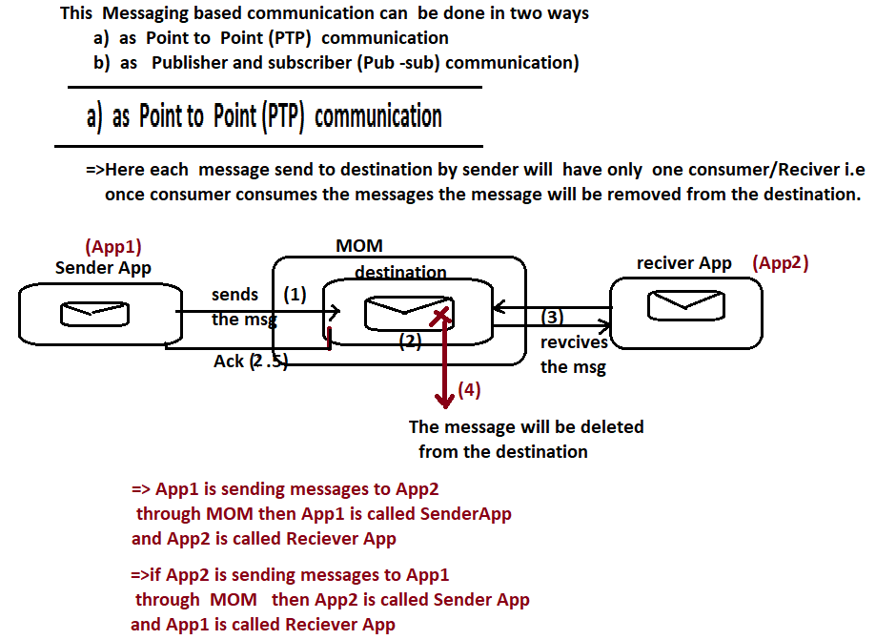

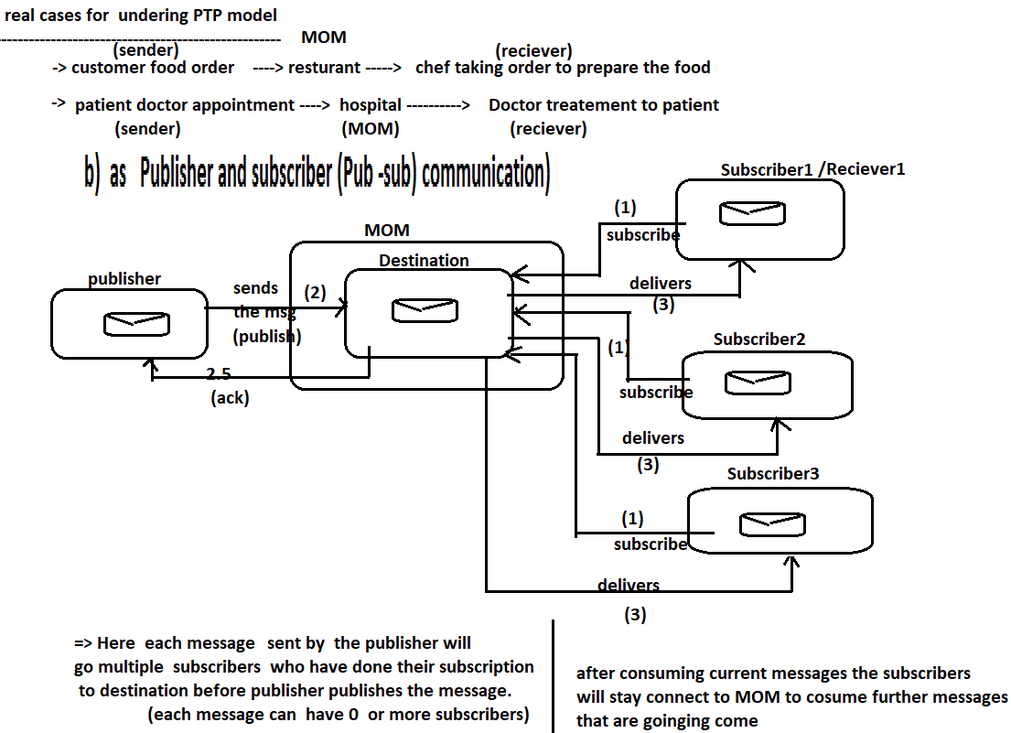

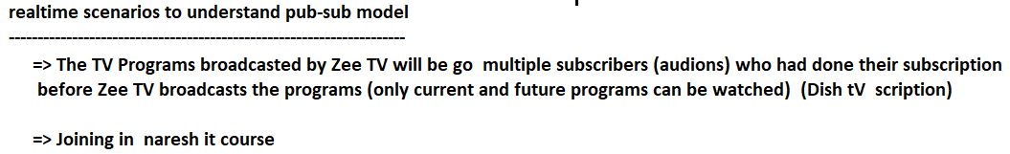

# NTSPBMS615- Messaging using JMS - sept 3rd 2022

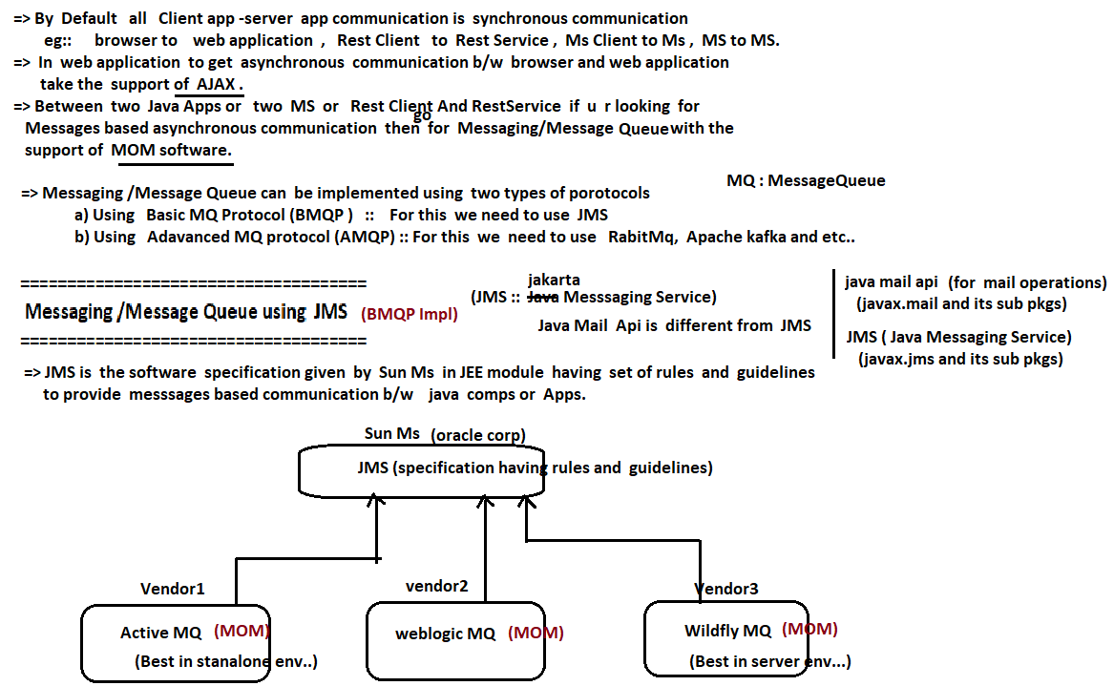

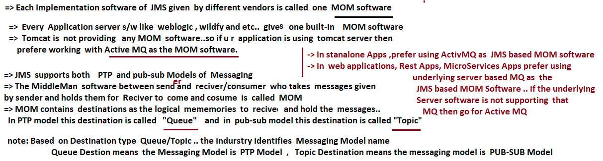

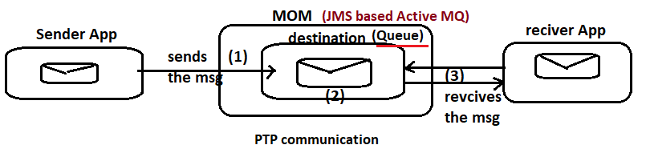

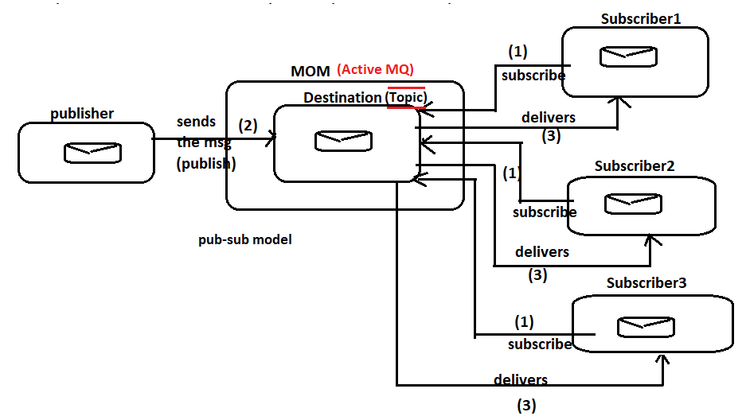

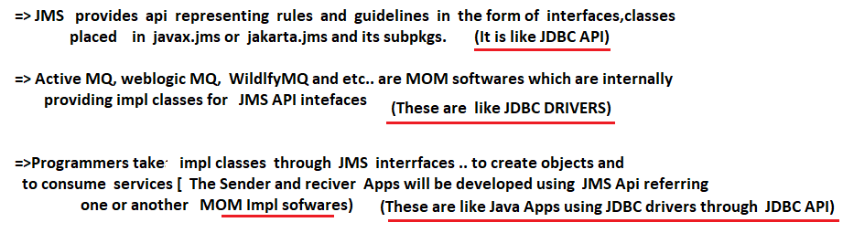

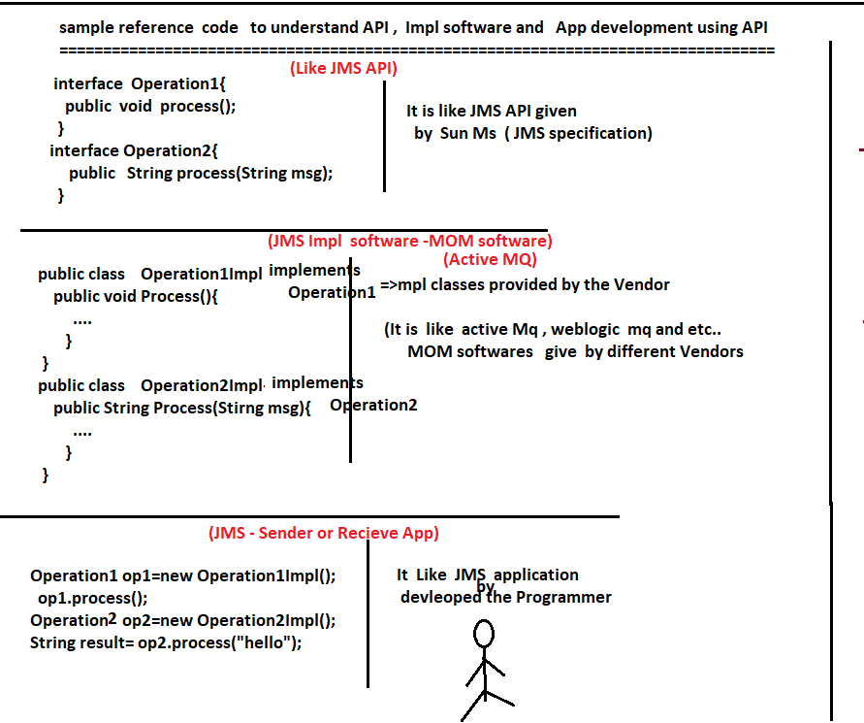

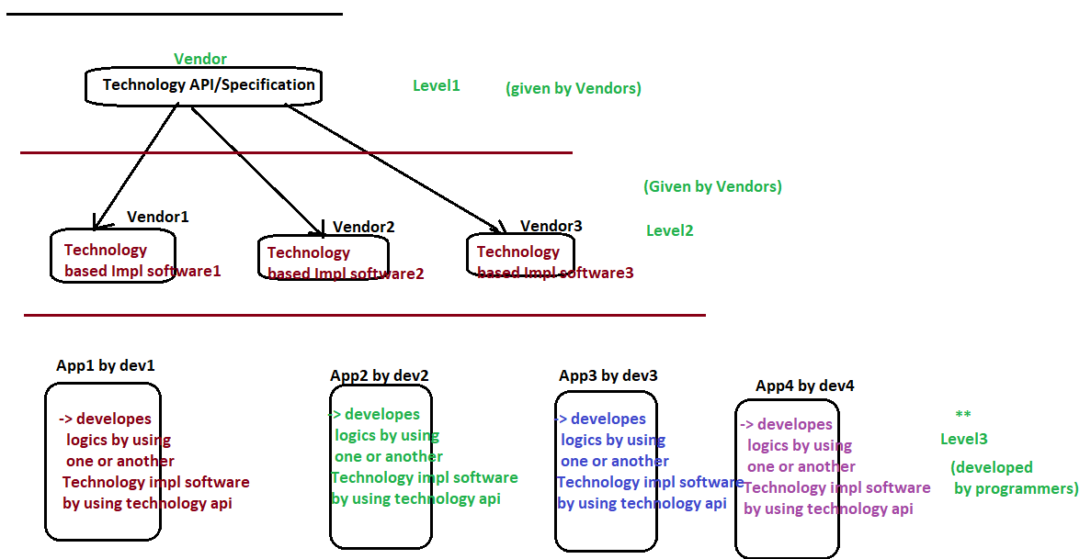

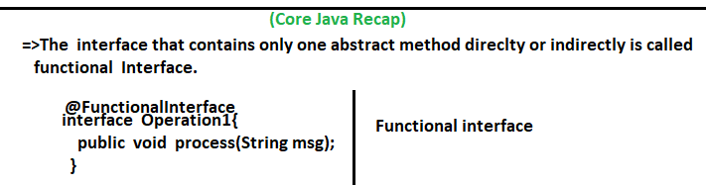

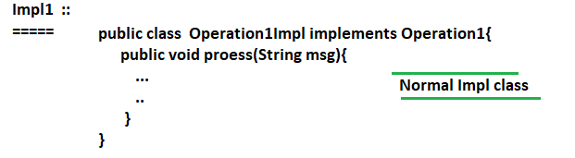

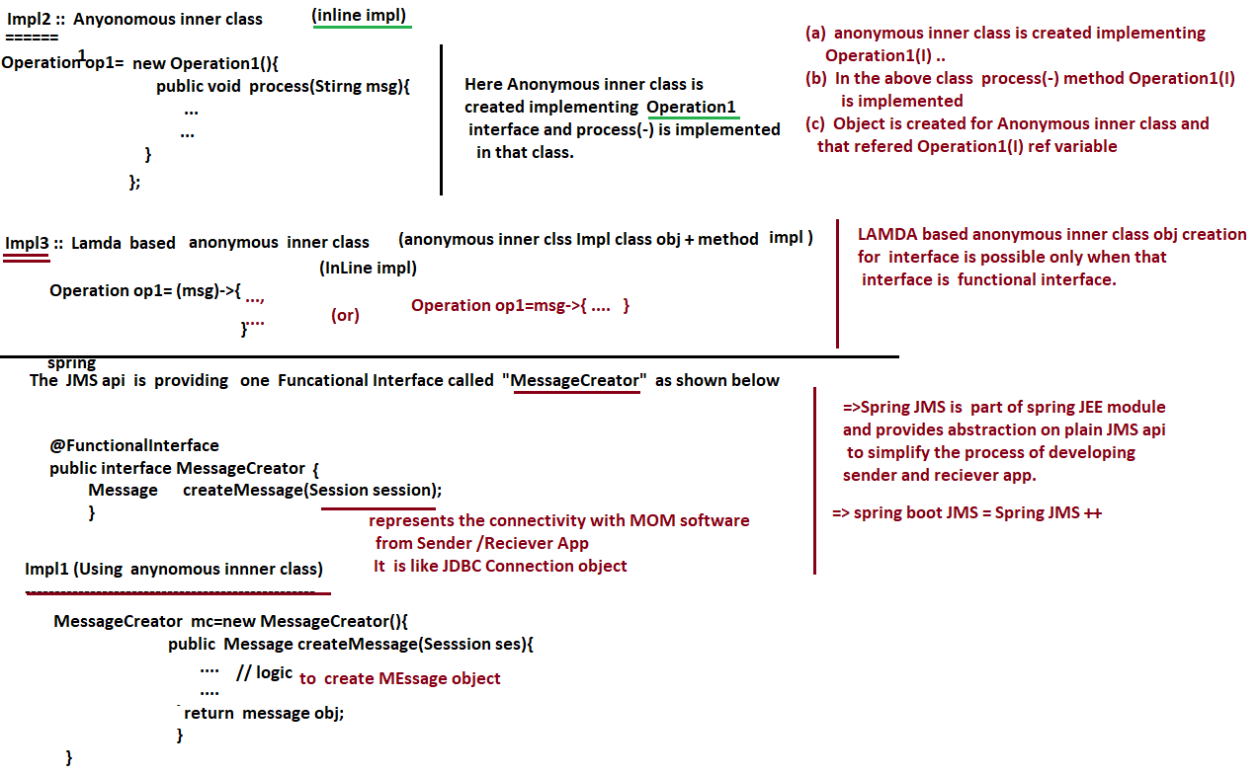

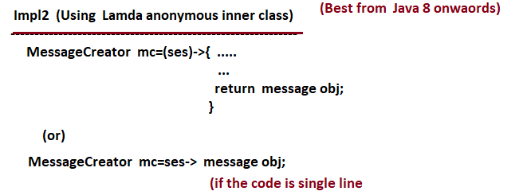

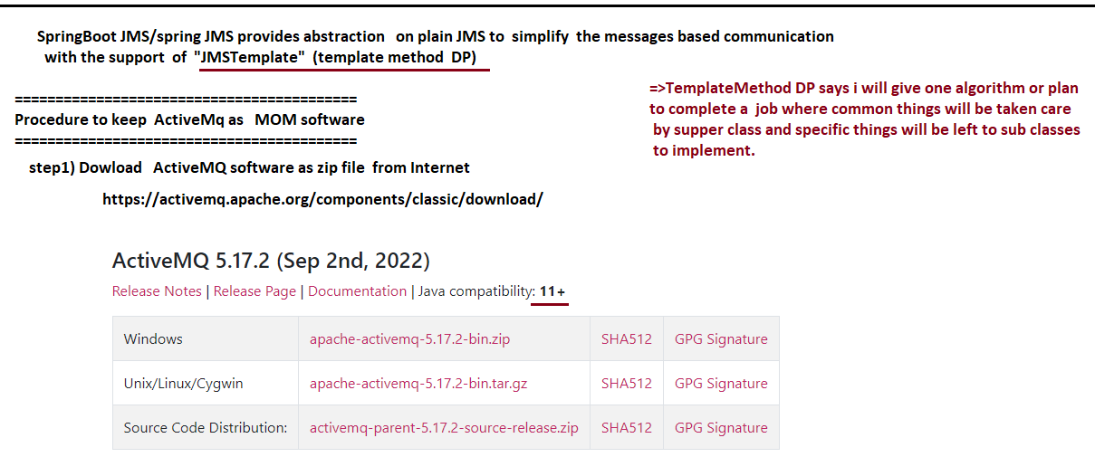

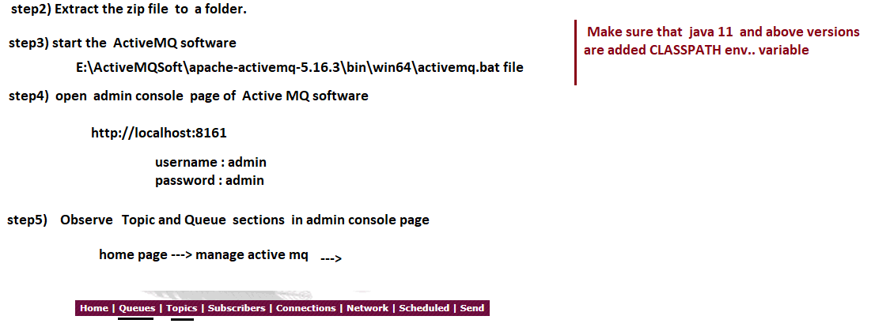

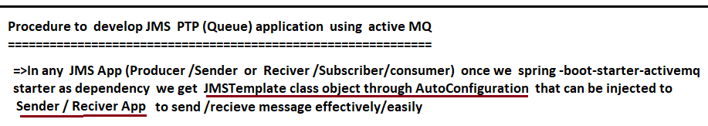

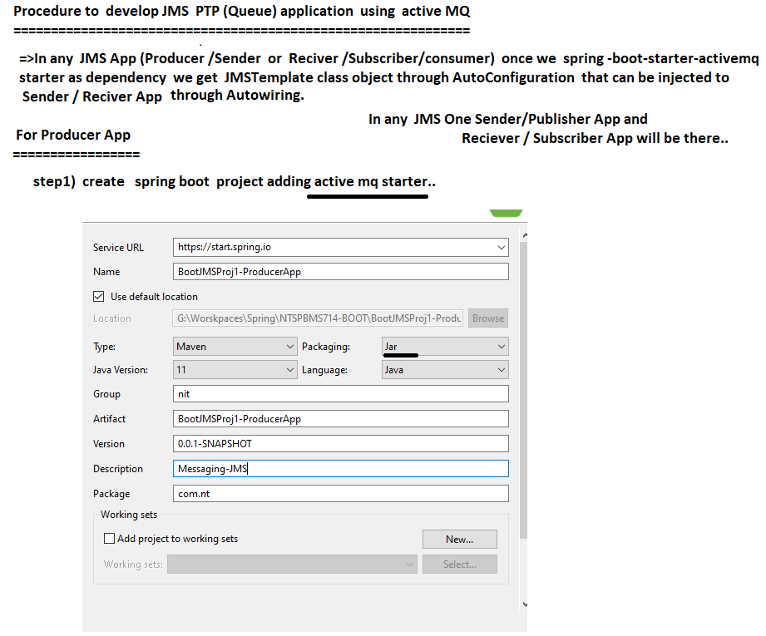

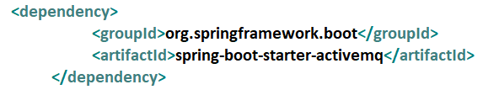

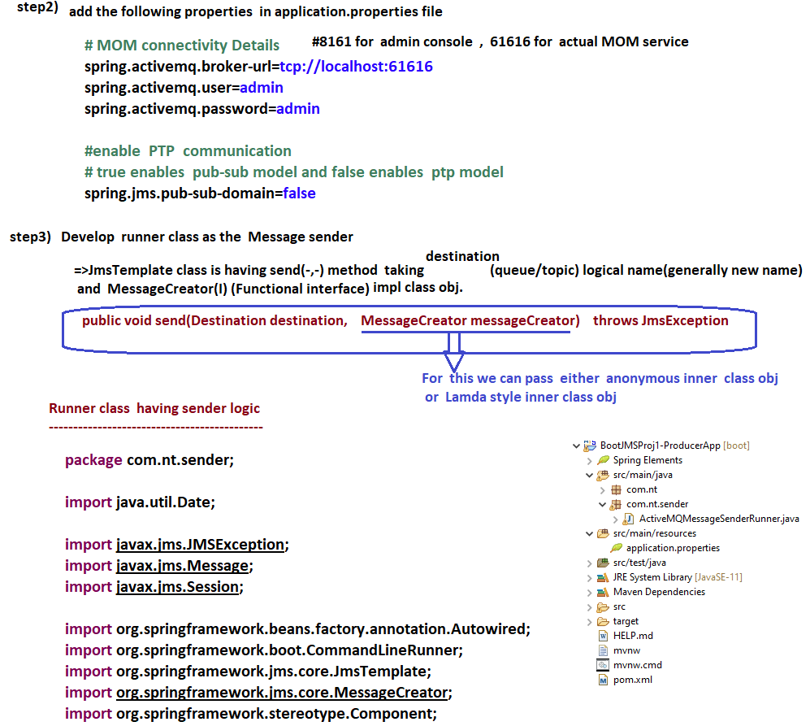

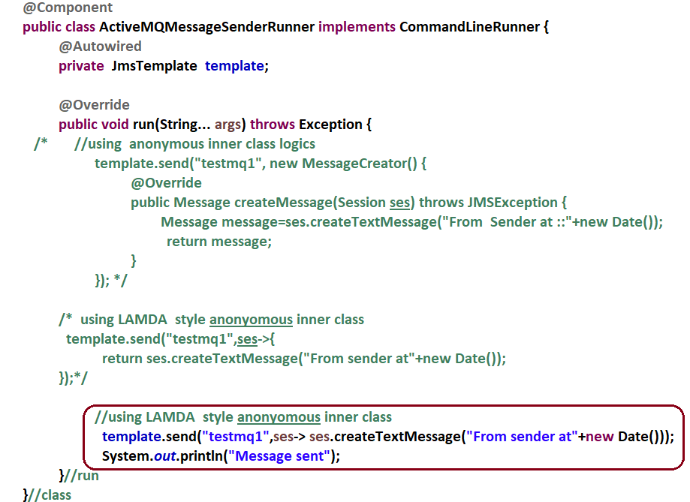

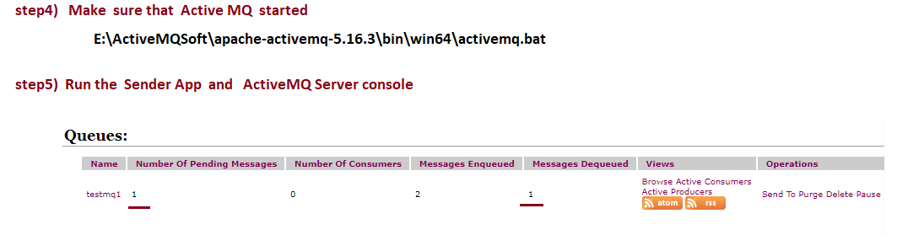

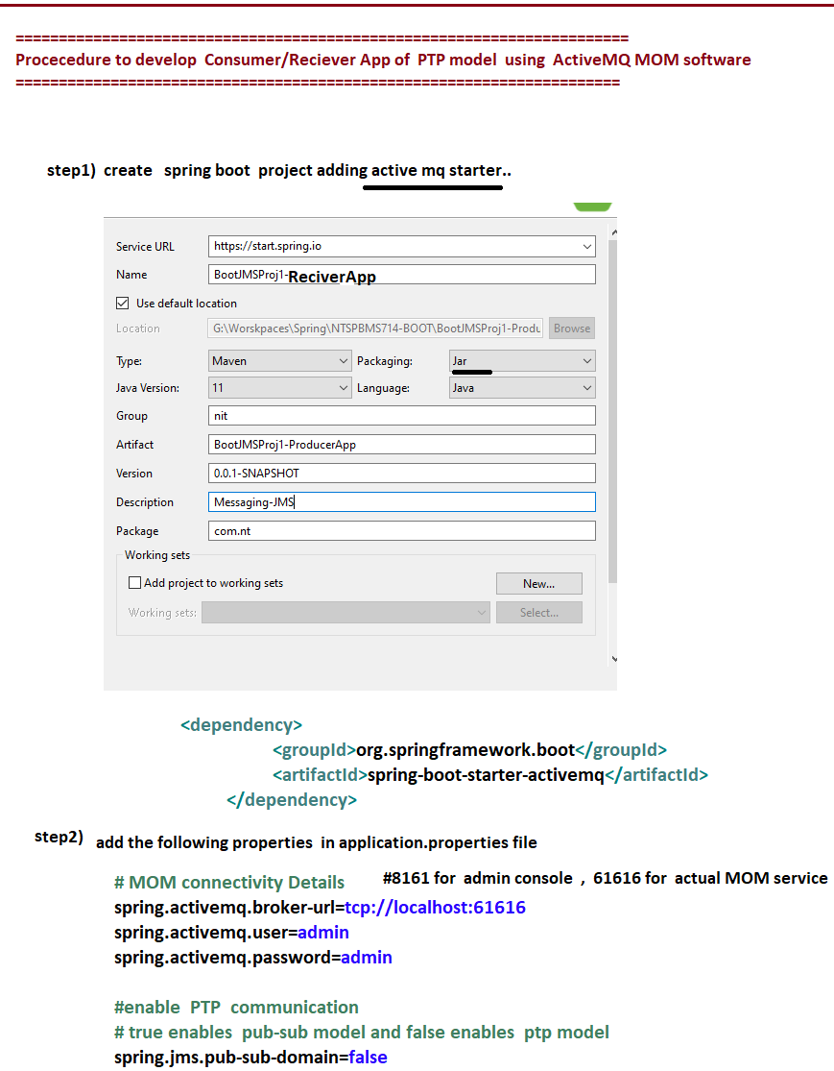

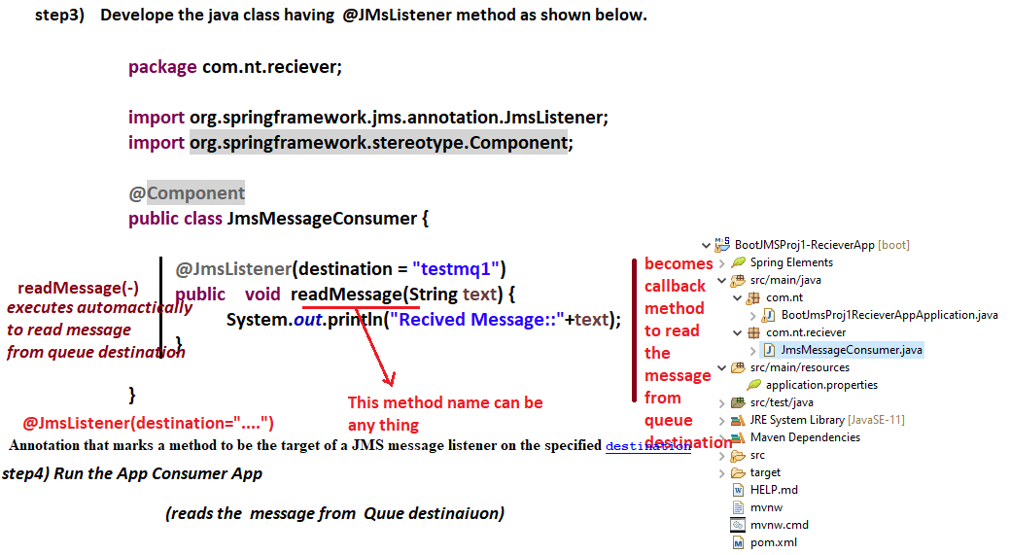

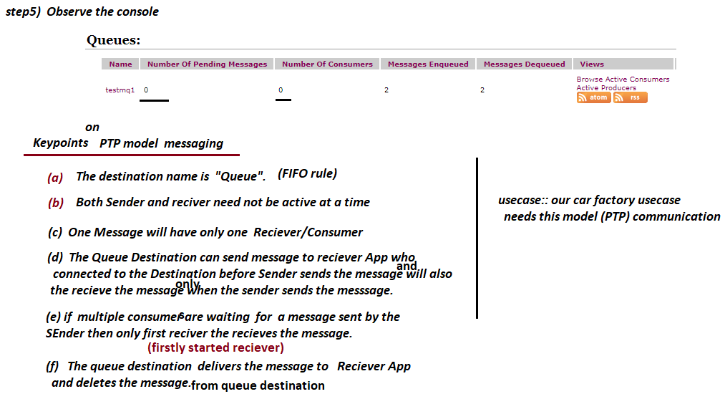

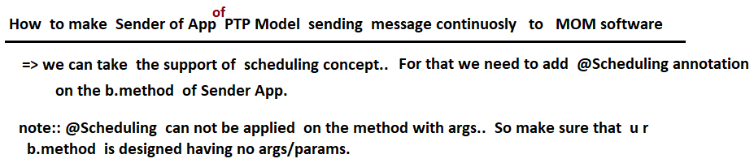

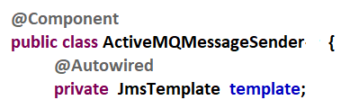

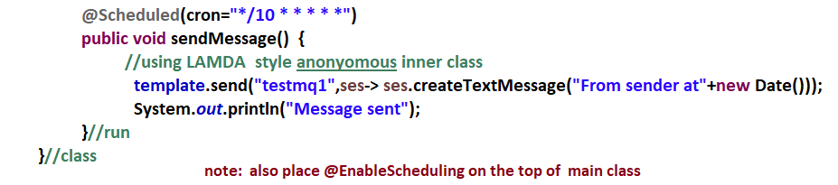

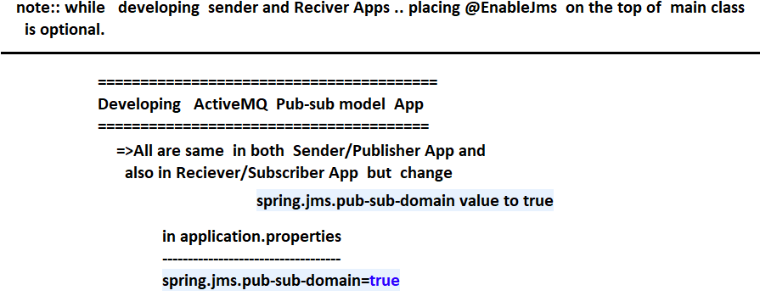

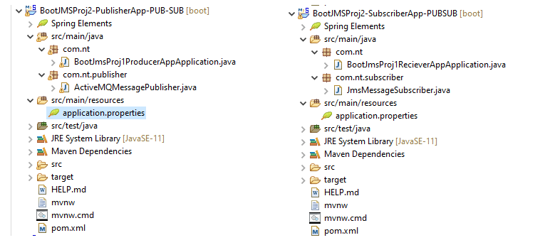

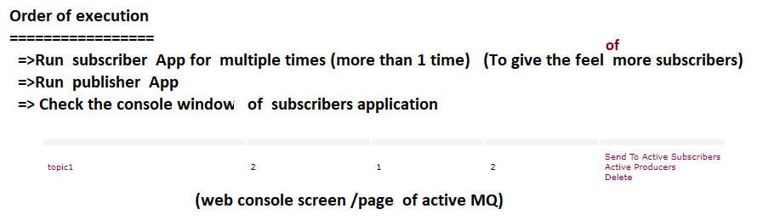

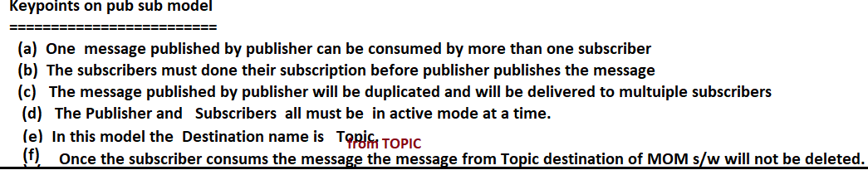

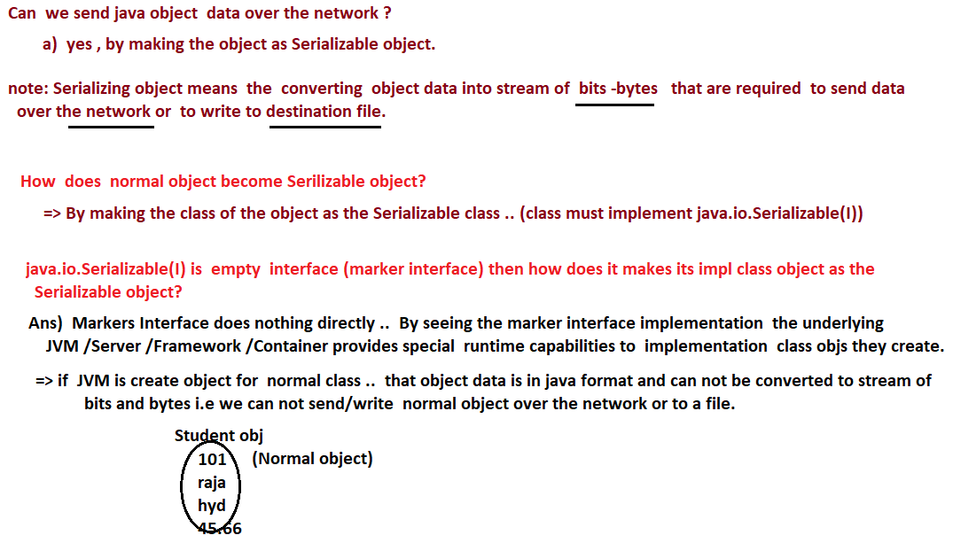

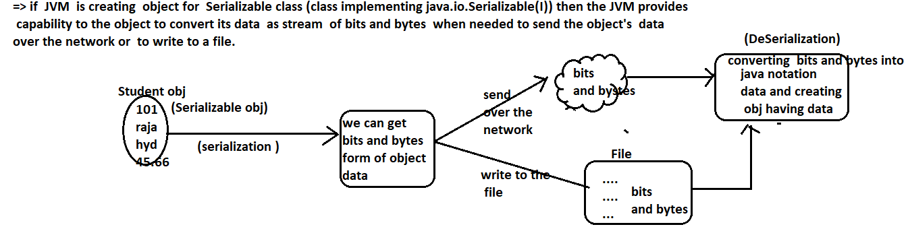

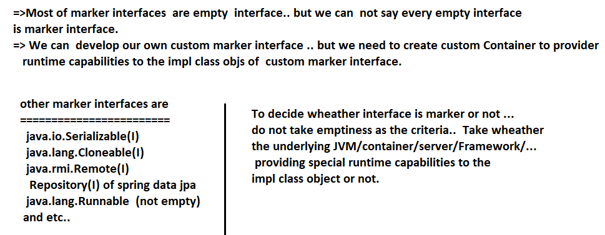

# NTSPBMS615- Messaging using JMS for sendign Object as Message - sept6th 2022

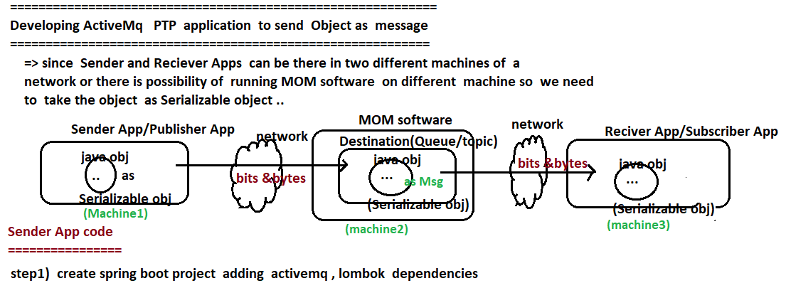

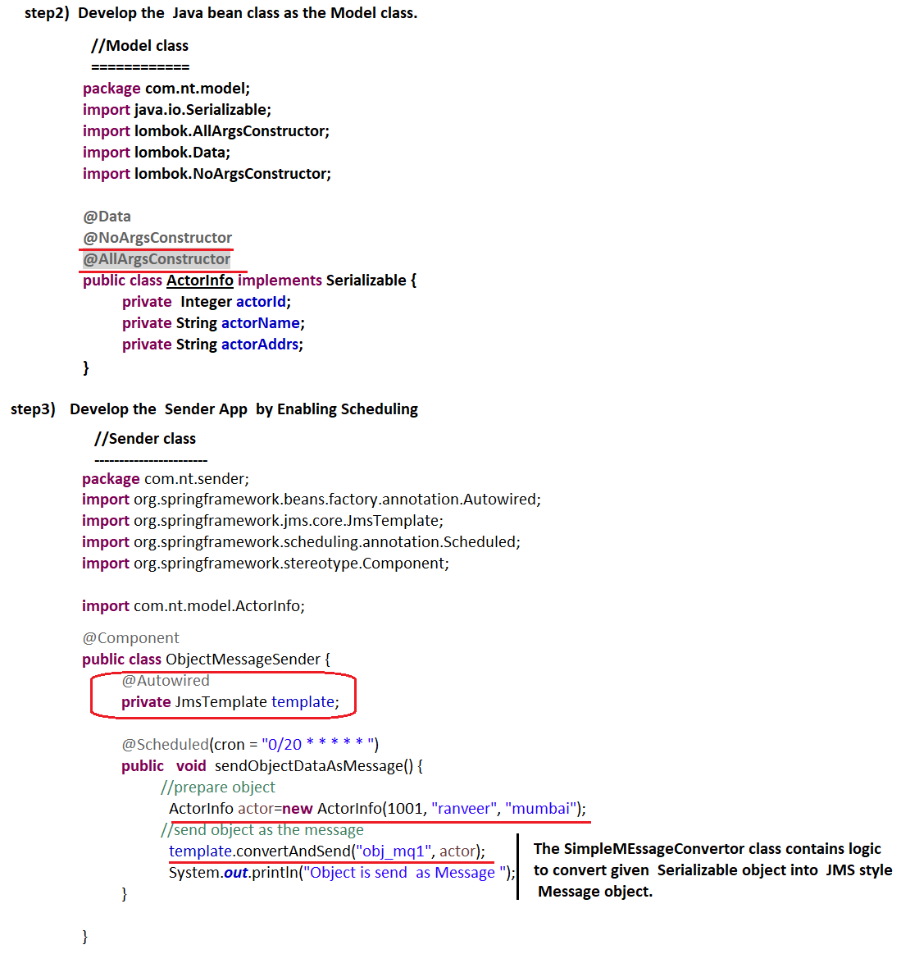

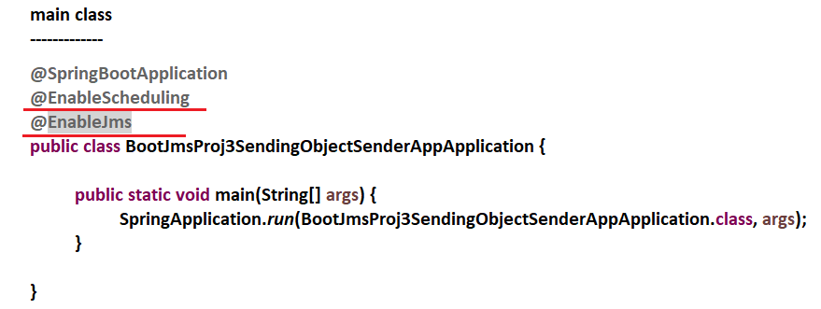

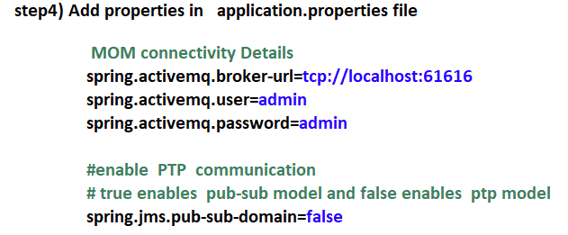



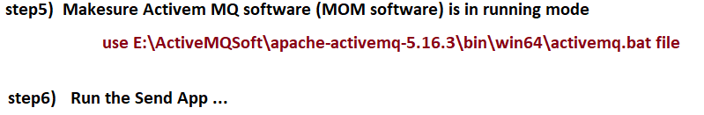

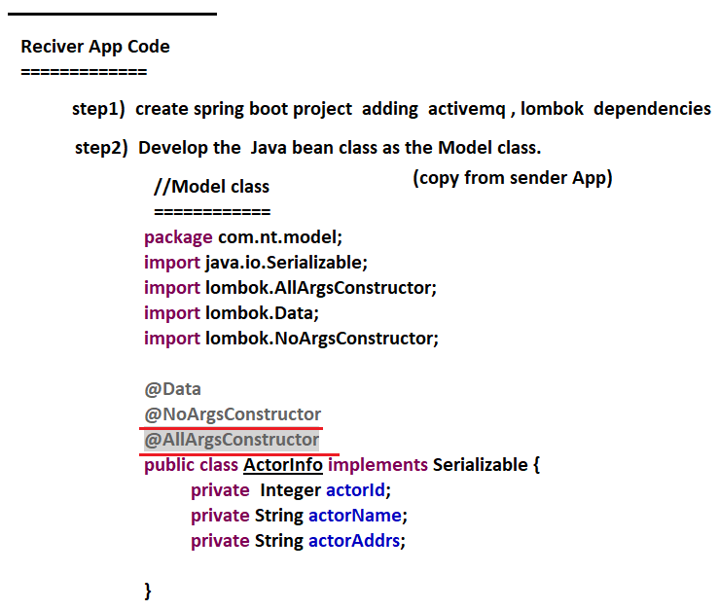

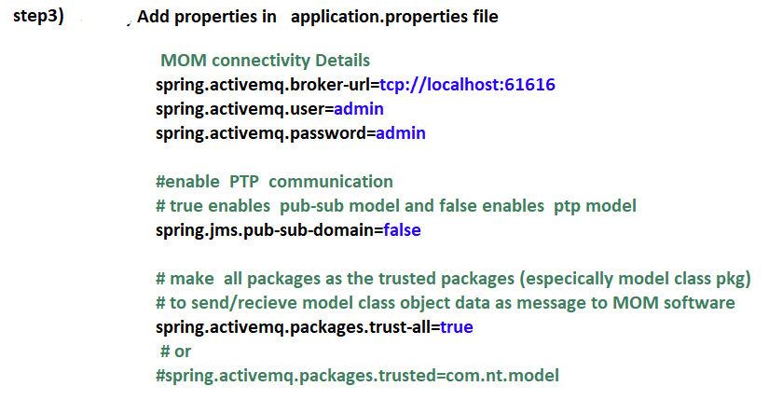

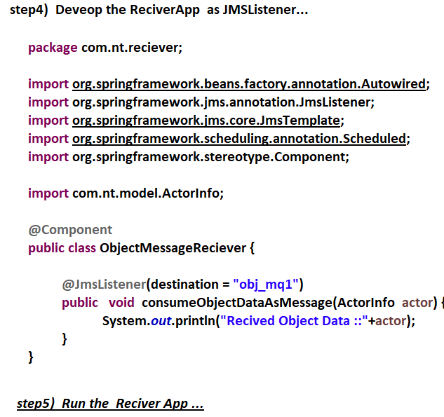

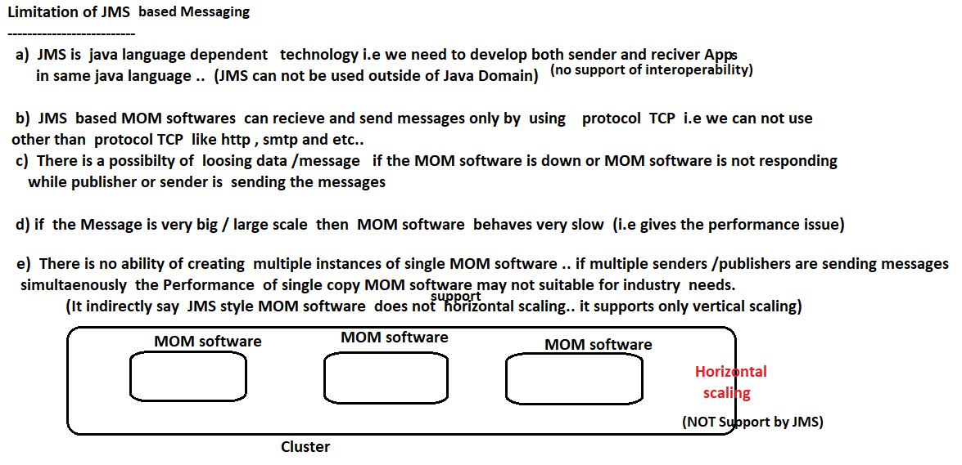

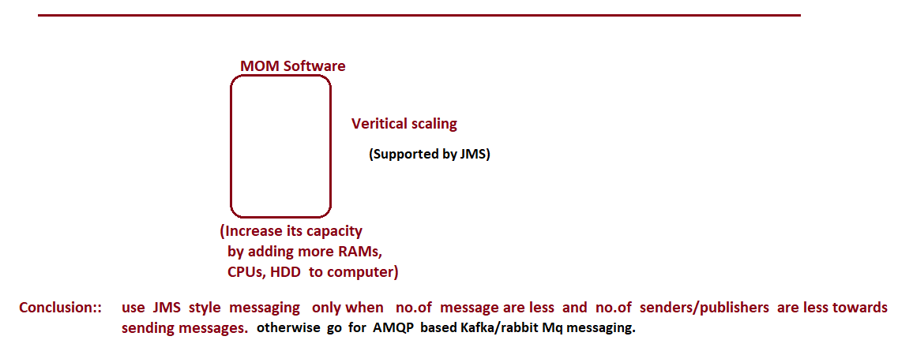

# NTSPBMS615- kafka Intro - sept 7th

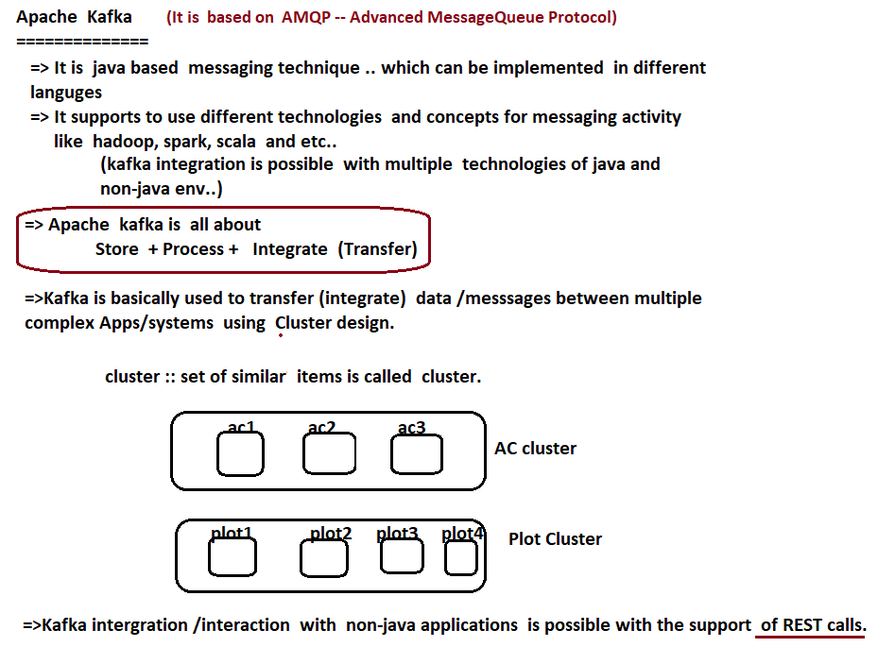

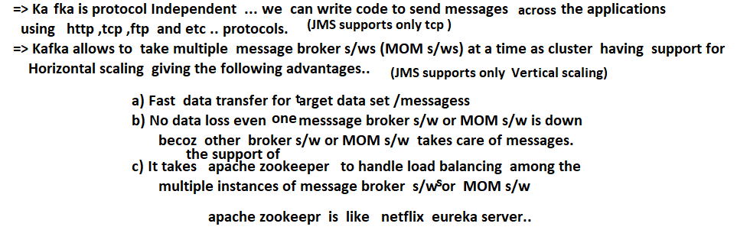

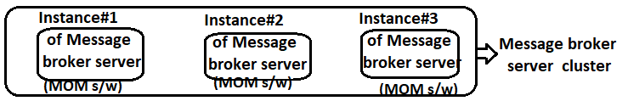

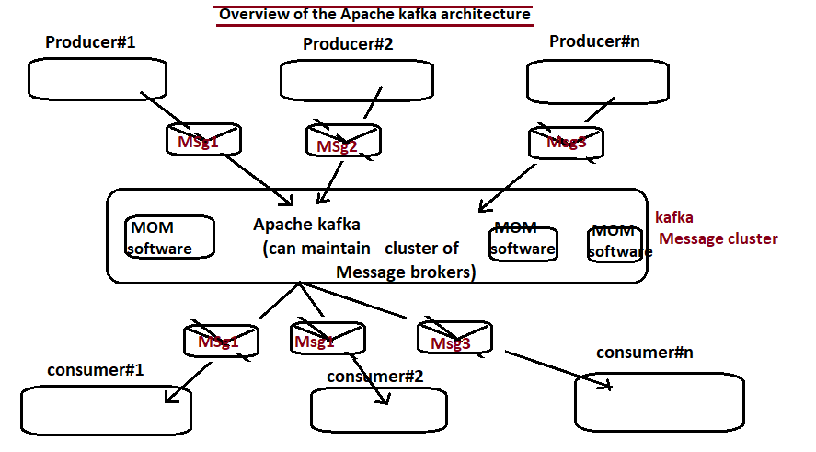

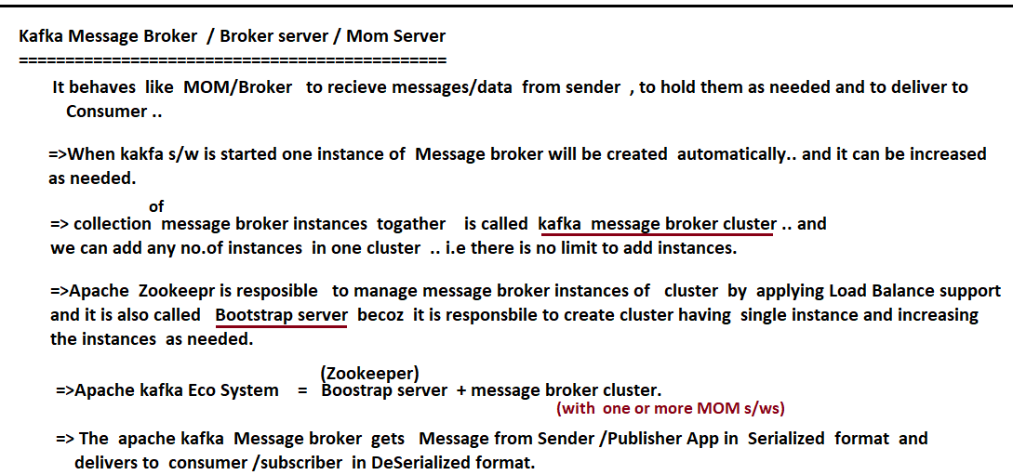

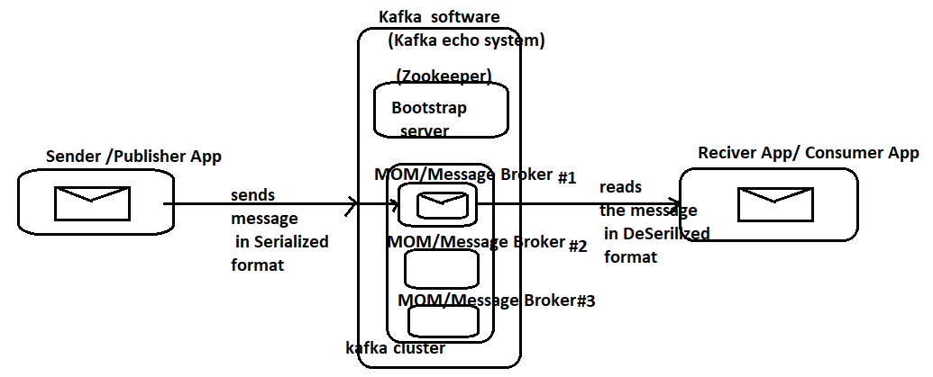

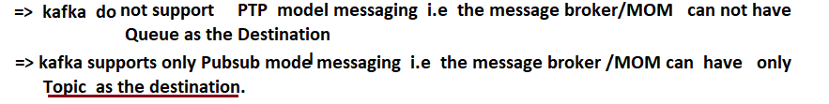

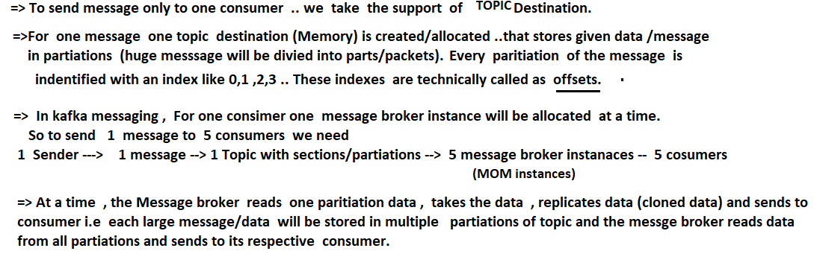

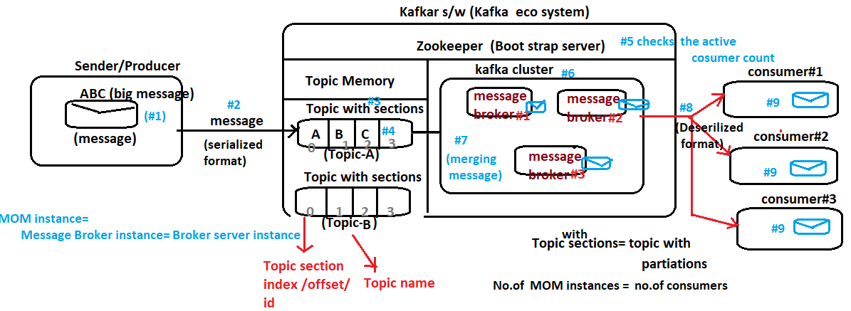

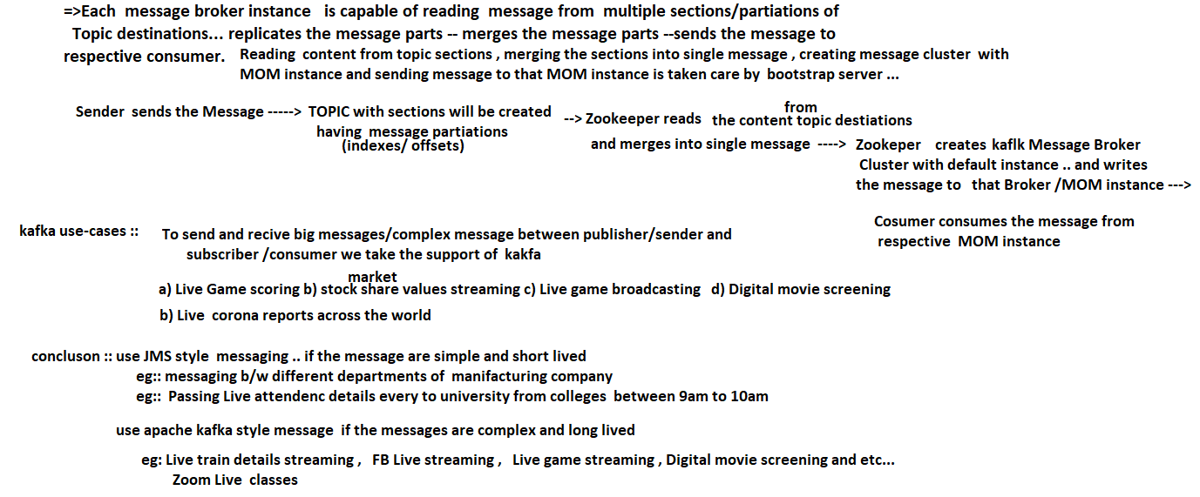

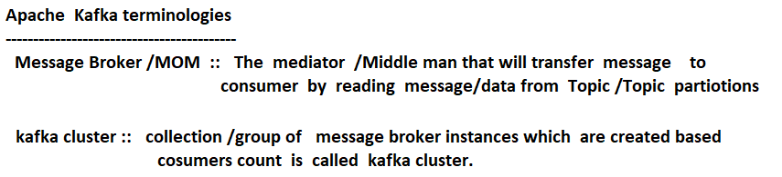

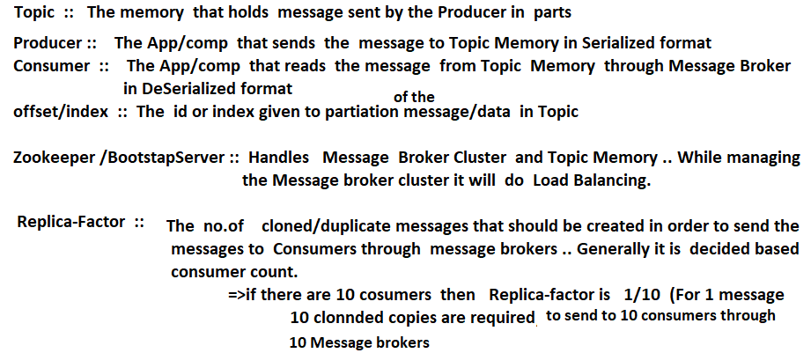

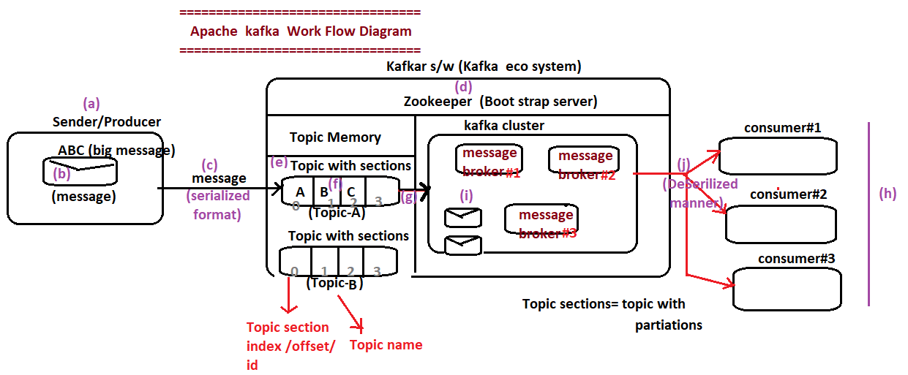

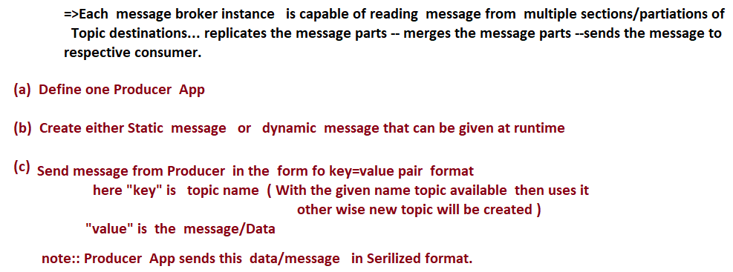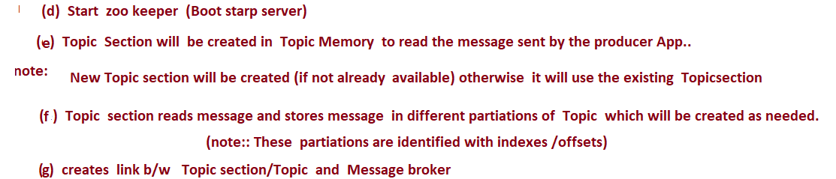

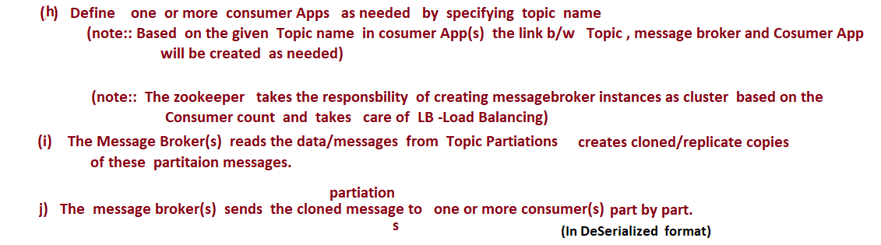

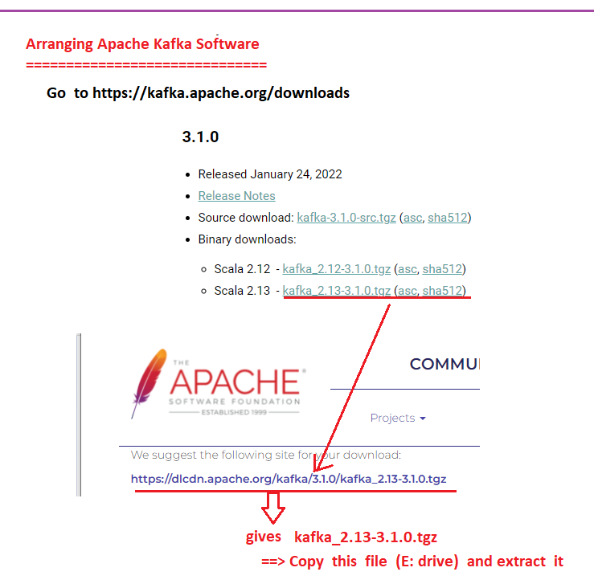

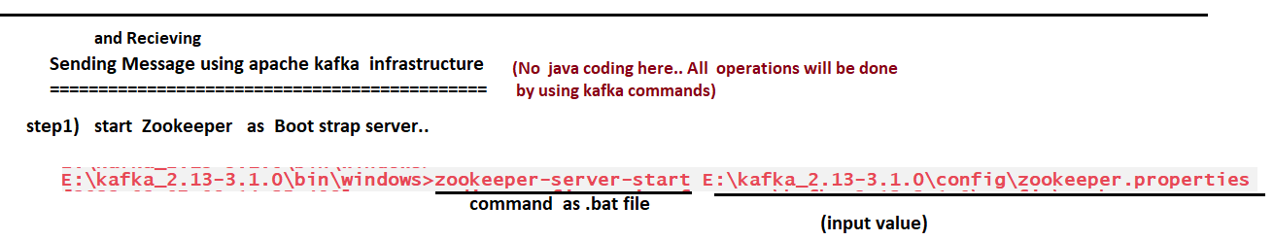

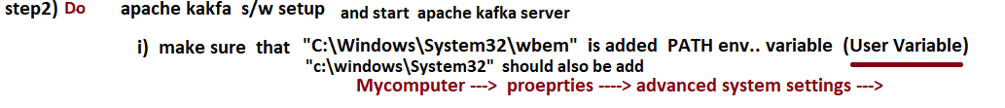

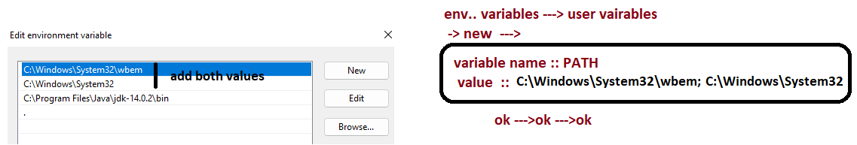

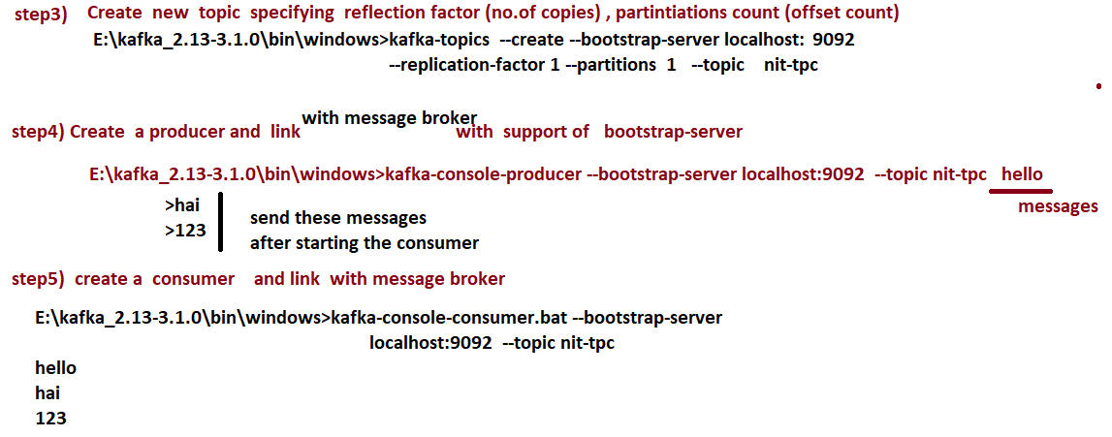

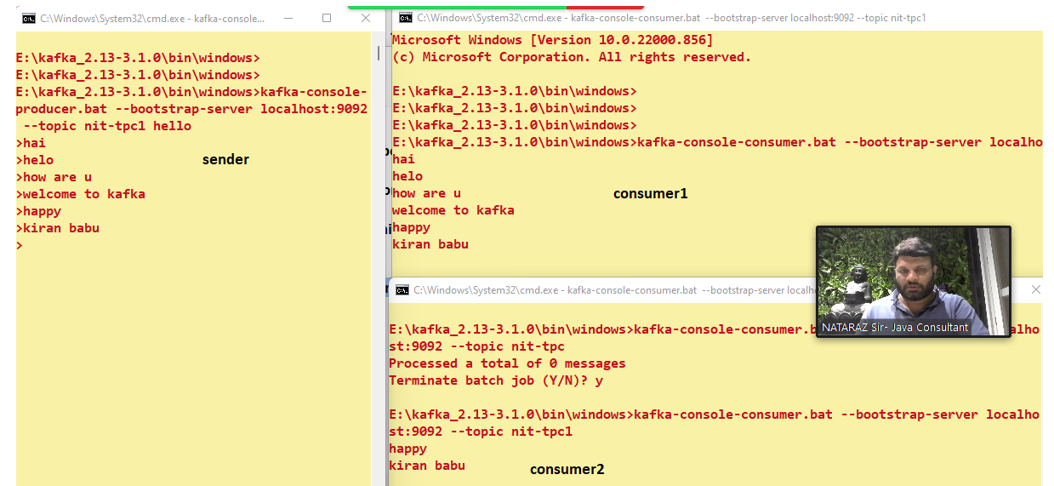

# NTSPBMS615- Developing Kafka Clients using Java APIs - sep9th-2022

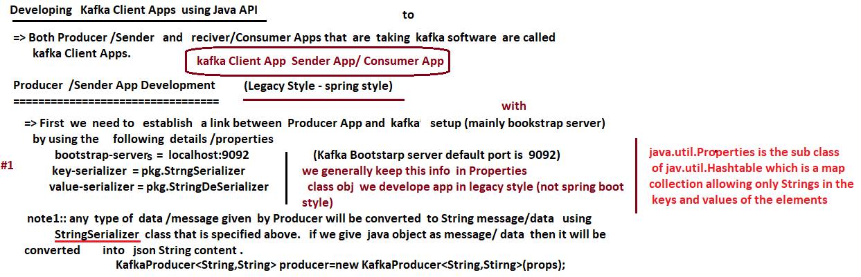





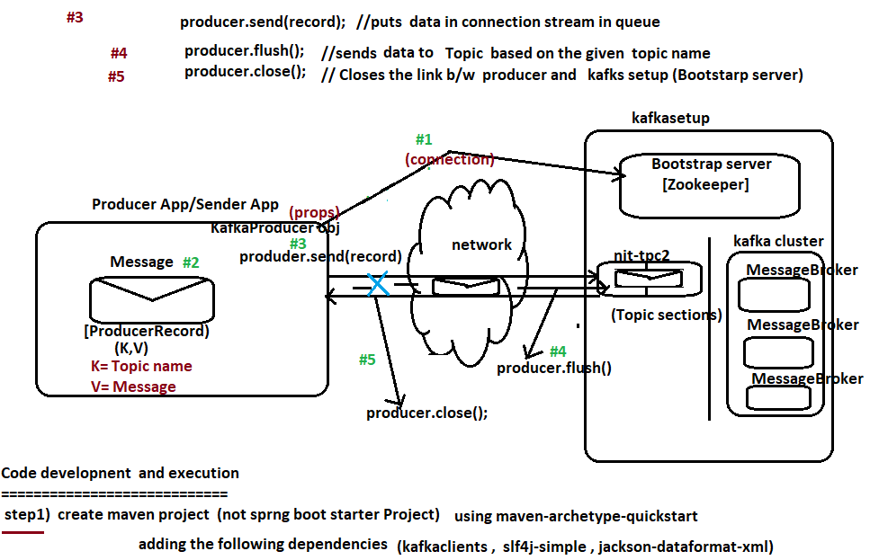

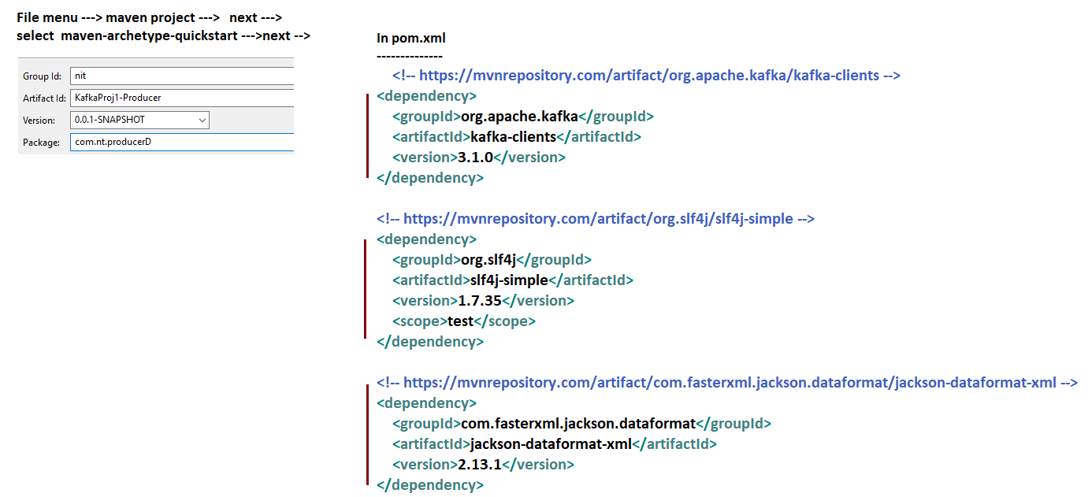

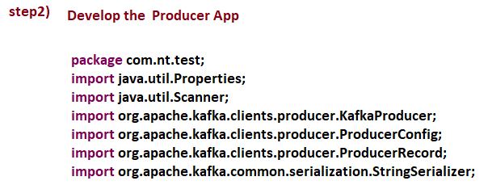

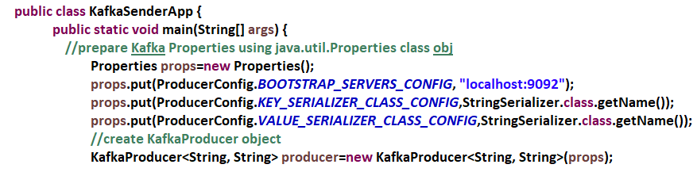

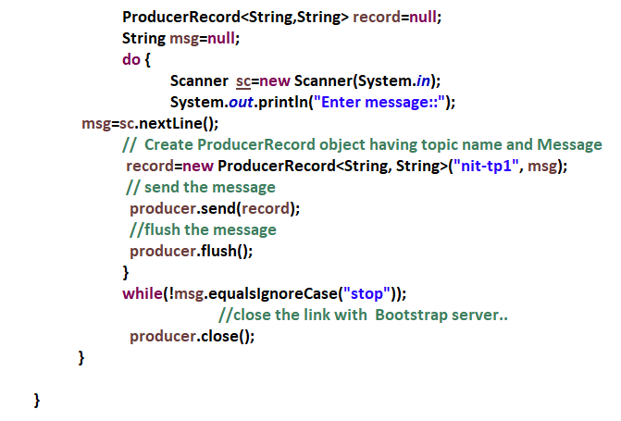

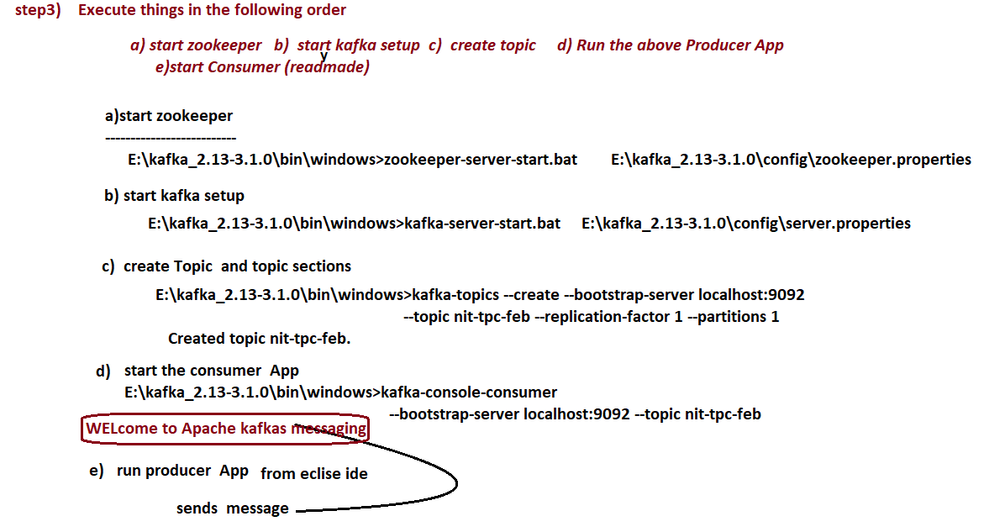

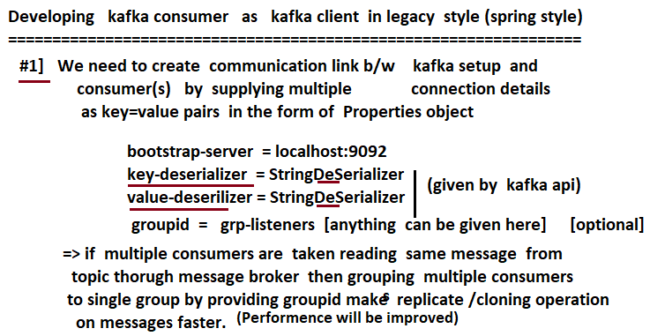

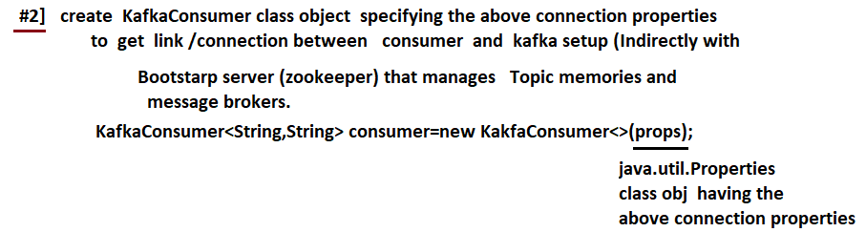

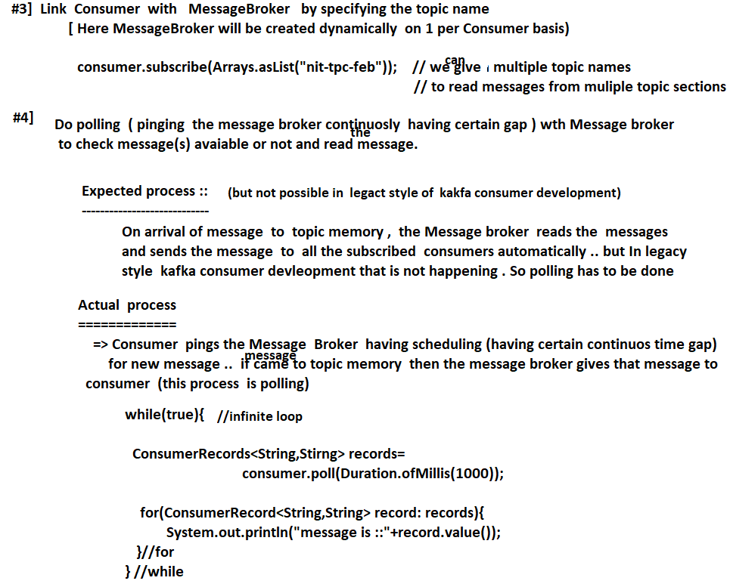



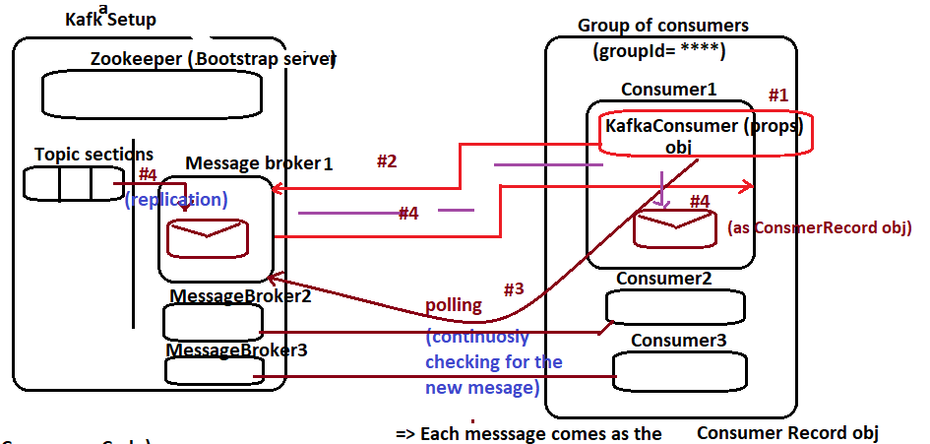

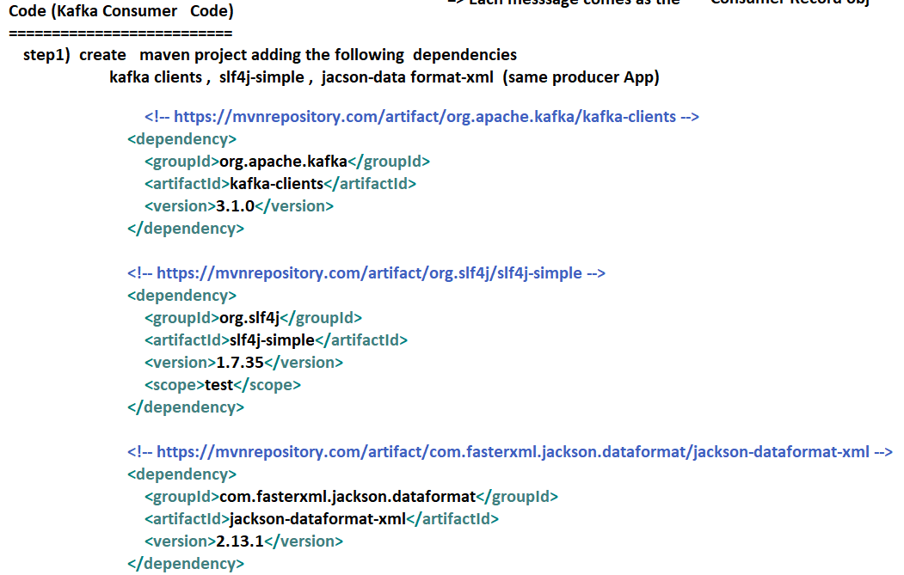

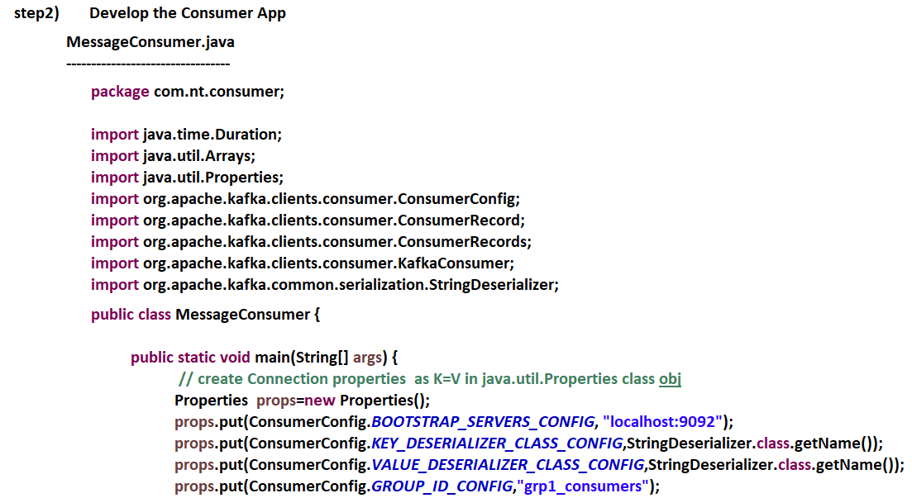

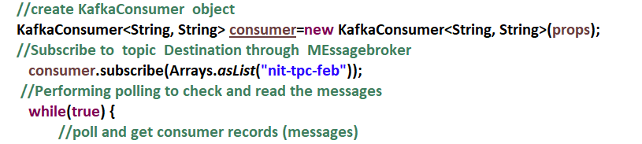

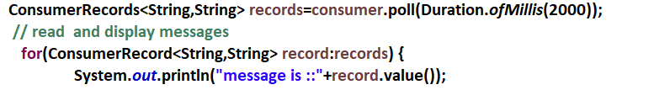

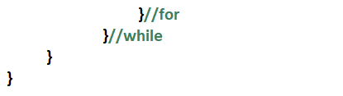

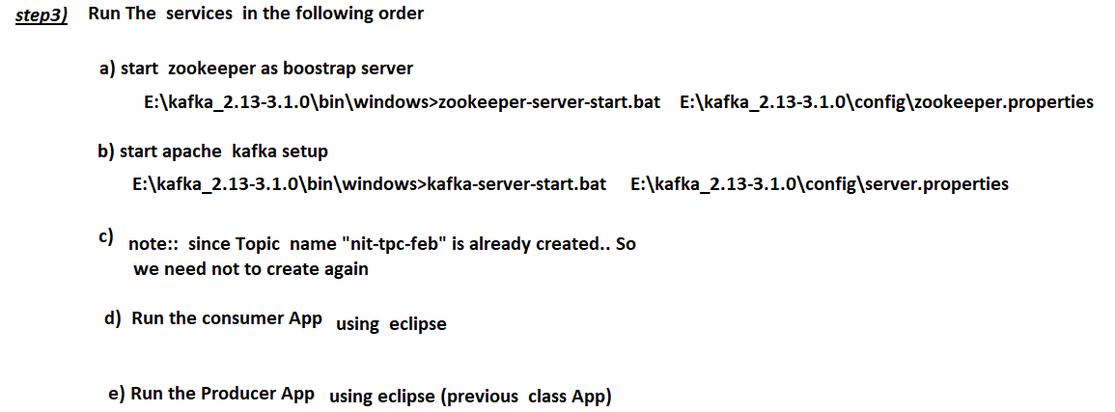

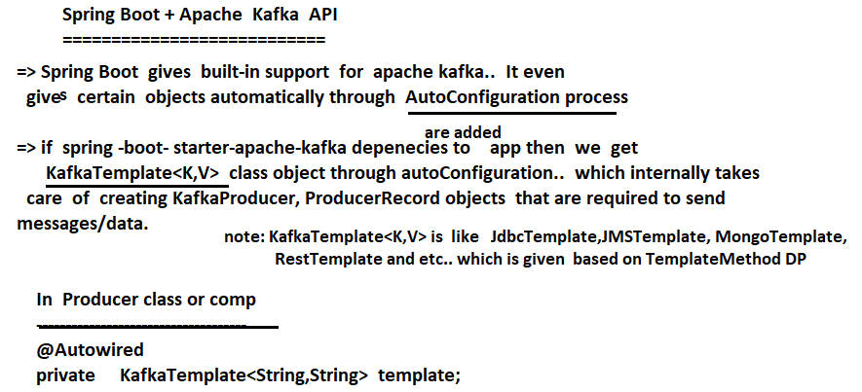

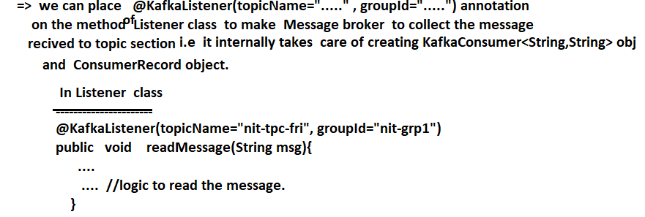

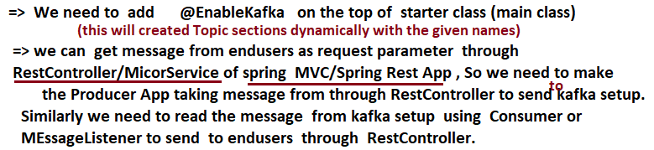

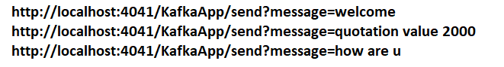

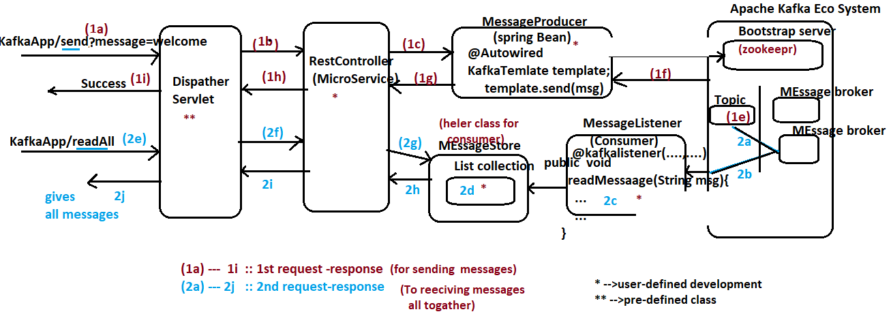

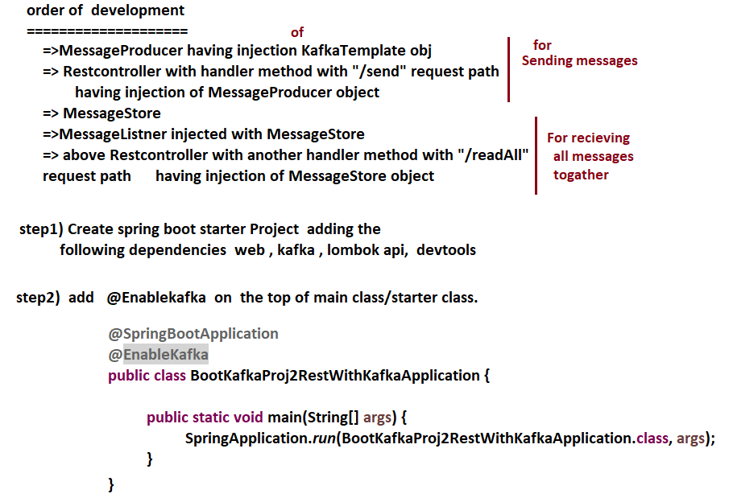

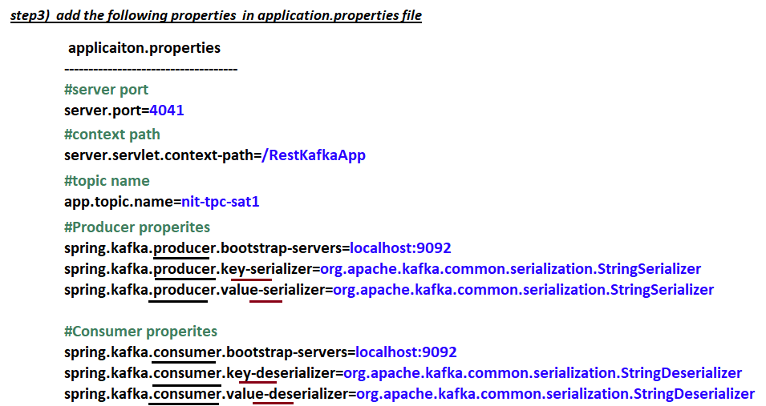

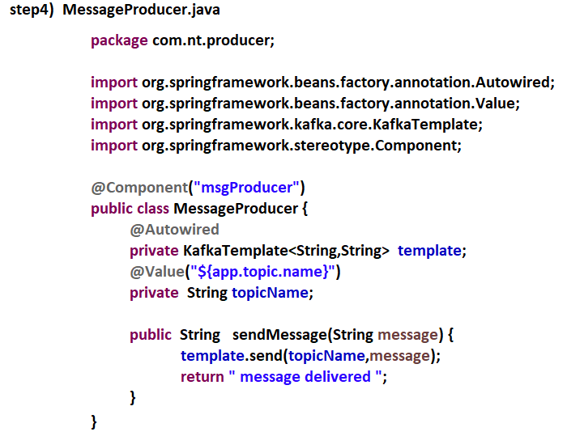

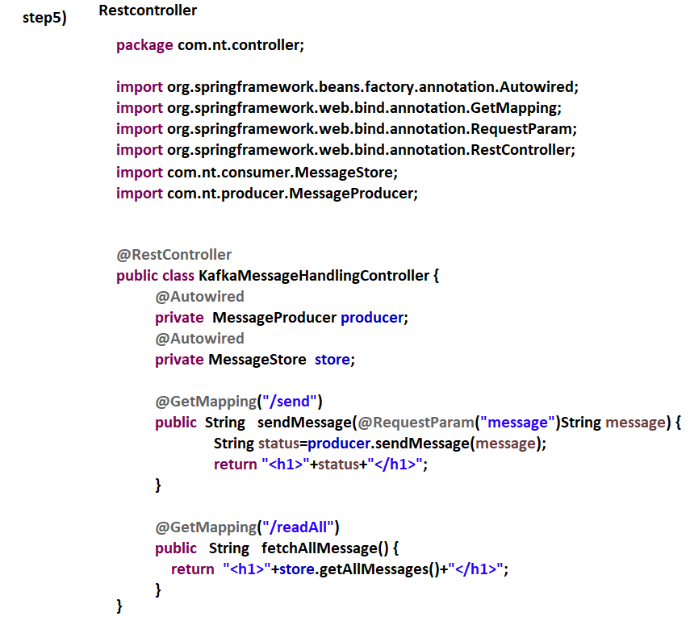

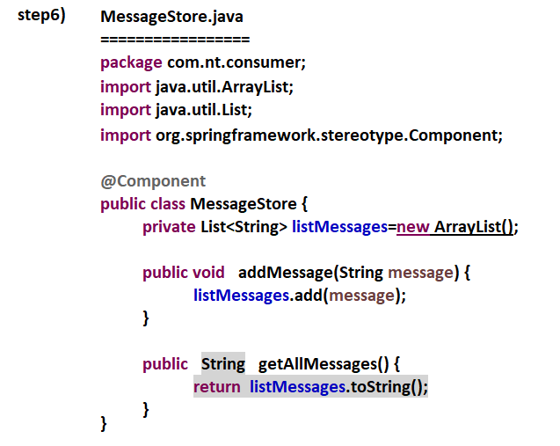

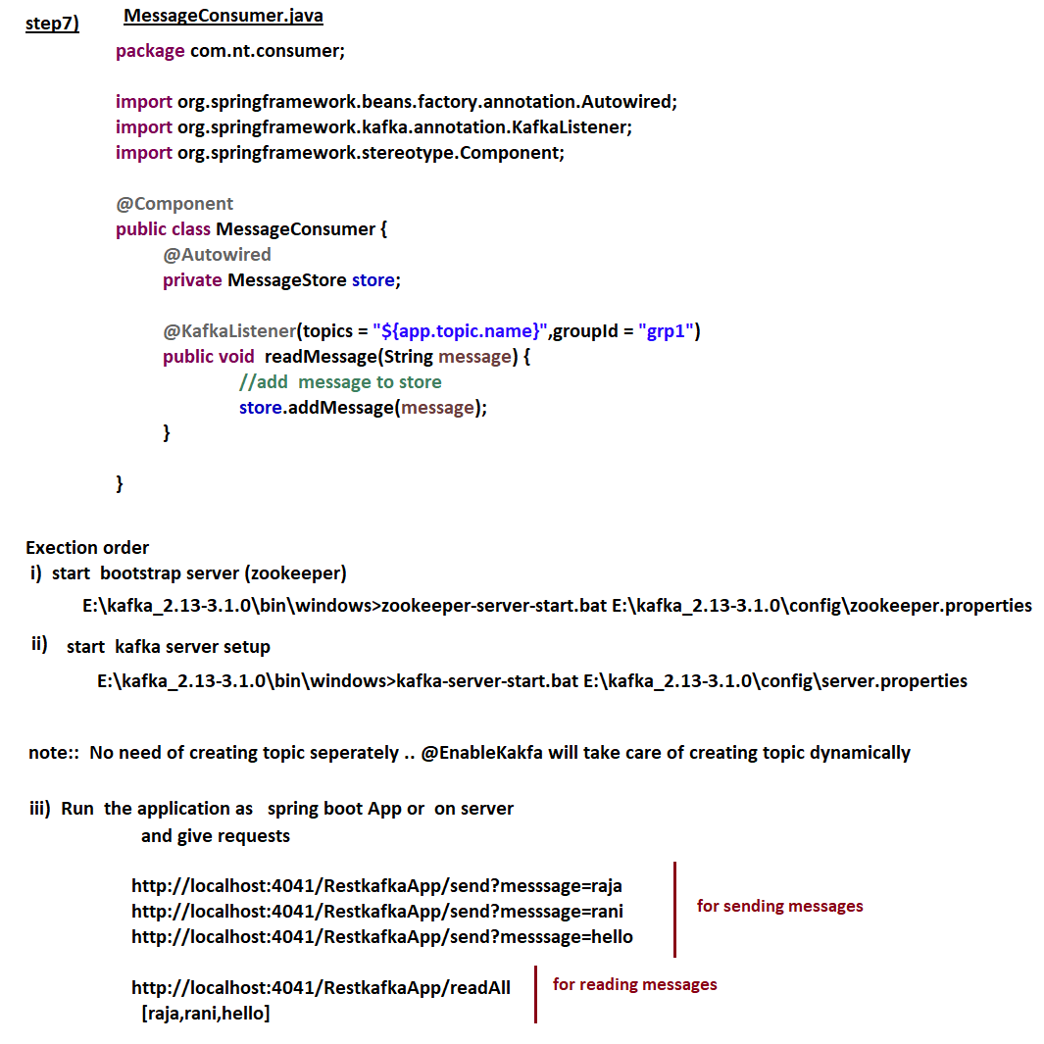

# NTSPBMS615- MiniProject using MicroServices -sept13th-2022

